CSAMS: A Web-based Attendance Monitoring System with Contact Tracing and Notification via SMS using QR Code for CSTC College of Sciences,

Technology and Communications, Inc.

A Capstone Project

Presented to

The Faculty of School of Information Technology of

CSTC College of Sciences, Technology and Communications, Inc.

In Partial Fulfillment

of the Requirements for the Degree of

Bachelor of Science in Information Technology

Members:

Cabuyao, Gio R.

Abulencia, John Kent A.

De La Cruz, Monsoure D.

July 2023

**ABSTRACT**

In the present time, CSTC uses traditional method of recording the attendance and contact tracing, which adhere to safety protocols that has posed significant problems. The issue correlates with inconsistent and outdated, paper-based attendance monitoring system that requires extensive manual effort. Moreover, lack of an efficient contact tracing mechanism would result to challenges in maintaining a safe environment, especially during outbreaks or health emergencies.

To address this, the proponents developed CSAMS, a web-based system for monitoring attendance at CSTC College of Sciences, Technology, and Communications Inc. The system incorporates contact tracing and SMS notifications, offering a dependable and effective method of tracking attendance, specifically designed to address the challenges posed by the COVID-19 pandemic.

Utilizing the iterative and incremental model, the researchers divided the development process into smaller and incremental stages, including Planning and Requirements, Analysis & Design, Implementation, Testing, and Evaluation. The web application architecture consists of front-end components (HTML, CSS, JavaScript) hosted on Hostinger where users interact via browsers, sending HTTP requests to the web server. MySQL handles data storage, and responses may include HTML, CSS, JavaScript, or MySQL data. Semaphore serves as the SMS provider, while qrcode.js generates QR codes.

CSAMS was subjected to an assessment using a checklist questionnaire based on ISO 25010 standards. The evaluation process involved obtaining input from a group of 45 individuals who were non-IT experts, as well as five (5) experts from the IT field. The assessment covered functional suitability, performance efficiency, compatibility, security, usability, reliability, maintainability, and portability of the developed system. Based on the findings, CSAMS is a viable solution for attendance tracking, health declaration forms, SMS notifications, and symptom monitoring. Furthermore, enhancing CSAMS with additional features would significantly improve its functionality and overall effectiveness in promoting health and safety, facilitating communication, and preventing the spread of infectious diseases like COVID-19. These would optimize operations, streamline workflows, and contribute to creating a safer and healthier environment for students, visitors, and the entire educational institution.

*Keywords:* Analysis Options, Contact Tracing, COVID-19 pandemic, CSAMS, Front-end Components, Iterative and Incremental Model, qrcode.js, Web Application Architecture

**ADVISER’S RECOMMENDATION SHEET**

The capstone project entitled *“CSAMS: A Web-based Attendance Monitoring System with Contact Tracing and Notification via SMS using QR Code for CSTC College of Sciences, Technology and Communications, Inc.”*, developed and submitted by Gio R. Cabuyao, John Kent A. Abulencia and Monsoure D. De La Cruz in partial fulfillment of the requirements for the degree of Bachelor of Science in Information Technology, has been examined and endorsed for final defense as bounded by the stipulated objectives, scope, and limitations of the project.

**JORGE T. JADER, MIT**

Capstone Project Adviser

**APPROVAL SHEET**

This approval sheet certifies that the capstone project entitled **CSAMS: A Web-based Attendance Monitoring System with Contact Tracing and Notification via SMS using QR Code for CSTC College of Sciences, Technology and Communications, Inc.** developed and submitted by Gio R. Cabuyao, John Kent A. Abulencia and Monsoure D. De La Cruz, has undergone a comprehensive oral panel defense and software examination and has been deemed satisfactory and in compliance with the academic standards set forth by the institution.

**JORGE T. JADER, MIT**

Capstone Project Adviser

Approved by the Committee on Oral Examination with a grade of ______on________

**ENGR. JOHN C. VALDORIA, MIT**

Member

**MARK BRYAN F. VALENCIA, MIT**

Member

**RHODERICK G. CARRIAGA, MIT**

Chairperson

The project is accepted and approved in partial fulfillment of the requirements for the degree of Bachelor of Science in Information Technology.

**JORGE T. JADER, MIT**

Dean, School of Information Technology

CSTC Inc. – Sariaya Campus

**ACKNOWLEDGEMENT**

Our deepest gratitude and appreciation go out to everyone who has helped us make our research possible with all their efforts.

Above all, thank you to **Almighty God** for His gift of life, the blessing of guidance, and the divine intervention of this academic endeavor.

To our **Parents and Family**, for their constant support and encouragement throughout our academic journey, along with their unwavering love and belief in us.

To **College of Sciences Technology and Communications Inc.**, our institution, where we have continuously grown as Bachelor of Science in Information Technology students.

To our research adviser, **Jorge T. Jader, MIT**, for his guidance, support, and invaluable feedback throughout the research process. His insights and knowledge have been instrumental in shaping the direction and content of this work. Also, thanks to our panelists, **Engr. John C. Valdoria, MIT, Rhoderrick S. Carriaga, MIT,**and **Mark Bryan Valencia, MIT,** who also offered guidance and support.

To **all the Professor** for sharing their knowledge and expertise, recommendations, valuable suggestions, and pieces of advice and for their continued support.

We would also like to thank our friends and classmates, especially **Renz, Liandrey, Joseph, Paul, Reichelle, Laiza, and Mariel,** for their help, knowledge, and inspiration during our capstone project.

***Gio R. Cabuyao***

***John Kent A. Abulencia***

***Monsoure D. Dela Cruz***

**DEDICATION**

In heartfelt gratitude and profound reverence, we dedicate this research capstone to the following.

To God, our constant source of knowledge and direction, whose heavenly light has guided us on this journey and enlightened our way, and for giving us ability to overcome obstacles and explore new areas of knowledge.

To our treasured families, whose unchangeable love and constant trust served as the foundation for our goals. Your ongoing support, sacrifices, and encouragement have strengthened our resolve and given us the constant support we needed to achieve this significant milestone.

To our outstanding professors and educators, whose insight, expertise, and continuous dedication have molded our minds and excited our desire to learn. We have grown into accomplished researchers and scholars because of your solid faith in our potential, patient guidance, and persistent pursuit of perfection.

To our close friends who helped us on this difficult but wonderful journey. This journey has been made into a memorable adventure by your continuous support, words of encouragement, and laughter. Your confidence in our abilities served as a constant reminder of the strength of teamwork and the joy of shared victories.

**TABLE OF CONTENTS**

**PRELIMINARIES**

TITLE PAGE i

ABSTRACT ii

ADVISER’S RECOMMENDATION SHEET iv

APPROVAL SHEET v

ACKNOWLEDGEMENT vi

DEDICATION viii

TABLE OF CONTENTS ix

**CHAPTER I. BACKGROUND OF THE PROJECT**

1.1 Overview of the Current State of Technology 1

1.2 Project Context 4

1.3 Objectives of the Project 8

1.3.1 General Objectives 8

1.3.2 Specific Objectives 8

1.4 Research Framework 9

1.4.1 Theoretical Framework 9

1.4.2 Conceptual Framework 12

1.5 Scope and Limitation of the Project 14

1.6 Significance of the Project 22

1.7 Definition of Terms 24

1.7.1 Operational Terms 24

1.7.2 Technical Terms 25

**CHAPTER II. REVIEW OF RELATED LITERATURE AND STUDIES**

2.1 Related Literature and Studies 28

2.2 Synthesis 48

**CHAPTER III. DESIGN AND DEVELOPMENT METHODOLOGY**

3.1 Software Methodology 50

3.2 Requirement Documentation 57

3.2.1 Functional Requirements 57

3.2.2 Non-Functional Requirements 60

3.3 Data and Processing Model 64

3.3.1 Context Diagram 64

3.3.2 Data Flow Diagram 66

3.4 Methods of Data Gathering 67

3.5 Requirements Specification 68

3.5.1 System Architecture 68

3.5.2 Hardware and Software Specification 69

3.6 Object Analysis and Design 72

3.6.1 UML Diagram 72

A. Use Case Diagram 72

B. Class Diagram 73

C. Activity Diagram 74

D. Sequence Diagram 79

E. Entity Relationship Diagram 84

F. Data Dictionary 85

3.6.2 System Storyboard 97

3.7 Testing and Evaluation 140

3.7.1 Test Plan 140

3.7.2 Test Case Document 143

3.7.3 Evaluation Plan 152

3.7.4 User Acceptance 155

3.7.5 Deployment Plan 156

**CHAPTER IV. RESULT AND DISCUSSION**

4.1 System Performance Result 159

4.2 Perception of the Respondents 160

4.3 Tabulation of Result 161

4.4 Result and Evaluation by IT Expert 167

**CHAPTER V. SUMMARY OF FINDINGS, CONCLUSIONS AND RECOMMENDATIONS**

5.1 Summary of Findings 177

5.2 Conclusions 180

5.3 Recommendations 182

**REFERENCES**

**APPENDICES**

A. Request Letter and Consent Letter

B. Gantt Chart for the Project Development

C. Letter for Respondent and IT Expert

D. Survey Questionnaire for Respondent and IT Expert

E. Grammarians Certification

F. User Manual

G. Narrative Report

H. Panel Defense Documentation

I. Relevant Source Code

J. Test Case Document

K. Curriculum Vitae

**List of Figures**

**Figure Title Page Page**

1 Bioecological model of influences on student engagement 9

2 Conceptual Framework for CSAMS 12

3 Iterative and Incremental Model 50

4 Context Diagram 64

5 Data Flow Diagram 66

6 System Architecture 68

7 Use Case Diagram 72

8 Class Diagram 73

9 Admin Activity Diagram 74

10 Teacher Activity Diagram 75

11 Student Activity Diagram 76

12 Visitor Activity Diagram 77

13 Nurse Activity Diagram 78

14 Admin Sequence Diagram 79

15 Teacher Sequence Diagram 80

16 Student Sequence Diagram 81

17 Visitors Sequence Diagram 82

18 Nurse Sequence Diagram 83

19 Entity Relationship Diagram 84

20 System Storyboard 97

94 Agile Testing Methodology 141

95 User Acceptance Testing 155

96 Deployment Plan 157

97 End User Overall Evaluation of the CSAMS Web-based System 167

98  Summary of the CSAMS Web-based system Evaluation Results for

IT Experts based on ISO 25010 176

99 Summary of the System Evaluation Results Based on

the ISO 25010 Software Criteria 177

**List of Tables**

**Table Title Page Page**

1. System used in CSAMS Web-based system 69
2. Hardware specification of CSAMS Web-based system 70
3. Data Dictionary for Users 85
4. Data Dictionary for System Administrator 86
5. Data Dictionary for Teacher 87
6. Data Dictionary for Student 88
7. Data Dictionary for Visitor 89
8. Data Dictionary for Classes 90
9. Data Dictionary for Subject 91
10. Data Dictionary for student subject 92
11. Data Dictionary for survey 92
12. Data Dictionary for survey submit 93
13. Data Dictionary for student survey 94
14. Data Dictionary for student survey details 94
15. Data Dictionary for student survey details 95
16. Data Dictionary for Nurse 96
17. Test Case Document Admin Dashboard 143
18. Test Case Document Visitor 147
19. Test Case Document Student 148
20. Test Case Document Teacher 149
21. Test Case Document Nurse 151
22. Scales for the Evaluation Ratings 153
23. Four Point Scale Rating 160
24. End user Evaluation Result for Functional Suitability   
    Criteria of the developed web-based system 161
25. End user Evaluation Result for Performance Efficiency

Criteria of the developed web-based system 163

1. End user Evaluation Result for Compatability  
   Criteria of the developed web-based system 164
2. End user Evaluation Result for Usability

Criteria of the developed web-based system 165

1. End user Evaluation Result for Portability

Criteria of the developed web-based system 166

1. IT Expert Evaluation Result for Functional Suitability

Criteria of the developed web-based system 168

1. IT Expert Evaluation Result for Performance Efficiency

Criteria of the developed web-based system 169

1. IT Expert Evaluation Result for Compatability

Criteria of the developed web-based system 170

1. IT Expert Evaluation Result for Usability

Criteria of the developed web-based system 171

1. IT Expert Evaluation Result for Reliability

Criteria of the developed web-based system 172

1. IT Expert Evaluation Result for Security

Criteria of the developed web-based system 173

1. IT Expert Evaluation Result for Maintainability

Criteria of the developed web-based system 174

1. IT Expert Evaluation Result for Portability

Criteria of the developed web-based system 175

**CHAPTER I**

**BACKGROUND OF THE PROJECT**

The researchers include the study details in this chapter. It consists of an overview of the current state of technology, the project context, the project objectives, the research framework, the scope and limitations of the project, the significance of the study, and the operational and technical terms used by the researchers in this paper.

* 1. **Overview of the Current State of Technology**

Digital attendance system allows easier access and faster process of information compared to the traditional manual attendance in school, universities, or private institutions. There are a variety of digital attendance systems, examples of these are Barcode Attendance System, Biometrics Attendance System, and RFID attendance monitoring.

In schools, barcode stores the student information to provide better and faster data transfer in taking attendance. Biometrics also store the unique human physical characteristics such as the fingerprint, iris, voice, and facial features serving as the student unique identifier. Radio-frequency Identification (RFID) uses radio signals for fast, and almost error-free recognition per student.

Attendance automation requires little to no effort from the teacher, resulting in a reduced workload. In the case of biometric or RFID attendance, students have to punch in or flash the RFID card in front of the device. No paperwork, no manual attendance, and no time are waste resulting in less hassle and allow the already overburdened teacher to focus more on teaching. The attendance data captured by the app, biometric, or RFID device is saved in the attendance management system, which provides role-based access and ensures zero data manipulation (Ahmed, 2021).

Furthermore, the Calling National High School, District 04, San Manuel, Isabela has an attendance monitoring system that utilizes the QR Code and SMS in tracking and monitoring. The system monitors the attendance of the students and when the cut-off time is met, a present/absent notification will be disseminated to the parents via SMS. The system also provides attendance reports to the teachers and to each student. The research findings suggested that it improved the monitoring of the attendance (Rivera, Ronald, & Lagarteja, 2021).

For the development of the project web-based system, the researchers utilized the Quick Response (QR) code. QR code is a square type of barcode that stores or encodes information, retrievable by scanning using a software that can read the pattern of matrix in the QR code (Hayes & Estevez, 2021). The researchers intend to improve the monitoring of the attendance while maintaining the cost of equipment lower. Through utilizing electronic devices such as smartphones that are already in circulation can be used in QR code attendance systems to make attendance faster (Rizal et al., 2016).

However, studying when there is a threat of a highly communicable disease such as COVID-19 requires extra measures to prevent infection. One of those preventive measures that should be considered is the contact tracing. According to WHO (2020) it should emphasize solidarity, reciprocity, and the common good. Participants of contact tracing can help control the local spread of COVID-19, vulnerable people will be protected, and more restrictive measures, such as general stay-at-home orders or wide area quarantine will be strengthened. Public health agencies implementing contact tracing for COVID-19 should be prepared to communicate how the information will be used, stored, and accessed, and how individuals will be protected.

The researchers also found an existing application for contact tracing. In Alberta, Canada they introduced the ABTraceTogether app and the BC COVID-19 support app in British Columbia which helps the Canadian health departments to inform the risk of the users to the epidemic exposure. The federal government also complemented the function of the app by releasing an alert app that improves the awareness of the COVID risk levels in the regions. The implementation of the contact tracing, and cooperation from the users help the government to trace the infections. The example was from international study of Canada in 2020.

StaySafe.ph, a digital contact tracing app owned by the DILG, can be a good preventive measure of an institution, but it cannot track and monitor the user immediately if the user declares some COVID-related health symptoms because the data or information required by the institution comes from the DILG, it may result in further virus transmission.

The developed web-based attendance monitoring system with contact tracing and notification via SMS using QR code can improve the monitoring of attendance. It will allow simultaneous taking of the student attendances using QR code, or the teacher can manually mark the student attendance. It can also help the teachers in generating the attendance reports and help in identifying which students have absences. The developed web-based system can also send Short Messaging Service (SMS) notification to the admin, nurse, and guard. The attendance monitoring system also has a health declaration form survey for contact tracing as a response to have an additional preventive measure against the COVID-19 virus.

* 1. **Project Context**

It has been announced that face-to-face (F2F) classes would resume since COVID-19 infection is under control and gradually declining. The implementation of the new F2F class setup requires some adjusting to accommodate the new-normal changes brought about by the COVID-19.  As said by Father Harris Iñigo Garcia (2022), the Vice President for Administration, CSTC is still using the traditional pen-and-paper way of taking attendance and contact tracings. The importance of education and health are advised to be prioritized both at the same time. The attendance is a must in learning, but the course of studying should follow the guidelines of the Inter-Agency Task Force (IATF). It was concluded that safety protocols such as the social distancing rule are sometimes being overlooked.

Based on interviews conducted with Wilson De Los Reyes and Ronald Escarza (2022), it was found that the usage and accuracy of the Stay Safe PH contact tracing app among entrance to the campus was very low. Only around 10 out of 100 entrants per day were using the app to comply with the health declaration form. In an effort to increase user appreciation and compliance, the researchers propose incorporating contact tracing into the attendance monitoring system.

However, it was also noted that non-CSTCian entrants such as parents and visitors still use a pen-and-paper approach for contact tracing, borrowing a pen from the entrance receiving area most of the time. This suggests that there is still room for improvement in terms of implementing digital contact tracing systems across all entrants to the campus.

In accordance with Vanessa Gabrigo (2022) when a CSTC student exhibits more than three COVID-19 symptoms, the school nurse would advise to isolate and assist them. The student would undergo a check-up, interview, and if the symptoms prevail, they need to fill out a May Go Home Slip form. The health declaration form may be used to gather additional information as the Nurse and LGU Sariaya investigate the situation. However, in severe cases, the student would be immediately transported to the hospital for medical attention. The school nurse would coordinate with the LGU Sariaya to ensure that appropriate measures are taken, and necessary information is relayed to the concerned parties.

According to Mr. Eriberto Gerardo A. Gabiola, Sanitation Inspector V from the Office of Environmental Health and Sanitation Services, the developed system on contact tracing can serve as the initial basis for investigating possible COVID-19 cases in CSTC. In case of a suspected case, the school nurse would have to contact the office of Environmental Health and Sanitation Services for assistance

Moreover, it was created under the approval of WHO which the IATF needs regarding the guidelines for doing contact tracing. He added that if the web system was developed successfully, the LGU Sariaya can use the web system to identify and verify COVID-19 hotspot locations. Thus, the records gathered by the system can assist the LGU Sariaya in determining where to start the COVID-19 investigation. The health declaration, when administering a contact tracing survey, can help different local government units to trace COVID-19 cases.

As cited from the briefing of Senate Economic Planning Office (2021), contact tracing can help in interrupting the ongoing transmission of COVID-19, and help alerting the possible close contacts. Different public and private institutions can help the government by implementing strategies such as having records of contact tracing and ensuring relevant personal health information is readily available to be accessed by the public healthcare workers.

In an interview conducted with Mr. Jubert Reyes, the Neo LMS Administrator, he shared his insights on the proposed system and provided suggestions on how the system can be further developed.

As a result, the researchers have decided to incorporate contact tracing into the developed web-based system. The CSAMS would be utilized to track the attendance of CSTC college students and administer the contact tracing survey for the health declaration of students and visitors. The information gathered by the system will be made available to LGU public healthcare staffs, and the LGU can cooperate with the private institution of CSTC Sariaya in case a possible COVID-19 case occurs on campus. This information will be readily accessible and can aid in the prompt identification and isolation of potential cases to prevent the spread of the virus.

The traditional method of taking student attendance and the contact tracing process at the school should be enhanced for better efficiency. The researchers have taken into account the current safety and health protocols being implemented by the CSTC stakeholders in developing the plan for the system. Improvements to the attendance and contact tracing processes can aid in the early identification and isolation of potential COVID-19 cases, thus promoting a safer and healthier environment for the students, staff, and visitors of CSTC.

It was observed by the researchers that attendance is a significant factor in a student’s academic success, as it affects their overall performance and fulfillment of graduation requirements. It is crucial to improve student attendance, while also ensuring that proper health and safety protocols are in place. It is with this premise that they decided to develop a system that can efficiently monitor attendance while also promptly identifying and isolating potential COVID-19 cases, thereby promoting a safe and conducive learning environment for the students of CSTC.

**1.3 Objectives of the Project**

**1.3.1 General Objectives**

The main objective of this study is to provide an efficient and effective way of monitoring attendance using QR Code, ensuring the safety of students, visitors, and staff by implementing contact tracing, and notifying parents whether their child arrives at school via SMS and in case of emergencies.

**1.3.2 Specific Objectives**

1. To design a web-based attendance monitoring system that can efficiently track and generate attendance reports for the CSTC college department, thereby improving attendance management and making an innovative way of taking attendance using QR Code.
2. To develop a user-friendly and secure contact tracing health declaration form that utilizes for contactless filling out of necessary information when entering the college campus, ensuring the safety and health of students, staff, and visitors.
3. To implement an SMS notification system that sends an alert to the guardian or parent upon the entry in the school and providing them with real-time updates on their children.
4. To integrate a notification system that promptly alerts the school nurse and guard regarding symptomatic entrants on the campus, enabling them to take appropriate preventive measures and preventing the possible transmission of infectious diseases similar to COVID-19.

**1.4 Research Framework**

**1.4.1 Theoretical Framework**

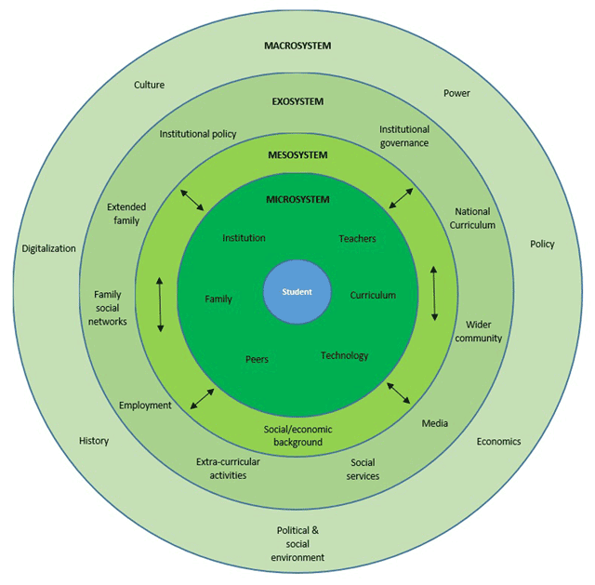

*Figure 1.* Bioecological model of influences on student engagement

Based on Bronfenbrenner’s model, individuals are shaped by the interactions between their biology and their environment. The environment is composed of various nested systems, including the microsystem individual’s immediate environment such as family and school while mesosystem was the interactions among different settings in the individual’s life, the exosystem are the external environments that indirectly impact the individual, macrosystem larger cultural and societal context.

Generally, the influencing factors of student engagement can be divided into internal and external factors. Bond and Bedenlier, (2019) unveil detailed factors that influence student engagement by adapting the bioecological model of influences on student engagement.

In the case of attendance monitoring systems, Bronfenbrenner’s model would suggest that regular attendance in school is a critical component of a student’s microsystem. Consistent attendance ensures that students have access to important educational resources and social connections with peers and teachers. However, the model also recognizes that factors in the mesosystem, such as family or community challenges, can impact a student’s ability to attend school regularly. Thus, attendance monitoring systems may help identify and address challenges in the mesosystem that are impacting a student’s attendance and overall development.

Digital contact tracing, on the other hand, is a tool that has become increasingly important during the COVID-19 pandemic to track and limit the spread of the virus. This tool can be seen as part of the ecosystem, which refers to the broader societal context in which the student is situated. Digital contact tracing can help identify individuals who have been in close contact with someone who has tested positive for COVID-19, allowing for targeted testing and quarantine measures to limit the spread of the virus.

The researchers further investigate the institutions that establish a culture of student success by setting high expectations for both students and faculty, as well as investing in support services and infrastructure, such as reliable connections and technology, are far more likely to foster positive student engagement. As a result, it is critical that low-cost hardware and software can be made available to students and families in order to bridge the digital divide, as well as that institutions conduct needs assessments in order to gain a better understanding of real and potential barriers for students and families.

As cited by Aguilar (2020) targeted implementation can be applied with a set of customized strategies to arrive at a desired result such as particularly improving the attendance of the student affecting the student social, and educational aspects. The strategies proposed for data monitoring can assist in identifying students who require the most special attention. A review of available resources can also help the student. Making contact with the students’ parents or guardians can also improve their lives. As a result, it was hypothesized that tailoring good strategies could yield the desired results.

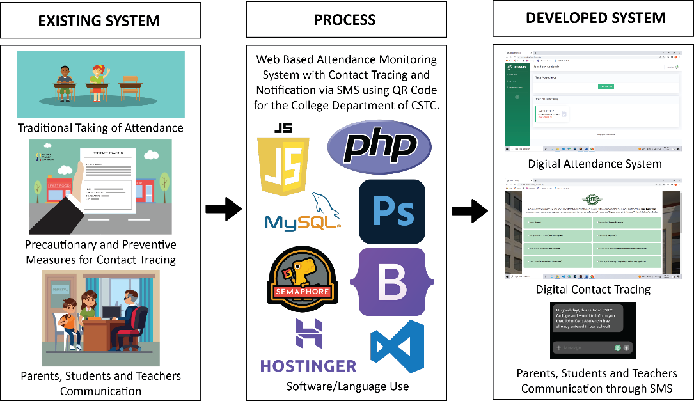**1.4.2 Conceptual Framework**

*Figure 2*. Conceptual Framework for CSAMS

Figure 2 shows the linked concepts and dimensions dedicated to provide a comprehensive understanding of the research project. The framework illustrations and brief descriptions present the relevance and map out the relationship of the different processes in developing the develop web-based system.

Figure 1 shows that technology made an impact on education as it has changed practically every element of school life, with attendance being one of the most notable examples. Schools which have access to statistics on overall attendance, can standardize how teachers implement the attendance regulation, and can make attendance data public to the evolving attendance monitoring system. The improved transparency and time-efficiency of attendance reduces instructor effort, boosts student engagement, and facilitates improved parent communication.

Meanwhile figure 2 shows the factors to consider in managing the student attendance, improving precautionary and preventive measures against COVID-19 through contact tracing, and explaining the importance of communication among the students, parents, and teachers. It helps the researchers to identify what information from different resources should be gathered acting as the inputs for the improvement and development of the develop system.

The developed web-based system utilizes a combination of front-end and back-end technologies to create a comprehensive and interactive platform. The front-end of the system is built using Bootstrap, a widely used front-end framework that incorporates HTML, CSS, and JavaScript. By leveraging Bootstrap, the system achieves a responsive web design, ensuring optimal user experience across various devices. It provides pre-built components such as forms, tables, buttons, and navigation elements, enabling the researchers to efficiently create a visually appealing and intuitive interface.

On the backend, PHP is employed as the programming language of choice. PHP is an open-source language that specializes in handling data-heavy website features. Its flexibility allows the researchers to easily customize and modify the code to meet the specific requirements of the web-based system.To facilitate development, the researchers utilize Visual Studio Code as their primary text editor. With its rich set of features, Visual Studio Code offers a robust environment for editing, navigating, and designing the system, enhancing productivity and code quality. JavaScript is utilized for the generation of QR Codes for subjects within the system. This implementation enables the system to dynamically create QR Codes, which can be scanned and processed as needed. For data storage and management, MySQL serves as the database of choice. With its ability to handle large amounts of data, MySQL allows the system to effectively collect and organize information to meet the needs of the website and its target audience.

In summary, the developed web-based system combines Bootstrap, PHP, Visual Studio Code, JavaScript, Adobe Photoshop, MySQL, Semaphore, and Hostinger to create a responsive, customizable, visually appealing, and efficient platform for data collection, management, and communication.

**1.5 Scope and Limitation of the Project**

This project focuses on developing digital monitoring of the student attendance in the college department and a safer method of contact tracing among the entrants of the CSTC College of Sciences, Technology and Communications, Inc. The project CSAMS applied the rules and regulations complying with the Data Privacy Act of 2012 or Republic Act No. 10173 in establishing the agreement to the Terms and Conditions for the usage of the system. This becomes the basis for the collection of data in any form, aligned to the necessary information needed only by the school. The web system has such features like generating QR Code for attendance, creating attendance summary reports, and survey forms. To ensure data privacy and security, only authorized personnel chosen by the CSTC admin will have access to the data inputted by the developed web system.

To maintain data confidentiality, the responses from surveys would only be shared between the CSTC school nurse and the LGU Sariaya Environmental Health and Sanitation Services office with a purpose was to investigate potential COVID-19 cases. The system would follow strict privacy protocols to prevent unauthorized parties from accessing the personal information collected through the survey.

Furthermore, to make use of the contact tracing health declaration form, the web-based system will seek permission to utilize the devices camera for scanning the QR code. This step is crucial for ensuring accurate and efficient contact tracing, as well as preventing the transmission of COVID-19 within the college campus. The system will enforce strict security measures to ensure that camera access is solely employed for its intended purpose and will not be subject to misuse or abuse.

The developed system has five (5) intended users; system administrator, college teacher, college student, school nurse, and visitor. The accessible features of the system are different according to the user-account type. First, the system administrator can manage all the accounts of the users and perform actions such as creating, updating, and removing a user account. The system administrator also manages the subjects assigned to the teachers and students. Second, the college teacher features are to manage the handled subjects, generate attendance reports, and handle the college student attendance. Third, the college students will have features of taking attendance and answering the health declaration survey form. Fourth, the school nurse can manage the questionnaires, and record the answers from the survey of the health declaration form. Lastly, the school visitors have the lowest accessibility allowing only the answering of health declaration survey forms.

The log-in page will be accessible by either scanning the QR code at the entrance or manually typing the address domain into a compatible internet browser such as Google Chrome, Microsoft Edge, or Mozilla Firefox. The log-in page requires the username and password generated by the system administrator. However, the entrant without an account needs to click the “I am a visitor” button and fill out the basic user information such as the full name, address, and contact number that will serve as the record for visiting the school.

The health declaration form survey will be accessible to students and visitors after logging into the web-based system. The form will require them to check the box for their current health condition or symptoms, such as fever, headache, cough/colds, diarrhea, body pains, loss of smell or taste, sore throat, difficulty of breathing, none of the above, and any other additional questions added by the school nurse. Once all the necessary information has been provided, they can submit the form by clicking the "submit" button.

In case a student or visitor marks 1 to 2 symptoms, the system will display a green checkmark along with a confirmation message that their submission was successful. If there are more than two (2) noted symptoms, the system will display the message "Please wait, you are not allowed to enter!" and instruct them to wait for the school nurse’s assistance. This will notify the school nurse and guard, who will get an SMS text message. As a result, the school nurse can immediately support symptomatic students and visitors to take appropriate measures to avoid the spread of COVID-19 on campus.

The system administrator has the main features of managing all the user accounts, and the subjects. After a successful log-in, the system administrator can see the total number of the accounts of the admin, teachers, nurse, and students as well as the total number of encoded subjects. In the admin dashboard there was a side panel for different features such as account management, subject management, and settings. First on the list is the “Account Management” where the system administrator can choose and manage the accounts of co-admin, teacher, nurse, and student. In the admin account management, the list of admin accounts can be seen. By clicking the “Add Admin” button, the system will ask for the unique ID number, name, contact number, username, and a password with complexity before creating the account. The system administrator can also edit and update the account information by pressing the “Edit” button of the chosen admin account, and clicking the “Update Account” button to save changes. The system administrator can also search through, generate as .xlsx file, or directly print the list of accounts when viewing the information on the table. Removing an account is also possible by pressing the delete button. Every information and record will be deleted when an account is removed.

The teacher, nurse, and student accounts can be managed in the same way as the admin accounts. The student account has additional necessary information needed such as course, year, and semester. The subjects of every student can also be managed by pressing the “view” button. This will open the subject management panel where the system administrator can add or remove subjects assigned for a student. Second on the list of the hamburger menu is the “Subject” which allows in creating a subject and encoding the necessary information such as subject code, subject name, number of units, assigned teacher, time, and day of the subject. The subjects created can be also edited or removed. The third on the list of the hamburger menu is the “Settings” that allows the system administrator to update the contact number of the admin, school nurse, and guard for SMS notification.

The teachers account has the ability to handle attendance management. After logging in successfully, the web-based system will display a list of all the classes scheduled for the current day, including the "Attendance" section, for each block and subject that the teacher is responsible for. Pressing the “Start Class” of the current subject, a QR code for the subject will appear. The QR code will be scanned by the students for the attendance. The teacher can also see the name of the subject, scheduled time, list of the students with attendance status (Present/Absent), the time-in, and time-out. The teacher can also manually mark a student as present by pressing “set present” in the row of the student list. The manual attendance marking will be useful when the students do not have any means to access the developed system, or when the QR code failed to be scanned. Students are required to check in within 15 minutes to be marked as present, while those who fail to do so will be marked as late. If a student fails to check in within 30 minutes or not at all, they will be marked as absent.

To provide convenience for teachers, they will be able to search through the attendance records and generate a report in .xlsx format or print the list of students who have checked in. This feature will enable teachers to easily monitor the attendance of their students and provide necessary intervention for those who are frequently absent or late.

The teacher can also review the assigned subjects in the “My Subject” sidebar menu. Every enrolled student can also be viewed by clicking “View Students” for each subject. It will show the list of enrolled students of the subject. The list of the students can be searched through and generated as a .xlsx file, or directly printed when the printer is available. The third on the hamburger sidebar menu is the “Class History.” It shows the list of past subjects and can be reviewed to see who are the present students per subject. The fourth on the sidebar menu is “My Profile”, it allows updating the contact number and password of the account.

The school nurse account is for customizing the survey questions of the health declaration form, and viewing the survey answers. The “Survey Customization” will show a panel for adding, editing, or deleting a question. In adding a question, the column and descriptions should be filled out. The column 1 is a longer query such as a full question, and the column 2 is for a short query such as health symptoms. Necessary fields should be filled out before pressing the “Create Survey” button. The questions can also be edited or deleted. The “View Survey” contains the survey answers of the students and visitors. The school nurse can also view the answers of a specific individual. The survey answers can also be searched through, generated as a .xlsx file, or directly printed when the printer is available.

The student account provides several useful features, including scanner for attendance, viewing attendance history and update profile information. After completing the health declaration form survey, the student will be redirected to the class today. In the background, the system will send SMS to the guardians of the students informing about the student entry. The student can press “Scan QR code” to take attendance by scanning the QR code provided by the teachers. It will also show all the classes today. The student can also update the contact number and password on “My Profile” and review the “Attendance History” from all the attended subjects. The attendance history can also be searched through, generated as a .xlsx file, or directly printed when the printer is available.

Furthermore, a visitor or as a non-registered account user can access the CSAMS by scanning the provided QR code. This will direct them to the login page, where they need to select "I am a visitor" and provide their user information. Additionally, they are required to complete a health declaration survey form to assist with contact tracing. Once they have filled out the necessary information, click the submit button to proceed with your visit to the campus.

Hence, the developed system was specifically designed to meet the requirements of the CSTC college department. As a result, it will not be accessible to students from other departments such as CSTC senior high and junior high school. The system is tailored to meet the requirements of the college department and is not suitable for use by students outside the target audience.

The developed web-based system has no manually set absent if ever the student scanned the QR Code in their subject and do not return after they leave the room. The developed web-based system is only capable to mark present or upon scanning to the generated QR Code for the subject and change status to the Attendance List. Moreover, the developed web-based system cannot control any unwanted behavior of the students for taking pictures and send it to other students. Classrooms rules shall be implemented to have a better class study.

The developed web-based system has no automatic deletion for survey answered of the student and visitor because as advised from LGU Sariaya Environmental Health and Sanitation Services the data gathered from the past survey can be used in case of emergency.

The system does not have the capability to confirm or verify the responses provided in the survey by the students and visitors. Its function is only to document the individual’s details, and it is up to the nurse to determine if the symptoms reported indicate a case of COVID-19. Any further actions that concern physical tracking of close contacts is beyond the capabilities of the system. Therefore, the validation and future actions regarding the possible COVID-19 cases are beyond the developed system. Furthermore, it was determined that the CSTC school nurse, and the LGU Sariaya Environmental Health and Sanitation Services office already have protocols to be followed when suspected COVID-19 case occurred.

**1.6 Significance of the Project**

The generalization of this study would improve attendance monitoring and contact tracing, hence enhancing COVID-19 preventive safety measures at the College of Sciences, Technology, and Communications, Inc. (CSTC). The developed system will benefit the following sectors:

**For CSTC College Students.** The developed system can help college students to take the attendance easily, and safely provide the necessary information when entering inside the CSTC campus. The developed system can also become an additional safety measure against disease transmission through physical contact. The developed system only allows the students to take the attendance after filling out the health declaration form. Hence, this may encourage the college students to appreciate the contact tracing not just the developed system of the researchers but also the other web/mobile applications existing in the market.

**For Administrator.** The developed system can monitor the health declaration forms of the college students and visitors who enter the school campus and generate reports for entry log reviews. This can be the basis of the school administration to make plans and regulate the number of entrants to avoid possible outbreak of COVID-19 in the school premises.

**For College Teachers.** The developed system will benefit them by easily monitoring the student attendances and save time in the daily attendance marking process. Instead of recording attendance on paper, teachers can use a digital solution through the use of common gadgets such as computer, or smartphone to streamline the process.

**For Visitors.** The developed system can offer them a safer and portable way of filling out their basic information and complying in answering the Health Declaration Form Survey before entering the school premises.

**For Local Government Unit.** The developed system can become the basis of the LGU Sariaya for investigating and tracking possible COVID-19 close contacts through its gathered data. The system can be used by the institutions to file immediate reports of gatherings such as the list of students within specific day, list of visitors that may come from COVID-19 hotspots, or record of symptomatic student verified by the CSTC school nurse to help the local government of Sariaya.

**For School Nurse.** The developed system can help the nurse to monitor and evaluate the symptoms of users entering the institution. Also, the system will allow the nurse to respond immediately to the users who declared to have more than 2 symptoms.

**For Parents/Guardians.** The developed system will notify the parents or guardians of the exact time the student enters and take surveys in the entrance of the school. Notification via SMS text will assure the guardians of the student were entering the facilities. It can inform positively the guardians of the student is not a truant, safely arrive at CSTC. The developed system can become an additional measure to help in assuring the parents that the school have proper combative measures against the COVID-19.

**For Researchers.** This research can benefit the researchers in the cultivation and improvement of different development skills such as researching, digital designing, teamwork, and strategy planning. The research will also help the researchers to develop critical thinking that will be beneficial in analyzing and solving client-based, real-world problems. It will encourage young talents to innovate and create develop such as web-based system that will be beneficial to future endeavors within the information technology industry.

**For Future Researchers.** This research can benefit the future researchers as a guide or reference material to formulate an improved research topics related to the topic of the study. This research can become the baseline for future studies allowing the researchers to gather new ideas and new projects.

**1.7 Definition of Terms**

For clarification and understanding of the terms related to this study, the following terms are defined operationally and technically.

**1.7.1 Operational Terms**

**Administrator.**The one who handles, monitor, and manage the data in the web-based system.

**Client.** Refers to anyone who is invested in the welfare and success of a school.

**CSAMS.** Acronym for the developed web-based system, which stands for college student attendance monitoring and survey.

**Digital Attendance System.** Tracks student attendance quickly, safely, and efficiently to support learning and school.

**Digital Contact Tracing.** A contact tracing method that relies on tracking systems, most often based on mobile devices, on determining contact between an infected patient and a user.

**Traditional Contact Tracing.** It is an act or the process of identifying persons who may have come into contact traditionally with an infected person.

**Visitors.** Anyone who visits the school and does not classify as a student, faculty member, school staff member, volunteer, or employee.

**1.7.2 Technical Terms**

**Absenteeism.** The practice of regularly staying away from work or school without good reason.

**Barcode.** A series of lines of varying width, printed, as on a container or product, that can be read by an optical scanner to determine charges for purchases, destinations for letters, etc.

**Biometric.** Pertaining to, noting, or using a persons unique physical and other trait for the purposes of identification and security:

**Bootstrap.** A potent front-end framework used to create modern websites and web apps.

**Contact Tracing.** A public health measure undertaken to slow and eventually halt the spread of a disease that is transmitted person-to-person.

**CSS (Cascading Style Sheet).** A format of the web pages and used to define text styles, table sizes, and other aspects of web pages.

**Drawbacks.** A hindrance or disadvantage; an undesirable or objectionable feature.

**Excel.** A spreadsheet program from Microsoft and a component of its Office product group for business applications.

**Inter-Agency Task Force (IATF).** a task force organized by the executive of the government of the Philippines to respond to affairs concerning emerging infectious diseases in the country.

**JavaScript.** A text-based programming language used both on the client-side and server-side that allows you to make web pages interactive.

**MySQL.**  Relational database management system based on SQL – Structured Query Language.

**PHP.** Is a widely-used open-source general-purpose scripting language that is especially suited for web development and can be embedded into HTML.

**QR CODE.** A machine-readable code consisting of an array of black and white squares, typically used for storing URLs or other information for reading by the camera on a smartphone.

**Receiver Modules.** Small electronic device used to transmit and/or receive radio signals between two devices.

**RFID.** A radio frequency identification, denoting technologies that use radio waves to identify people or objects carrying encoded microchips.

**SMS (**Short Messaging Service)**.** A system that enables mobile phone users to send and receive text messages.

**Web.** The common name for the World Wide Web, a subset of the Internet consisting of the pages that can be accessed by a Web browser.

**CHAPTER II**

**REVIEW OF RELATED LITERATURE AND STUDIES**

This chapter includes the ideas, finished thesis, generalization or conclusions, methodologies and others. The included in this chapter helps in familiarizing information that are relevant and similar to the present study.

**2.1 Related Literature and Studies**

**Digital Attendance**

According to Kotevski et al. (2018), student attendance tracking systems are primarily based on contemporary identification technologies. These technologies comprise RFID, Bluetooth, Barcode, and biometrics such as Fingerprint, Voice, and Face recognition. Some solutions employ web technologies only and offer attendance tracking services over the Internet. All the different attendance tracking systems are built on IP infrastructures but exhibit other performance that makes them more or less suitable for classroom use.

In the study of Maleriado et al. (2021), they claimed that the combined evaluations of the teachers-user and students revealed that QR Code as an attendance monitoring system was generally very highly acceptable in terms of reliability, efficiency, accuracy, usability, while highly acceptable in terms of security and confidentiality.

As mentioned by Iffan et al. (2021), the benefit of designing a web-based online attendance information system application is the accuracy in providing information to offices and educational institutions. This aims to tackle fraud or falsification of attendance. Online attendance is very much needed and can make it easier for workers and students to do attendance and make it easier for admins to monitor attendance.

The common way of getting attendance is manually. This software of QR code system attendance for student improves the time it takes manual attendance and human errors. They are implementing a system that will hide everyone student information (ID card) within the QR code, so when the student scans the QR code at that time, the date the QR code scanning time will be stored in the database (Sunil Jadhav et al., 2018).

In this study, a new and enhanced attendance monitoring system using QR Code and SMS technology in tracking and monitoring student’s attendance for Callang National High School, District 04, San Manuel, Isabela was introduced. It was developed primarily to improve the monitoring of students’ attendance through the use of modern technology. The system records student’s information, automates generation of IDs equipped with QR Code, facilitates tracking and monitoring of student’s attendance through casting and sending notification to parents / guardians of students (Rivera et al., 2021).

The study of Carreon (2019) revealed the features and acceptability of the Quick Response (QR) innovative Code platform as an attendance monitoring system in General Emilio Aguinaldo National High School, Imus City, Cavite. The digital application was accessible on Android smartphones that can be exported to Microsoft Excel, while the system does not require an internet connection and is ideal for a big class. With the combined evaluations of the teachers-user and students, data revealed that QR Code as an attendance monitoring system was generally very highly acceptable in terms of reliability, efficiency, accuracy, and usability, while highly satisfactory in terms of security and confidentiality.

This study primarily aimed to assess the efficacy of the Scan Attendance Manager Application using the Quick Response Code as perceived by the teachers in Dagohoy National High School, Dagohoy, Bohol, Philippines, during the School Year 2019-2020. Scan Attendance Manager is a reliable application wherein teachers could conveniently use it to monitor class attendance by simply scanning the QR code embedded in each students ID. This application provides efficient data output from detecting absent students to generating reports; thus, it is advisable to use (Jason et al. 2020).

In the study of Amora et al., (2021) DigiAtt is a system designed in order to help fill in the gaps by the current online attendance system which uses google forms as major means in sending daily time record (DTR) and accomplishment reports. This also features a web-based system that contains dashboard for easy monitoring and printing of reports needed by the administration for the work from home arrangements.

Moreover, Abdul et al. (2019) said that higher education institutions in Malaysia are now encouraged to explore the potential use of Quick Response (QR) code and smartphone as a future attendance management system to track and record the student’s attendance to the class and tutorial. In addition, it also provides a faster and simpler way to take attendance, which could be easily adopted by lecturers to facilitate the process of taking, managing and keeping the record of student’s attendance.

In the study of Childress (2018) through analysis of the current study, three findings were present: (a) an electronic attendance monitoring system increased academic success for students, (b) the presence of a positive relationship between electronic attendance monitoring and academic success, and (c) different literature-based demographics effect academic success of students depending on the course. Finally, the results show that attendance increases student academic success and implementing an electronic attendance monitoring system provides attendance accountability in the classroom.

As introduced by Marcel et al. (2022) an automated system helps lecturers record and manage daily student attendance to speed up the daily attendance process. University of Tourism, Technology, a Business Studies Attendance Management Information System (UTB-SAMIS) is a sub-module of the University Integrated Management Information System, a web-based, and online application automating the whole university’s management. UTB-SAMIS was designed to replace its existing manual record-keeping system. The new system makes it easy to add new students to the current module, create daily attendance, mark online attendance of students during class & reduce manual work, display the current timetable of the ongoing module, class, level, specialization, period, and Lecturers name.

Attendance Management System is a software develop for marking student attendance daily in schools as well as institutes. It facilitates to access the attendance information of a particular student in a particular class also for a particular subject. Operators are assigned to sort the information which will be provided by the teacher for respective subject and class. To evaluate the attendance eligibility criteria of a student this system is very helpful. To keep record of attendance for community organizations such as school clubs, athletics etc., and attendance management system is the easiest way (Singh et al., 2019).

In addition, Carreon et al. (2019) assumed that the development of smartphones proliferates the use of QR code obtaining features of scanning and decoding barcodes that are useful in modifying the checking of attendance in the classroom. Hence, the QR code in school is becoming a popular tool in modern education. In this study, the researcher governs the features of an attendance monitoring system using QR code and the acceptability of the innovative platform used in checking the attendance of students and participants point of view about the QR code embedded in the classroom.

EZCheck.me (2021) introduced the Online QR code attendance apps that automatically facilitate student’s registration and generation of students ID. This ease monitoring of student’s attendance. Class advisors spend less time in preparing the attendance report through the auto-generated app class attendance.  During the quarantine, physical meetings and conventional classrooms had been prohibited, and schools were under strict lockdown guidelines. Huge technological giants had to developed software that mitigated the education industry.

The employment of technologies such as QR Code and facial recognition to validate the student’s attendance certainly has helped in addressing this issue. In order to ensure the transparency of the existing manual student merit system used in the campus, this paper presents a solution known as CyberScan QR Code for Student Merit System that allows the students to obtain merits by scanning QR codes, as well as allowing student councils to provide merits for any events by generating QR codes.

**QR Code**

QR Codes were designed to allow for fast decoding speeds and owe their existence to the development and success of barcodes. The popularity of the code among the general public was due to its sheer convenience, as the QR Code is an open code that anyone is allowed to use (Wave, 2019).

As described by Kharat, Panage, and Nagarkar (2017), QR codes can contain data for a locator, identifier, or tracker that points to various data sources, such as a website, a URL, an application, text, or other types of data, which can be easily read by cameras of mobile devices.

Wave (2019) concluded that QR Codes are readable from any angle and are dirt and damage resistant. QR Codes have a small printout size, with the high-capacity encoding of data and a structured appending feature, making them suitable to use on construction materials.

According to Hossain et al. (2018), machine-readable labels have the ability to store information both vertically and horizontally as opposed to conventional one-dimensional barcodes that could store information only in the horizontal plane.

While in the study conducted by Abdul Rabu et al. (2018), the integration of Quick Response (QR) codes in classrooms have been identified as an important tool in promoting active as well as distributed learning, especially in higher education. Even though the versatility of this technology within the educational milieu cannot be over-emphasized, the initial perceptions of students who are at the center of QR integration are important towards achieving the prospects of this technology in the pedagogical process, particularly in a large classroom context.

Petel et al. (2019), stated in their study that QR Code has a wide range of applications in this evolving technology world. QR code used to store massive information in a smaller space. The researchers decide to use QR code in their system and proposed smart attendance system using QR code. Secure authentication, is achieved using data-hiding algorithms with the embedded QR Code. In their project by using smartphones student scan QR code which will be displayed by the teacher. When student scan this QR code, automatically attendance will be marked according to the user id. It also discusses how the system verifies student identity to eliminate false registrations.

Although QR codes have a vast use potential in education, studies on the use of QR codes in science education in Turkey have only recently begun (Karahan & Canbazoglu Bilici, 2017; Yilmaz & Canbazoglu Bilici, 2017; Canbazoglu Bilici, Tekin & Karahan, 2017). However, there is a clear need for further studies on the use of QR codes in education. The tablets distributed within the scope of the Movement of Enhancing Opportunities and Improving Technology (FATIH project) enabled teachers and students’ access to mobile devices and diversified the educational process through mobile applications such as QR codes. Karahan and Canbazoglu (2017) aimed to examine the opinions of science teachers about the use of QR codes in their classes.

In believe with the study of Nakamoto et al. (2018), the implementation of QR code can be used to identify and differentiate the health status of the individual. It can serve as well as a tool for other purposed including contact tracing, exposure risk self-triage, and self-update of health status. The QR code can effectively deployed uniformly, interconnecting different responders including individuals and institutions to minimizes the error by having a fragmented cooperation from the responders. Enhancing the promptness, interoperability, credibility, and traceability containment measures.

**Contact Tracing**

According to Medel et al. (2021), contact tracing is a process that is used to control the spread of diseases such as COVID-19 that is being processed manually in most areas of the Philippines. Technology-based approaches such as Quick Response (QR) Codes and Bluetooth have emerged to provide better solutions. To help contain the spread of COVID-19, various contact tracing approaches have been used, with technology-based and human tracing being the most widely used. Governments and communities around the world, on the other hand, vary in their adoption of digital contact tracing, with many preferring the human approach, as cited by Epstein (2020).

Moreover, Anglemyer et al. (2020) added that contact tracing clarifies people who have recently been in contact with an infected person to isolate them and prevent further transmission. Digital technology could be used to supplement and expedite manual contact tracing. Digital tools for contact tracing may be grouped into three areas: 1) outbreak response, 2) proximity tracing, and 3) symptom tracking. They conducted a rapid review on the effectiveness of digital solutions to contact tracing during infectious disease outbreaks.

Bender (2020) noted that COVID-19 could survive on contaminated surfaces for several hours. For this reason, disinfectant is very valuable in preventing and killing the virus on different possible contaminated surfaces. Moreover, different precautions and control measures should be implemented for the schools to continue the welcoming, respectful, inclusive, and supportive environments for all while preventing the spread of COVID-19 and minimizing the disruption.

Skulmowski and Rey (2020) found that the COVID-19 resulted in the necessity for transitioning from regular on-campus to technology-enhanced teaching formats in university hybrid campuses. Schooling in the new normal on-campuses may combine the digital and face-to-face teaching methods with a more precise social distancing regulation. The transition should be optimized through various means, such as utilizing the emerging technologies in digitalization that also includes smartphone-based solutions.

According to Owusu (2020) the expected advantages of this new technology over the traditional method of contact tracing include speed, specificity, and mass reach. Beyond its use for mitigating and containing COVID-19, digital technology can complement or even augment the traditional approach to global health program implementation. Having safeguarded this, perhaps the global health community will witness the beginning of a new era of implementing mass health programs through the medium of digital technology.

In consonance with Montemayor (2020) the city of Valenzuela, Philippines implements a contactless system that claimed to improve the overall efficiency of contact tracing up to 70%. The finding stated that in August 2020, only about 45 % of contacts were traced with a ratio of 1:3:5. The improved ratio is 1:4:10, with nearly 70% efficiency. According to their local government unit, adding a contactless contact tracing system can improve efficiency and possibly reduce hospitalization (LGU). Furthermore, from traditional paper contact tracing to digital contact tracing should be done gradually.

Amore et al. (2021) introduced The Bohol Quarantine Pass Tracer (QPass Tracer) aiming to implement a contact less verification and validation of the issued quarantine passes with the use of QR codes, minimize the extra job done by the front liners in checking the quarantine passes, easily track the whereabouts of the quarantine pass holder, provide data transparency, provide data portability, view real time reports via dashboard.

Digital Contact Tracing and Exposure Notification Systems were among the most prominent of those tools and were largely driven by Apple and Google. Rather than relying on memory, individuals would download a mobile app and give permission to exchange Bluetooth keys. Should an individual test positive to COVID-19, they would simply upload a verified code given to them by healthcare providers, which would trigger a notification to other devices in the population if they were in close enough proximity to the infected individual for their phones to exchange keys (Carnovale et al., 2021). Minimizing testing delay had the largest impact on preventing and reducing further disease transmission. Optimized testing, coverage tracing, and reducing delays by using digitally and technological approach aside from the conventional form can further enhanced the contact tracing effectiveness.

According to Whitelaw et al. (2020), one of the strategies of the countries that maintain low count of COVID-19 is the successful application of digital technology and its integration to the healthcare. Highlighting the ways which technological adoptability could be applied including but not limited to the planning and contact tracing only. The scale of high coordination and good data management appears to flatten the COVID-19 incidence curves and maintained low mortality rates.

In the study of Park et al. (2020), implementing Information Technology-based tracing strategy against COVID-19 helps in improving different measures such as trace, test, and treat strategy. South Korea extensively utilized the IT systems for tracking such as contact tracing for the individuals suspected of infection to flatten the curve of new cases and deaths. The application of IT techniques is reported to be effective but facing legal obstacles regarding data and information privacy.

According to the team of Gasser et al. (2020), different data collection and processes via digital technology are being encourage by the government and other private organization to be adopted against COVID-19. Different development and digital deployment are used to mitigate against the pandemic. However, these digital tools must be guaranteed to be scientifically and ethically sound to ensure trust and uptakes. These technological solutions should be developed by combining and discerning the complex ethical-legal landscape. The framework that should be followed adhering to the local government and minimize ethical lapses.

In the evaluation test by Hernandez-Orallo et al. (2020), revealed that smartphone contact tracing technology can reduce the spread of infectious disease. Detecting and controlling the diffusion of COVID-19 is crucial. A common measure to this subject is to detect infected individuals, and trace their close contacts but can be hindered by data incompleteness and unavailability. It was evaluated that contact tracing through mobile technology is effective but must be used by most of the population to be more effective.

Smartphones become an important tool in tracing COVID-19. The different emerging technologies and contact tracing in smartphones are aiding and improving the tracing capability of the health authorities to identify possible individuals that may had been exposed to COVID-19. However, data management, privacy, and security concerns are also rising. These issues should be address by the next emerging contact tracing programs (Ahmed et al., 2020).

Contact tracing and data protection can work together. This gathers different personal and health information indicating that solving the health crisis can start privacy and security crisis. Data-minimizing solutions require cooperation from the user to become a success. The collection of every necessary data must be minimized as much as possible to improve the acceptance from the users. Data minimization begets acceptance. This data solution often increases the effectiveness and efficiency of the system only if the people trust the system that does not spy on them.

**Web-based application**

Craig et al. (2017) identified that Web-based applications are typically used through web browsers. Each browser is slightly different and displays web pages in different ways. As a result, the programming of web-based applications needs to be specialized to accommodate the ways that browsers interact with different web languages, such as HTML**, XML**, Flash, Perl, ASP, and PHP. This variability in browsers, along with the likelihood of their use by potential users, must be considered when designing web-based applications. To address this issue and maximize exposure for a consumer-based application, [open-source code](https://www.sciencedirect.com/topics/computer-science/open-source-code) can be used to develop a web-based application.

Krish Compusoft Services (2021) added that most web-based applications are far more compatible across platforms than traditional installed software. The minimum requirement would be a web browser, of which there are many. (Internet Explorer, Firefox, Chrome, Safari, to name but a few). Whether you use Windows, Linux, or Mac OS, you can still run the web-based system.

The study compared to desktop applications; web-based applications provide a whole range of advantages. Web-based applications can be accessed from any computer through the internet, instead of having to be individually installed on each computer that you wish to access it from. The user can easily customize content within web-based applications on various devices, such as mobile. This web-based application makes the application user-friendly and pleasant to use since the presentation of information can be altered accordingly (Khamooshi, 2019).

**MySQL AND PHP**

MySQL is a free-to-use, open-source database that facilitates effective management of databases by connecting them to the software. It is a stable, reliable, and powerful solution with advanced features (McLean, 2017).

As cited by Agrawal (2020), one of the major advantages of MySQL is the availability of the MySQL cluster servers that facilitate auto-sharding, wherein data is distributed across several servers. In this way, data is well-balanced and always accessible, even during high-traffic situations.

Based on the study of Uni Assignment Centre (2020), MySQL advantage is comprised of enhanced MySQL, Apache, PHP, and Perl, to create an integrated Web development environment. This technology suite delivers a complete, stable environment for building and deploying database-driven applications for the Internet. Available for Linux, Unix, and Windows, Advantage allows users to develop and deploy on their choice of platforms. This flexible, multiple-platform environment brings unity and scalability to development and Web-based system.

In the study of Webxloo in 2022, he found out that MySQL is the first choice of PHP developers. As an open-source Relational Database Management System (RDBMS) that uses SQL language, MySQL database helps to automate data retrieving and provide great support in PHP MySQL web-based system development.

Larua (2020) found in her study that PHP and MySQL are popular in Web Development due to their ease of maintenance and open-source nature. The performance is superior, the scalability is greater, and the reliability is better. The platform is independent and runs on Linux, Windows, or Unix. It is compatible with operating systems such as IIS, Apache, etc.

Dharshini (2020) argued that it has both procedure programming language and OOP (object-oriented programming) language features. This means the PHP programming language can be easily learned by any programmers from different programming language backgrounds in a short period of time as this is more similar to C & C++ language syntax.

Dharshini (2020) points out that one of the main advantages of PHP is that it is open-source and free of cost, which helps developers to install it quickly and readily available for use. Hence, PHP is available for free to every user, and the community of PHP developers gives an excellent technical support. Therefore, all its components are free to use and distribute.

According to Adam et al. (2019) Hypertext Preprocessor (PHP) web application frameworks have become significantly popular in web development, by providing built-in libraries which could help developers to write codes without writing them from scratch. This was supported by the study of Kromann (2018) which posited that MySQL is a relational database engine/tool that allows developers to use something called Structured Query Language (SQL) to interact with the database. MySQL can be used to perform two types of tasks. The first type is to create alter or drop objects in the database. The objects are tables, views, procedures, indexes, etc. The second type of commands is used to interact with the data by selecting, inserting, updating, or deleting rows in a table. A table can be compared to a spread sheet with rows and columns. Each column has a name, a data type, and a length as well as other flags that define how data is handled.

Moreover, he added that MySQL offers powerful built-in security features with minimal configuration requirements. Despite the prevalence of intellectual property theft and damage within corporate IT systems, many developers continue to invest minimal time and effort into creating secure computing environments.

**Bootstrap**

According to Cyber Success (2021) having a website is a prerequisite for every small and big business. But having stylish and efficient websites designed in a small-time frame is the need of the hour. Due to this reason, User Interface (UI) designers and web designers choose to take up code reusability. With this, the same HTML code is used for website projects, saving time and effort. The proponents in such a backdrop are the UI frameworks, and the key player amid this is Bootstrap. The varied advantages of Bootstrap make it one of the most popular among developers. Besides, it is an open-source toolkit that helps develop UI using CSS, HTML, and JS.

In addition, Manso et al. (2016) found that in their article on the development of the educational platform Zera (Cuba), he expresses that the use of the Bootstrap framework facilitated the programming of interfaces and improved the user experience in navigation from any mobile device. Bootstrap has served a very useful purpose of helping developers and designers alike come to terms with the concept of mobile-friendly design. In fact, prior to the advent of Bootstrap, responsive design almost entirely was an enigma. Bootstrap is a free and open-source CSS framework. It is ideally meant for frontend development with a focus on responsive and mobile-friendly layouts.

Moreover, López-Gorozabel (2021) defined Bootstrap as a framework with the function of adjusting the resolution of websites that can be develop from a computer and then be displayed correctly in the different screen resolutions of mobile devices. The style pages have been facilitating the elaboration of web pages for some years now. However, programmers have not created any framework to optimize the size of the interfaces automatically. By doing so, navigation from any device without any anomaly.

In the study of Gupta (2020) the primary goal of Bootstrap is to help developers quickly build responsive, mobile-first websites. Before Bootstrap, many developers struggled with manually adapting CSS media queries. It could ensure that a website looked essentially the same regardless of whether a user was viewing it through Internet Explorer, Chrome, Safari, or Firefox.

Saniukaite (2017) added that Bootstrap is the most used an HTML/CSS/JavaScript front-end framework that offers a little more than just fancy customizable user interface elements. It provides a great starting point for many types of projects, a plethora of components, and many nifty styles predefined for responsive layout and utility classes to help keep your HTML and CSS code clean.

**School Nurses in Pandemic**

The role of the school nurse should not be understated when addressing the Covid-19 pandemic and its effects on children and families. Knowledge surrounding this virus is rapidly changing and quick adaptation within the school system is required. In addition to the provision of direct care and education to students, school nurse responsibilities include the development and implementation of new policies; consideration of social and emotional well-being; and effective communication with students, families, teachers, administrators, and community stakeholders (McIntosh et al., 2022).

In 2021 Martinsson et al. claimed that the highest priority for school nurses is students, and school nurses should adapt different working methods to give support to students during the changing circumstances. School nurses are both pragmatic and highly creative. Cooperation with other school professions is critical, as is support and guidance during crisis situations.

In the studies of Grano et al. (2021) school nurses play a critical role as public health nurses and are guiding school communities through a global pandemic unlike anything seen in the past 100 years. Due to the coronavirus pandemic and worldwide shutdown, remote education became a necessity. According to Webb, K et al. (2020) the voice of a school nurse can be the voice of reason for a school community during a global health crisis. This article briefly examines how school nurses can best use their voices to be both sources of support and agents working against the spread of misinformation. Components of impactful communications will be explored, along with multiple modes of communication. At all times, and especially during unusual health events such as pandemic, school nurses must create messages that are clear, evidence based, and empathetic toward the school community.

**LGU Response in Pandemic**

Tabuga et al. (2020) found that in the public sector, the pandemic shows the importance of having harmonization and synergy between and among national government agencies and subnational governments. It has illustrated the importance of investing in digital education, ecommerce, and innovative ways of delivering social protection as well as fostering business innovations to meet fast-changing demand.

This was supported by the studies of Talabis et al. (2021) where they claimed that responses of subnational government units are crucial in the containment of the spread of pathogens in a country. To mitigate the impact of the COVID-19 pandemic, the Philippine national government through its Inter-Agency Task Force on Emerging Infectious Diseases outlined different quarantine measures wherein each level has a corresponding degree of rigidity from keeping only the essential businesses open to allowing all establishments to operate at a certain capacity.

According to Alampay et al. (2018) the use of social media platforms is especially useful in the Philippines where there is high level of diffusion, not just among the general public, but also in the government and public offices including LGUs. Within the context of COVID-19, LGUs may include information about how they can protect themselves from the virus; how they can help in slowing down/preventing its transmission; the governments health and emergency response/strategies; number of confirmed cases/Persons Under Investigation (PUI)/Persons Under Monitoring (PUM); state of healthcare capacity; transmission scenarios, etc. These types of information can enable the public to make informed decisions with respect to protecting themselves or their communities from COVID-19, as well as facilitate civic engagement and collective action toward mitigating the current crisis and preventing future risks.

**2.2 Synthesis**

The develop web system is based on the idea of creating a web-based attendance monitoring system for the college department, complete with contact tracing and SMS notification via QR code technology. The aforementioned literature and studies backed up and supported this concept. With the information gathered from different studies and literature, digital attendance is making a mark in our society as a new way of taking attendance as the school, the universities and private progress to the new normal operation. The use of digital technologies provides an obvious logistical solution, and consideration must be given to their instructional appropriateness. Quick Response (QR) codes are helpful in a variety of situations. This 2D matrix barcode can embed a hyperlinked URL, Survey, or almost any information that can be embedded. QR Codes can provide users with access to information quickly and effortlessly.

Moreover, a contactless contact tracing will be more efficient in making a better preventive measure in the institution. This contactless contact tracing can support case investigation and contact tracing. As a result, this automated and digital approach provides a more cost-effective and easily scalable method than traditional contact tracing.

The bootstrap was used to create front-end design for the develop web-based system which is a collection of HTML, CSS, and JavaScript codes that can be used to build responsive websites and web systems. PHP allows to work with databases and create dynamic content. PHP is known for its ease of use, speed, and flexibility, which have helped it become a web development staple. MySQL will be the database used for the developed web-based system. Bootstrap, PHP and MySQL can create an interactive, user-friendly website that allows admin students, teachers, and visitors to interact while also producing truly dynamic and flexible content freely.

In the different digital attendance related studies. The barcodes are versatile and help with inventory management. Linear barcodes can only store a limited amount of data. To store large amounts of data, it must be horizontally extended with additional vertical lines and gaps, resulting in large bar codes. Fingerprint attendance system allows for a great deal of accurate identification which are difficult to obtain rather than using passwords or decent cards, to replicate or fake. System accuracy is not always guaranteed, and additional hardware and/or installation are required. Third, Bluetooth attendance system, this technology makes use of electronic tags to facilitate automatic wireless identification, with a Bluetooth Smart enabled device. Fourth, RFID Automatic attendance are not as accurate or reliable as barcode scanners. RFID readers are frequently more expensive than barcode scanners. Facial Recognition Attendance System, which the quality of the reference image is critical. If the images resolution is insufficient, cameras may be fooled into believing that the person being scanned is not the same as in the photograph.

**CHAPTER III**

**DESIGN AND DEVELOPMENT METHODOLOGY**

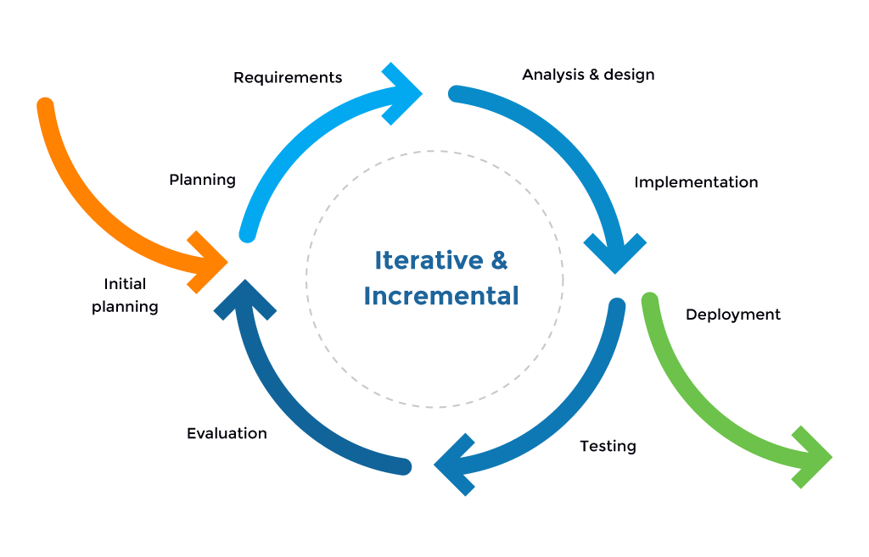This chapter describes and discusses the needed materials for the development. The chapter includes the software methodology, requirement documentation, data, and processing model. It also discusses how the researchers gathered the necessary data as well as the requirements specification, object analysis and design, and testing and evaluation of the project.

**3.1 Software Methodology**

*Figure 3.* Iterative and Incremental Model

The researchers used the iterative and incremental model to develop the web-based system. According to Nonyelum (2020), the iterative and incremental development model is a software development approach where a project is divided into smaller and more manageable parts, with each part being developed and tested in multiple iterations. Each iteration builds on the work done in the previous one, and feedback from users and stakeholders is used to refine and improve the product at each stage of development. This model allows for greater flexibility and adaptability in the development process, as changes can be incorporated more easily and the final product can better meet the needs of its users.

The iterative and incremental development model are applied to the development of an Attendance Monitoring System with Contact Tracing and Notification via SMS using QR Code. This model involves breaking down the development process into smaller, incremental stages that allow for flexibility and adaptation to changes in requirements. As the development process progresses, additional features could be added incrementally, such as the ability to track contact tracing information and send notifications via SMS. Each feature could be developed, tested, and refined in an iterative manner, with feedback incorporated into the next iteration. By using this iterative and incremental approach, the researchers can work more efficiently and respond quickly to changes in requirements or user feedback. This can result in a final product that better meets the needs of its users, as the development process is based on continuous refinement and improvement and also involves based on user feedback and changing requirements.

**First Iteration**

**Planning and Requirements Phase**

In this phase, the researchers focus on finalizing the project scope and objectives, identifying stakeholders, and gathering requirements. Hence, all the necessary preliminary requirements for the start of the project development such as software tools for designing and coding as well as suggestions from the interviewed potential users, review the documentation of system architecture, and finalize the required specifications and resources needed by the system. The researchers also define the project timeline and budget, and create a project management plan.

**Analysis & Design Phase**

In this phase, the researchers developed the system architecture, user interface design, and database schema, as well as algorithms for generating and reading QR code. The researchers also create a detailed design specification document that outlines the systems functionality.

**Implementation Phase**

In this phase, the researchers implement the web application, database schema, and algorithms for QR code reading and generating in the web system. Hence, to ensure that the system is scalable and secure while performing on the testing phase stage.

**Testing Phase**

In this phase, the researchers conduct a unit and integration tests, as well as system testing, to ensure the system is functioning as intended. In this stage the researchers also identify and fix any defects or issues that arise during testing. The researchers also sought consultations to review the features of the developed web system for improvements, suggestions, and feedbacks.

**Second Iteration**

**Planning and Requirements Phase**

In this phase, the researchers review stakeholder feedback and refine requirements based on the previous iterations testing results. The researchers also update the project management plan and schedule to reflect any changes.

**Analysis & Design Phase**

In this phase, the researchers design the notification system for SMS notification to students, nurses and guard, and integrate it with the web application. Hence, the researchers designed high fidelity front-end of the web system with basic features focused on navigation among the forms while prioritizing the responsiveness of each functionality. Also, the researchers include the different user interface for each intended users: system administrator, teacher, student, and visitor. The researchers also created the general log-in page, and the initial health declaration survey form for student, and visitors.

**Implementation Phase**

In this phase, the researchers implemented the notification system and conduct user acceptance tests to ensure it is working correctly. The researchers also ensure that the systems are working perfectly fine after implementing the SMS notification. The researchers implemented the front-end of the web system with basic features navigation and functionality. Also, the different user interface for each intended users: system administrator, teacher, student, and visitor were implemented. The researchers also implement the general log-in page, and the initial health declaration survey form for student, and visitors.

**Testing Phase**

In this phase, the researchers conduct system tests and acceptance tests with stakeholders to ensure the system is meeting their needs. In this stage the researchers also identified and fix any defects or issues that arise during testing phase. This helps the researchers to navigate and adjust errors based on the stakeholder feedbacks.

**Third Iteration**

**Planning and Requirements Phase**

The researchers examine all stakeholder feedback and incorporate it into the refinement of requirements. In doing so, the researcher analyzes and assess the previous iterations testing results to ensure that all necessary modifications and adjustments are made. Additionally, the researchers update the project management plan and schedule to accurately reflect any changes that may arise. the researchers ensure that the projects objectives are fully met, and all stakeholders needs are satisfied.

**Analysis & Design Phase**

In this phase the researchers undertake the design and implementation of the contact tracing functionality. The researchers work on developing and refining the necessary algorithms, and conduct comprehensive user acceptance tests to ensure the system meets the highest standards of functionality and usability. Additionally, researchers created a detailed design specification document that outlines every aspect of the systems functionality.

**Implementation Phase**

In this phase, the researchers focus on creating and implementing the contact tracing functionality, which involve collecting and analyzing data from users to identify potential contacts with infected individuals. To ensure the success of this phase, the researchers conducted precise user acceptance tests, incorporating feedback from real users to refine and improve the system.

**Testing Phase**

In this phase, the researchers conduct precise user acceptance tests, incorporating feedback from real users to refine and improve the system. They will also identify and fix any defects or issues that arise during testing.

**Fourth Iteration**

**Planning and Requirements Phase**

In this phase, the researchers review stakeholder feedback and identify and prioritize additional features such as reporting. The researcher also updates the project management plan and schedule to reflect any changes.

**Analysis & Design Phase**

In this phase, the researchers added the required back-end features for the students such as requesting the camera permission to allow the chosen web browser to scan the generate QR code. The user interface is also simplified to show the subjects available only for today. The researchers also used the Semaphore API to send SMS notification for the guardians of the student as well as to the integration of notification to school nurse and guard.

**Implementation Phase**

In this phase, the researchers developed the additional features, integration of API and conduct user acceptance tests to ensure they are functioning as intended. The researchers also ensure that the system is scalable and secure.

**Testing Phase**

In this phase, the researchers actively identify and track any defects or issues that arise and work to fix them promptly. Moreover, prioritizing the defects based on their severity and impact on the system and address them accordingly. The researcher also involves all relevant stakeholders in the testing process and gather their feedback on the systems performance and document all test results, including any defects or issues that were identified and resolved, to provide transparency and accountability.

**Final Iteration**

**Evaluation Phase**

In this evaluation phase, it involves reviewing the system performance against the projects objectives and goals. This includes assessing the systems functionality, reliability, and overall effectiveness in meeting stakeholder needs. Additionally, stakeholder satisfaction is evaluated to determine if their expectations were met and to identify areas for improvement.

**Maintenance Phase**

In this phase, it involves developing a maintenance plan to ensure the system remains operational and meets changing needs. This includes identifying necessary updates and upgrades, establishing procedures for maintaining the system, and ensuring that all stakeholders are aware of the maintenance plan.

**3.2 Requirement Documentation**

**3.2.1 Functional Requirements**

The researchers conducted a thorough analysis to clearly define and establish the essential functionalities of the system being developed. These functionalities were identified based on the operations and activities required to achieve the goals of the users. The resulting set of functionalities served as a roadmap for the development team, ensuring that the system is built to meet the user’s specific needs and requirements. By doing so, the researchers ensured that the system is efficient, effective, and user-friendly. The features that the researchers must implement in the develop CSAMS includes the following.

**Login.** The developed system must allow the intended users to log-in to the correct account according to the required username and password, and refuse if the account credentials are incorrect.

**Terms and Conditions.** The developed system must allow the user to read the terms and conditions which contains any necessary information. The Introduction, Intellectual Property Rights, Restriction, Content, Limitation of Liability, Severability, Variation of Terms, Arrangement, and Entire Agreement

**Dashboard.** The developed system must show the specific welcome start interface according to the user account (system admin, teacher nurse and student) in the system that consists of different features according to the users need such as account management, health declaration form survey, attendance management, and profile management.

**Sidebar Hamburger Menu.** The developed system must allow the users to navigate through the options inside the menu. The hamburger menu should contain different options according to the account currently log-in.

**Change Password.** The developed system must allow the user including the system administration, teachers, students and nurse to change the password of the account currently log-in.

**I am a Visitor.** The developed system must allow the visitors to answer the health declaration form survey serving as a record for contact tracing of the web-based system.

**Survey.** The developed system must allow the system administrator to administer the health declaration form survey questionnaire to the student and visitor. This will allow the institutions to improve the contact tracing strategy and might as well serve as additional preventive measure against COVID-19.

**Survey Customization.** The developed system must allow the system administrator to create, update, and delete questions for the health declaration form of the contact tracing. The system will also allow to view the answers of the students and visitors.

**Create Subject.** The developed system must allow the system administrator to encode the necessary subject information such as subject code, subject name, number of units, subject teacher, and schedule when creating a subject. The system administrator can also assign the students to the encoded subjects.

**Scan QR Code.** The developed system must allow the scanning of QR Code to allow the students to take attendance.

**Generate QR Code.** The developed system must allow the teachers to easily generate the attendance QR Code per handled subjects.

**Delete Subject.** The developed system must allow the system administrator to remove the subject if needed. Removing the subject will also remove the list of students assign to the subject to be deleted.

**Account management.** The developed system must allow the system administrator to create account for the users, and perform different actions such as update and delete. Updating the account credentials should reflect on the user account, and removing a user account is also allowed if needed.

**Search Bar.** The developed system can help the users to navigate through the list of information on the table where the search bar is present. The develop system can allow the system administrator to search through the list of accounts, survey questionnaire, survey answers, and subjects created. Whereas the teacher can search through the list of students, and record of attendances. The student can search through the history.

**3.2.2 Non-Functional Requirements**

The researchers determine the quality related to the functions of the developed web system taking the criterion of this characteristic standards. The following are the non-functional requirements of the developed web-based system based on the ISO 25010 product quality model:

**Functional Suitability.** This characteristic represents the degree to which a product or system provides functions that meet stated and implied needs when used under specified conditions. The developed web system was able to record attendance and generate reports accurately. Also, it was able to identify the suspected persons by navigating record date, time, and declared symptoms upon entering the school campus. The developed web system also allows to send SMS notifications to nurse and guard who may have been exposed to a person based on contact tracing data. The system should be able to generate QR codes for each user to scan for quick and easy attendance monitoring.

**Performance Efficiency.** This characteristic represents the degree is relative to the number of resources used under stated conditions. The researchers overlooked performance efficiency as a critical software quality characteristic that can have a significant impact on the overall success of a software system. A large number of users and attendance records can be handled without lag or delay by the developed web system. The developed web system should be able to generate reports in real-time. The developed web system should be able to send SMS notifications on time.

**Compatibility.** This characteristic represents the degree if the product, system, or component can exchange information with other products, systems, or components, and/or perform its required functions while sharing the same hardware or software environment. The developed web system is compatible with all major web browsers such as Google Chrome, Mozilla Firefox, Safari, etc. The developed web system was compatible with different operating systems like Windows and macOS. The developed web system should be compatible with various devices like desktop computers, laptops, tablets, smartphones, etc. By doing so, the researcher can ensure that the application is accessible and usable by a broad range of users, ultimately leading to its success.

**Usability.** This characteristic represents the degree to which a product or system can be used by specified users to achieve specific goals with effectiveness, efficiency, and satisfaction in a specified context of use. The developed web system generated QR codes was easy to read and scan using any smartphone. The scanning process should be easy and straightforward. The users will be able to scan the QR code quickly and efficiently using their smartphones. The developed web system will implement a user-friendly, and interactive user interface component. The researchers’ visual goal will be to prioritize ease of navigation, easy-to-learn operation, responsive layout and buttons, and simple pop-up messages that work on a variety of browsers.

**Reliability.** This characteristic represents the degree to which a system, product or component performs specific functions under specified conditions for a specified period of time. The developed web system is well-designed to ensure that it can handle a large number of concurrent users and high traffic loads without crashing. It should also be scalable, allowing for future growth and upgrades. The QR codes are encrypted to prevent tampering, and to prevent failures upon scanning by the users. The progressive web system has backup and recovery mechanisms in case of system failures or data loss. The system should have a high level of uptime and availability.

**Security.** This characteristic represents the degree to which a product or system protects information and data so that persons or other products or systems have the degree of data access appropriate to their types and levels of authorization. The developed web system implements a strong authentication mechanism to ensure that only authorized users can access the system. Also, the researchers used a secured web hosting to ensure that all communication between the web server and client is encrypted. The level of account access and authorization will be properly analyzed, the rights and permissions of the users and the administrator will be different with in mind of preventing unauthorized access to or modification of sensitive information.

**Maintainability.** This characteristic represents the degree of effectiveness and efficiency with which a product or system can be modified to improve it, correct it, or adapt it to changes in environment, and in requirements. The developed web system designed in such a way that individual components can be reused in other systems or projects, reducing the need for extensive maintenance as well as easy to maintain and easy-to-understand system architecture. Moreover, the researchers considered the perspective for future improvements and updates, which will ensure that the web system remains relevant and useful to its target users.

**Portability.** This characteristic represents the degree of effectiveness and efficiency with which a system, product or component can be transferred from one hardware, software or other operational or usage environment to another. The developed web system ensure that the design is working on both Android and iOS devices. This involve using emulation software or physical devices to simulate different operating systems, screen sizes, and input methods. By doing so, researchers can ensure that developed web system is robust and can seamlessly run on a wide range of hardware and software environments.

**3.3 Data and Processing Model**

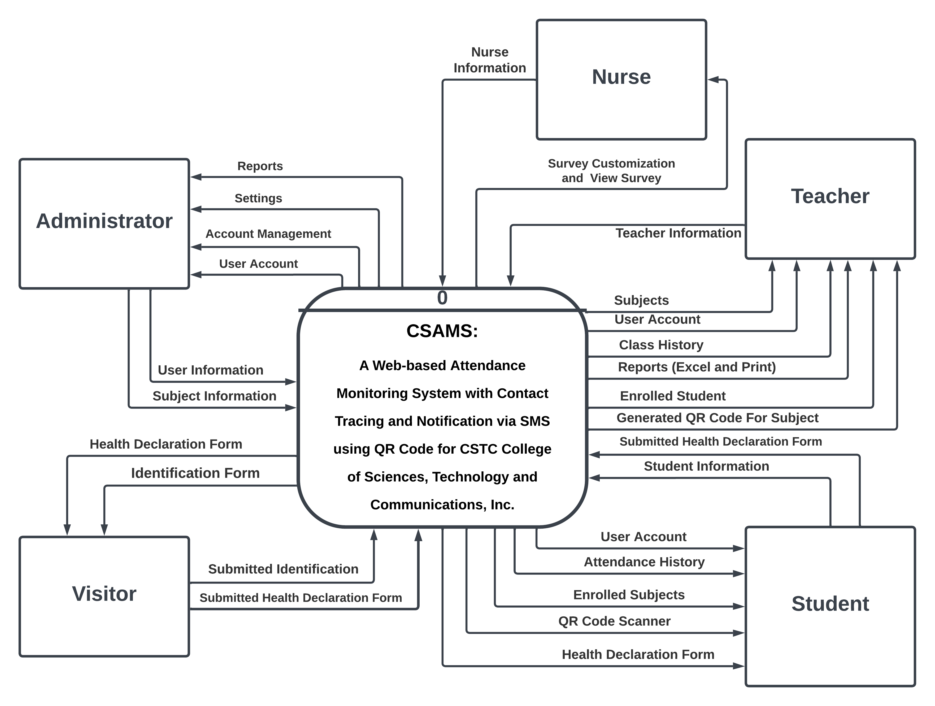**3.3.1 Context Diagram**

*Figure 4*. CSAMS Context Diagram

Figure 4 shows the five entities that are involved in the CSAMS: A Web-based Attendance Monitoring System with Contact Tracing and Notification via SMS using QR Code. The five entities which are the (1) Administrator, (2) College Student, (3) Teacher, (4) Nurse and (5) Visitors have their own role in the application. The administrator is assigning for overall account managements, Subjects, and Settings for the nurse and guard. Also, it can generate the reports that the application gathered. The teacher has a start class to generate the QR Code subjects and it can manually set present the student. Moreover, the teachers have some features like Attendance, My Subject, Class history and My Profile in their side panel features. The college student can access the system by the accounts provided by the administrator and has different features Class Today, My Profile and Attendance History. Moreover, the user has a scan QR Code which the college student needs to open their camera and scanned. The nurse will have the Survey Customization for customizing the health declaration form and View Survey result for the student and visitor. The visitors who are only for visiting needs to click the I am visitor to fill up information in the survey created by the admin. It will help the institution to track records if virus spread and alert them immediately.

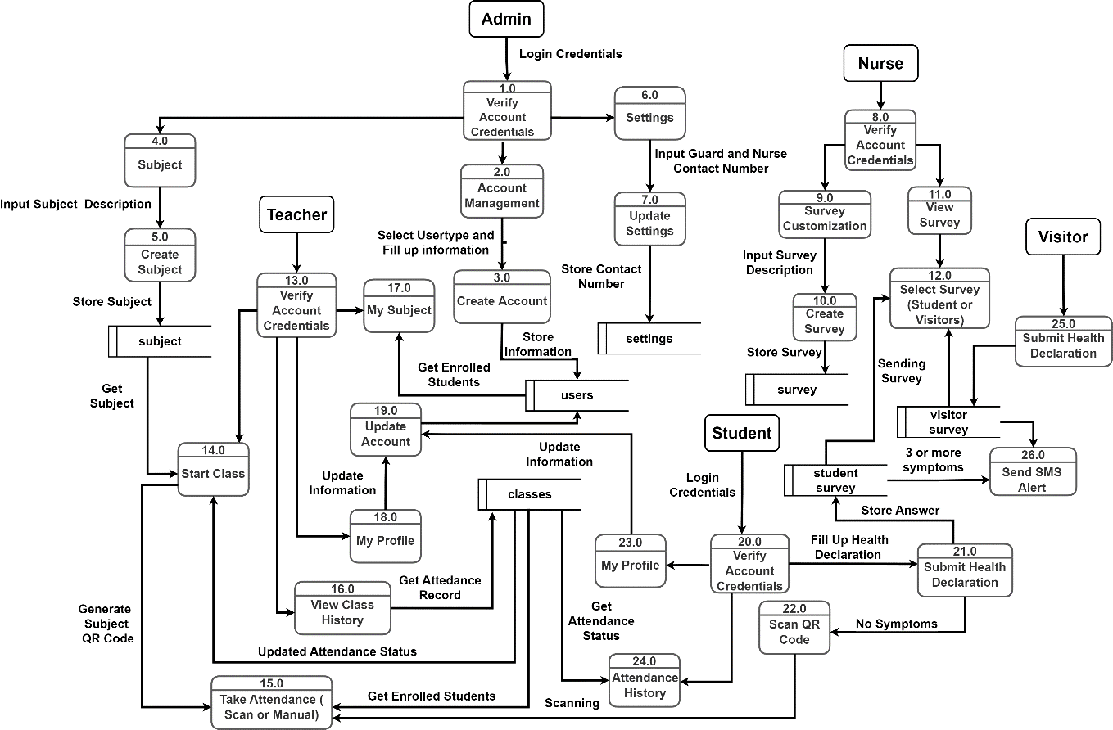**3.3.2 Data Flow Diagram**

*Figure 5.* CSAMS Data Flow Diagram

Figure 5. shows how the data flow in the web-based system. As it shows what are the process of the features and how different data was it stored and update information from the database. This diagram also shows how user accounts are integrated with different features, allowing for seamless input and output of information. A well-designed diagram illustrating the data flow of a web system can enhance comprehension of its functionality for researchers and stakeholders, and facilitate identification of potential areas for optimization or improvement.

**3.4 Methods of Data Gathering**

**Interview.** This is a meeting in which an interviewee is asked by the interviewer to gather information. The researchers used the interview method to the client to gather additional information on how the researchers would implement this kind of system in the school facilities. By incorporating feedback and constructive criticism from researchers during the design and development phases of this web-based system, the researchers can make significant enhancements to improve its functionality and overall performance.

**Questionnaire.** This research tool that was created and designed to gather information from a targeted group of respondents in CSTC Sariaya by asking them a series of questions. The data collected were analyzed to draw meaningful conclusions and insights from the results. The researchers carefully evaluated the responses to gain a deeper understanding of the targeted groups attitudes, opinions, and behaviors, and use this knowledge to inform their analysis and interpretation of the data. The researchers aim to enhance the broader understanding of the subject matter under investigation by conducting a study.

**Web Search.** The researchers browsed the web to conduct the search for the related articles, educational contents, and important information for the research project through the internet.

**Document Review.** The researchers searched and looked up several documented studies related to the research project in order to gather relevant data, and to back up the information gathered previously through other meaningful dissertations and documents.

**3.5 Requirements Specification**

**3.5.1 System Architecture**

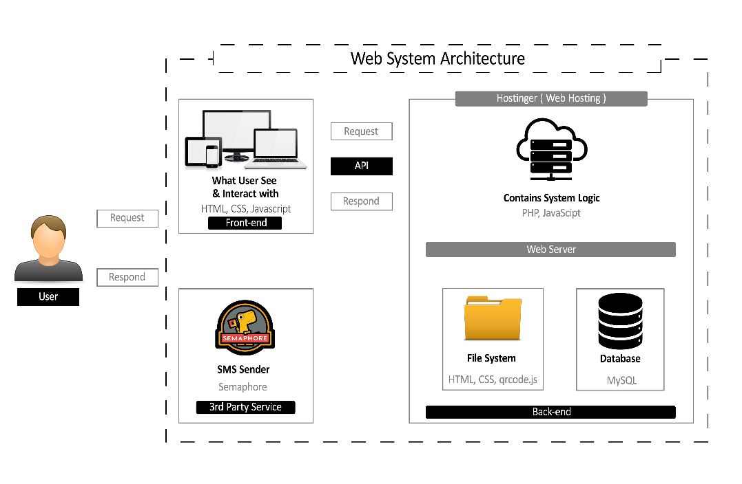

*Figure 6.* CSAMS System Architecture

Figure 6 shows the system architecture for a web application involves several components. The front-end is developed using HTML, CSS, and JavaScript, and stored on Hostinger web hosting platform. Users interact with the front-end through their browsers, which send HTTP requests to the web server. The web server routes the requests to the appropriate endpoint in the web application. Endpoints may interact with a MySQL database to retrieve or store data. The web application generates a response to the user’s request, which may include HTML, CSS, JavaScript, or data from the MySQL database. The web server sends the response back to the user’s browser, which renders it as a webpage. In addition to these core components, the system also utilizes Semaphore as the SMS provider for SMS functionality, and qrcode.js as the API for generating QR codes.

**3.5.2 Hardware and Software Specification**

The following are the specifications of both software and hardware to be used in the development and testing of the CSAMS web-based system:

Table 1.

*System used in CSAMS Web-based system*

The following are the software specifications required for the development of the CSAMS Web-based system.

|  |  |
| --- | --- |
| Software Development Software Requirements | |
| It serves in the backend of the web-based system. | PHP |
| For front-end framework for web development and scripting some features | Bootstrap (HTML, CSS & JavaScript) |
| Database | MySQL |
| SMS API for sending messages to admin, nurse and guard | Semaphore |

Table 1. shows the following software specification for the development of the CSAMS Web-based system. The PHP are for the backend of the develop web-based system and for the server-side scripting language to interact the bootstrap and database of the web-based system. The Bootstrap are the for the front-end frameworks that gives the visual design of the developed web-based system. MySQL are the database which store the information gathered by the web-based system from the input of the users. Lastly is Semaphore which was as API for sending messages to admin, nurse and guard as the user was probable suspect of Covid-19.

Table 2.

The following are the hardware specifications required for the implementation of the developed web-based system.

|  |  |
| --- | --- |
| Devices | Android/IOS Minimum Requirements   * Android Version 6.0 * IOS version 10.3.3 * 3gb RAM * 32 ROM   Android/IOS Recommended Requirements   * Android 10 * IOS version 12.5.5   PC Minimum Requirements   * Windows, MacOS * 4-GB RAM * 120GB Hard Drive   PC Recommended Requirements   * Windows 11 * 8-GB RAM * 500GB Hard Drive |
| Internet Connection | WiFi (Recommended)  4G/5G Data connection (Minimum requirements) |
| Web Browser | Google Chrome, Mozilla Firefox, Microsoft Edge  Safari |

Table 2. show the hardware specifications required that suited for the implementation of the developed web-based system. It shows what type of version, hardware and software specification of the mobile and pc requirements and where the developed web-based system suited in the different web browser.

**3.6 Object Analysis and Design**

**3.6.1 UML Diagram**

The following shows the Unified Modelling Language diagrams utilized in the analysis and design phase. This includes Use Case Diagram, Class Diagram, Activity Diagram, Sequence Diagram, Entity Relationship Diagram and Data Dictionary.

**A. Use Case Diagram**

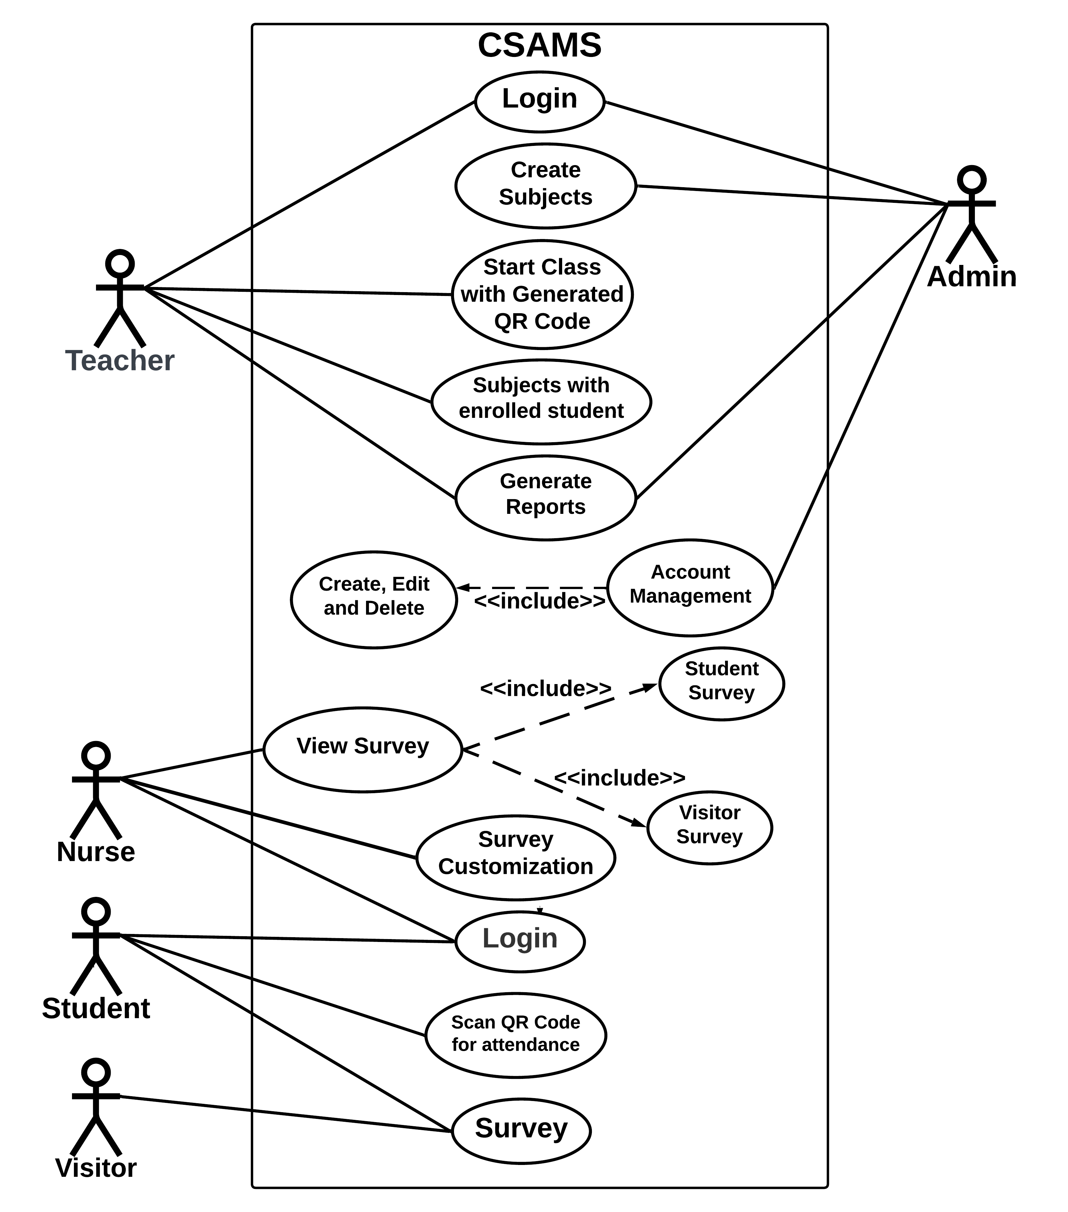

*Figure 7.* CSAMS Use Case Diagram

Figure 7. shows the Use Case Diagram of CSAMS which describe the level functions and scope of the system. These diagrams also identify the interactions between the systems and its actors. The description provides an overview of the systems functionalities and the actors interactions with it. However, it does not delve into the internal operations of the system.

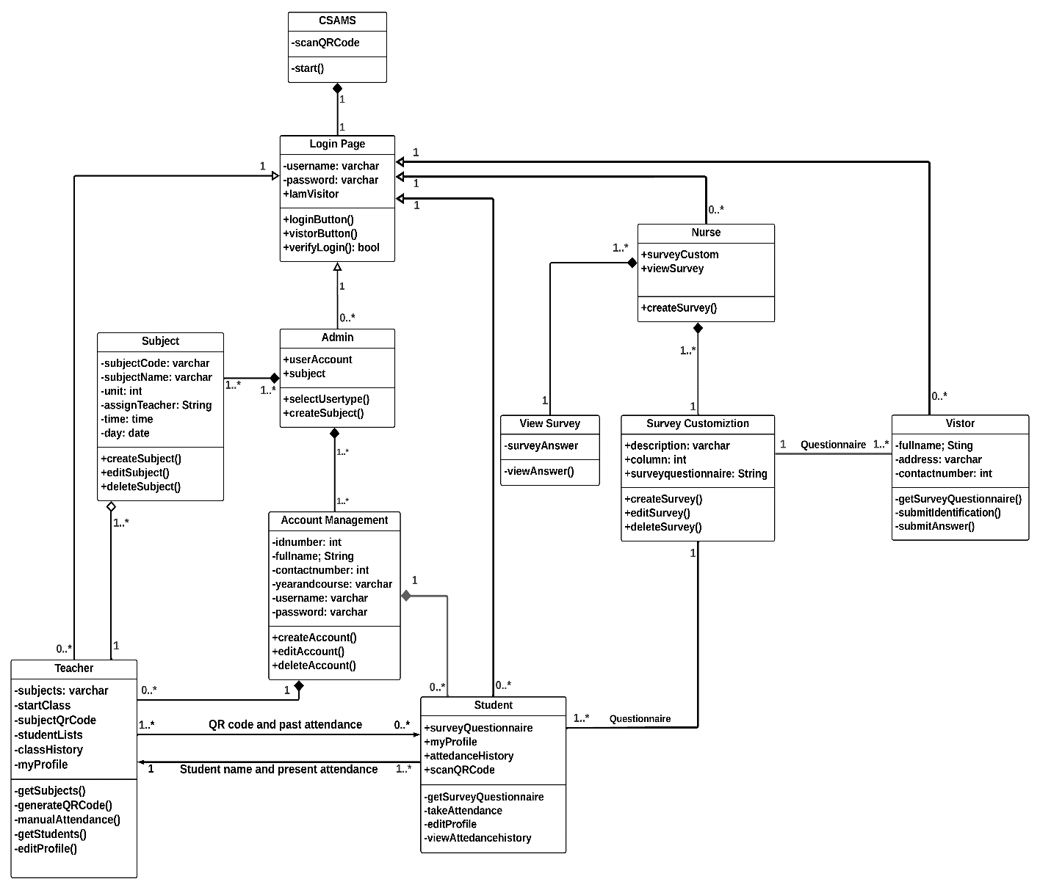**B. Class Diagram**

*Figure 8.* CSAMS Class Diagram

Figure 8. shows the structure of the CSAMS: Web based attendance monitoring and survey which indicates class diagram, its classes, attributes, relationships, and operations among the different objects and components.

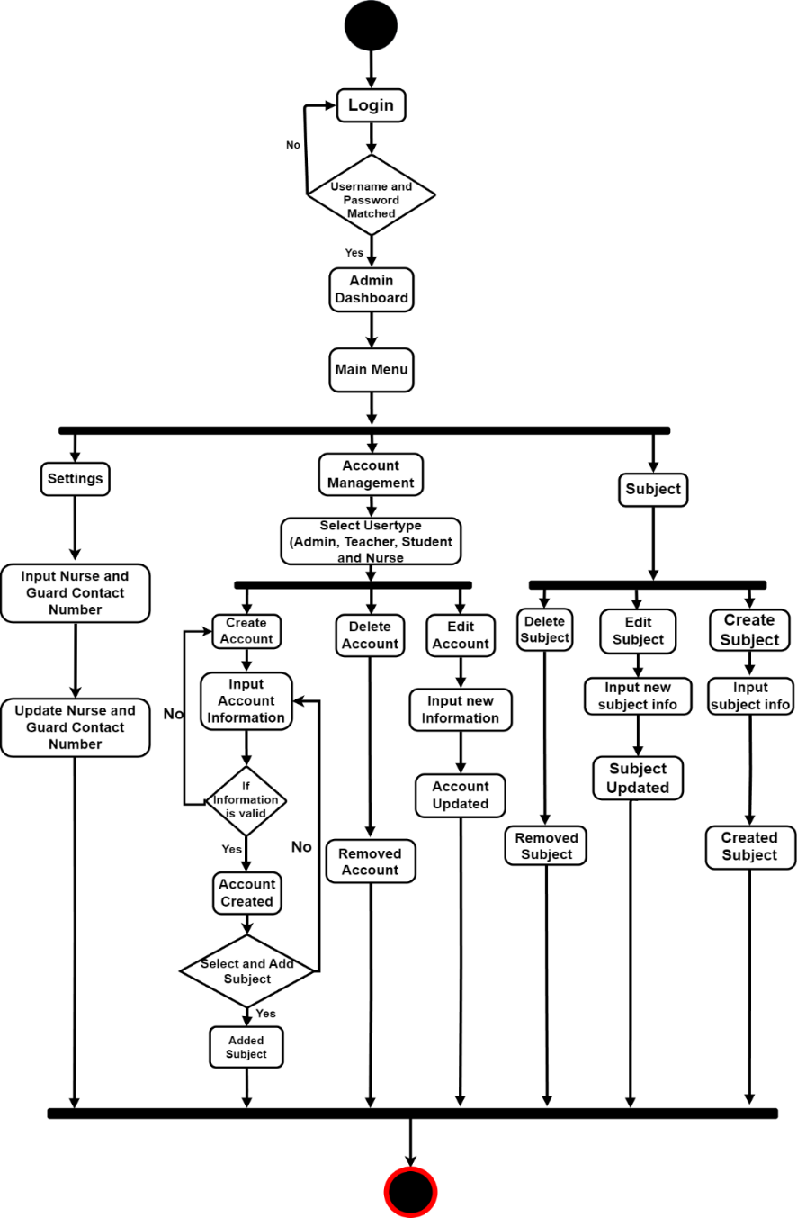**C. Activity Diagram**

*Figure 9.* Admin Activity Diagram

Figure 9. shows the process and action that admin would follow to create an account of users, input the contact number and a subject for teachers. The system prompts the admin to enter the required details for each step and verifies the information. The diagram illustrates the connection of each activity to other activities within the web system. Once all the steps are completed, the admin logs out of the system.

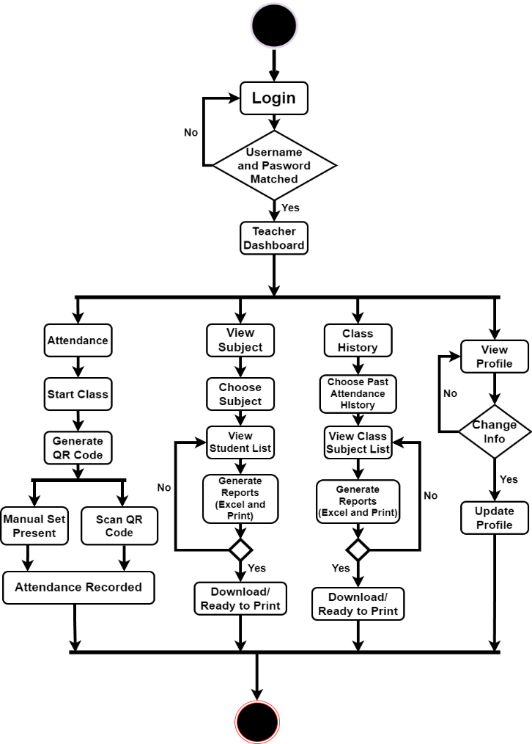

*Figure 10.* Teacher Activity Diagram

Figure 10. shows the visual representation of the series of actions that a teacher undertakes while interacting with the system. In this diagram, the teacher starts logging in their accounts. From there, they can access several other functions. The View Subjects function allows the teacher to see a list of all the subjects they teach. After viewing the details, they can go back to the list of subjects. The Class History function allows the teacher to view a list of all the classes they have taught. User can select a specific class to view more details about it. After viewing the details, they can go back to the list of classes. The View Profile function allows the teacher to view their personal profile. After 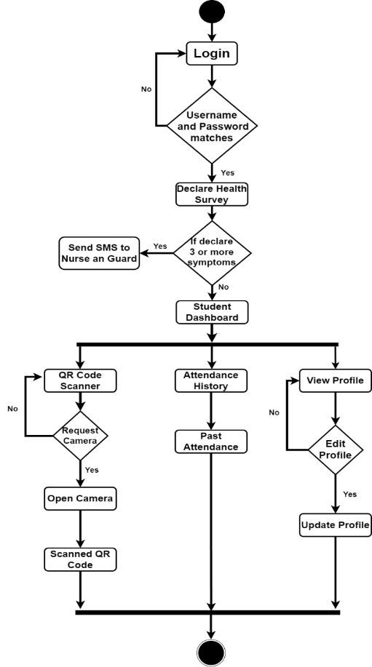making changes, user can save their changes and go back to their profile.

*Figure 11.* Student Activity Diagram

Figure 11 shows the representation of the applications activity flow, which varies based on the user chosen category. The user starts with the logging into the web system by entering their username and password. Once verified, the system displays a health declaration form which the student fills out and submits. After submitting the form, the student clicks on the "Scan QR Code" button to record their attendance for the subject. The system prompts the student to scan the QR code and records the attendance after successful verification. The student can then view their attendance history and profile by selecting the respective options. The process ends with the student logging out of the system.

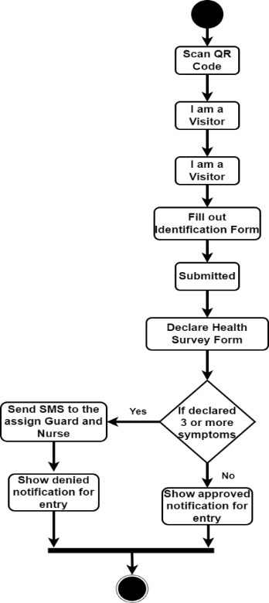

*Figure 12.* Visitor Activity Diagram

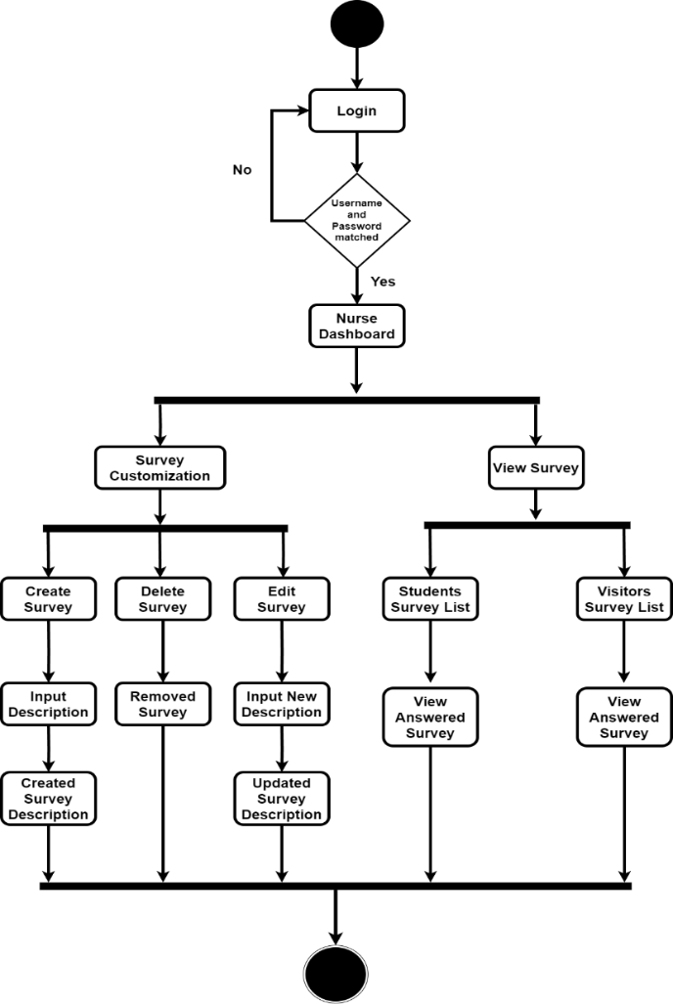Figure 12. Shows the graphical representation or flowchart to demonstrate how visitors interact with the CSAMS web-based system while entering a school campus. It shows a display for each stage of process of action, including check-in and registration, visitor information collection, and contact tracing procedures. Overall, a well-designed flowchart can effectively illustrate the user journey in the web system.

*Figure 13.* Nurse Activity Diagram

Figure 13. shows the process of action which a nurse logging into a system and accessing the survey customization section. Once there, the nurse can create, delete, or edit a survey questionnaire. To create a new survey, the nurse inputs the survey details, saves the survey, and receives a success message. To edit or delete a survey, the nurse selects the survey and either edits or confirms deletion. Finally, the nurse can view survey responses by selecting a survey and filtering the responses by date, question, or other criteria. It also shows how nurse can effectively track and record survey responses from college students and visitors entering the school campus.

*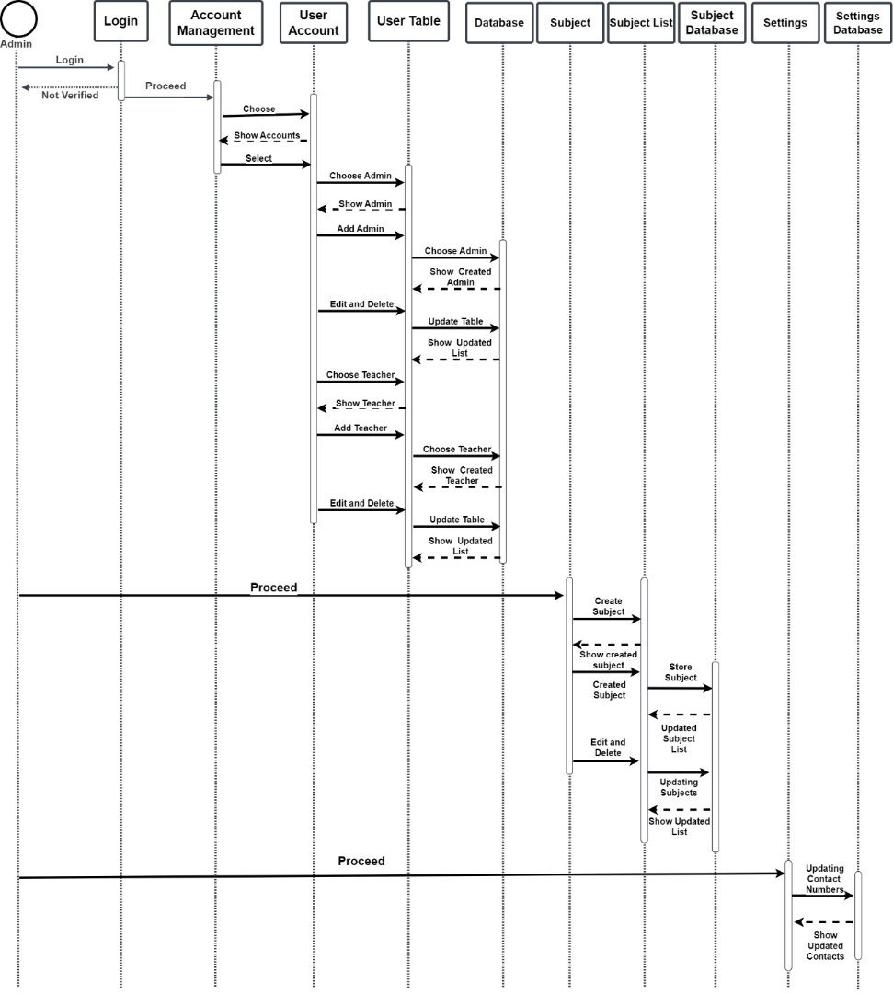***D. Sequence Diagram**

*Figure 14.* Admin Sequence Diagram

Figure 14 shows the how the data was being transferred while the admin interacts in the web system. Its also showed the process of the admin creating different user accounts for students, teachers, and nurses, each with specific access levels and permissions. Moreover, this represents the how the admin creating and managing subjects, as well as assigning mobile number to nurses and guards in the settings. These enhance the system ability to monitor and track user activity, and provide the necessary resources to support the various roles within the system.

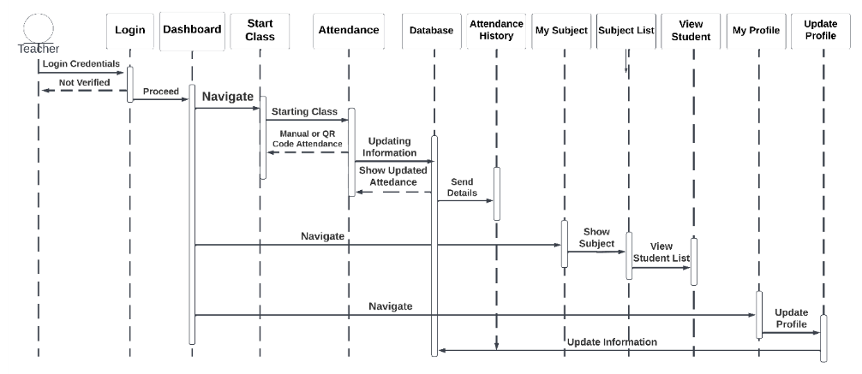

*Figure 15.* Teacher Sequence Diagram

Figure 15 shows the teacher flow of events between the different components of the system, including the user interface, the database, and any other external systems used to manage the attendance data. A teacher can access a personalized dashboard by logging into the system. The dashboard provides several functionalities such as starting a class and viewing attendance history. The attendance of each student data is securely stored in the systems database and they can access my subject and view subject list features. The teacher can also view their profile to 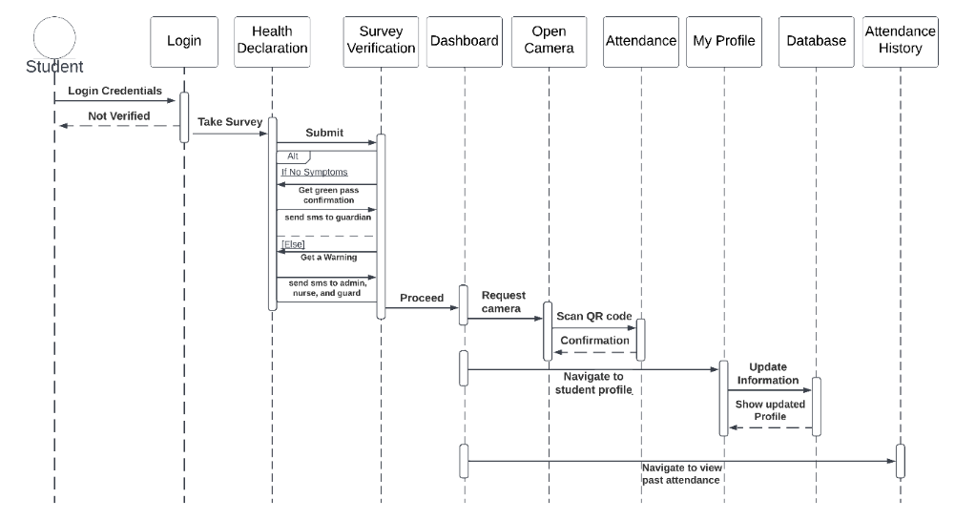update personal information such as their password and contact numbers.

*Figure 16.* Student Sequence Diagram

Figure 16 describes the flow of actions in a system that includes login, health declaration, survey verification, dashboard, attendance, profile and attendance history. The system starts with the user logging in with their username and password. Once logged in, the user is prompted to complete a health declaration survey, which the system verifies before granting access to the dashboard. From the dashboard, the user can scan for their attendance, view their profile, and check their attendance history. All attendance data is updated in the database, which the system retrieves to display the users information.

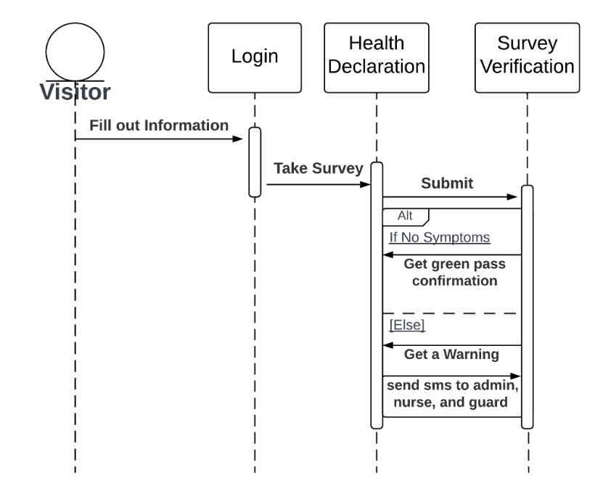

*Figure 17.* Visitors Sequence Diagram

Figure 17 shows the sequence diagram depicting the process of a visitor completing a health declaration and survey verification before entering the school campus. The visitor is directed to complete the form upon arrival. The visitor needs to fill out their personal information and answers health-related questions in the form. The data is then sent to database for verification against predefined rules and policies. Finally, based on the database response, the guard either grants or denies the visitor access to the building.

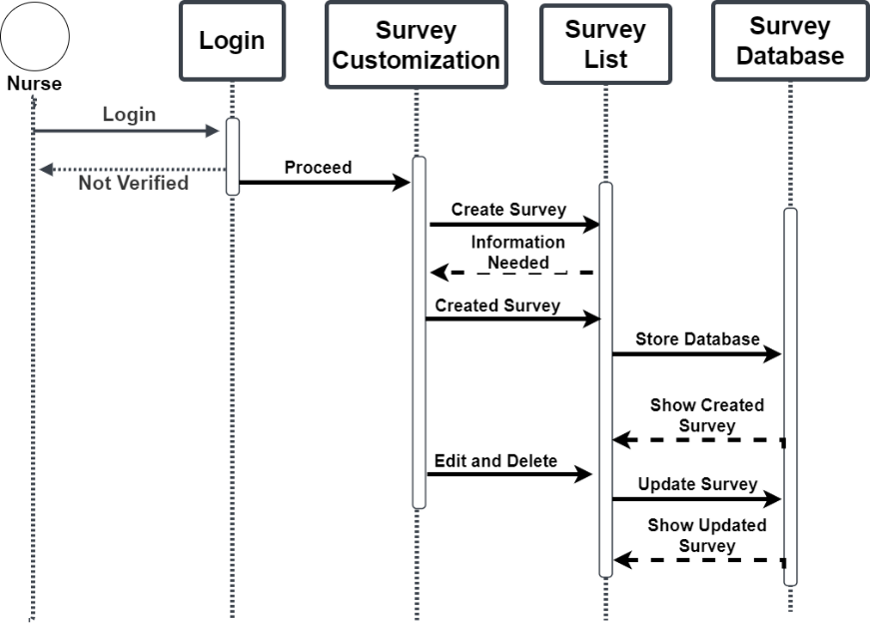

*Figure 18.* Nurse Sequence Diagram

Figure 18 shows sequence diagram that outlines the process for a nurse user to log in and customize a survey. The nurse first enters their login credentials and is validated by the system. They then select the customize surveys option from the main menu, and the system retrieves a list of available surveys from the survey database. After choosing a survey from the list, the nurse can customize it by adding, removing, or editing questions before saving the changes. The customized survey is then saved to the Survey Database, and the system sends a success message to the Nurse confirming that the survey customization was successful.

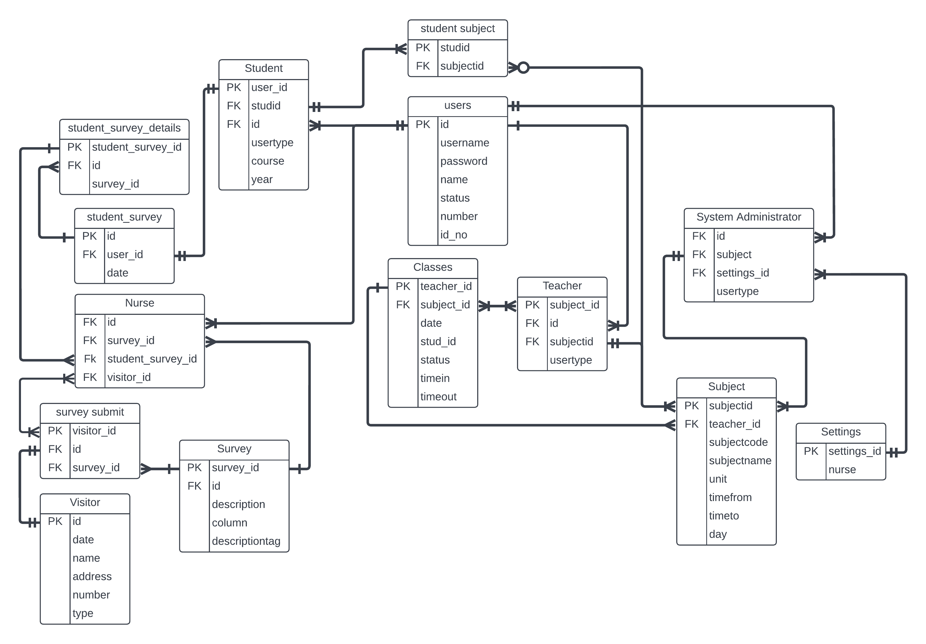**E. Entity Relationship Diagram**

*Figure 19.* CSAMS Entity Relationship Diagram

Figure 19. shows database structure which represent as an entity relationship model that outlines the interdependencies among users, system administrator, teacher, visitors, nurse, student, student survey details, student survey, survey submit, subjects, survey, classes and settings. This model depicts the relationships between the different entities involved in the system through an entity relationship diagram. By clearly defining the entities and their relationships, developers can create a database structure that is easy to use and maintain.

**F. Data Dictionary**

The following show the data dictionary containing the collection of attributes, proper data type, and additional description that will be used in the project. The data dictionary will be the reference of the researchers in creating and organizing the database tables while reducing the data redundancy.

Table 3

*Data Dictionary for Users*

|  |  |  |
| --- | --- | --- |
| Column | Data Type | Description |
| id | int | The generated unique account number per user. |
| username | varchar | The account unique username. |
| password | varchar | The set of unique characters for passwords. |
| name | varchar | The users full name. |
| status | int | Declared status of the users. |
| number | int | The contact number of the account. |
| id_no | varchar | Set of ID numbers of the user. |

Table 3 shows the data dictionary of the users (system administrator, teacher, or student) which contains seven (7) attributes of account. It has one primary key which is the id. It has username, password, name, status, number, and id_no to set all the users necessary information.

Table 4

*Data Dictionary for System Administrator*

|  |  |  |
| --- | --- | --- |
| Column | Data Type | Description |
| Id | int | Unique generated ID for the system administrator. |
| subject | int | Unique ID of created subject  . |
| settings_id | int | Unique ID for the contacts of admin, nurse, and guard. |
| usertype | varchar | Assigned usertype 1 for the user. |

Table 4 shows the data dictionary of system administrator which contains six (6) attributes of admin details. It has five (5) foreign keys such as id, survey_id, visitor_id, student_survey_id, and settings_id to manage the other users information. The usertype allows the system to identify and retrieve the other system administrator details.

Table 5

*Data Dictionary for Teacher*

|  |  |  |
| --- | --- | --- |
| Column | Data Type | Description |
| Id | int | Unique generated ID for the teacher. |
| subjectid | varchar | Unique ID for the generated subject. |
| subject_id | varchar | Unique ID for the subject name. |
| usertype | int | Assigned usertype 2 for the user. |

Table 5 shows the data dictionary of the teacher which contains four (4) attributes of teacher details. It has one primary key that which is the subject_id. It has two (2) foreign keys which are the id, and subject id to get the other teacher information such as user account information and subjects. The user type allows the system to identify and retrieve the teacher’s information.

Table 6

*Data Dictionary for Student*

|  |  |  |
| --- | --- | --- |
| Column | Data Type | Description |
| user_id | int | Unique ID for student survey. |
| Id | varchar | Unique generated ID for the for student. |
| usertype | varchar | Assigned usertype 3 of the user. |
| course | varchar | Set of course for student. |
| year | varchar | Set of year for student. |
| studid | varchar | Unique ID for each student containing enrolled subjects. |

Table 6 displays the data dictionary of the student which contains six (6) attributes of the student information. It has a one primary key which is the user_id for the identification of the account. It has two (2) foreign key which are the id, and studid that would be used for the retrieving the student account information and enrolled subjects.

Table 7

*Data Dictionary for Visitor*

|  |  |  |
| --- | --- | --- |
| Column | Data Type | Description |
| Id | Int | Unique generated Id of the visitor. |
| date | Varchar | Date of survey taken by the visitor. |
| name | Varchar | Full name of the visitor. |
| address | Varchar | Address in the survey form. |
| number | Int | Contact number in the survey form. |
| type | Int | Set the unique type for visitors only. |

Table 7 shows the data dictionary of the visitor which contains six (6) attributes of the Visitors. It has one primary key which is the id for generating the reference number for the visitor. It also contains date, name, address, number, and type to fill the necessary field of information needed from the visitors.

Table 8

*Data Dictionary for Classes*

|  |  |  |
| --- | --- | --- |
| Column | Data Type | Description |
| Date | Date | Date description of the subject |
| stud_id | Int | Unique ID for Student |
| subject_id | Int | Unique ID for Subject |
| status | Int | Status for Attendance |
| teacher_id | Int | Unique ID of teachers |
| timein | Time | Set of time in |
| timeout | Time | Set if time out |

Table 8 illustrates the data dictionary of the classes which contains seven (7) attributes. It has one primary key which is the teacher_id serving as the reference number for gathering the assigned subjects. It has one (1) foreign key which is the subject_id for finding the assigned teacher. It also contains date, stud_id, status, time in, and timeout for differentiate a class from other classes

Table 9

*Data Dictionary for Subject*

|  |  |  |
| --- | --- | --- |
| Column | Data Type | Description |
| subjectid | varchar | Unique ID for the subject. |
| subject code | varchar | Unique description for the subject code. |
| subject name | varchar | Name description for subject. |
| unit | varchar | Number of units for the subject. |
| timefrom | Time | Starting time schedule of the subject. |
| timeto | Time | Ending time schedule of the subject. |
| teacher_id | Int | Assigned teacher for the subject. |
| day | Varchar | Scheduled day of the subject. |

In table 9, it shows the data dictionary of the subject which contains eight (8) attributes. It has one primary key which is the subjectid serving as the reference number to gathering the subject for a certain student. It has one (1) foreign key which is the teacher_id connecting to the assigned teacher. It also contains subject code, subject name, unit, time from, time to, and day to fill the necessary information of the subjects.

Table 10

*Data Dictionary for student subject*

|  |  |  |
| --- | --- | --- |
| Column | Data Type | Description |
| studid | Int | Unique ID for assigned subject list of the student. |
| subjectid | In | Unique ID of every assigned subject. |

In table 10, it displays the data dictionary of the student subject which contains two (2) attributes. It has one primary key which is the studid serving for referencing the list of assigned subjects. It has one (1) foreign key which is the subject_id that will retrieve which subjects should be added to the list of assigned subjects for a student.

Table 11

*Data Dictionary for survey*

|  |  |  |
| --- | --- | --- |
| Column | Data Type | Description |
| id | Int | Total numbers of survey |
| survey_id | Int | Unique ID for survey answered |
| description | Varchar | Description for the symptoms (English) |
| column | int | For symptoms and questionnaire type of survey. |
| descriptiontag | varchar | Description for the symptoms (Tagalog) |

Table 11 shows the data dictionary of the survey which contains five (5) attributes to create the survey form. It has one primary key which is the survey_id serving as the reference for the list for health declaration survey questionnaire. It has unique generated attribute id to identify the specific number assigned to each question. It also has description, column, and description tag to hold necessary fields to create the survey form.

Table 12

*Data Dictionary for survey submit*

|  |  |  |
| --- | --- | --- |
| Column | Data Type | Description |
| visitor_id | int | Unique ID for each visitor survey form. |
| id | in | Unique ID for the visitors information |
| survey_id | int | Unique ID for retrieving the survey  questionnaire. |

Table 12 displays the data dictionary of the survey submit which contains three (3) attributes to record a specific visitor survey form. It has one primary key which is the visitor_id serving as the reference of each visitor form. It has two (2) foreign keys which are the id for getting the visitor basic information, and survey_id for viewing the visitors answers in the survey.

Table 13

*Data Dictionary for student survey*

|  |  |  |
| --- | --- | --- |
| Column | Data Type | Description |
| id | Id | Unique ID for student survey details. |
| user _id | Int | Unique ID of a student. |
| date | In | Date of survey taken by a student. |

Table 13 shows the data dictionary of the student survey which contains three (3) attributes to record the student surveys. It has one primary key which is the id serving as the reference of each student form. It has one (1) foreign key which is the user_id for getting the student basic information. It also has a date to record when the survey is taken.

Table 14

*Data Dictionary for student survey details*

|  |  |  |
| --- | --- | --- |
| Column | Data Type | Description |
| student_survey_id | int | Unique ID for each student survey form. |
| Id | in | Unique ID for the student information. |
| survey_id | int | Unique ID for retrieving the survey questionnaire. |

In table 14, it shows the data dictionary of the student survey details which contains three (3) attributes to record a specific student survey form. It has one primary key which is the student_survey_id serving as the reference of a student form. It has one (1) foreign key which is the id for getting the student basic information. It also has a survey_id to retrieve the survey questionnaire.

Table 15

*Data Dictionary for student survey details*

|  |  |  |
| --- | --- | --- |
| Column | Data Type | Description |
| settings_id | int | Unique ID for Settings Contact number |
| admin | varchar | Contact number for admin. |
| nurse | varchar | Contact number for nurse. |
| guard | varchar | Contact number for guard. |

Table 15 shows the data dictionary of the settings details which contains four (4) attributes for the SMS alert. It has one primary key which is the settings_id as the reference for getting the list of contacts. It also has admin, nurse, and guard to contain the contact numbers. It allows the system to pick which number should be alerted when someone declared 3 or more symptoms.

Table 16

*Data Dictionary for Nurse*

|  |  |  |
| --- | --- | --- |
| Column | Data Type | Description |
| Id | int | Unique generated ID for the system administrator. |
| survey_id | int | Unique ID of created survey. |
| visitor_id | int | Unique ID for visitors’ survey. |
| student_survey_id | int | Unique ID for student answered survey. |

In table 16, it shows the data dictionary of the Nurse details which contains four (4) attributes for the nurse details. It contains id, survey_id, visitors_id and student_survey_id to contain the specific answered survey. It allows the nurse to view the system lists of all the details of students and visitors who enter and answer the survey.

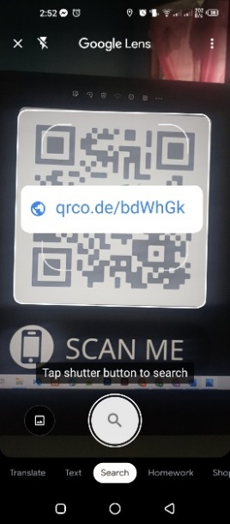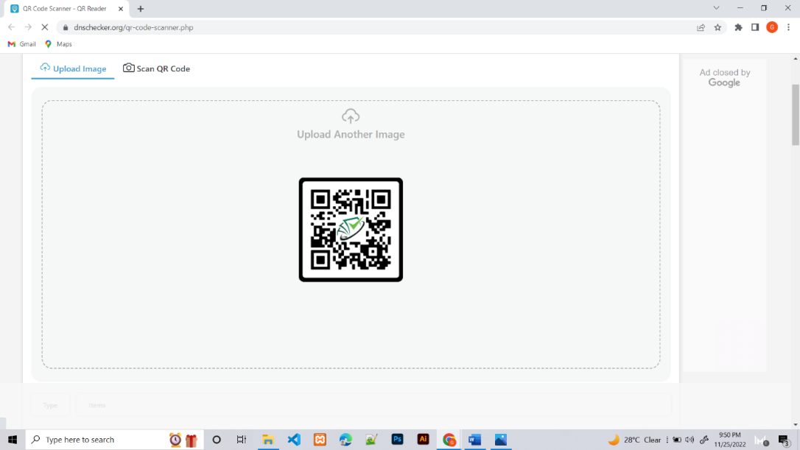**3.6.2** **System Storyboard**

*Figure 20*. Scanned QR Code

Figure 20 shows how users can access the developed web-system by scanning the QR Code. After scanning the QR Code, a link will appear, which the user must click to be directed to the website.

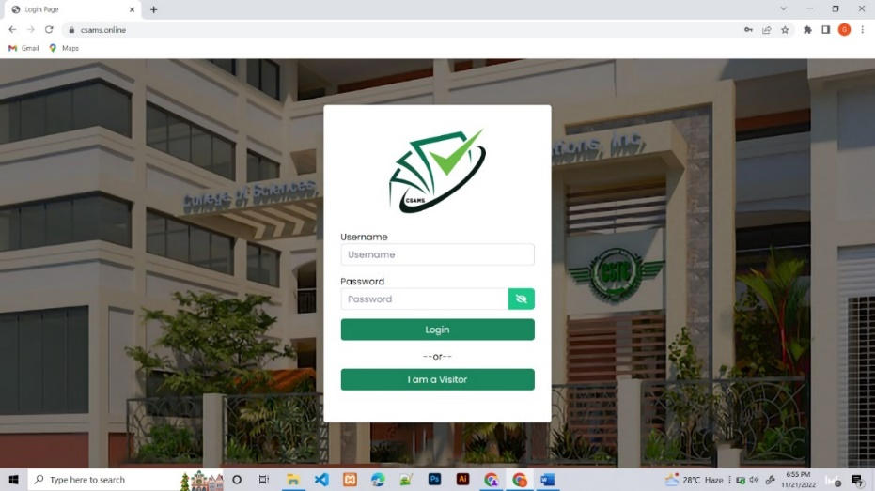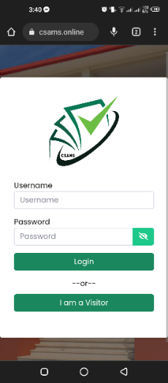

*Figure 21*. Login Page

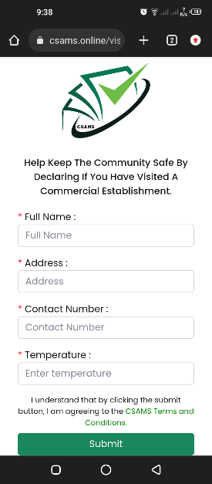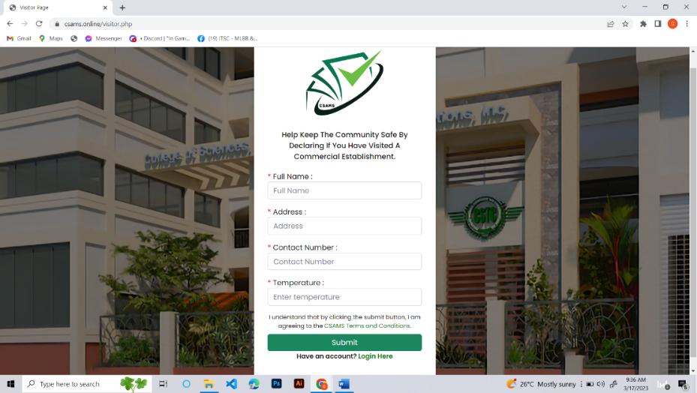Figure 21 shows the users landing page or login page after scanning the QR Code or manually entering the CSAMS website link. The admin, teachers, and students must complete their admin-registered username and password. In contrast, visitors must click the "I am a Visitor" button to complete the health declaration form.

*Figure 22*. Visitors Identification Form

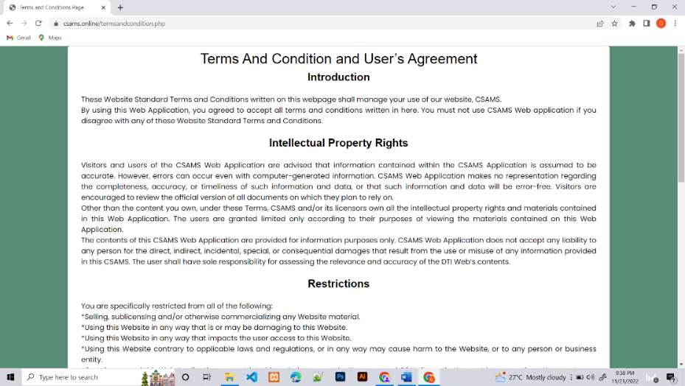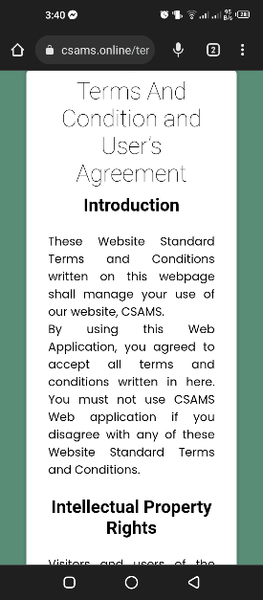 Figure 22 shows the identification form that the visitors must fill out for the school contact tracing. The form asks for your full name, address, phone number, and temperature. If visitors are concerned about their identification, the developed web-system has the Terms and Conditions.

Figure 23. CSAMS Terms and Conditions and Users Agreement

Figure 23 shows the Terms and Conditions page of the CSAMS web-based system, which contains any necessary information. The Introduction, Intellectual Property Rights, Restriction, Content, Limitation of Liability, Severability, Variation of Terms, Arrangement, and Entire Agreement are all part of the Terms and Conditions.

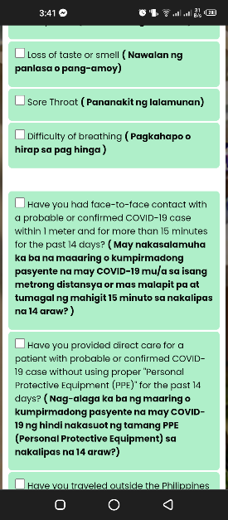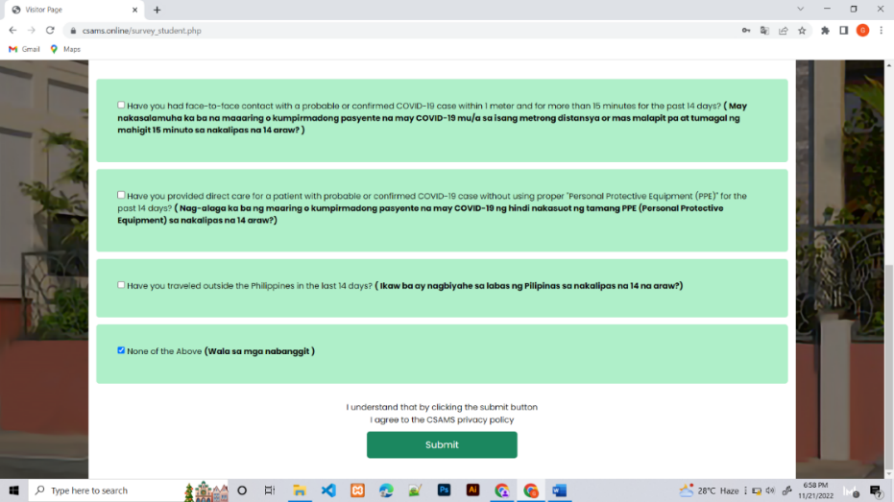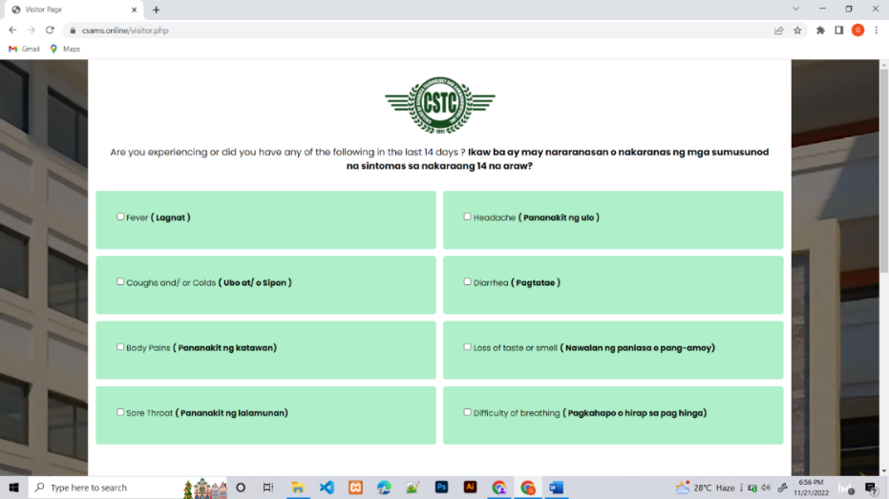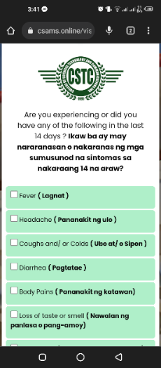

*Figure 24.* Visitors Health Declaration Form Survey

Figure 24 shows the Visitors Survey Questionnaire after completing the Identification Form. This survey questionnaire is for visitors of CSTC Sariaya, Quezon which would serve as a preventive measure of the school.

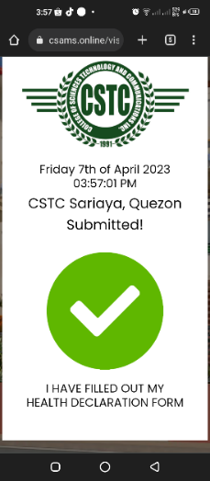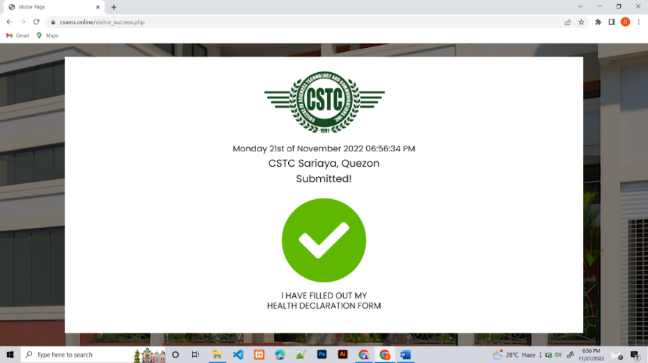

*Figure 25.* Confirmation of the Visitors Health Declaration Form

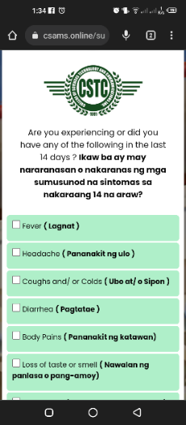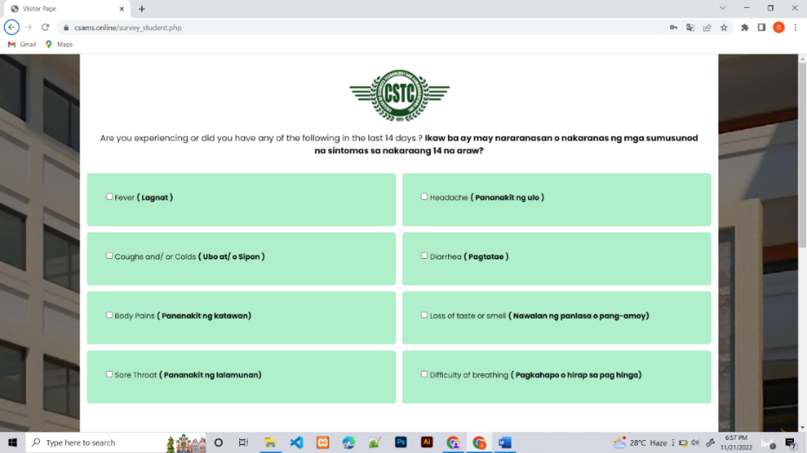Figure 25 shows the visitors health declaration form approval after they have completed the health declaration form. The visitor needs to show this approval to the guard so they can enter the school premises.

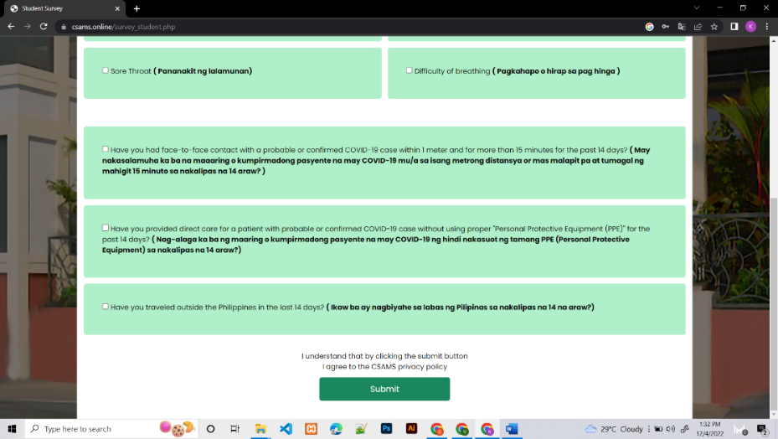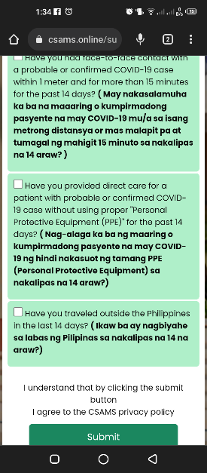

*Figure* 26. Students Health Declaration Form Survey

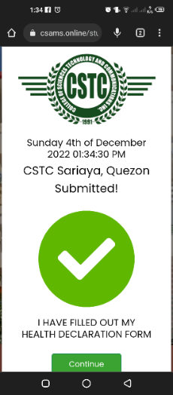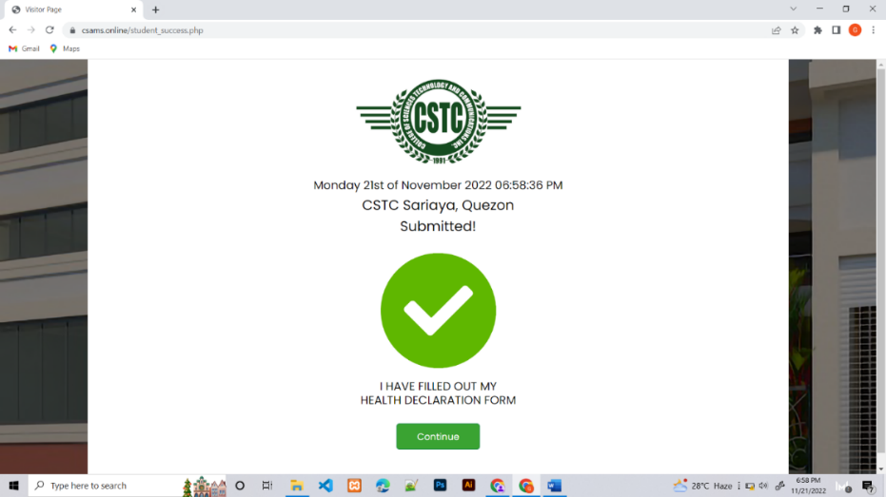Figure 26 shows the students survey questionnaire after they logged in to their account. It is necessary to collect one survey questionnaire from each student at a time in order to trace their contact information.

*Figure 27.* Confirmation of the Student Health Declaration for Student

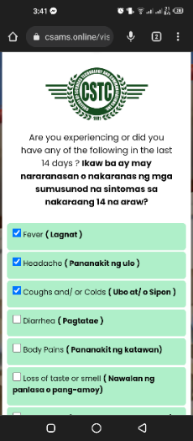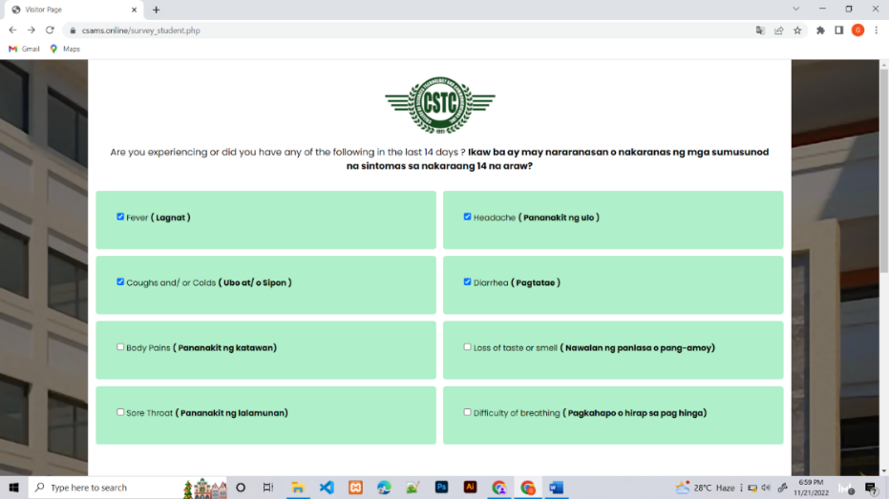Figure 27 shows the students completed health declaration form. The student must show this submitted health declaration form to the guard so they can enter the school premises.

*Figure 28*. Sample Health Declaration form with Symptoms

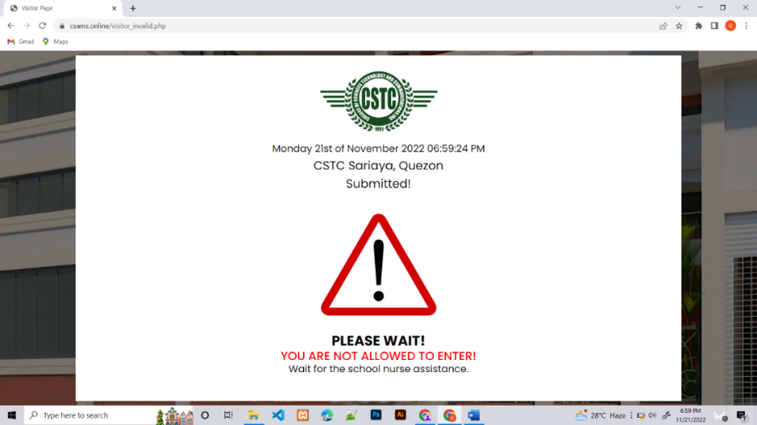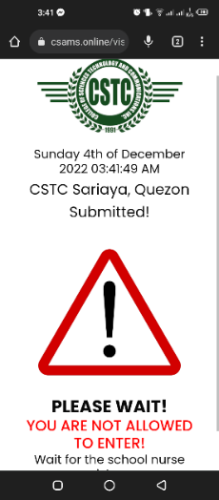 Figure 28 shows that the entrant declared three or more symptoms on their health declaration form.

*Figure 29*. Health Declaration Form when have Symptoms

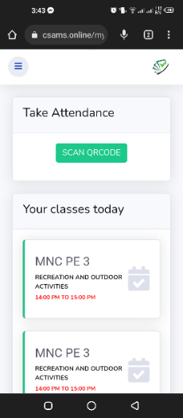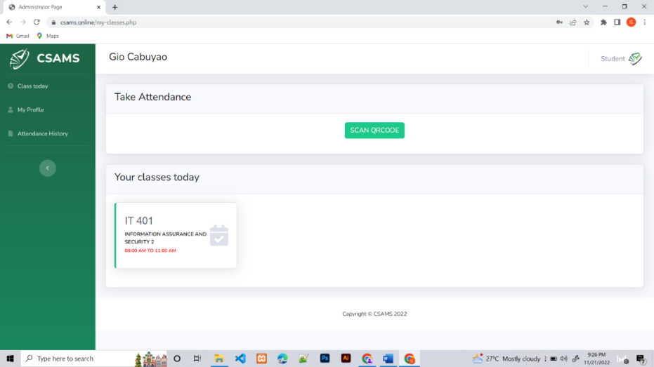 Figure 29 shows the “YOU ARE NOT ALLOWED TO ENTER!” sign after the entrant declares three or more symptoms. This will notify the nurse and guard via SMS notifications that there is a possible entrant who is trying to come into the school so that the nurse will have to interview the entrant to determine if it is a COVID-19 patient or not.

*Figure 30*. Class Today

Figure 30 shows the student dashboard that encloses their schedule. The student can view the number of classes he/she has today and the time of the classes. To take attendance, the student must click on the "SCAN QR CODE" button.

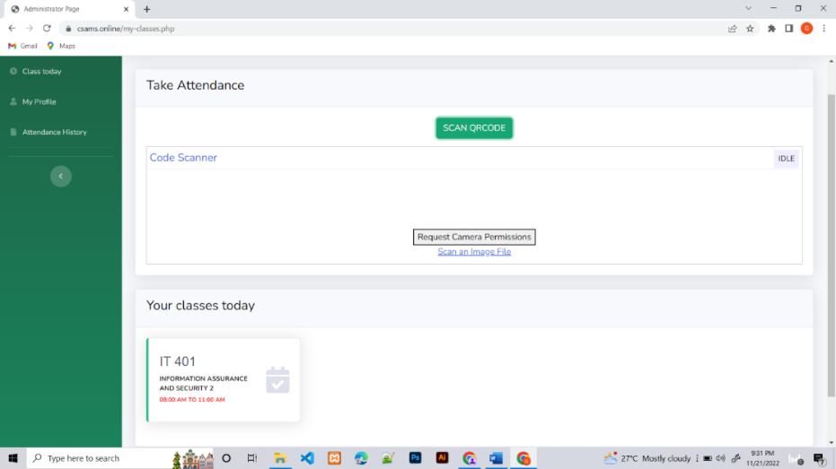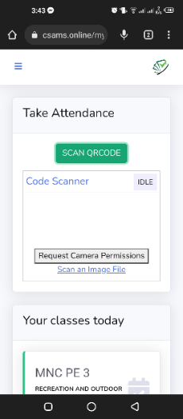

*Figure 31.* Scan Qr Code/Taking Attendance

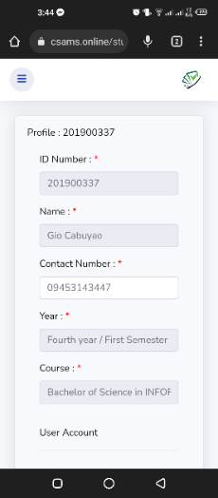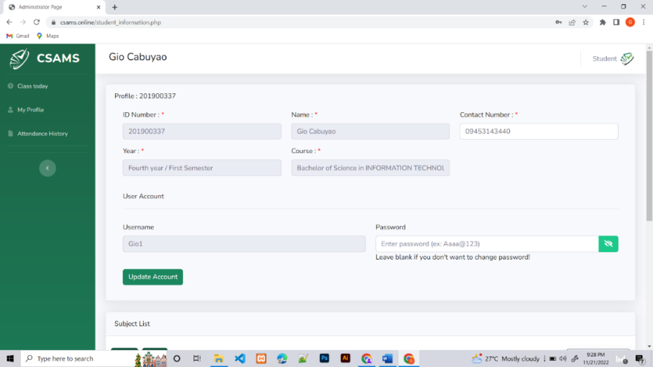 Figure 31 shows that after the student clicks the "SCAN QRCODE" button, the developed system request camera permission to open the camera. The developed system has front and back camera choices, and also, there is a scan image file.

*Figure 32.* My Profile

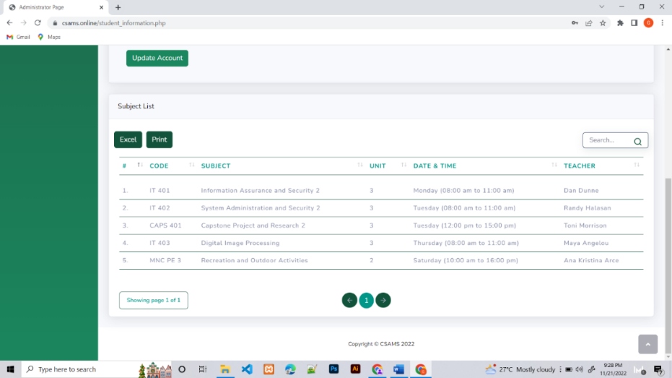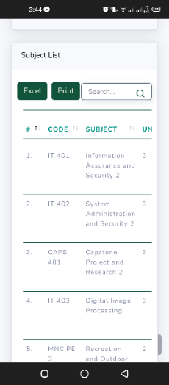 Figure 32 shows the My Profile page, where the student can update contact information and password. If there is something wrong with the student’s information that they cannot change, they can request the changes to the admin of the CSAMS.

*Figure 33.* Subject List

Figure 33 shows the students enrolled subjects. On the subject list page, the student can view the subject code, subject, unit, date and time, and the teacher of their enrolled subject in that semester.

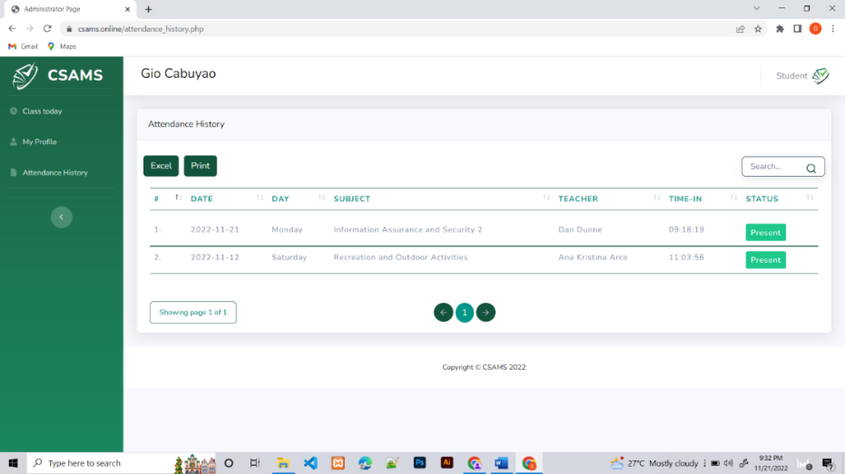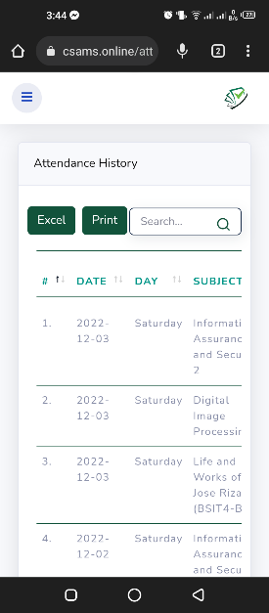

*Figure 34.* Attendance History

Figure 34 shows the history of students’ attendance in their enrolled classes. On the attendance history page, you can view the date, day, subject, teacher, time-in, and status of their attendance.

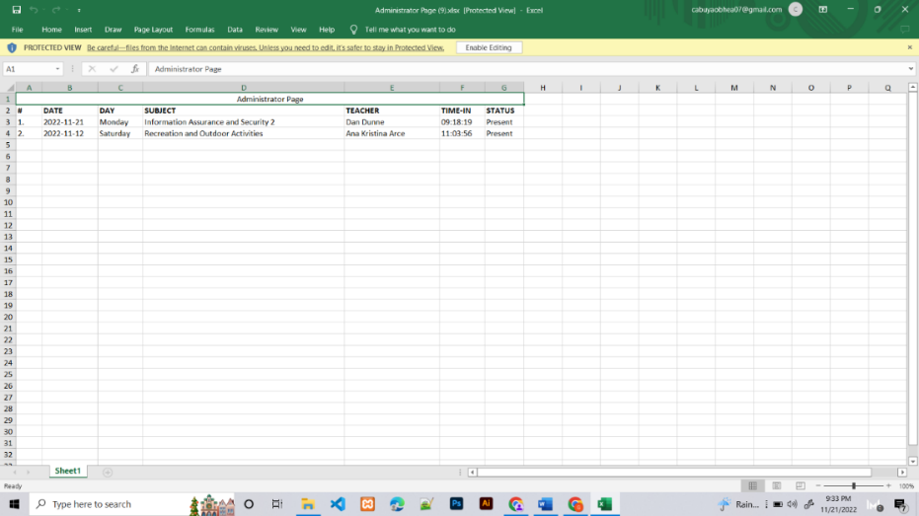

*Figure 35*. Attendance History (Excel)

Figure 35 shows the student can download their attendance history from an Excel file.

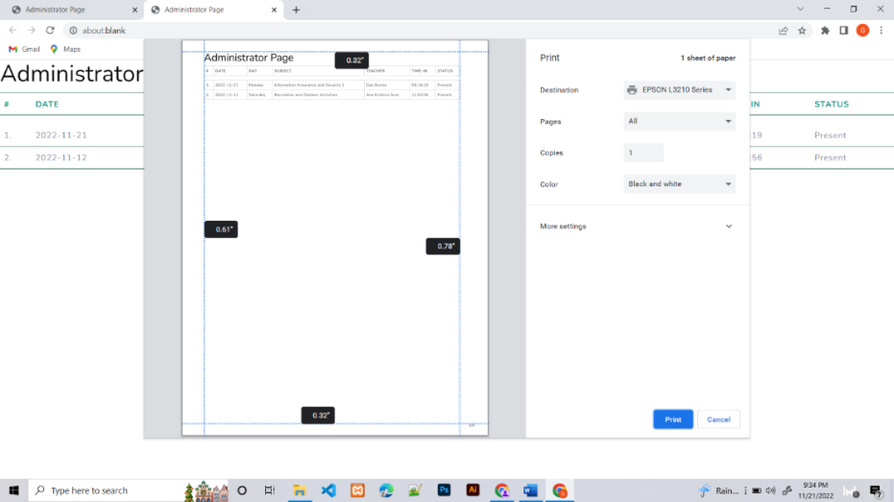

*Figure 36.* Attendance History (Print)

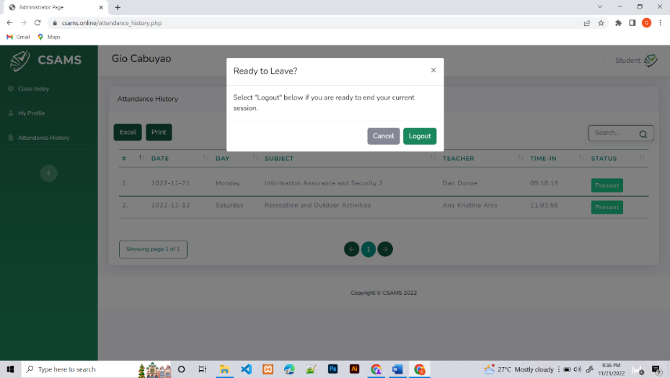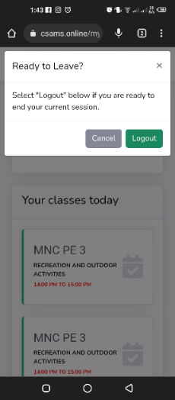Figure 36 shows that the student can print their attendance history by clicking the print button on the upper left side of the developed system.

*Figure 37*. Logout

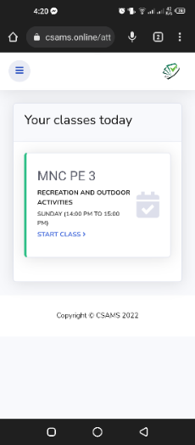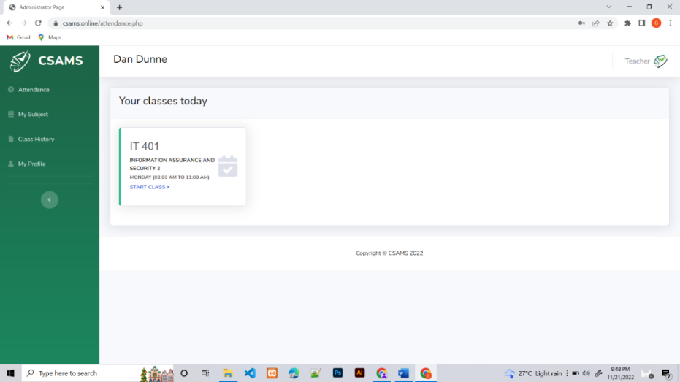Figure 37 shows that students can log out on their accounts. There is a pop-up log-out notification that appears when you click on the student in the upper right corner.

*Figure 38.* Teacher Dashboard

Figure 38 shows the teacher dashboard that has classes today. The teacher can view the subject code, subject name, date, and time of the classes. In the side panel, there is attendance, my subject, class history, and my profile that the teacher can view.

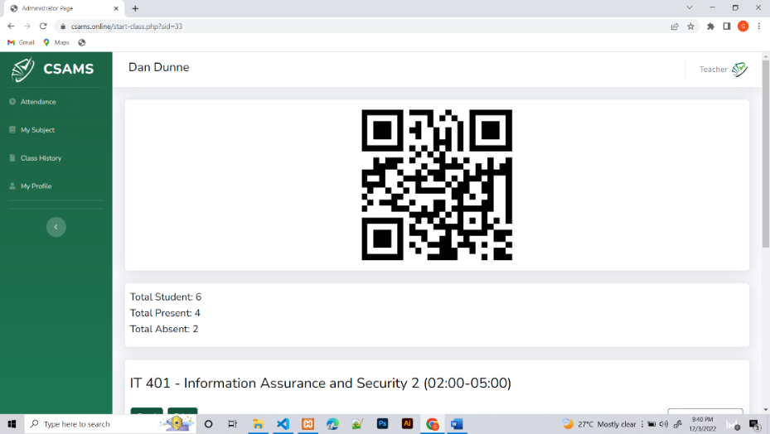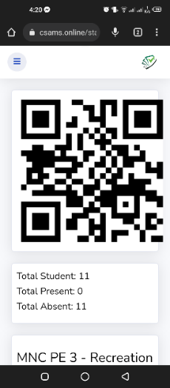

*Figure 39.* Generated QR Code for attendance

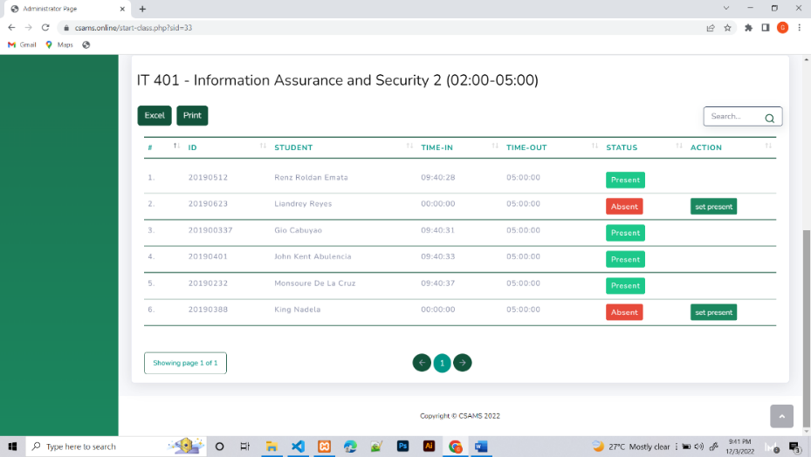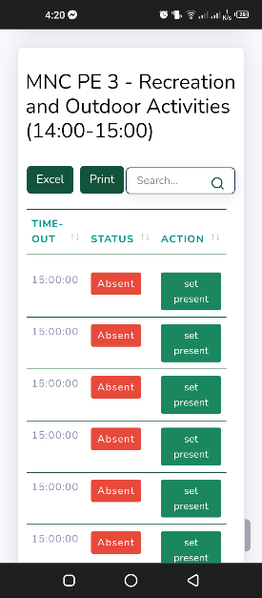Figure 39 shows the subjects generated QR Code that students can scan during class time. Also, the teacher can view the Total number of Students, Total Present, and Total Absent in their subject. After the teacher starts the class, this QR Code is automatically generated.

*Figure 40*. List of Students

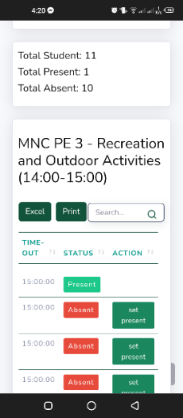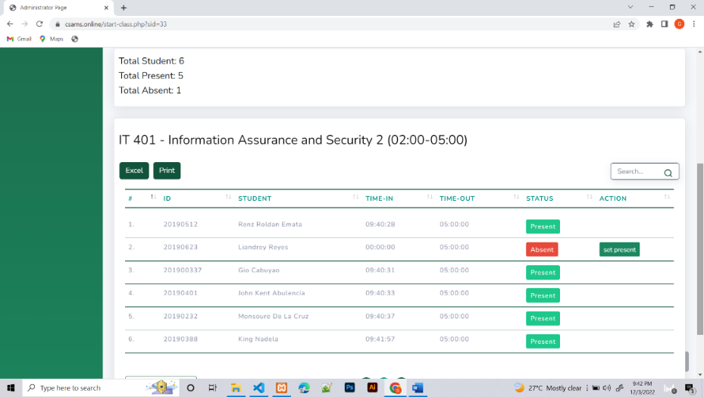Figure 40 shows the list of students that are enrolled in that subject. On this page, the teacher can view the students ID, students name, time-in, time-out, and status. The teacher can also manually set the attendance of the student if the student has no gadgets to take their attendance.

*Figure 41*. Student Attendance Status

Figure 41 shows the students status after they scan the generated QR Code. Attendance includes present, late, and absent statuses. After the start of class, the time is running. If the students attend after 15 minutes, the status shows it is late. However, if the students take attendance for more than 30 minutes, the status of the students will be absent.

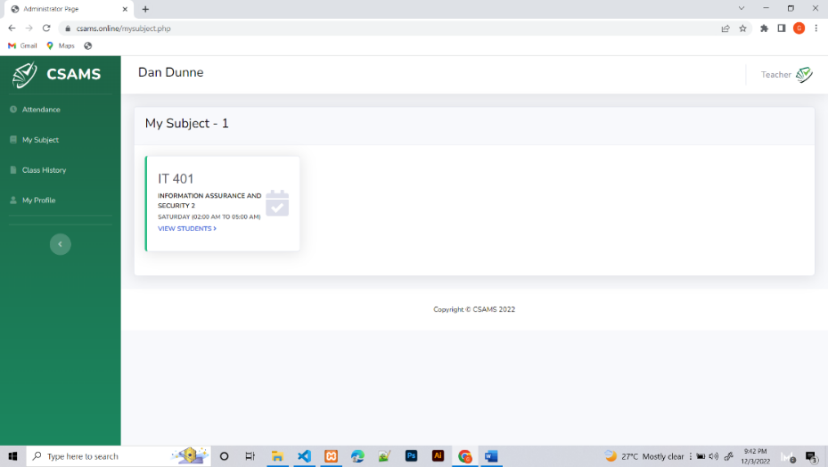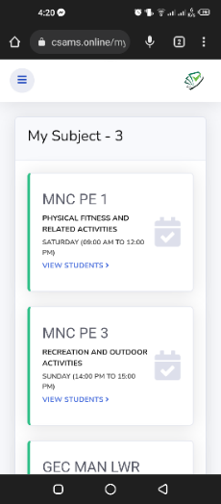

*Figure 42.* My Subject (View Student)

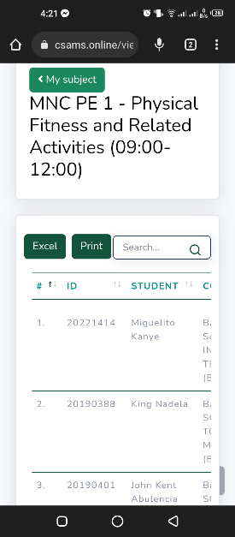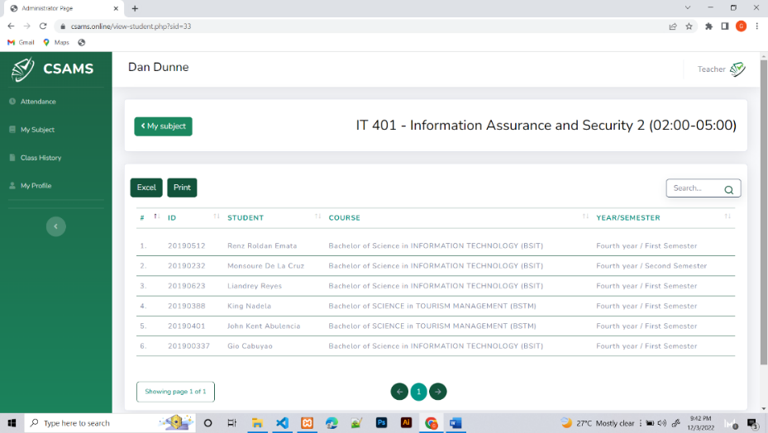Figure 42 shows the teacher can view their assigned subjects. The teacher can also view the students enrolled in the subject by clicking on view students.

*Figure 43.* My Subject (List of Students)

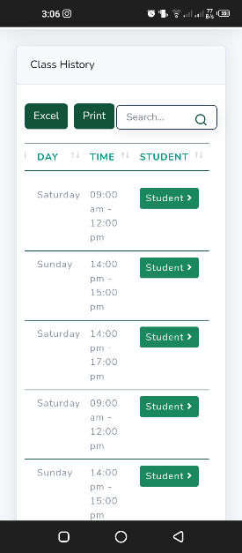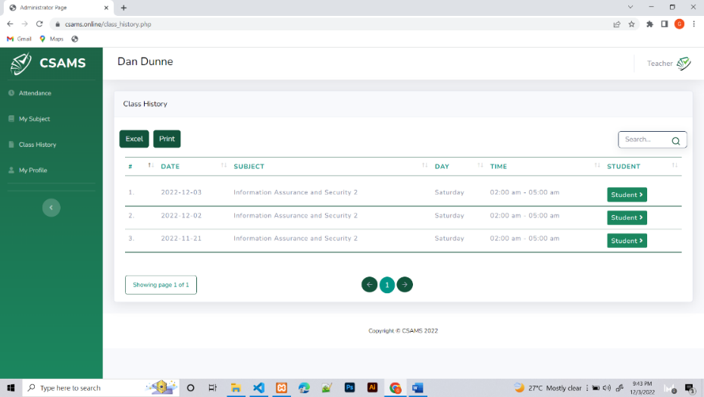 Figure 43 shows that once the teacher clicks the view students button, the list of students enrolled in the subject appears. The teacher can view the student ID, student name, course, and year/semester in the student list. Also, with the help of a search bar in the upper right corner can also identify their students immediately.

*Figure 44.* Class History

Figure 44 shows the attendance record of the teacher with their past subject classes. The date, subject, day, and time can be seen depending on when the teacher begins class and who takes attendance.

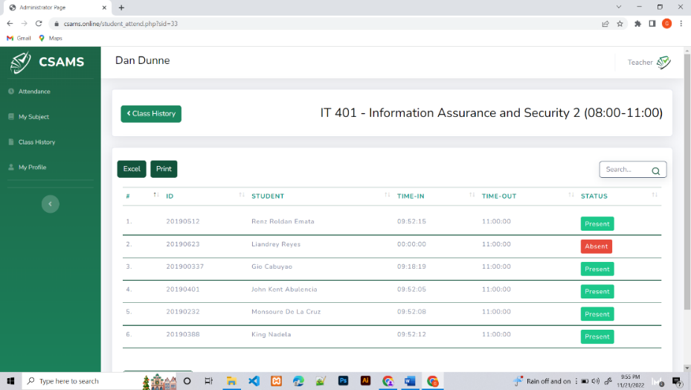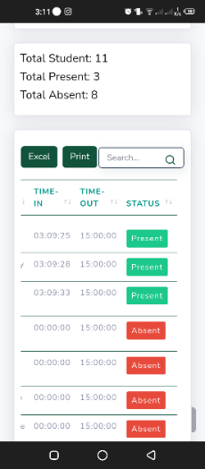

*Figure 45.* Students on this Subject

Figure 45 shows the list of students who are present, late, and absent from their specific subjects. There is a search bar in the upper right corner if the teacher is having difficulty finding the students name.

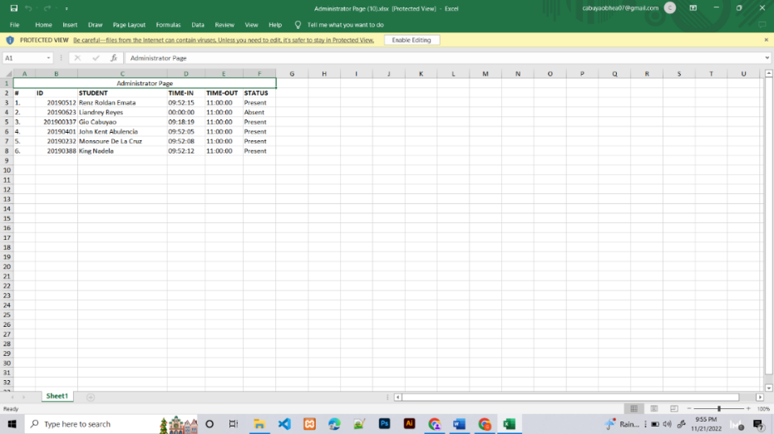

*Figure 46.* Excel

Figure 46 shows that teachers can generate a report for their subjects through an Excel file to quickly create attendance reports.

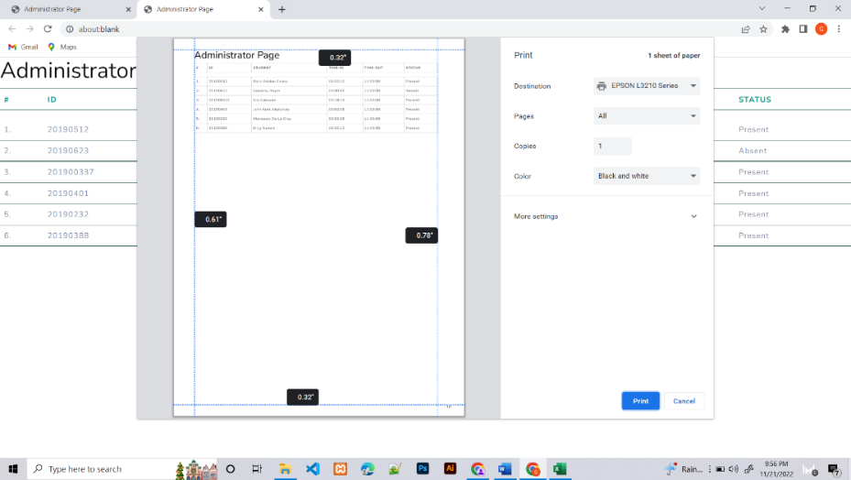

*Figure 47*. Print

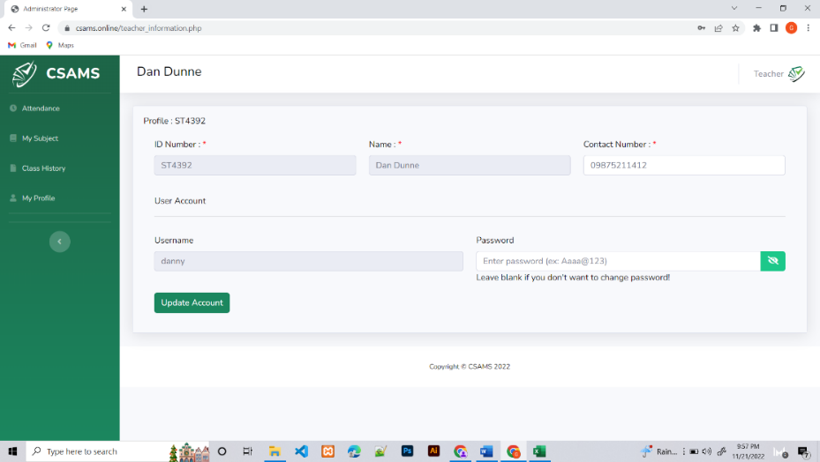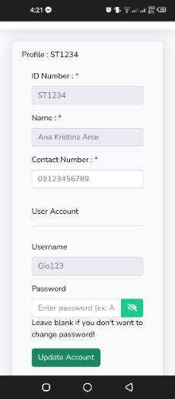Figure 47 shows that the class history report can be printed as a hard copy for their reference if an attendance record is required in physical form.

*Figure 48.* My Profile

Figure 48 shows where the teacher can update contact information and password. If there is something wrong with the teachers information that they cannot change, they can request the changes to the admin of the developed web-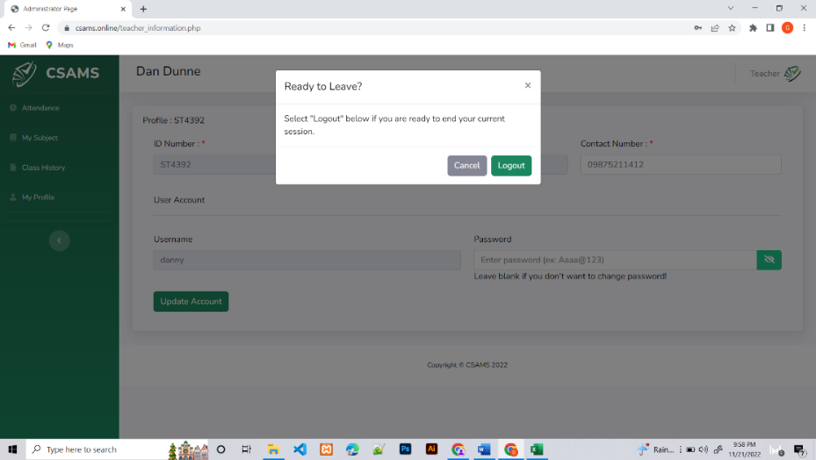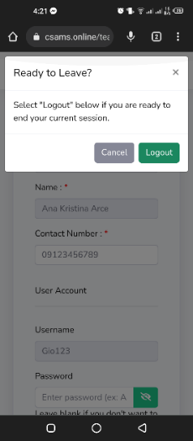system.

*Figure* *49*. Logout

Figure 49 shows the process of how the teachers can log out on their account, which involves accessing the Logout button through a pop-up window that appears upon clicking on the teacher icon in the websites upper right corner.

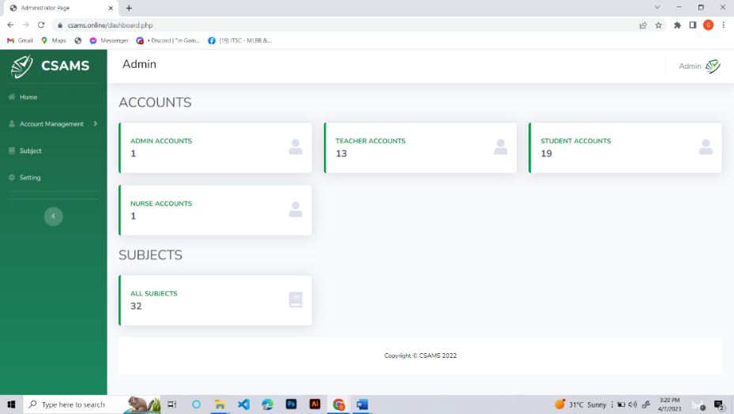

*Figure 50* Admin Dashboard

Figure 50 shows the admin dashboard with features such as account management, subjects, and settings. Administrators can view the number of registered accounts of teachers, students, nurses, and subjects.

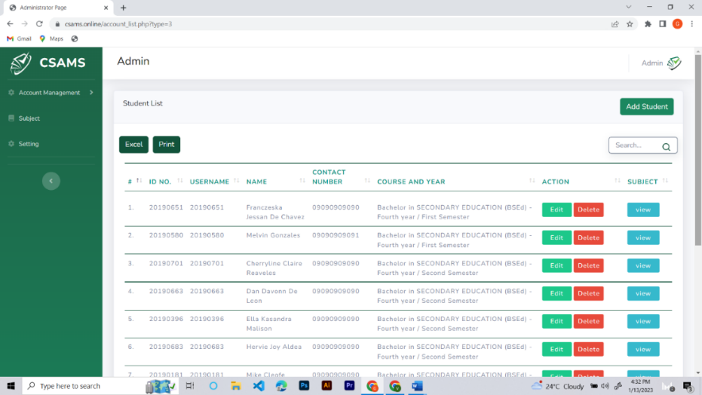

*Figure 51.* Account Management (List of Students)

Figure 51 shows the list of students in account management. Admins can view the students ID number, username, name, contact number, course, year, and subject. Also, it allows you to add, edit, delete, and view every students subjects.

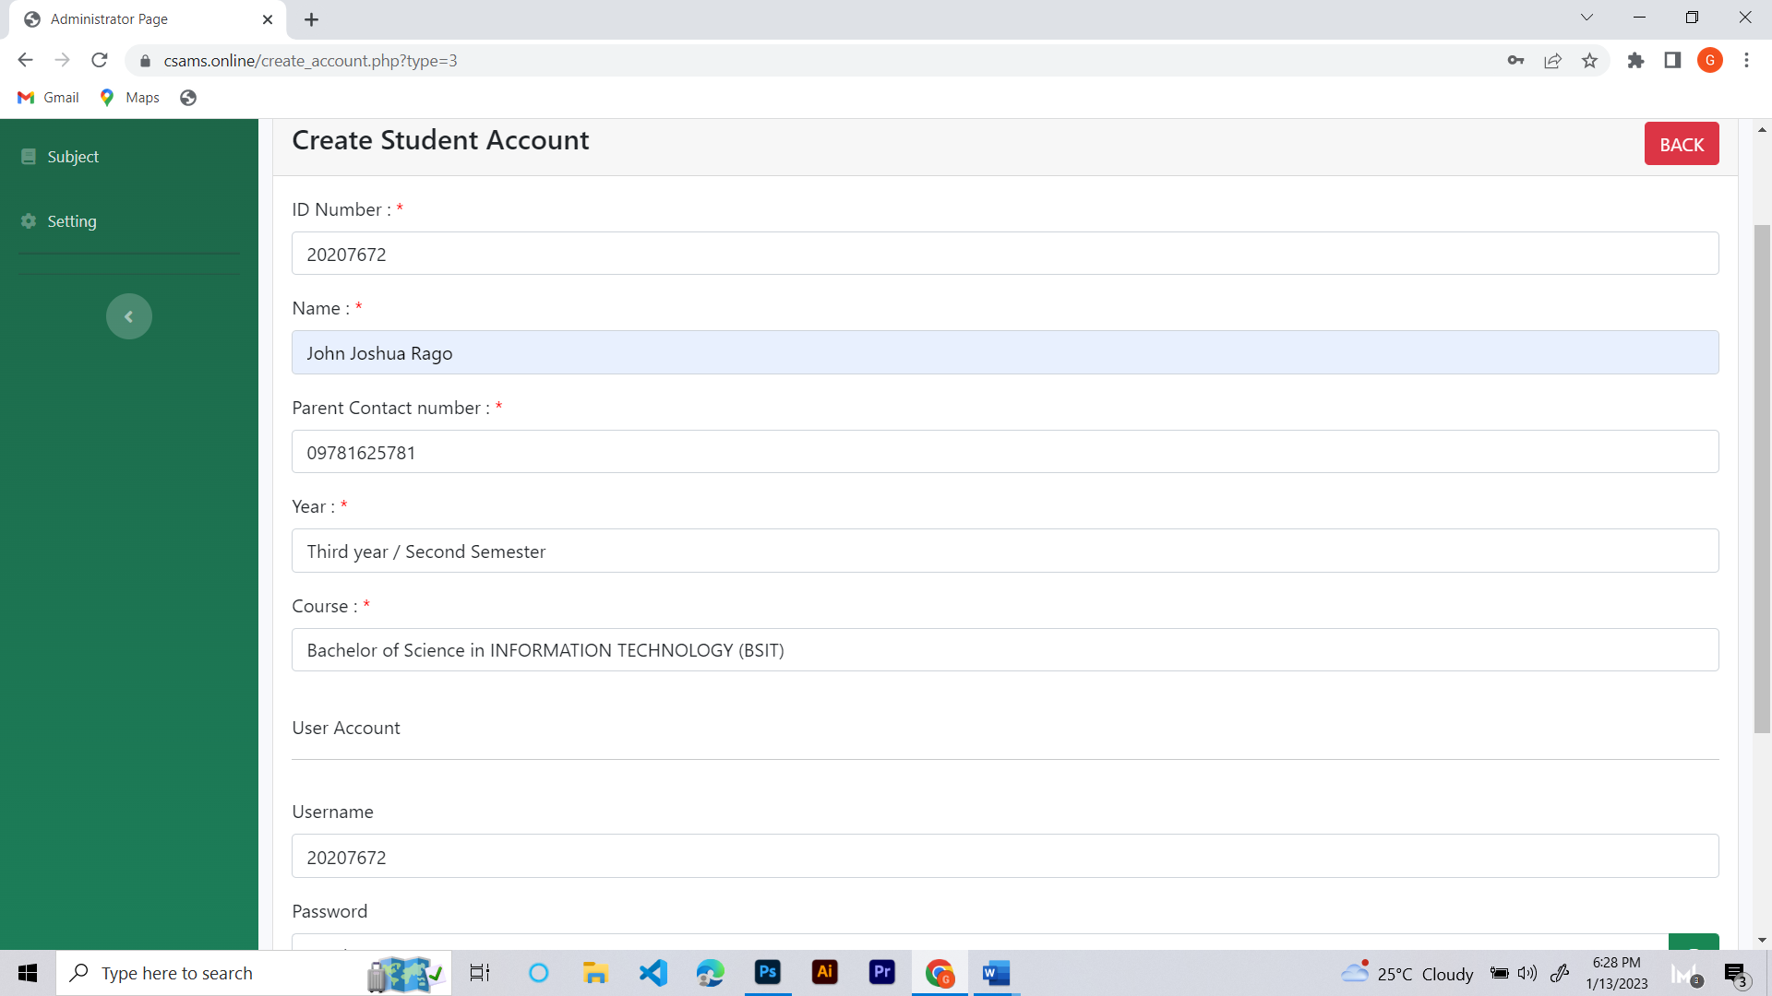

*Figure 52.* Account Management (Creating Student Account)

Figure 52 shows the feature where admin can create an account for the student after they click the "Add Student" button. To create an account, they need the information in the system, including an ID number, name, parent contact number, year, course, username, and password.

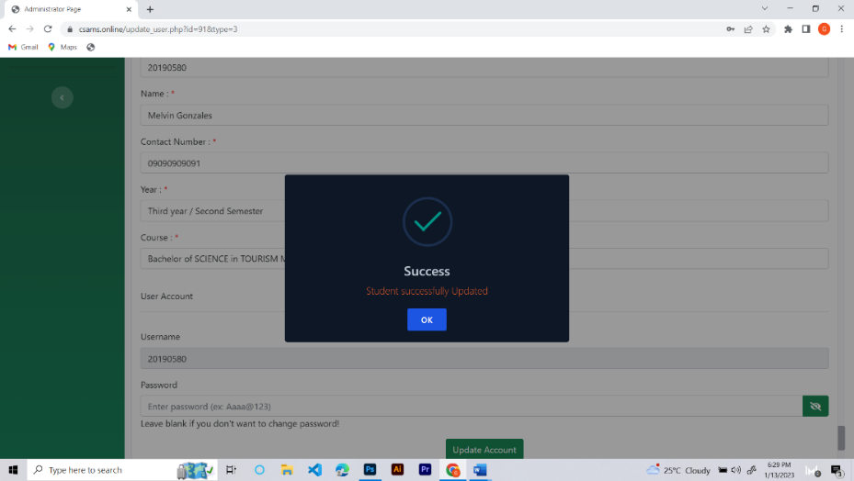

*Figure 53.* Account Management (Edit Student Account)

Figure 53 shows that administrators can update all details related to their student accounts, including their student information.

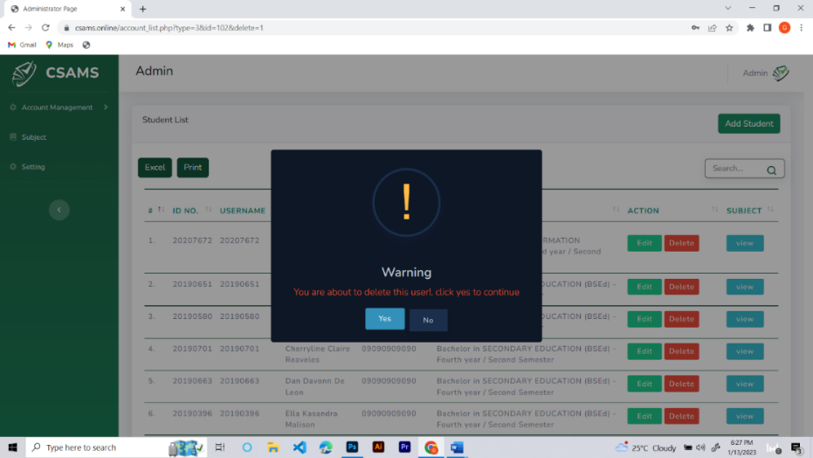

*Figure 54.* Account Management (Delete Student Account)

Figure 54 shows the administrators need to confirm the deletion of a student account before they can permanently remove it.

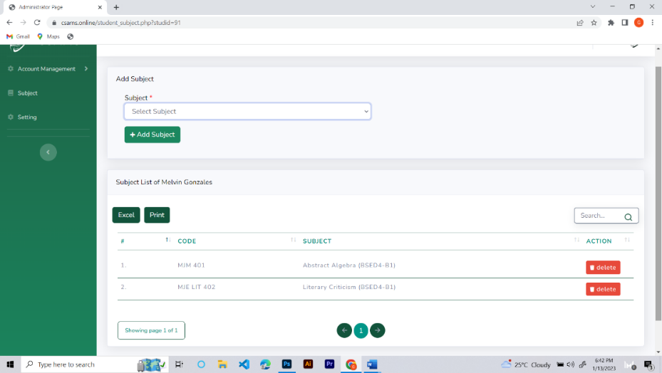

*Figure 55.* Account Management (View Student Account)

Figure 55 shows that after clicking the view button in the student account list. This page allows you to add and delete subjects. The admin can also view the subject code and subject registered for the student.

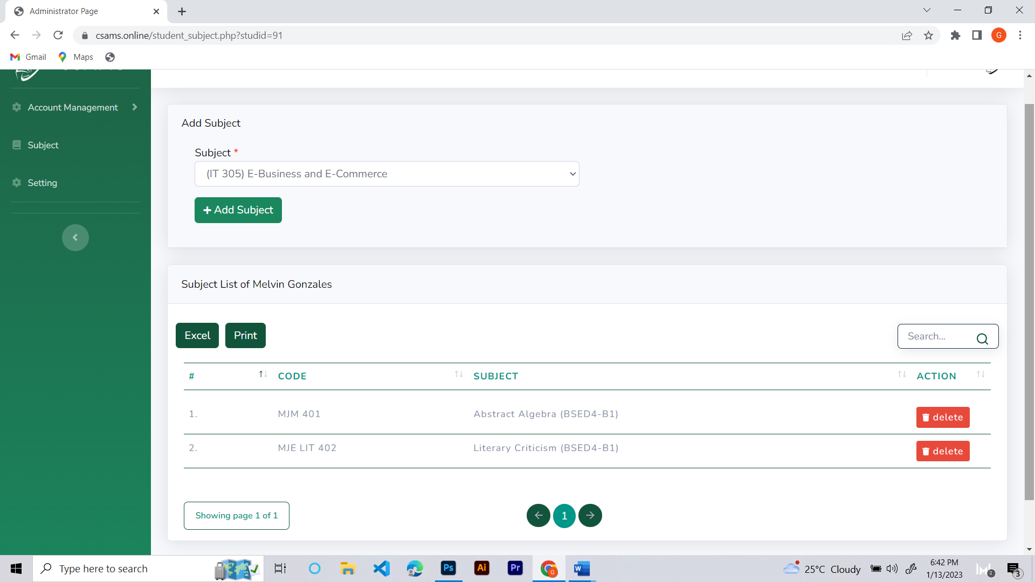

*Figure 56.* Account Management (Add Subject)

Figure 56 shows how to add a subject to the student. The admin can add the enrolled subject of the students to their accounts.

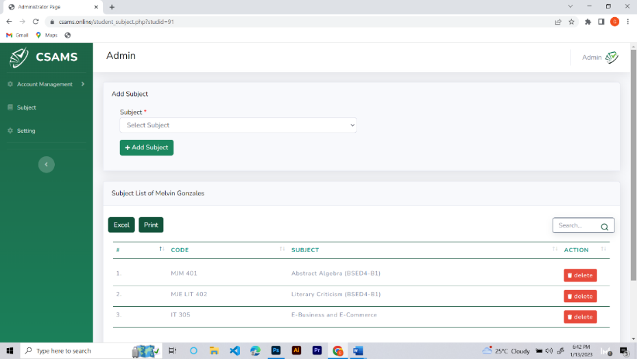

*Figure 57.* Account Management (Added Subject)

Figure 57 shows the subject the administrator added to the students subject list after the addition process was completed.

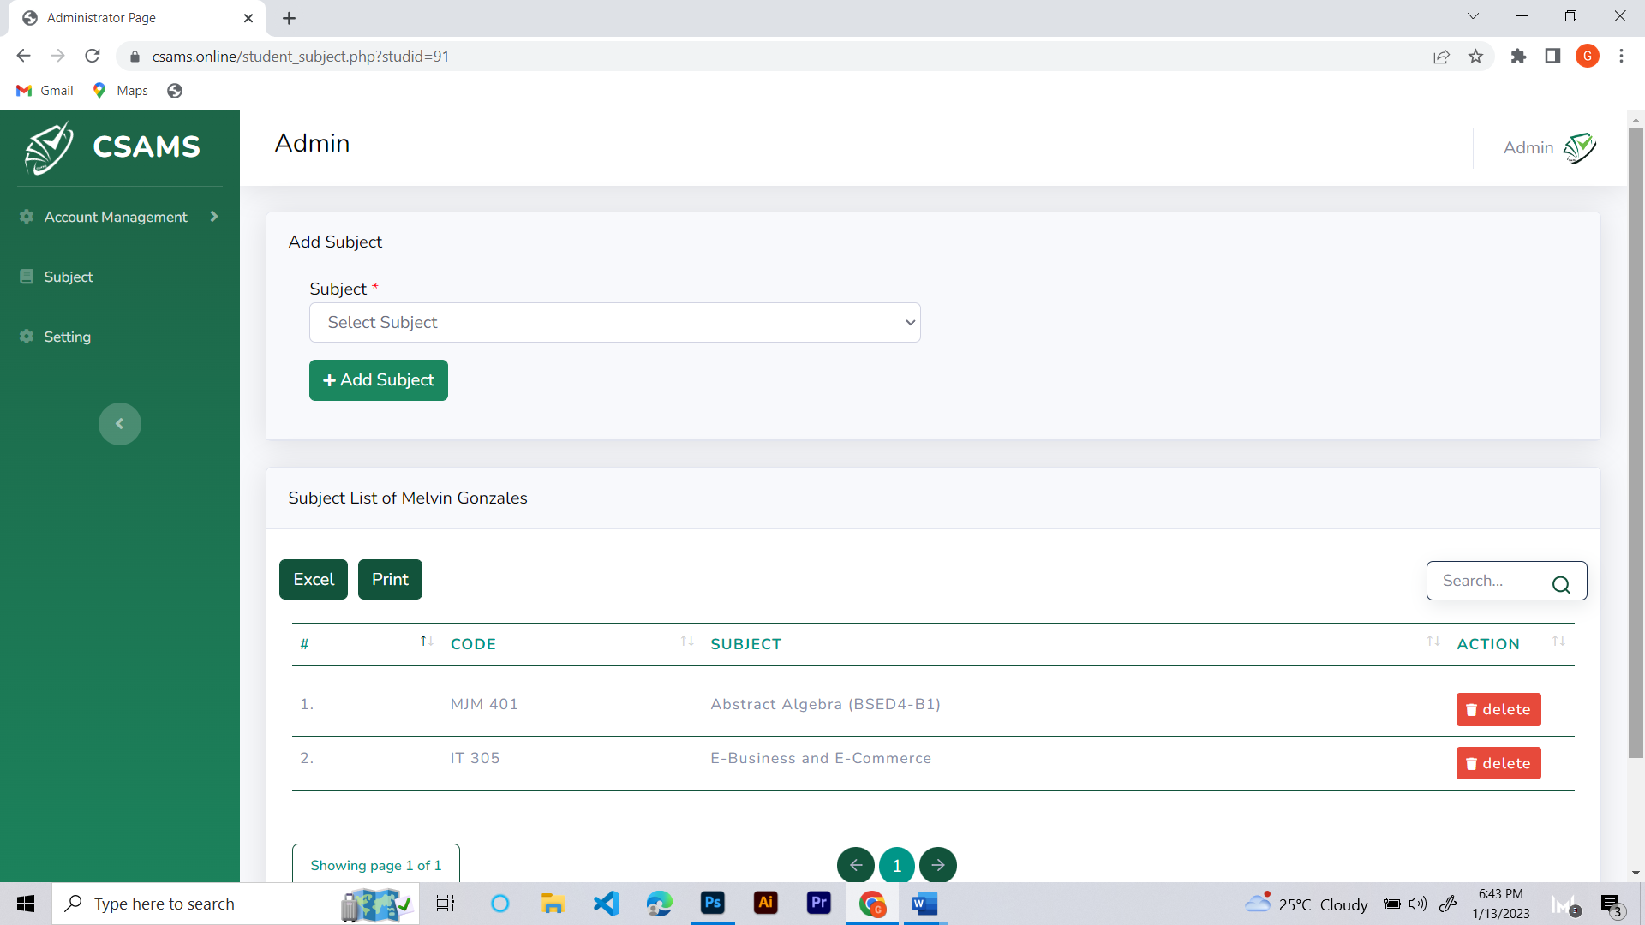

*Figure 58.* Account Management (Delete Subject)

Figure 58 shows that administrators can remove a subject from a student’s subject list.

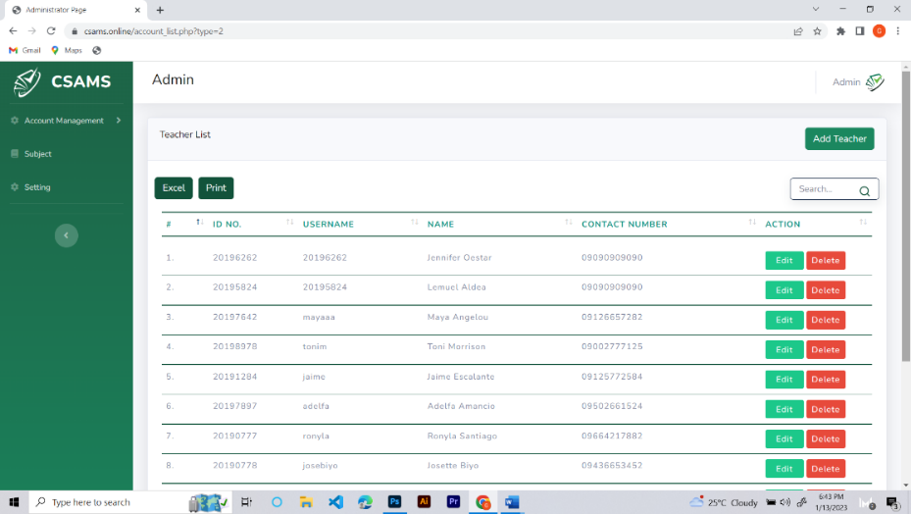

*Figure 59.* Account Management (Teacher List)

Figure 59 shows a list of teachers, displaying their unique ID numbers, usernames, names, and contact details. Additionally, the list provides options for editing and deleting teacher accounts.

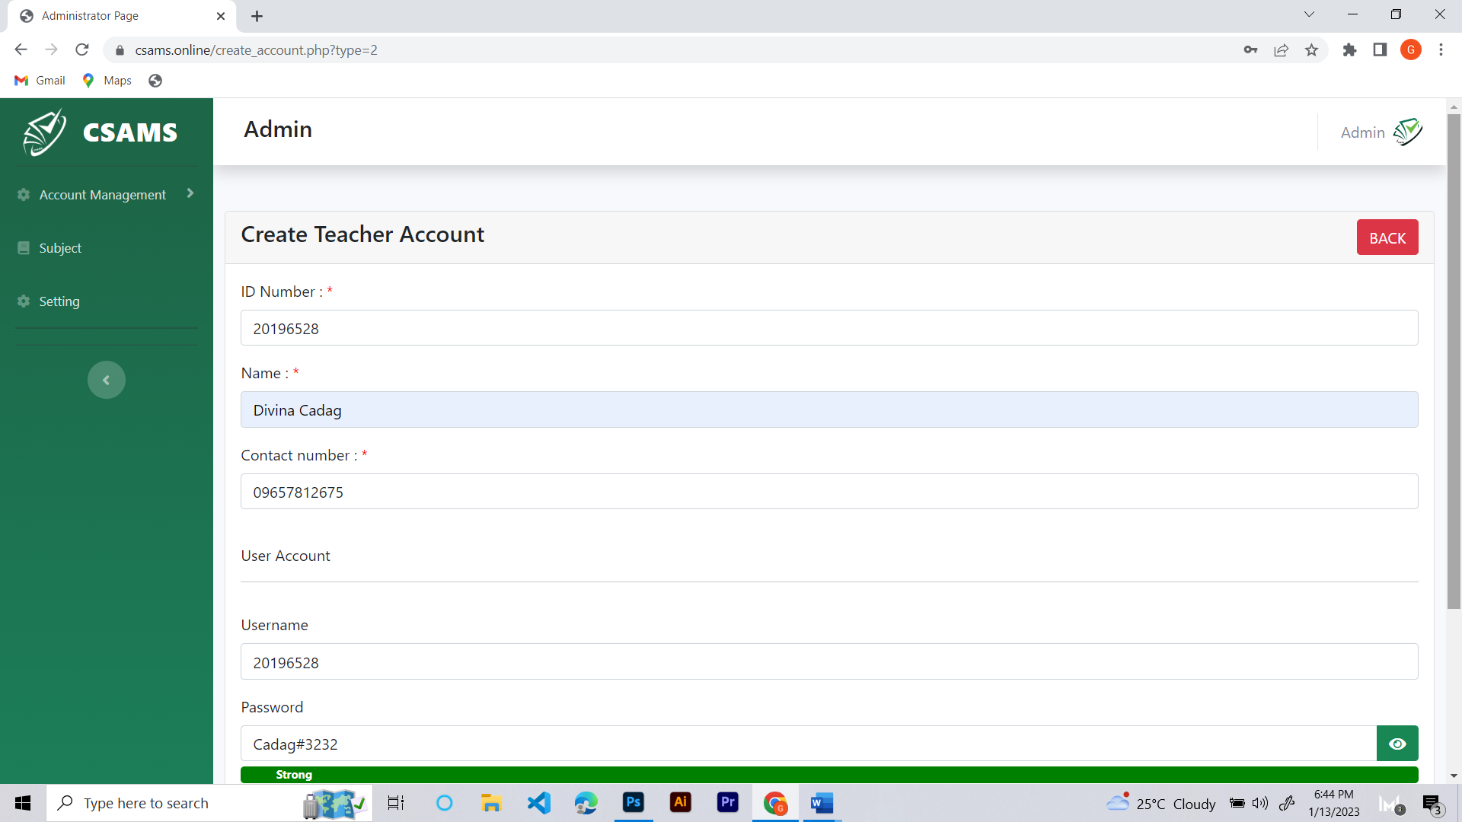

*Figure 60.* Account Management (Create Teacher Account)

Figure 60 shows the administrators process of creating a teacher account, which involves providing the required information, such as an ID number, name, contact number, username, and password, after selecting the Add Teacher button.

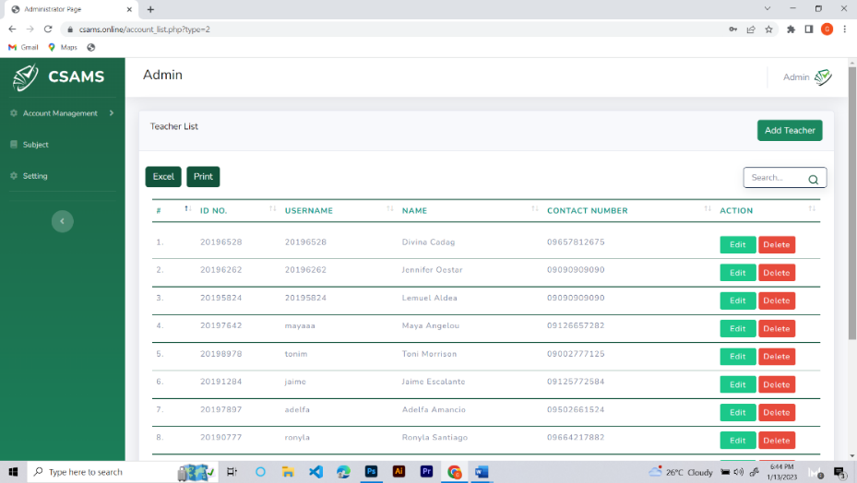

*Figure 61*. Account Management (Added Teacher Account)

Figure 61 shows that the administrator has added the newly created teachers account to the teachers list, which can be seen after completing the registration process.

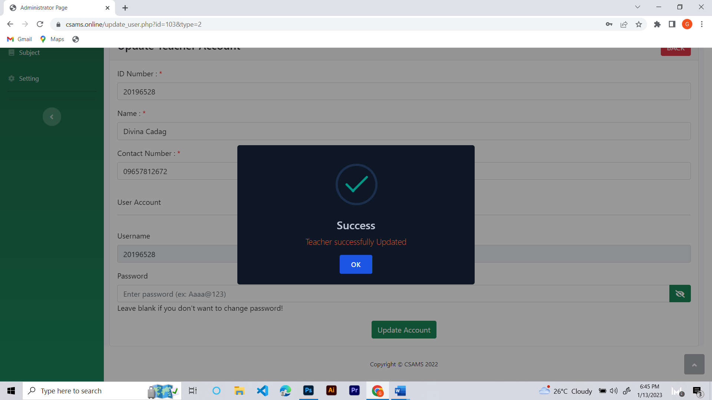

*Figure 62*. Account Management (Edit Teachers Account)

Figure 62 shows that administrators can change all of the information on the teachers account, including personal information and other relevant details.

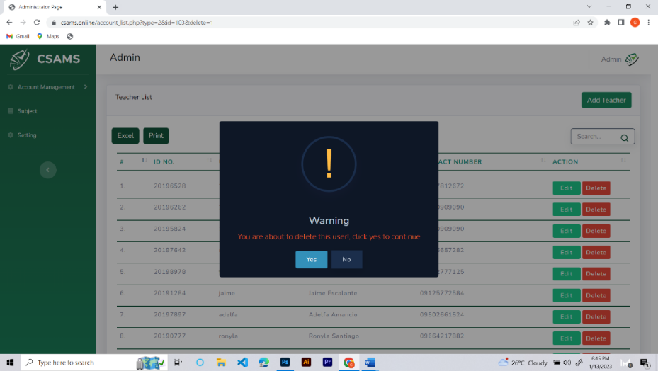

*Figure 63*. Account Management (Delete Teachers Account)

Figure 63 shows the administrators need to confirm the deletion of a teacher account before permanently removing it.

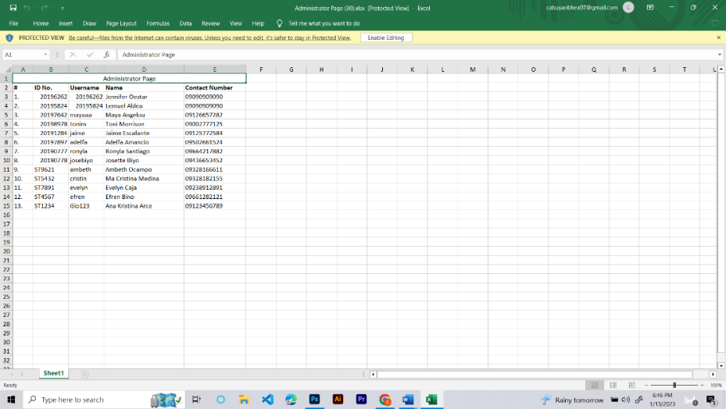

*Figure 64.* Account Management (Excel)

Figure 64 shows the list of teachers’ information that can be downloaded as an Excel file.

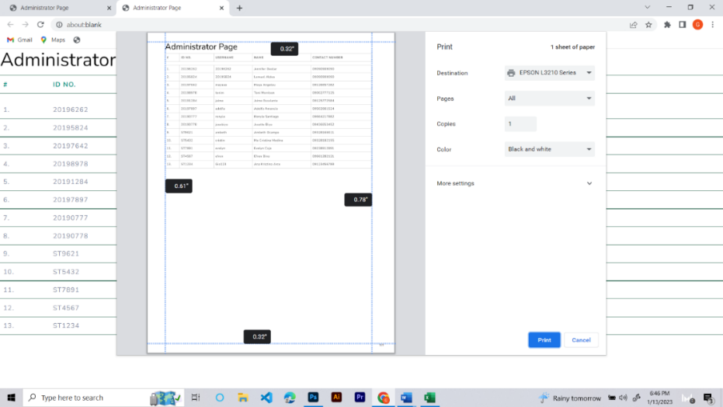

*Figure 65.* Account Management (Print)

Figure 65 shows that the administrators can print the list of teachers for their records.

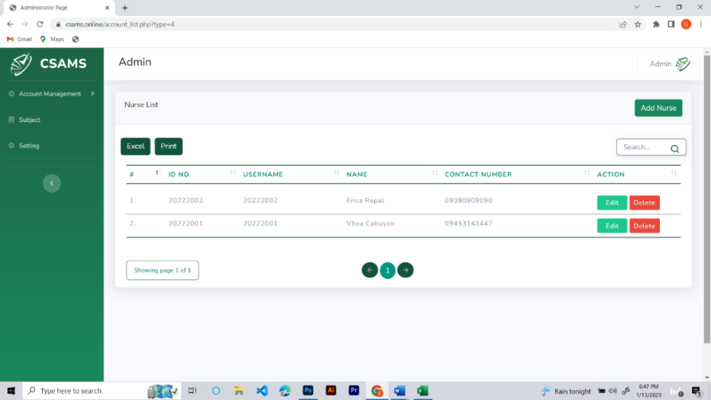

*Figure 66.* List of Nurse Account

Figure 66 shows the nurse list that the administrator created, including their unique ID numbers, usernames, names, and contact details. Moreover, the administrator can edit or delete nurse accounts from this list.

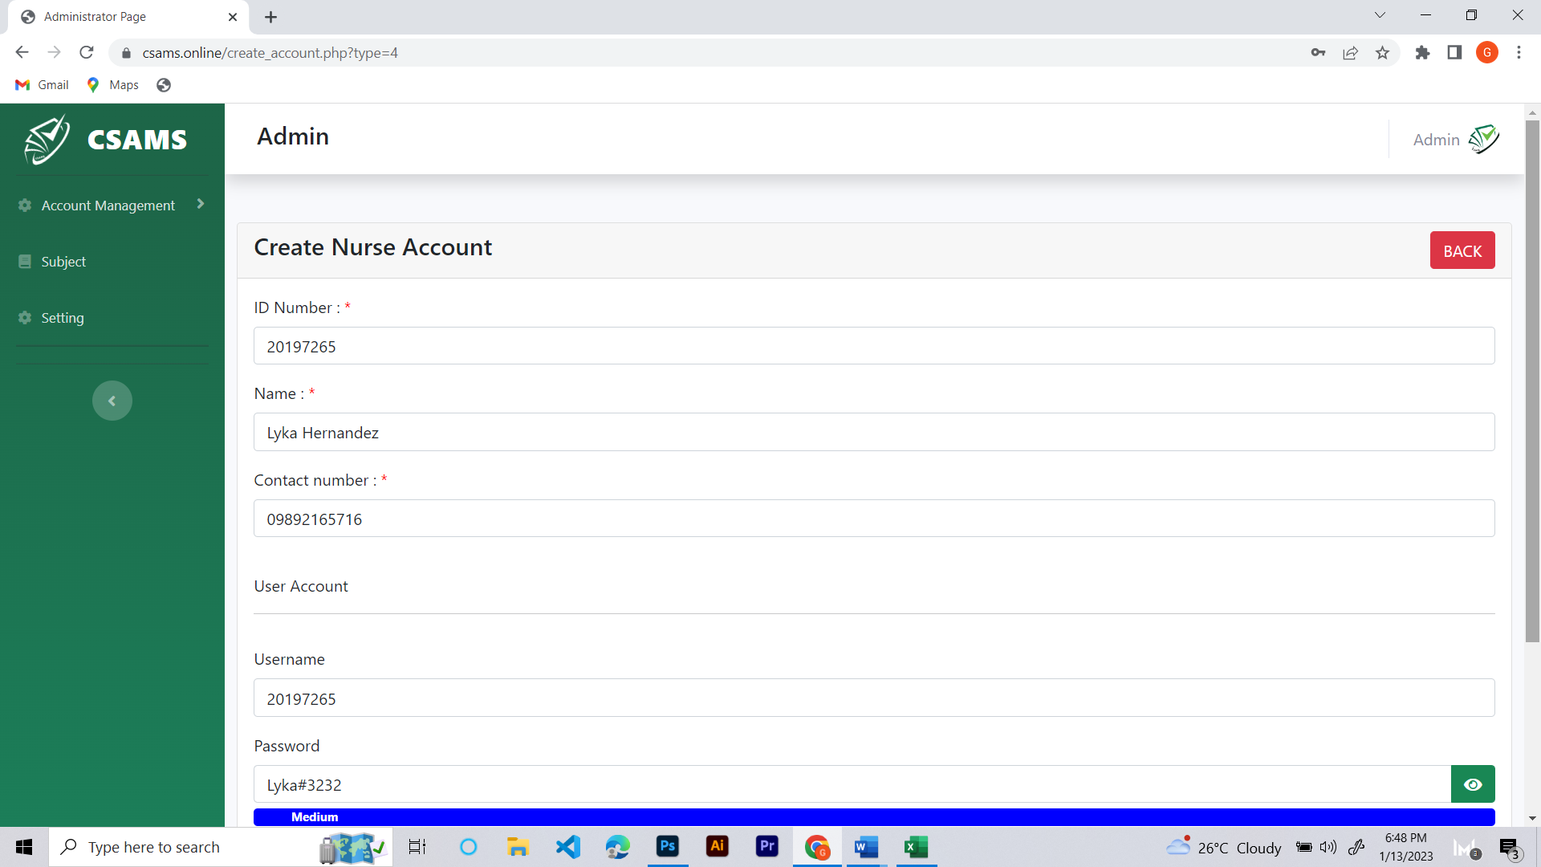

*Figure 67.* Creating Nurse Account

Figure 67 shows the administrators process of creating a nurse account, which involves providing the required information, such as an ID number, name, contact number, username, and password, after selecting the Add Nurse button.

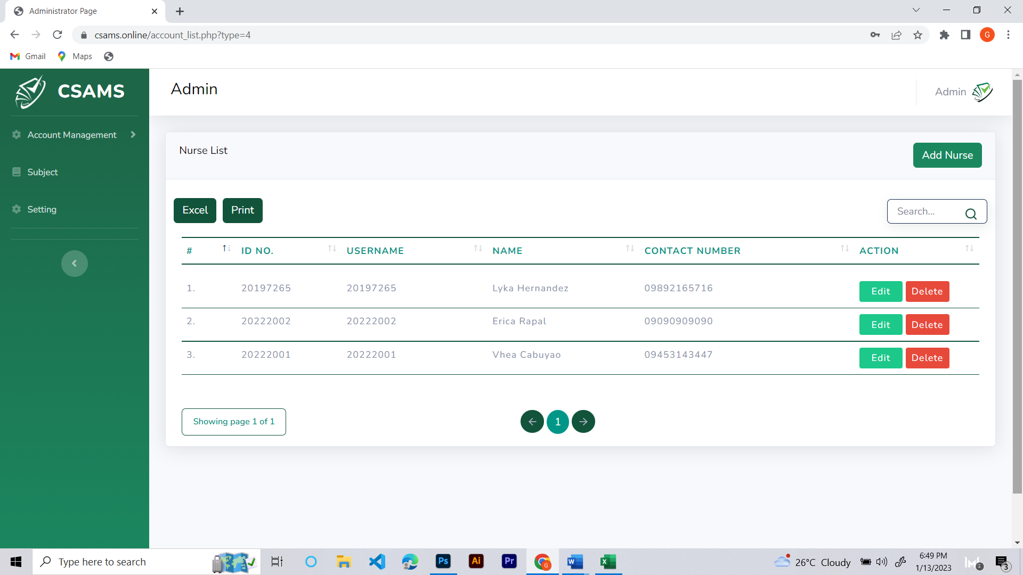

*Figure 68.* List of Nurse Account (with Added Account)

Figure 68 shows that the administrator has added the newly created nurses account to the nurses list, which can be seen after completing the registration process.

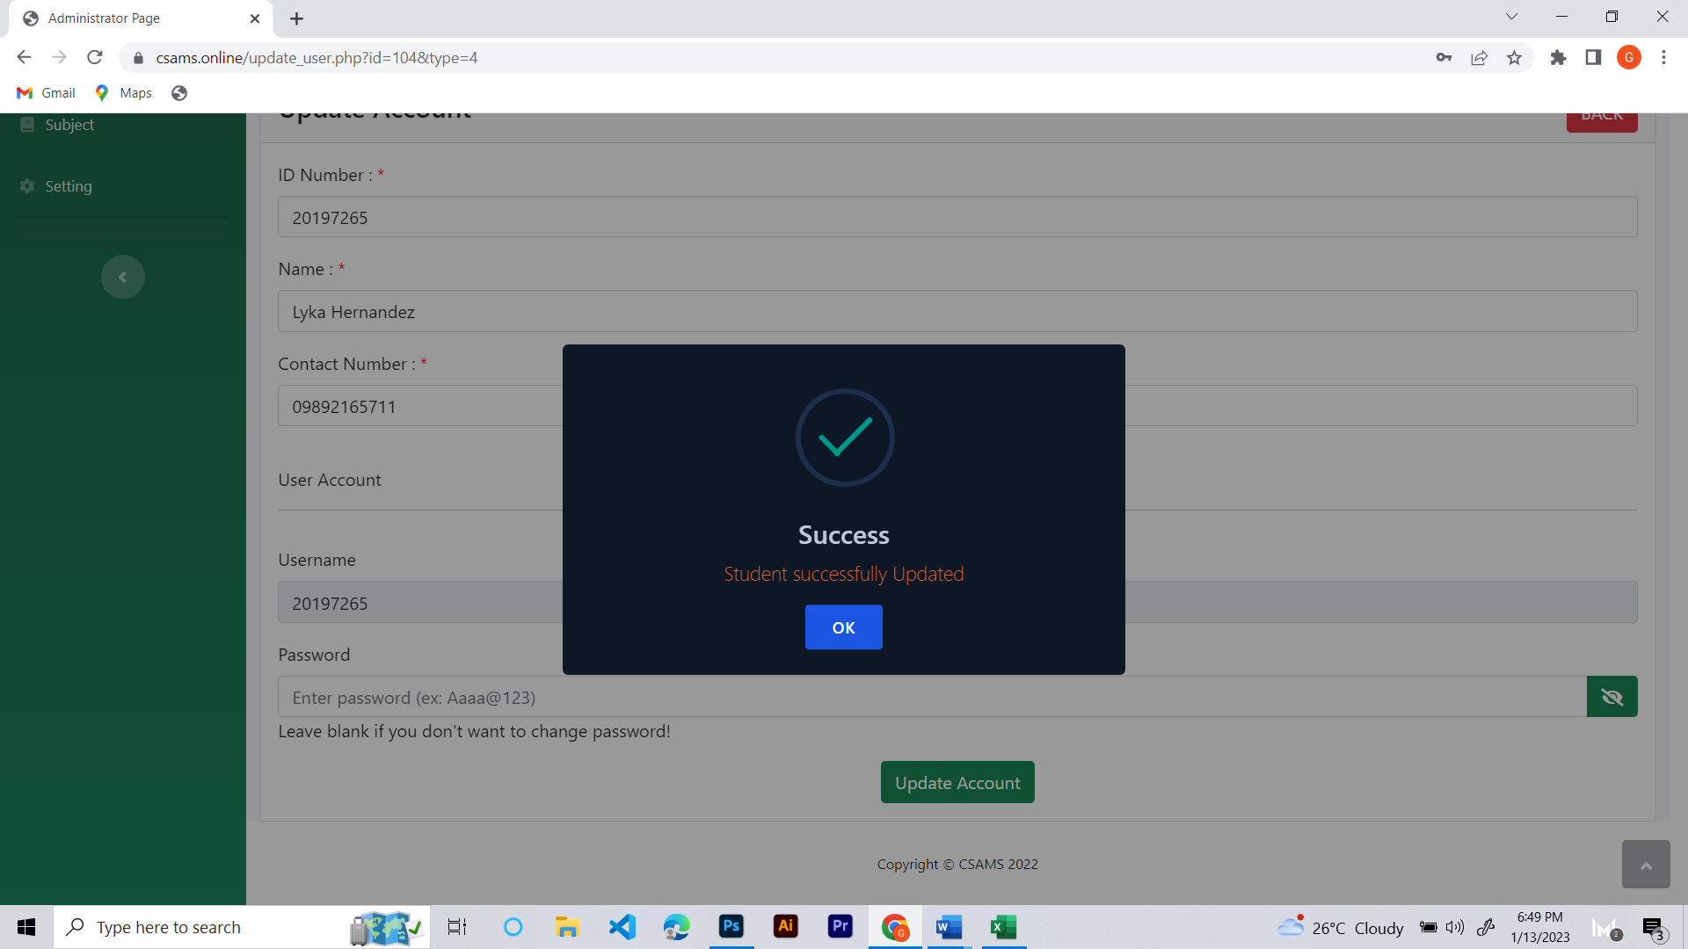

*Figure 69.* Editing Nurse Account

Figure 69 shows that administrators can change all information on the nurse accounts, including personal information and other relevant details.

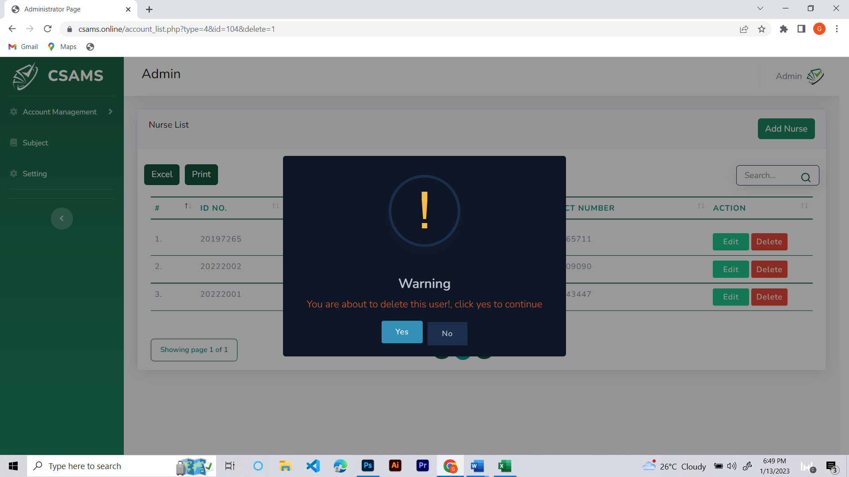

*Figure 70.* Deleting Nurse Account

Figure 70 shows the feature where administrators need to confirm the deletion of a nurse account before permanently removing it.

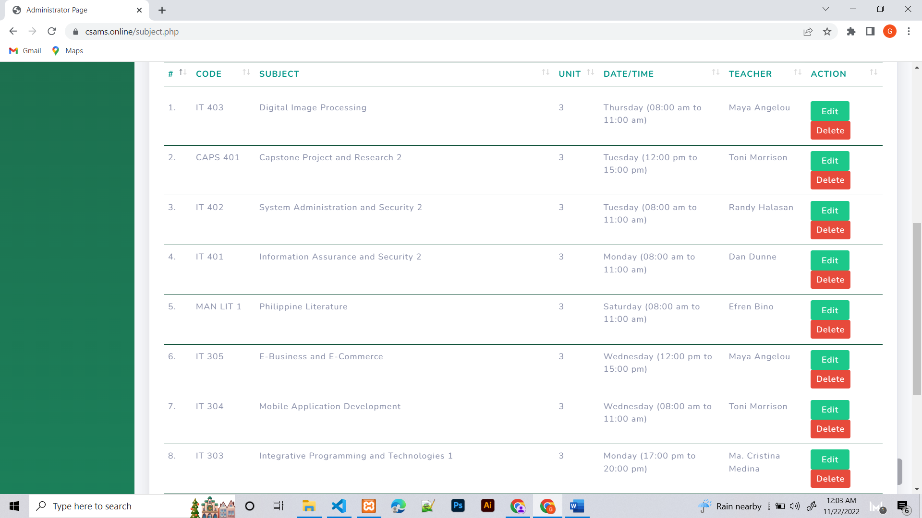

*Figure 71*. List of Subjects with Teacher assigned

Figure 71 shows the assigned/enrolled subjects of the teachers. The administrator can view the subject code, name, units, date/time, and assigned teachers. Furthermore, the administrator can edit or delete subjects directly from this page.

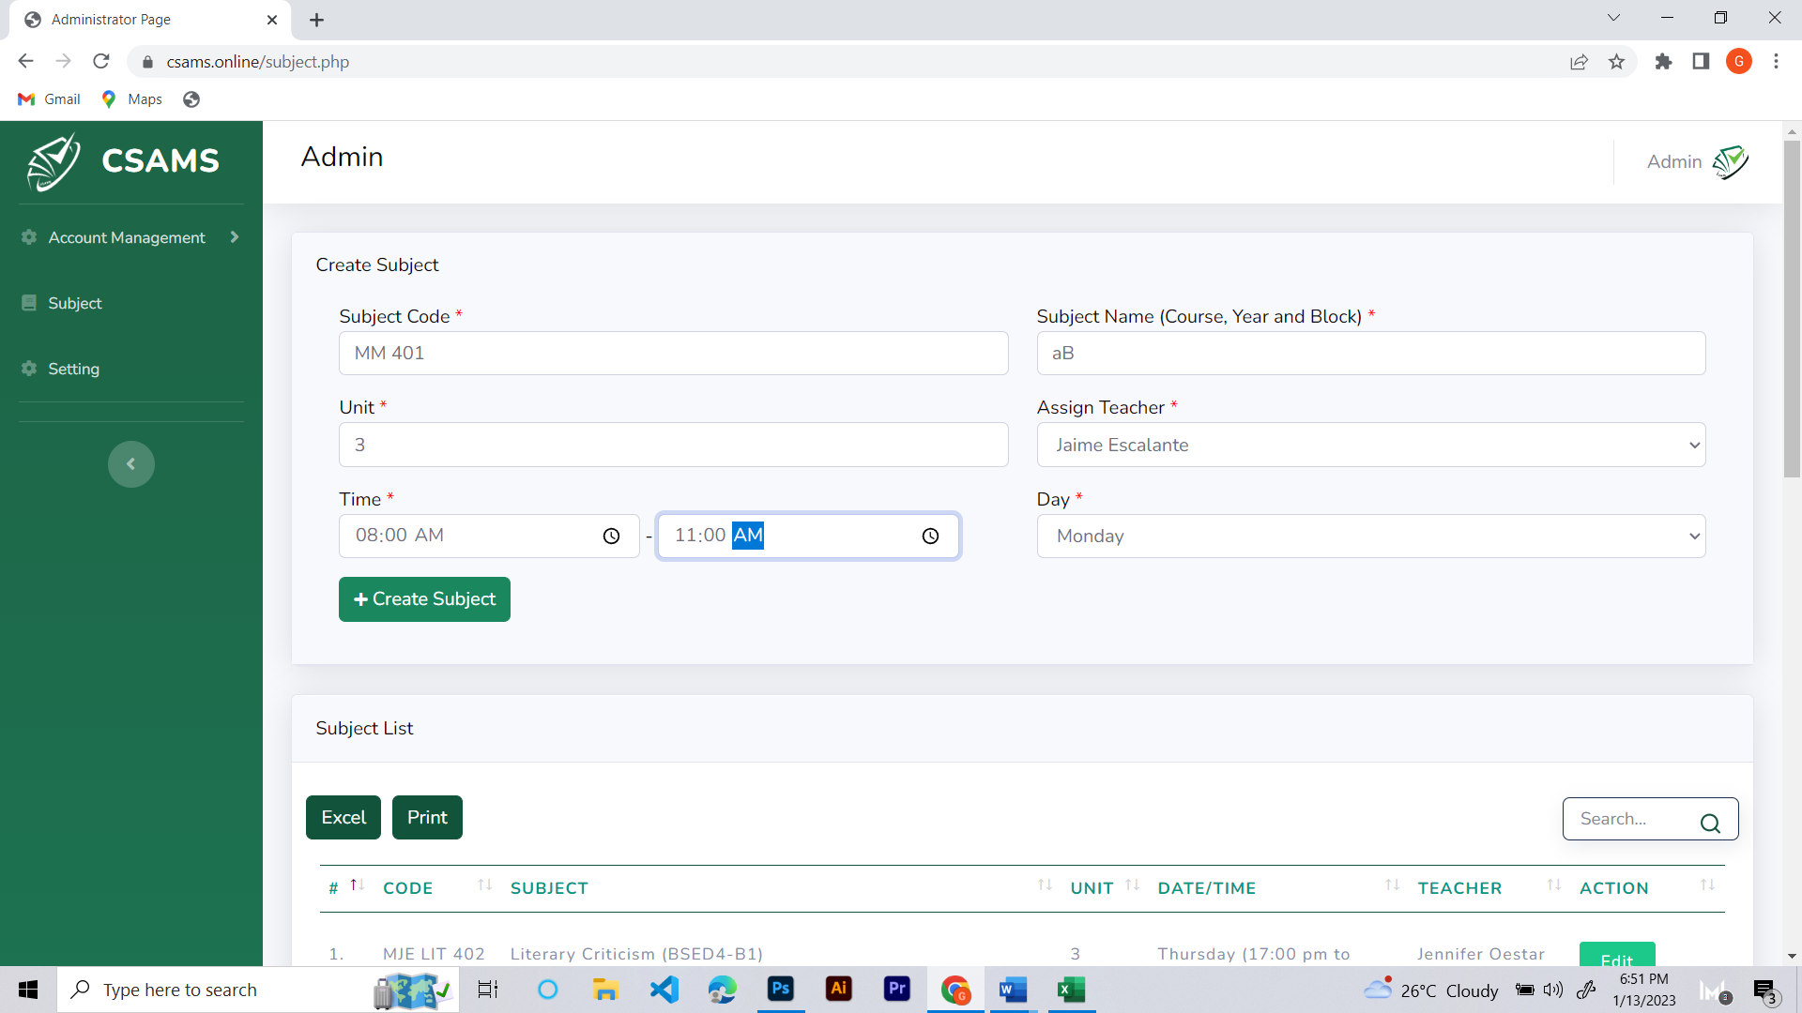

*Figure 72.* Create Subject for Teacher

Figure 72 shows the information required to create a subject for a teacher, including the subject code, units, name, assigned teacher, date/time, and day of the week.

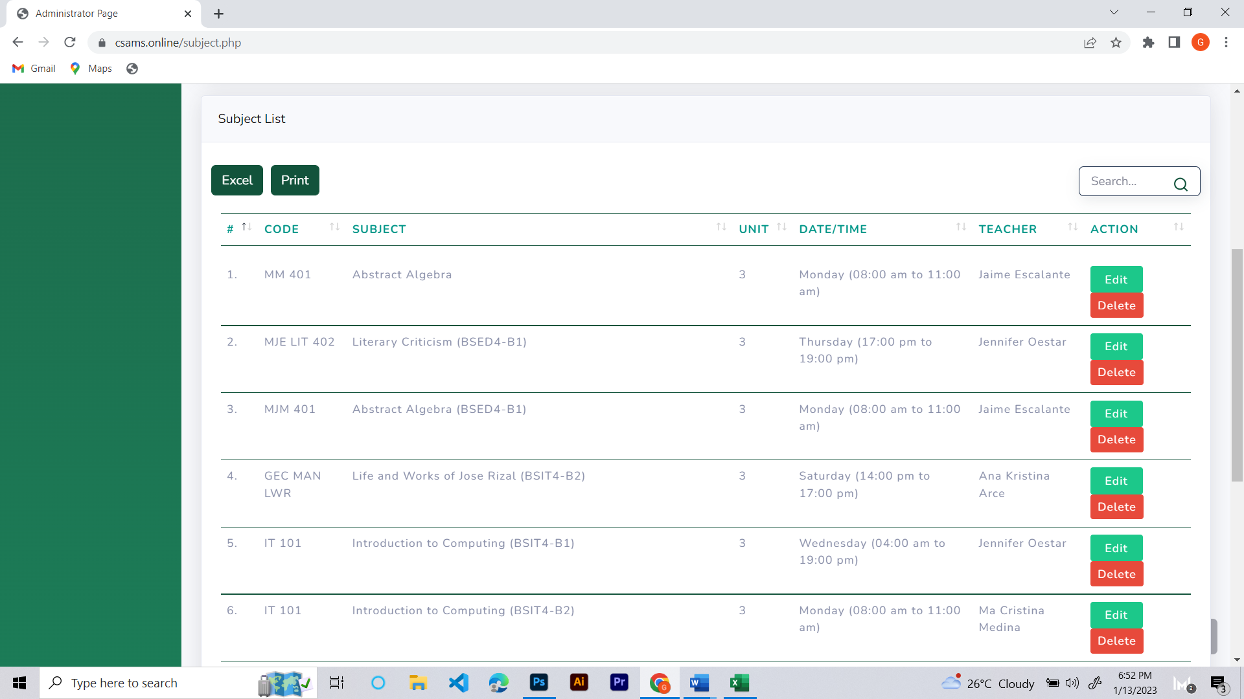

*Figure 73*. Added Subject to Teacher

Figure 73 shows the updated list of a teacher’s subjects, including the subject the administrator has successfully registered.

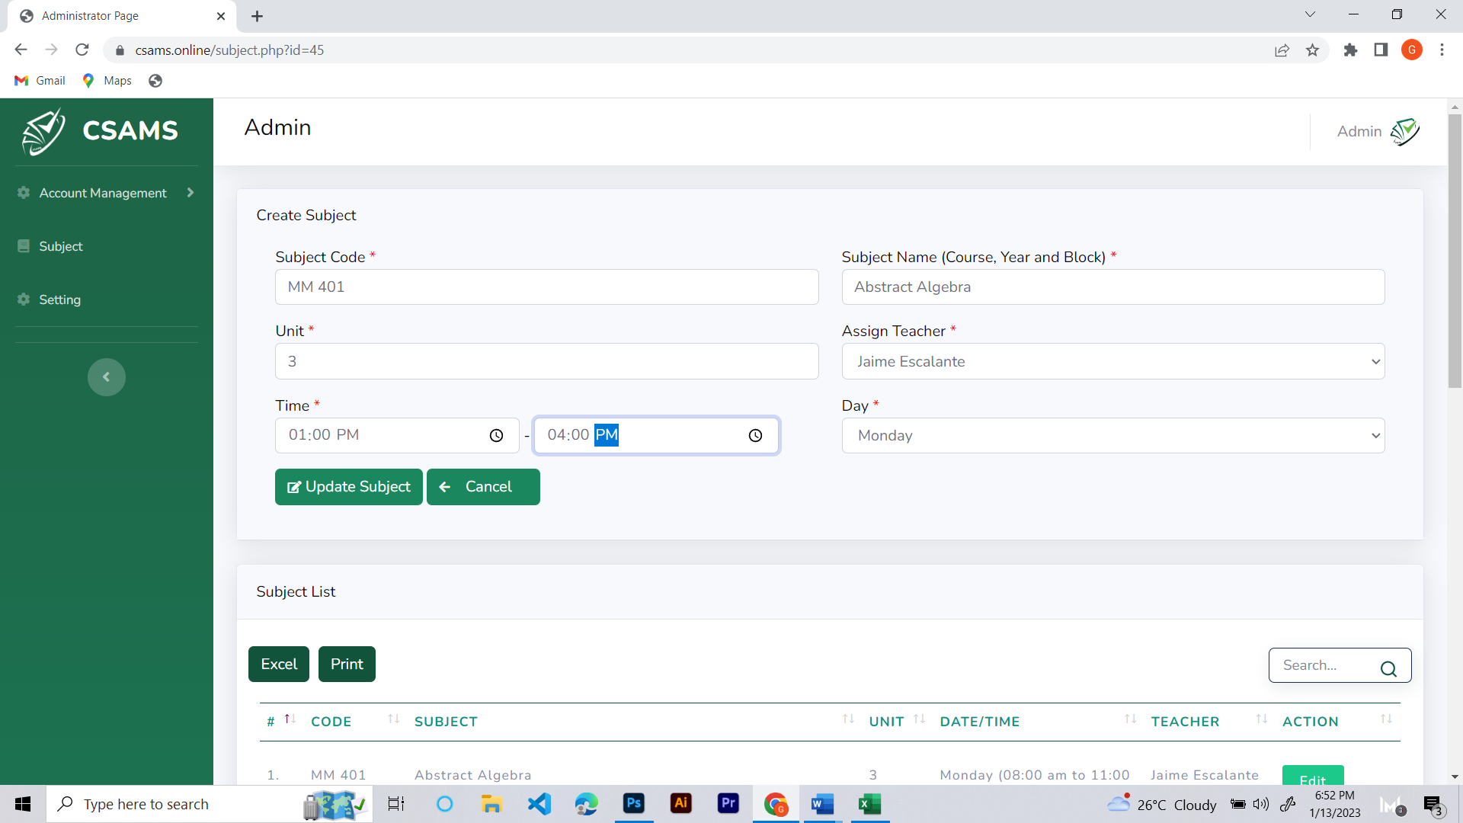

*Figure 74.* Update Teachers Subject Information

Figure 74 shows that the administrator can update the Teachers Subject information.

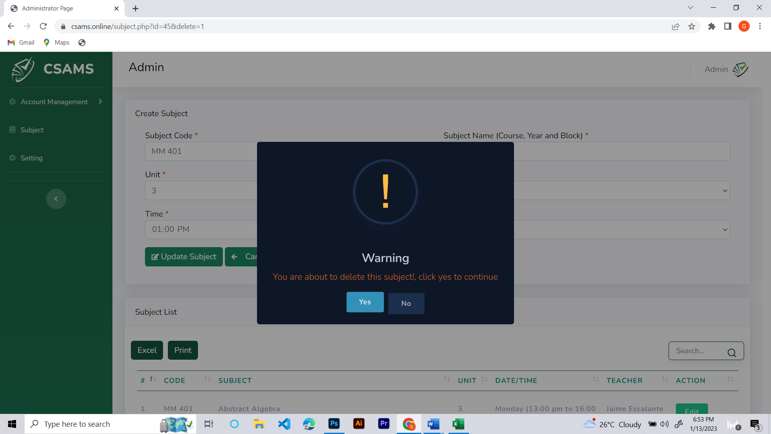

*Figure 75*. Deleting Teachers Subject

Figure 75 shows that there is a need for administrators to confirm the deletion of a subject to the teacher before it is permanently removed.

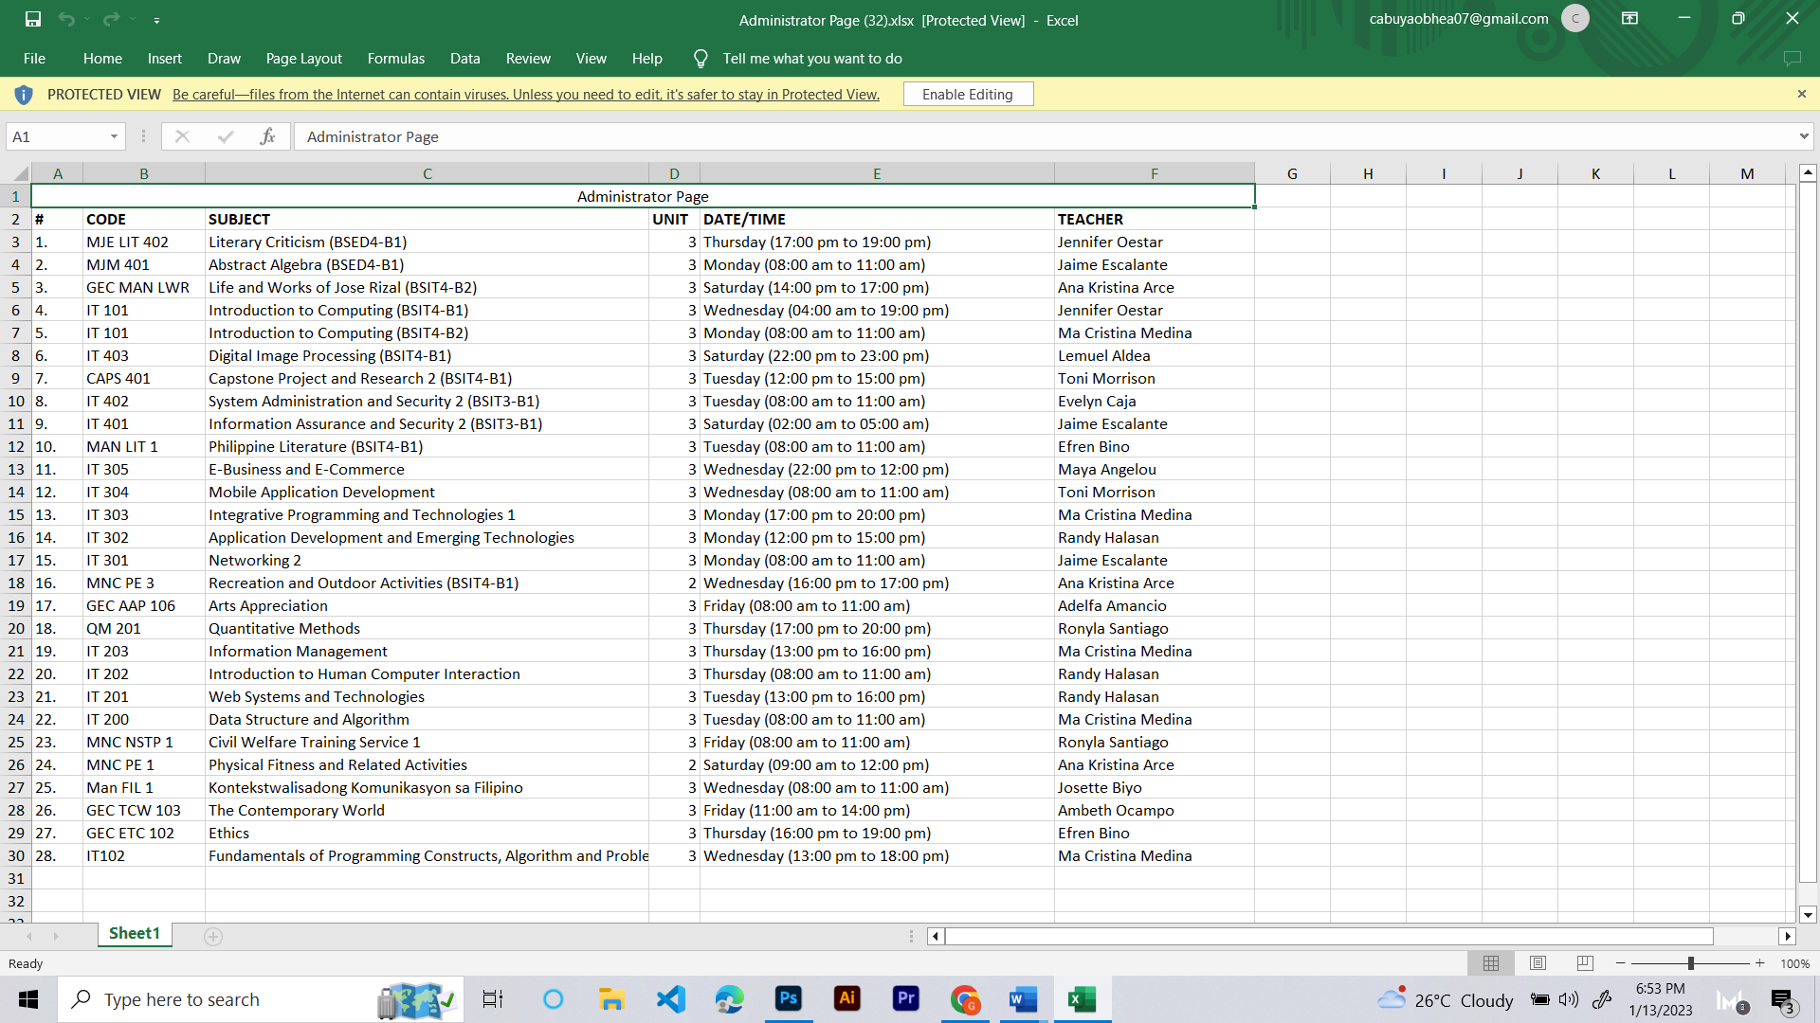

*Figure 76.* Subject (Excel)

Figure 76 shows the list of all subjects assigned to teachers that can be downloaded as an Excel file, providing administrators with an easy accessible record of these subjects.

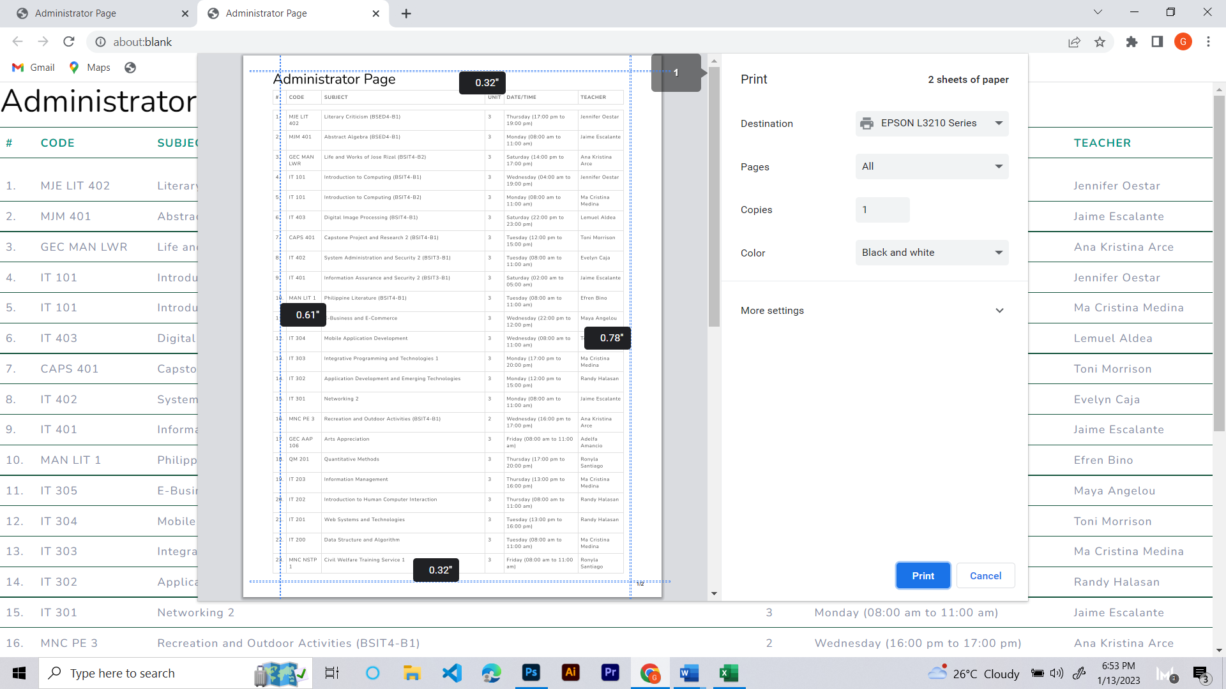

*Figure 77*. Subject (Print)

Figure 77 shows that the administrators can print the list of the teachers subjects for their records or reference.

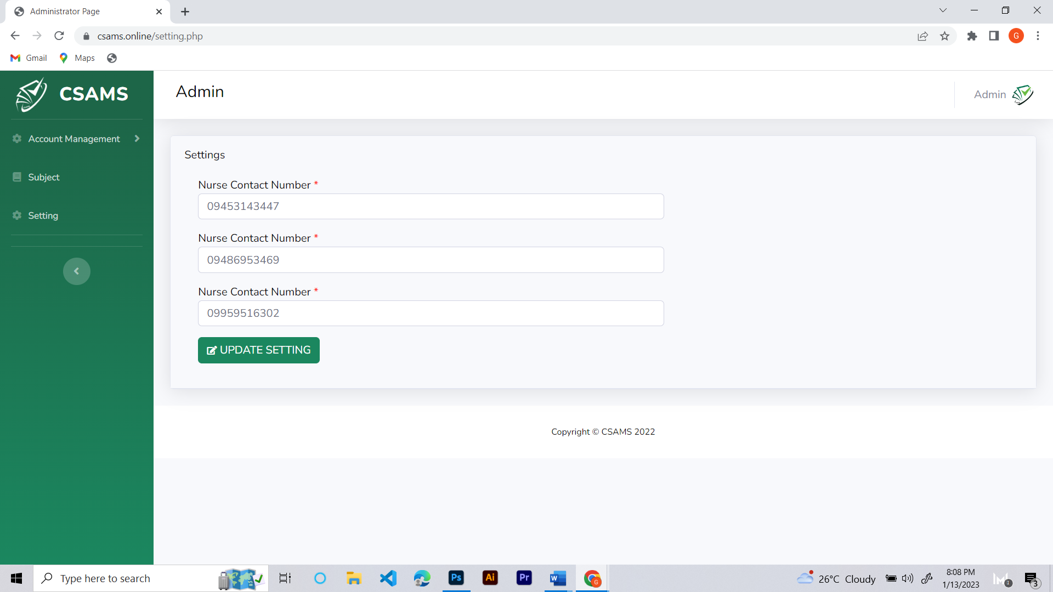

*Figure 78*. Settings

Figure 78 shows the contact numbers of the nurse and guard assigned to respond to probable suspected cases of COVID-19.

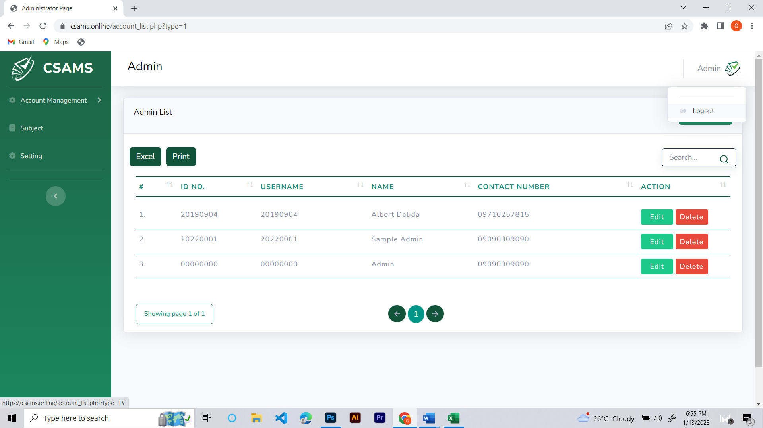

*Figure 79*. Logout

Figure 79 shows administrator can log out of the account by clicking on the Logout button, which can be accessed via a pop-up window that appears upon clicking on the admin icon in the websites upper right corner.

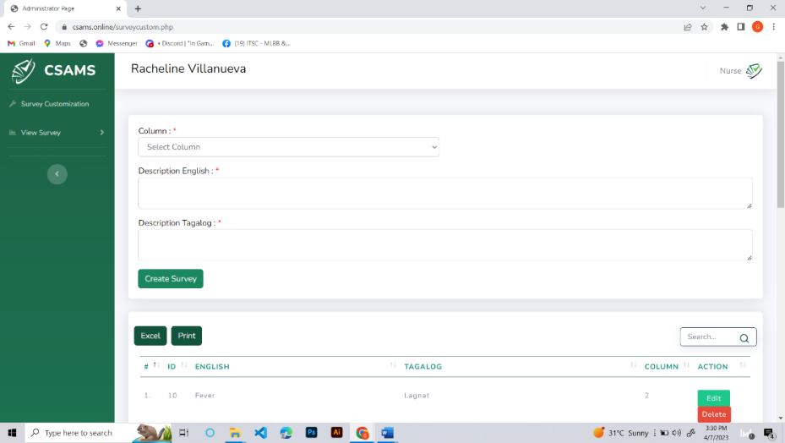

*Figure 80.* Survey Customization (Nurse Account)

Figure 80 shows a customized nurse survey dashboard that incorporates a selectable column feature, which caters to short and long descriptions and provides an English and Tagalog language option, thereby enabling nurses to efficiently and effectively conduct surveys with a diverse range of participants.

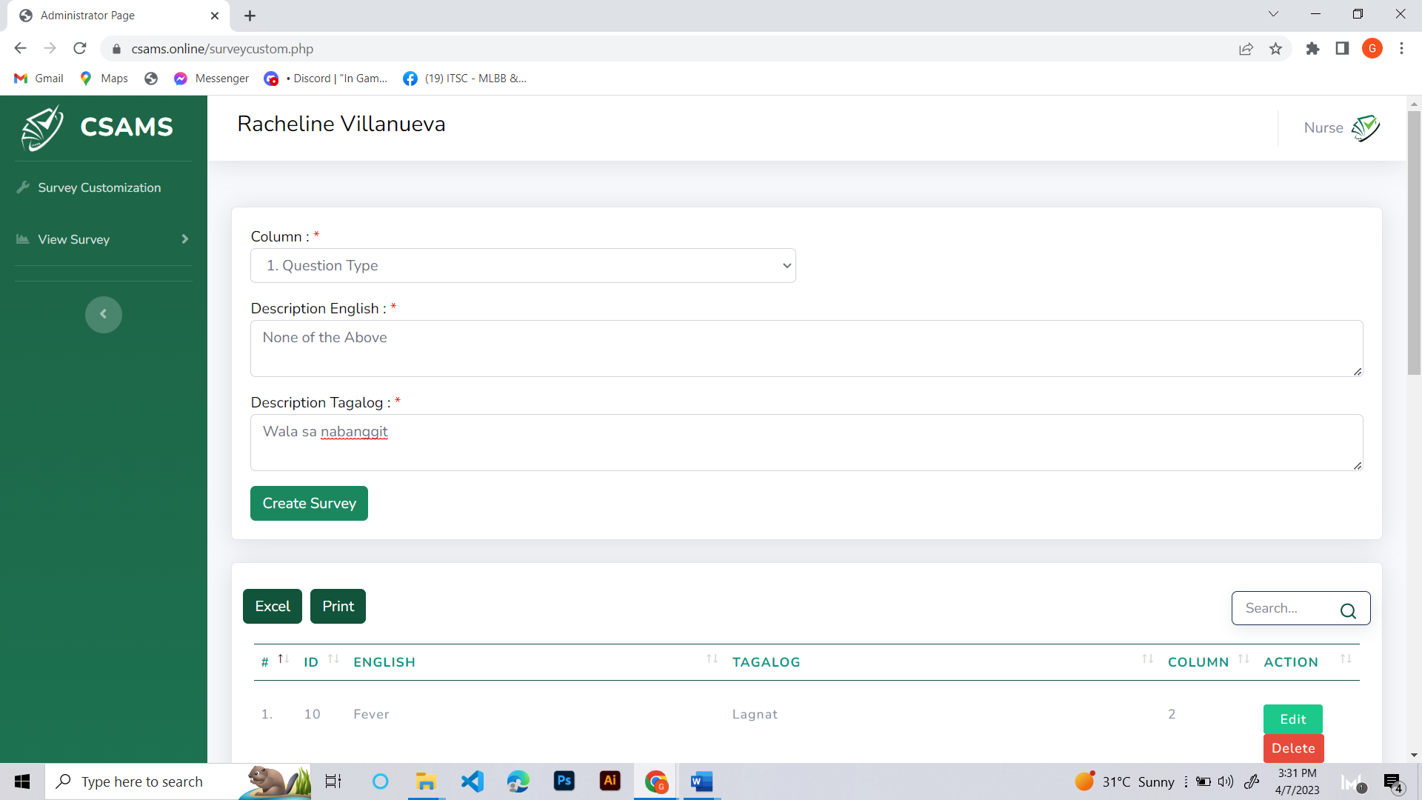

*Figure 81*. Survey Customization (Adding Survey Question)

Figure 81 shows how the nurse can create a survey questionnaire. It also shows an illustrative example provided to depict the process by which a nurse can add survey questions to the table.

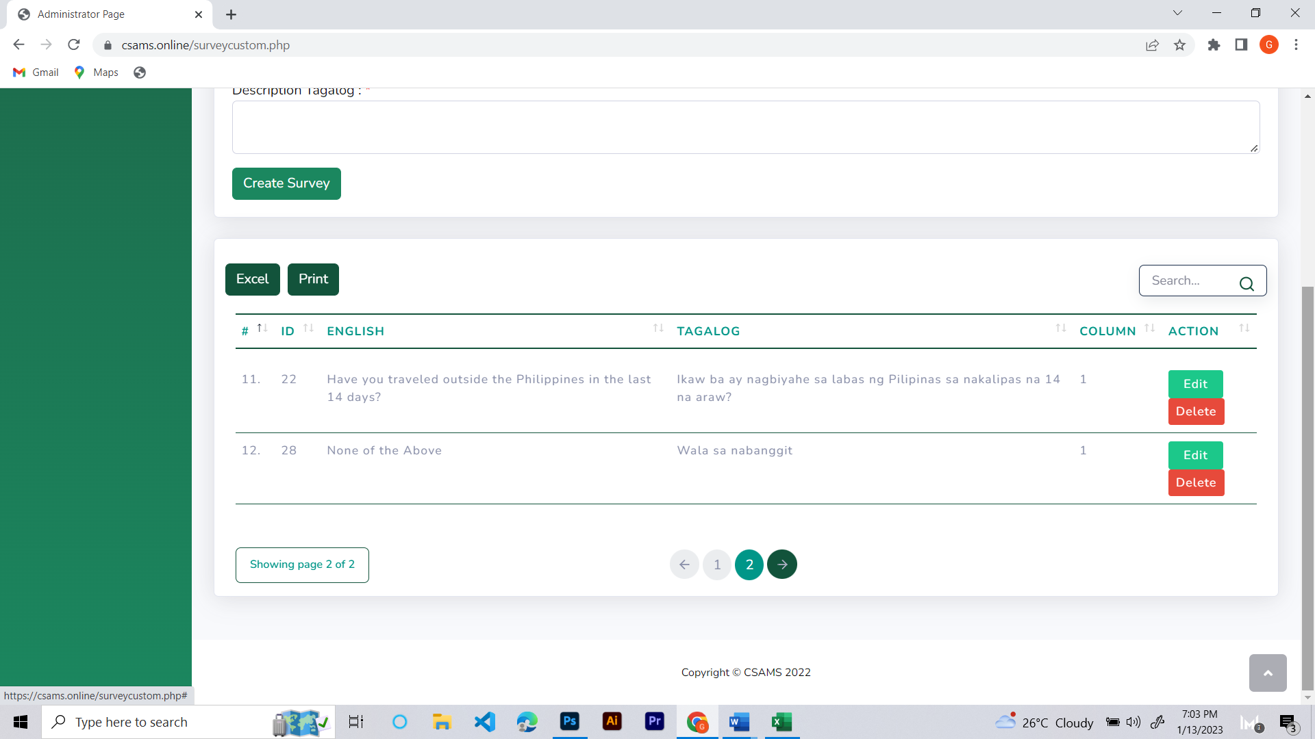

*Figure 82.* Survey Customization (Added Survey Question)

Figure 82 shows the added survey questionnaire after completing the process of adding the survey question.

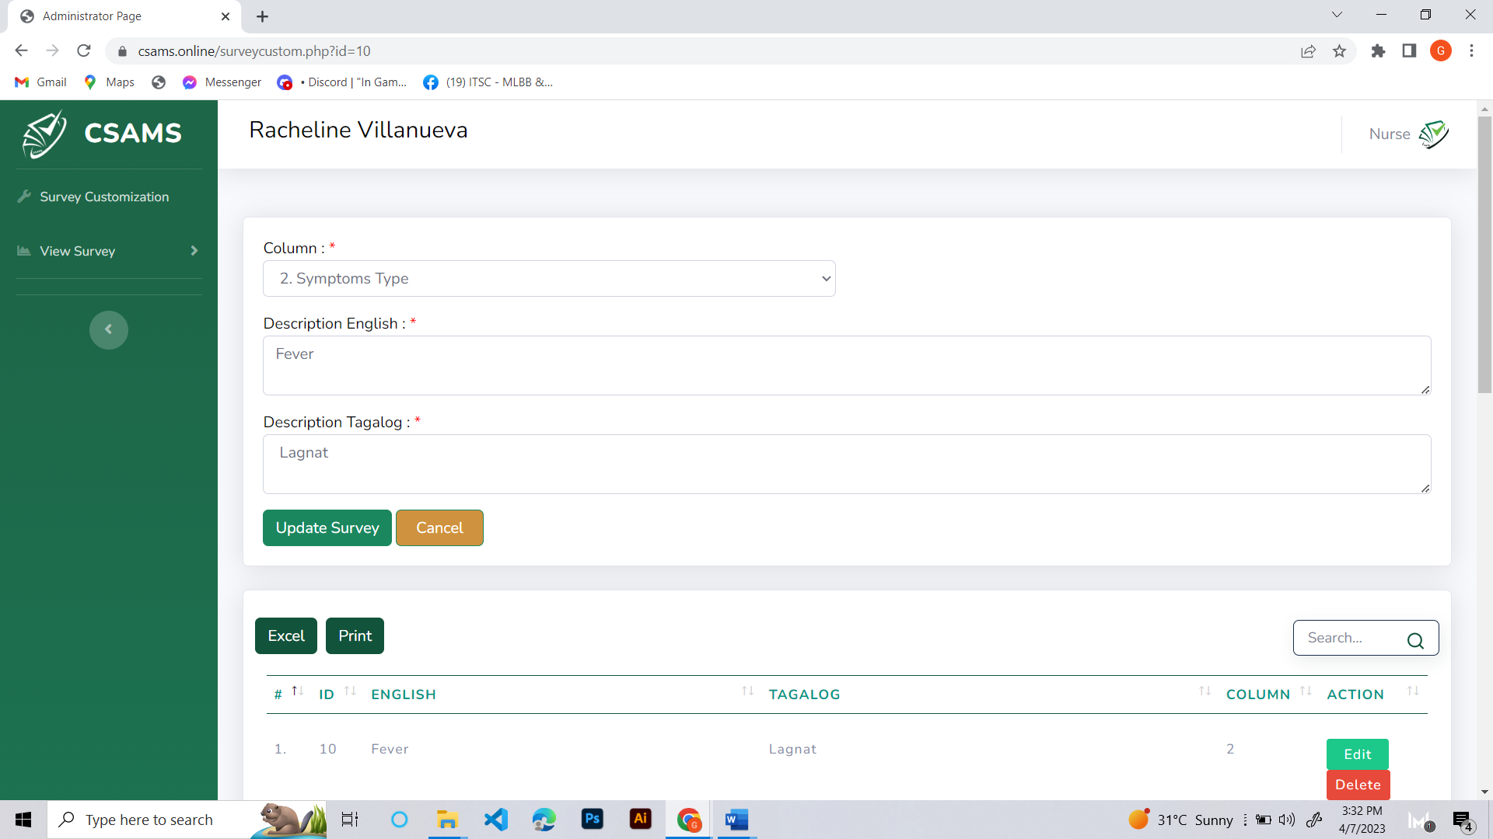

*Figure 83.* Survey Customization (Edit Survey Question)

Figure 83 shows that by clicking the edit button, the nurse can make modifications to the survey questions, which adds a level of flexibility to the survey process and allows for the refinement of questions to better elicit the desired information from survey participants.

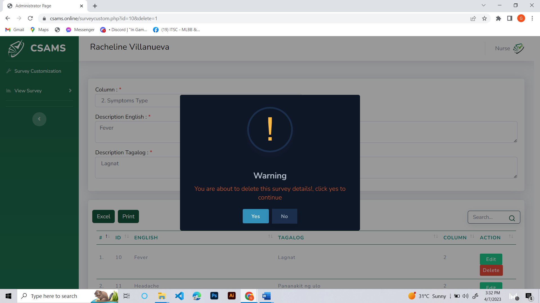

*Figure 84.* Survey Customization (Delete Survey Question)

Figure 84 shows that the nurse can delete survey questions from the survey list table by simply clicking on the delete button, thus removing any redundant or unnecessary questions and streamlining the surveying process.

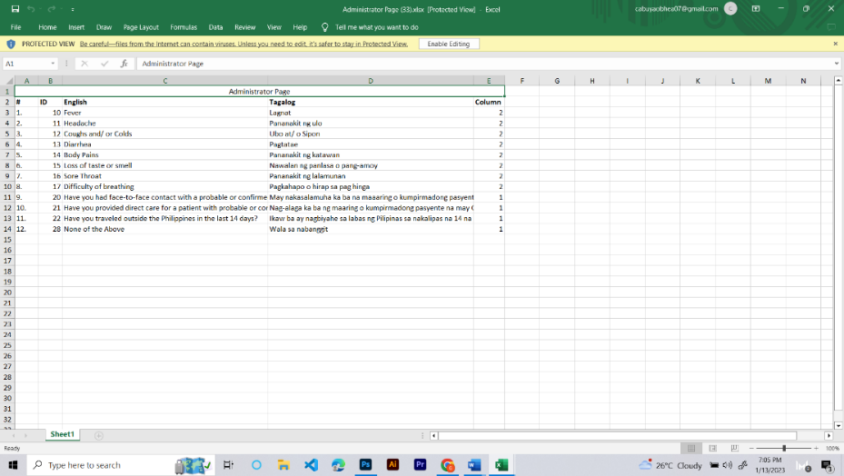

*Figure 85*. Survey Customization (Excel)

Figure 85 shows that all survey list questionnaires can be downloaded as an Excel file to have an accessible record of these survey questions.

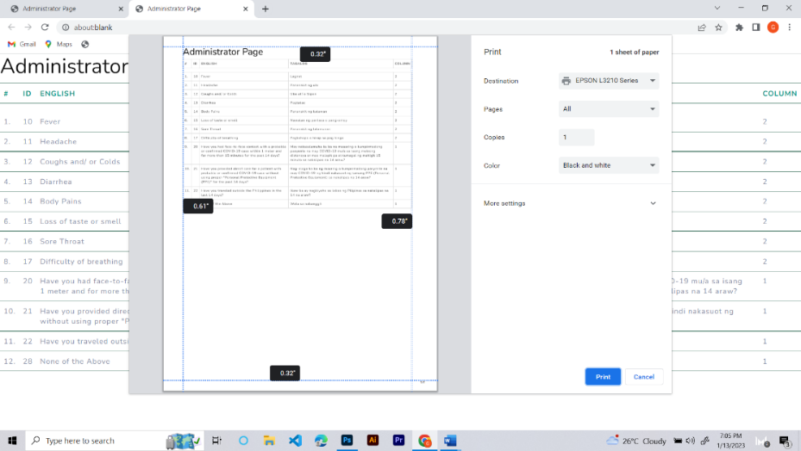

*Figure 86.* Survey Customization (Print)

Figure 86 shows that the survey questions can be easily printed, enabling nurses or other persons to have a physical copy of the questions on hand, ensuring that the questions are readily accessible and can easily be distributed to survey participants.

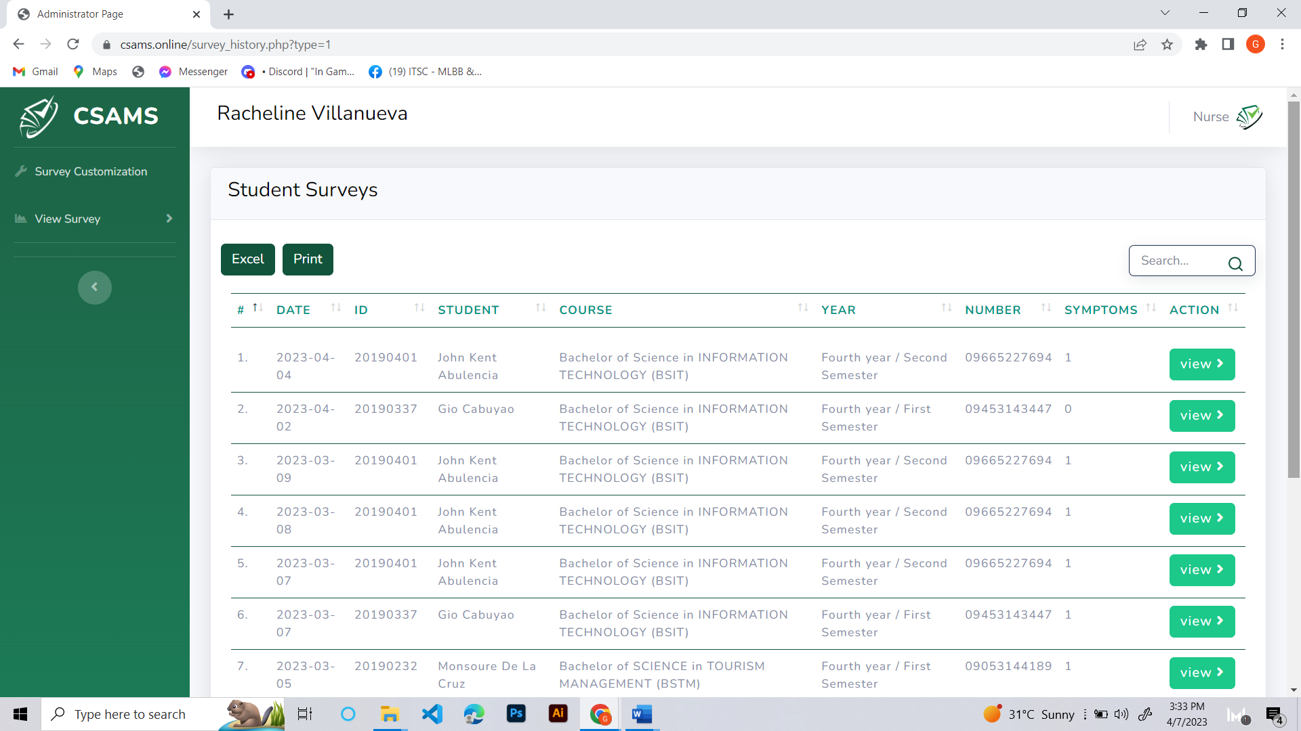

*Figure 87.* Students Survey

Figure 87 shows the list of student’s surveys. It can also view the student survey results, which contain information like date, ID number, student name, course, year, number, and symptoms.

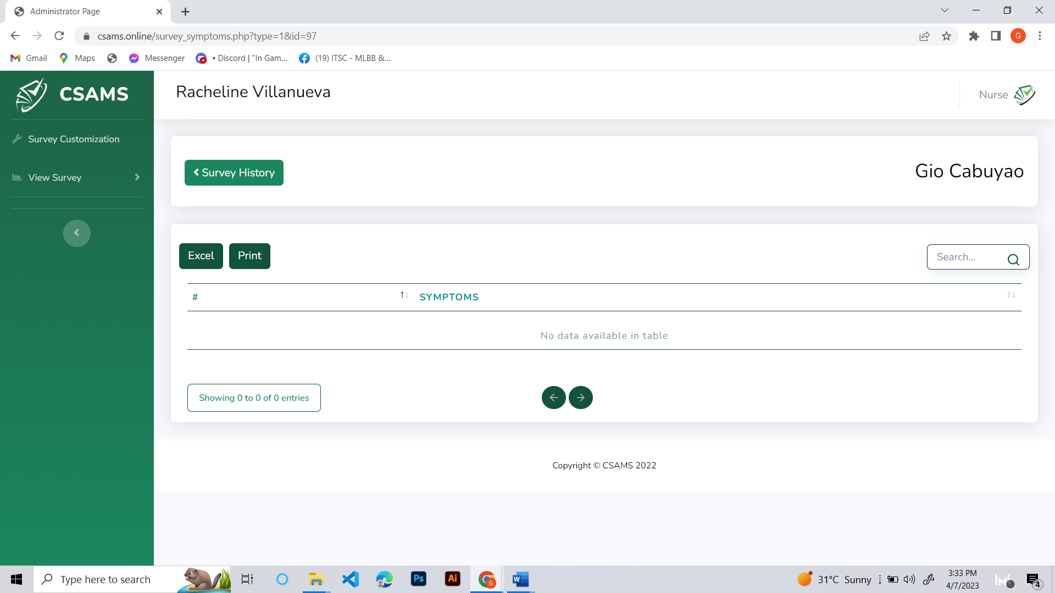

*Figure 88.* View Survey (Student Survey)

Figure 88 shows the nurses can view the answers provided by students in response to the survey questions, which enables nurses to gain a deeper understanding of the specific issues and concerns faced by students while also providing a means to track and monitor changes in student responses over time.

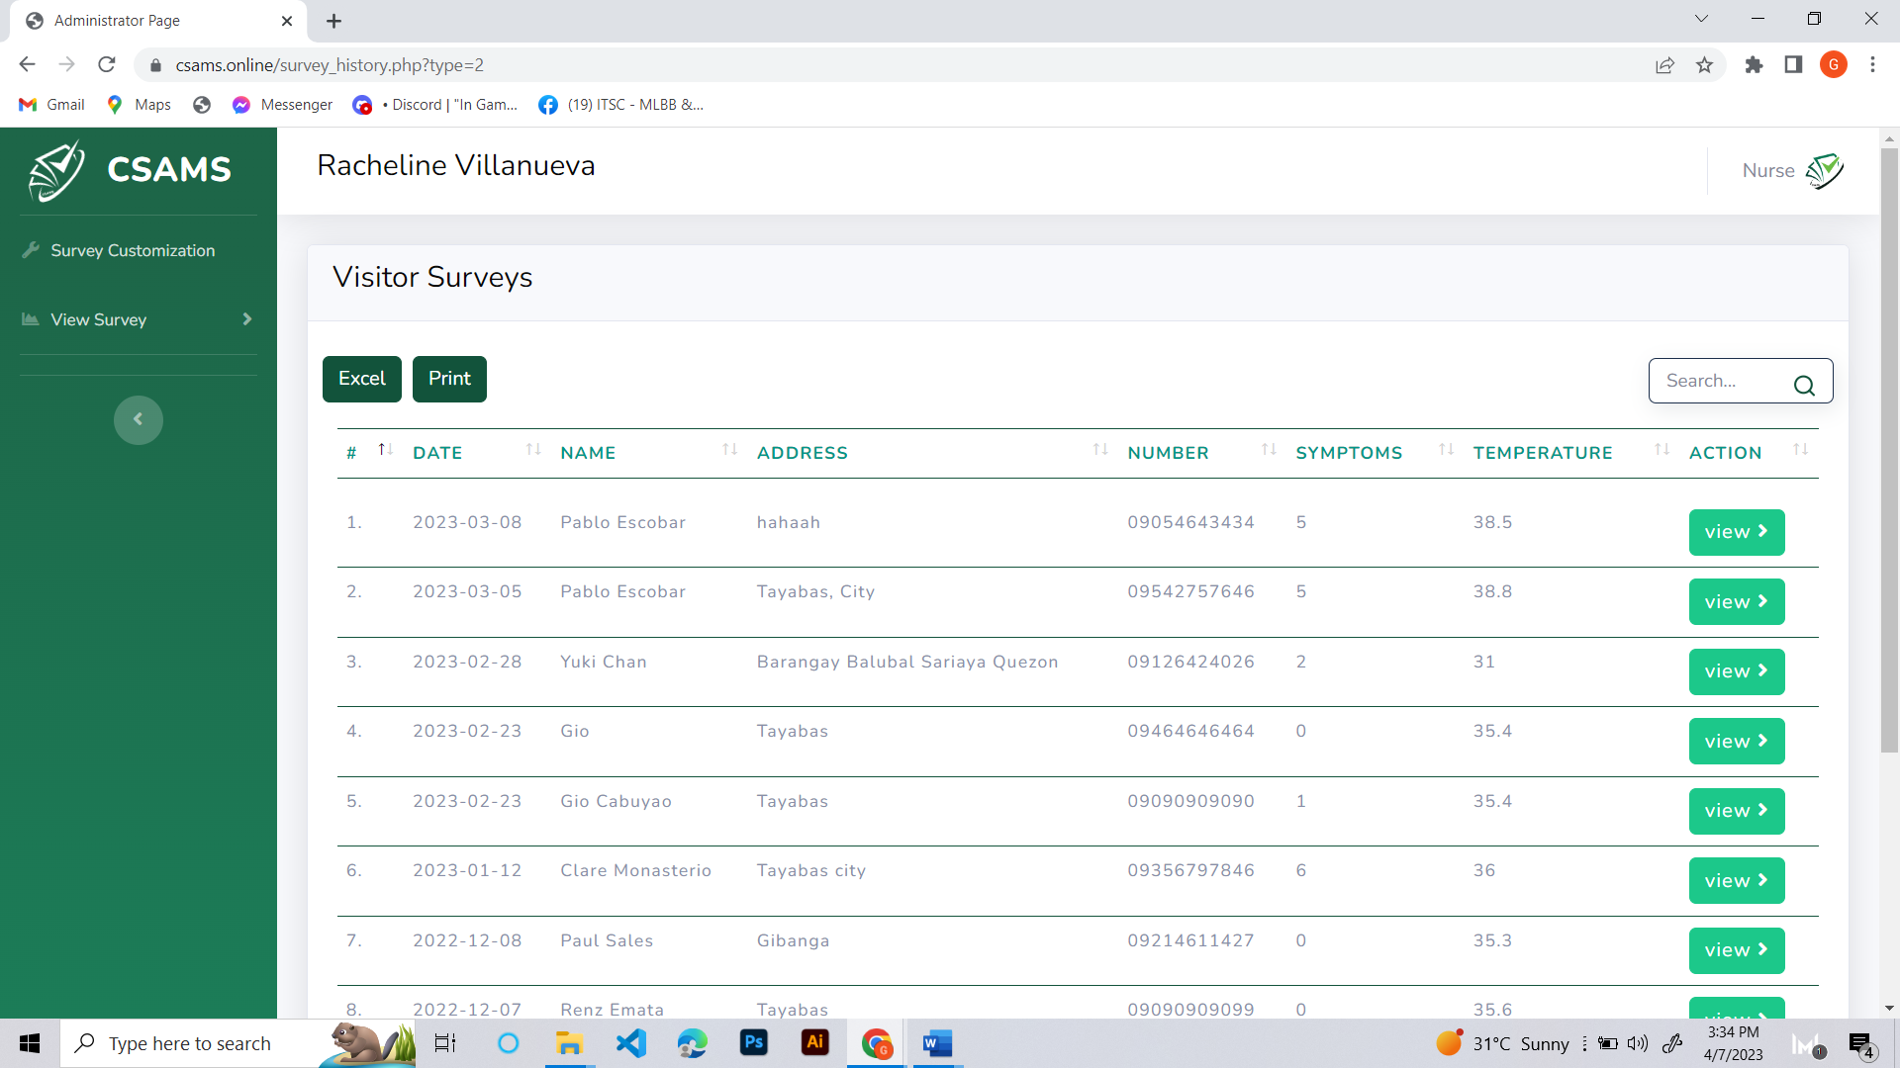

*Figure 89.* View Survey (List of Visitors Survey)

Figure 89 shows that the nurse can view the list of the visitor’s surveys. This list includes information such as the date of the survey, a name, an address, a phone number, symptoms, and a temperature scale. It can also view the survey symptoms by clicking the view button.

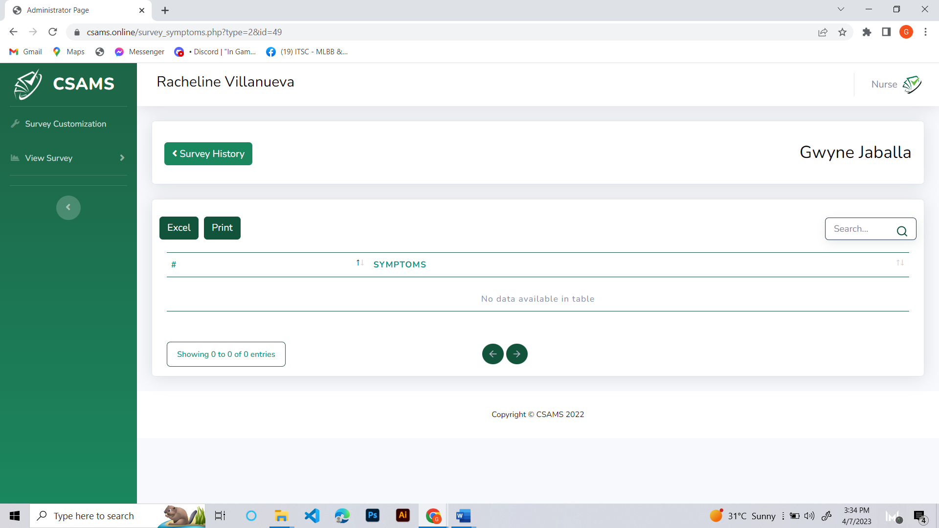

*Figure 90.* View Survey (Visitor Survey)

Figure 90 shows the nurses can view the answers provided by visitors in response to the survey questions, which enables nurses to gain a deeper understanding of the specific issues and concerns faced by students while also providing a means to track and monitor changes in student responses over time.

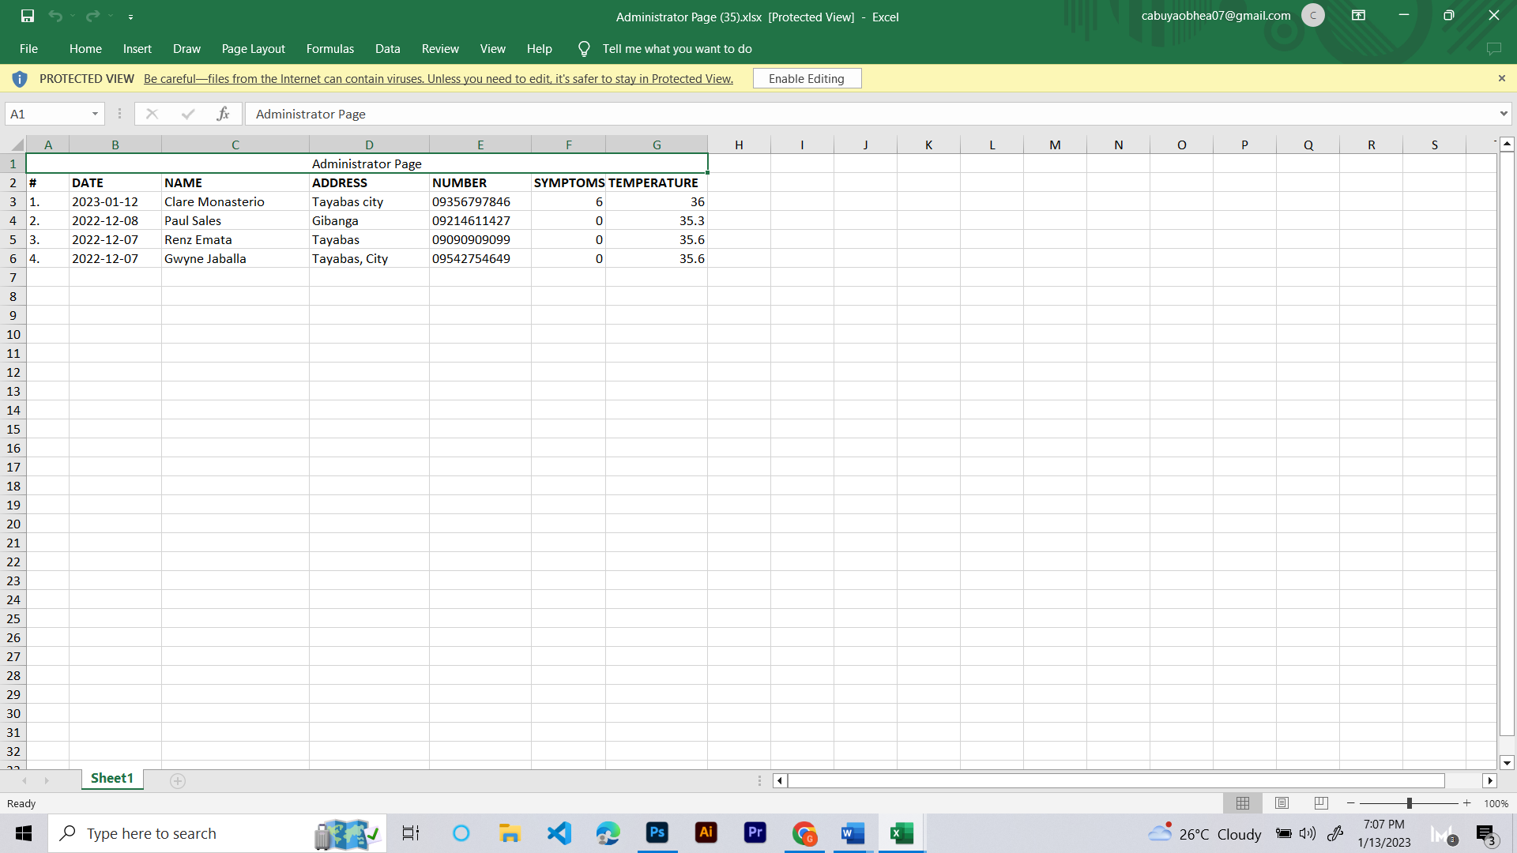

*Figure 91.* Entrants Survey (Excel)

Figure 91 shows that survey list results can be easily downloaded in an Excel file, which enables the data to be exported and analyzed using spreadsheet software.

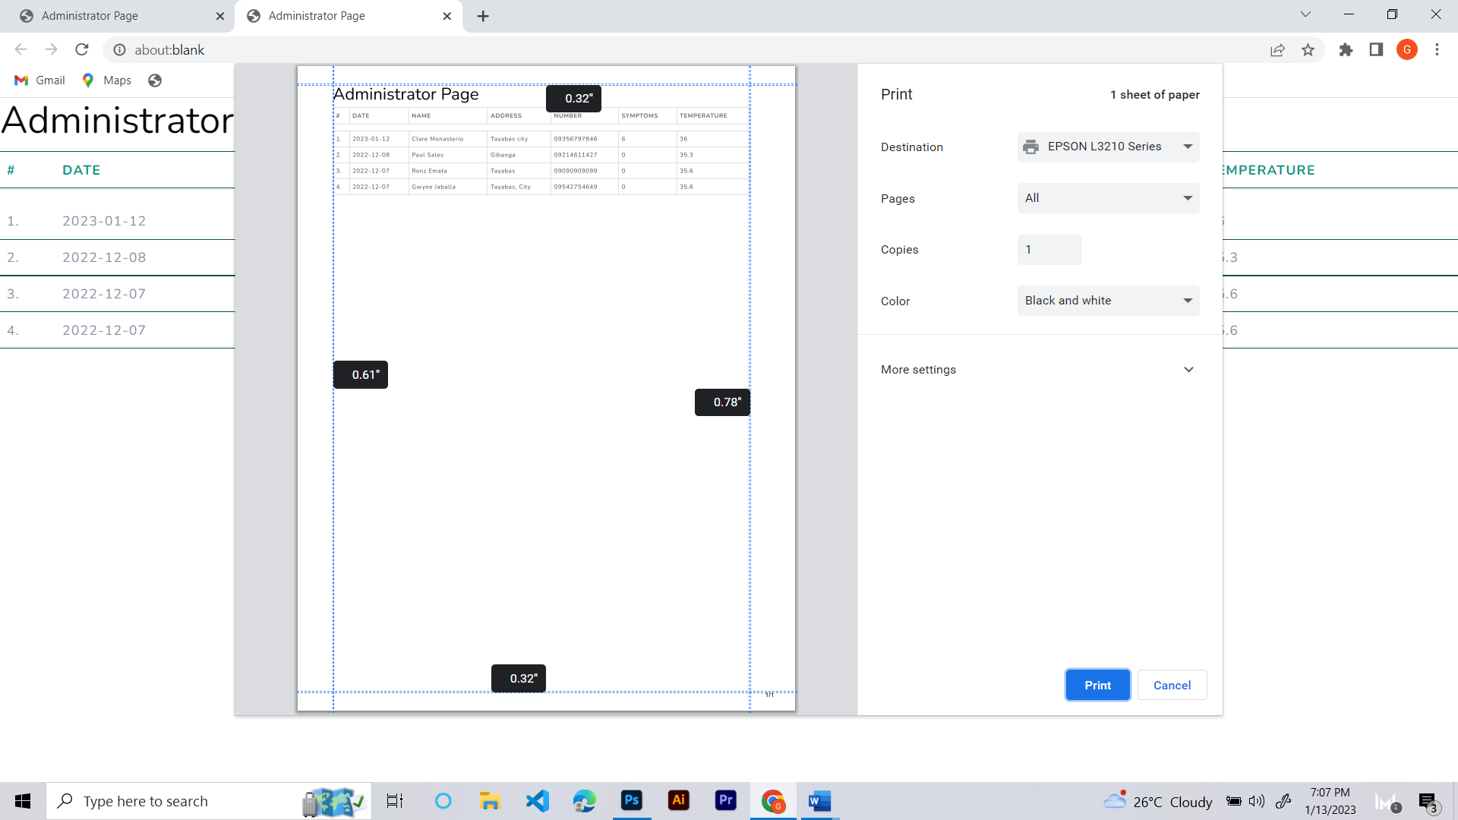

*Figure 92.* Entrants Survey (Print)

Figure 92 shows the ability to print the visitors survey, which provides a physical copy of the survey questions and enables the survey to be conducted in person.

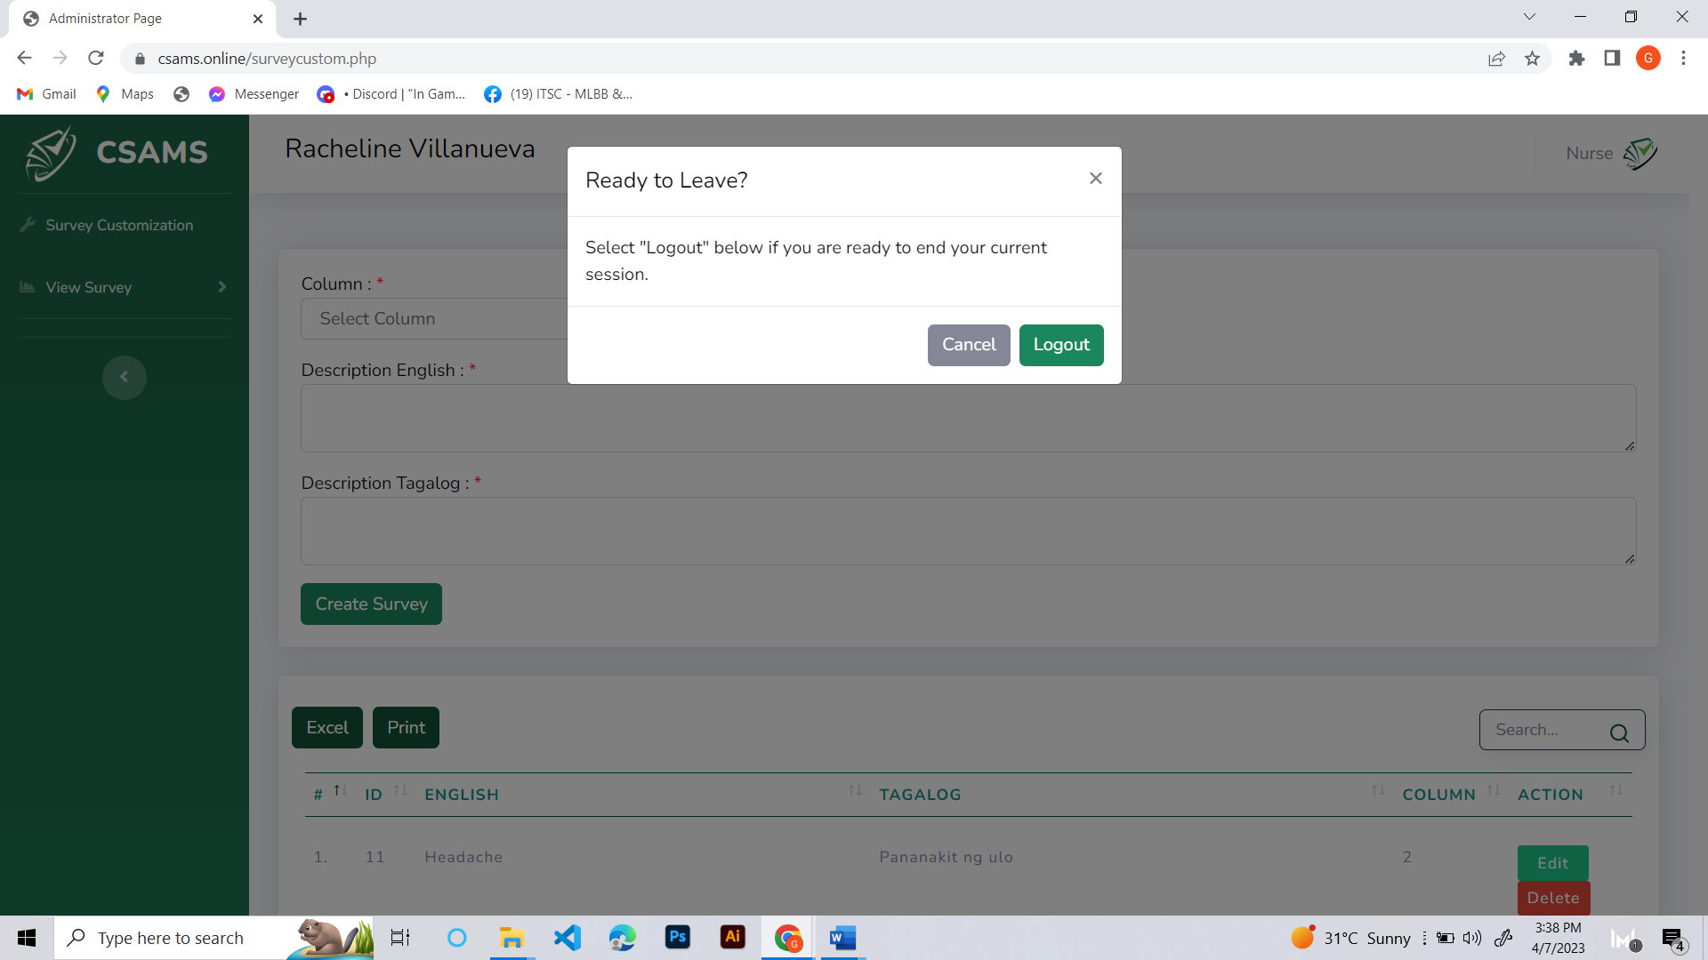

*Figure 93.* Logout

Figure 93 shows nurses can log out of their accounts by clicking on the Logout button, which can be accessed via a pop-up window that appears upon clicking on the upper right corner of the developed web system.

**3.7 Testing and Evaluation**

**3.7.1 Test Plan**

In order to attain the goal to convey a well-functioning web-based application, a Test plan is produced which is equipped for adjusting to the changing necessities of the product advancement venture the testing procedure incorporates Unit Testing, Integration Testing, System Testing, and Functional Testing.

The following shows the paradigm of Agile Testing Methodology for CSAMS: Web-based Attendance Monitoring System with Contact Tracing

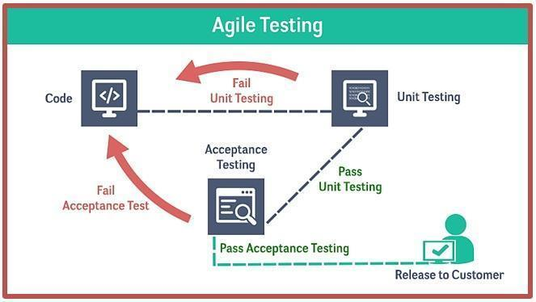

*Figure* 94. Agile Testing Methodology

**Unit Testing.** Unit testing guarantees that software components work as expected, and unit testing evaluates each part of the software independently. The database connection must be tested to ensure it works properly and that data is stored and retrieved correctly. Check whether the QR Code generator generates the correct QR code for the given data by examining the QR code it generates. The researcher also checks to ensure that an SMS notification service receives SMS notifications on the registered phone number.

**Integration Testing.**The integration testing verifies different software modules work together as expected. In the integration testing, the researchers test that attendance data is correctly recorded in the database when students scan their QR codes. Also, testing the contact tracing system can identify students who have come into contact with an infected student. The notification system will be reviewed to ensure that SMS notifications can be sent to all affected students, nurses, and guards via the notification service.

**System Testing.** After the integration testing, system testing verifies that the system meets the requirements and works as expected in a real-world environment. This test will see if the system can handle a large number of students by simultaneous scanning of QR codes. Test that the contact tracing system can accurately identify potential contacts and generate reports for health authorities. Test that the notification service to which it can handle a high volume of SMS notifications without delays or failures.

**Functional Testing.** Functional testing verifies that the system meets applicable requirements. Ensuring college students can scan QR codes to record their attendance using the QR code scanner. Test that faculty members can view attendance records and generate reports. Additionally, the researchers ensure that the contact tracing system can identify potential contacts based on their declared symptoms and the date and time of declaration to which the suspected student or visitor entered the school premises.

**Acceptance Testing.** Acceptance testing verifies that the system meets the target users requirements and is ready for deployment. Test and review whether the system meets the requirements specified in the project scope and user stories. The researchers test whether the system is easy to use and understand by students and faculty. Ensuring the system is stable and reliable, with minimal bugs or issues during testing. Continuous feedback will be received to ensure the system constantly improves and meets the users needs.

3.7.2 Test Case Document

The following shows an example of a Test Case Document that will be used in testing the developed web-based system in CSTC Sariaya, Quezon.

Table. 17

|  |  |  |  |  |  |  |
| --- | --- | --- | --- | --- | --- | --- |
| **TEST CASE**  CSAMS: A Web-based Attendance Monitoring System with Contact Tracing and Notification via SMS using QR Code for CSTC College of Sciences, Technology and Communications, Inc. | | | | | | |
| **Test Case #** | | 1 | **Test Case Name** | Admin Dashboard | | **Page: 1 of**  **5** |
| **System** | | CSAMS  Web system | **Subsystem** | Module 1 | |  |
| **Designed by** | | John Kent A. Abulencia | **Designed Date:** |  | |  |
| **Executed by** | |  | **Execution Date** |  | |  |
| **Short Description** | | Test the partial process of Web-based system |  |  | |  |
| **Pre-condition:**   1. The user has already opened the web-based system. 2. The user already talked about how to use the application. | | | | | | |
| **Step** | **Action** | | **Expected System Output** | | **Pass/Fail** | **Remarks** |
| 1 | Input Admin Account Username and Password | | It will be logged into their account | |  |  |
| 2 | Click the Account Management | | It will appear in the Admin, Student and Teacher. | |  |  |
| **Step** | **Action** | | **Expected System Output** | | **Pass/Fail** | **Remarks** |
| 3 | Click the Admin | | It will appear admin list and their details. | |  |  |
| 4 | Click Add Admin Button | | It will appear the admin needed details. | |  |  |
| 5 | Click Create Account | | It will create the account and it will appear in the admin list | |  |  |
| 6 | Click Edit and Delete Button | | It will show the edit form and in the delete button it will delete the admin in the list | |  |  |
| 7 | Click Update Account | | It will update the new information created by the user | |  |  |
| 8 | Click the Student | | It will show the students account list. | |  |  |
| 9 | Click Add Student | | It will appear the student needed details. | |  |  |
| 10 | Click Edit and Delete  Button | | It will appear the users account information. | |  |  |
| 11 | Click Edit Button | | The users new information will be updated. | |  |  |
| 12 | Click View Button in the Subject | | It will appear the subjects of the users. | |  |  |
| 13 | Select Subject | | Shows the subject lists. | |  |  |
| 14 | Click Add subjects Button | | It will add the subjects to the users. | |  |  |
| 15 | Click Teacher | | It will show the list of Teachers. | |  |  |
| 16 | Click Add Teacher | | It will show the needed information of the users. | |  |  |
| 17 | Click Create Account | | The user will be created and it will appear in the Teacher List. | |  |  |
| 18 | Click Edit Button | | It will show the user information | |  |  |
| **Step** | **Action** | | **Expected System Output** | | **Pass/Fail** | **Remarks** |
| 19 | Click Update Button | | It will Update the teachers account. | |  |  |
| 20 | Click Add Nurse | | It will show the needed information of the users. | |  |  |
| 21 | Click Create Account | | The user will be created and it will appear in Nurse List. | |  |  |
| 22 | Click Edit Button | | It will show the user information. | |  |  |
| 23 | Click Update Button | | It will Update the Nurse account. | |  |  |
| 24 | Click Subject | | It will appear the subject lists. | |  |  |
| 25 | Create Subject | | It shows the needed details of subject like subject code, subject name, unit, assign teacher, time and day. | |  |  |
| 26 | Click Create Subject | | It will create the subject and appear in the subject list. | |  |  |
| 27 | Click Edit Button | | It will show the subject information. | |  |  |
| 28 | Click Update Subject Button | | It will update the subject information | |  |  |
| 29 | Click Delete Button | | It will delete the subject. | |  |  |
| 30 | Click Setting | | It will show the contact number of the Admin, Nurse, and Guard to notify them for a precautionary measure. | |  |  |
| 31 | Click Update Settings | | You can change the number of the Nurses and Guard. | |  |  |
| 32 | Click Excel and Print | | It will show the Print page and in Excel, it will automatically download the list of every specific user. | |  |  |
| **Step** | **Action** | | **Expected System Output** | | **Pass/Fail** | **Remarks** |
| 33 | Click Admin in the upper  right corner | | It shows the logout button. | |  |  |
| 34 | Click Logout | | It will logout the users. | |  |  |
| **Post-condition:**   1. The options and features will launch and execute properly. 2. Tapping a particular option will launch them. | | | | | | |

Table 18

|  |  |  |  |  |  |  |
| --- | --- | --- | --- | --- | --- | --- |
| **TEST CASE**  CSAMS: A Web-based Attendance Monitoring System with Contact Tracing and Notification via SMS using QR Code for CSTC College of Sciences, Technology and Communications, Inc. | | | | | | |
| **Test Case #** | | 2 | **Test Case Name** | Visitor | | **Page: 2 of**  **5** |
| **System** | | CSAMS  Web system | **Subsystem** | Module 2 | |  |
| **Designed by** | | John Kent A. Abulencia | **Designed Date:** |  | |  |
| **Executed by** | |  | **Execution Date** |  | |  |
| **Short Description** | | Test the partial process of Web-based system |  |  | |  |
| **Pre-condition:**   1. The user has already opened the web-based system. 2. The user already talked about how to use the application. | | | | | | |
| **Step** | **Action** | | **Expected System Output** | | **Pass/Fail** | **Remarks** |
| 1 | Click I am a Visitor. | | It will appear the Identification Form. | |  |  |
| 2 | Click the Terms and Condition. | | It will show the terms and conditions of CSAMS. | |  |  |
| 3 | Fill out the Identificatin Form. | | Fill out the Identification Form. | |  |  |
| 4 | Click the Submit Button. | | It will then proceed to the Survey Form. | |  |  |
| 5 | Fill out the Survey Form | | It will accept answer input using the radio button. | |  |  |
| 6 | Click again the Submit Button | | It will appear your Permission Pass to enter the school. | |  |  |
| **Post-condition:**   1. The options and features will launch and execute properly. 2. Tapping a particular option will launch them. | | | | | | |

Table 19.

|  |  |  |  |  |  |  |
| --- | --- | --- | --- | --- | --- | --- |
| **TEST CASE**  CSAMS: A Web-based Attendance Monitoring System with Contact Tracing and Notification via SMS using QR Code for CSTC College of Sciences, Technology and Communications, Inc. | | | | | | |
| **Test Case #** | | 3 | **Test Case Name** | Student Dashboard | | **Page: 3 of**  **5** |
| **System** | | CSAMS  Web system | **Subsystem** | Module 3 | |  |
| **Designed by** | | John Kent A. Abulencia | **Designed Date:** |  | |  |
| **Executed by** | |  | **Execution Date** |  | |  |
| **Short Description** | | Test the partial process of Web-based system |  |  | |  |
| **Pre-condition:**   1. The user has already opened the web-based system. 2. The user already talked about how to use the application. | | | | | | |
| **Step** | **Action** | | **Expected System Output** | | **Pass/Fail** | **Remarks** |
| 1 | Input the username and password. | | It will log in and go to Survey Form. | |  |  |
| 2 | The student declares their status in survey form. | | It will accept the student’s input. | |  |  |
| 3 | Click Continue Button | | It will proceed to the student dashboard. | |  |  |
| 4 | Click Class Today | | It will appear the scan QR code. | |  |  |
| 5 | Click Scan QR code | | It will show the Request Camera Permissions and Scan an Image File | |  |  |
| 6 | Click Request Camera Permissions | | It will request your camera to open and it will appear the start scanning. | |  |  |
| 7 | Click Start Scanning | | It will start the camera and ready for scanning. | |  |  |
| 8 | Click Scan QR Code for Attendance | | It will appear the request access camera. | |  |  |
| **Step** | **Action** | | **Expected System Output** | | **Pass/Fail** | **Remarks** |
| 9 | Scanning QR Code | | It will be scanned and take attendance. | |  |  |
| 10 | Click Scan an Image File | | It will let you choose in your file for the downloaded QR code. | |  |  |
| 11 | Click My Profile | | It will appear the user information and the user subject lists. | |  |  |
| 12 | Users Edit Button | | It shows the user information | |  |  |
| 13 | Click Update Button | | It will update the new information of the student. | |  |  |
| 14 | Click Attendance History | | It will show the users attendance history. | |  |  |
| **Post-condition:**   1. The options and features will launch and execute properly. 2. Tapping a particular option will launch them. | | | | | | |

Table 20.

|  |  |  |  |  |  |  |
| --- | --- | --- | --- | --- | --- | --- |
| **TEST CASE**  CSAMS: A Web-based Attendance Monitoring System with Contact Tracing and Notification via SMS using QR Code for CSTC College of Sciences, Technology and Communications, Inc. | | | | | | |
| **Test Case #** | | 4 | **Test Case Name** | Teacher Dashboard | | **Page: 4 of**  **5** |
| **System** | | CSAMS  Web system | **Subsystem** | Module 4 | |  |
| **Designed by** | | John Kent A. Abulencia | **Designed Date:** |  | |  |
| **Executed by** | |  | **Execution Date** |  | |  |
| **Short Description** | | Test the partial process of Web-based system |  |  | |  |
| **Pre-condition:**   1. The user has already opened the web-based system. 2. The user already talked about how to use the application | | | | | | |
| **Step** | **Action** | | **Expected System Output** | | **Pass/Fail** | **Remarks** |
| 1 | Input the username and password | | It will go through their dashboard. | |  |  |
| 2 | Click Attendance | | It will appear a subject lists. | |  |  |
| **Step** | **Action** | | **Expected System Output** | | **Pass/Fail** | **Remarks** |
| 3 | Click Start Class | | It will show the generated QR code and the enrolled student lists. | |  |  |
| 4 | Click set Present Button | | It will manually set the attendance of the student. | |  |  |
| 5 | Late Status | | It will appear if the student is 15 minutes late. | |  |  |
| 6 | Search | | It will automatically search what the user input in the textbox | |  |  |
| 7 | Click My Subject | | It will appear the Teachers Subjects. | |  |  |
| 8 | Click View Student | | It will show the student listed in the subject. | |  |  |
| 9 | Click My Subject Button | | It will be set back in the Subject Lists. | |  |  |
| 10 | Click Class History | | It will show the subject list. | |  |  |
| 11 | Click Student Button | | It will show the class history for the present and absent students. | |  |  |
| 12 | Click My Profile | | It will show the user information. | |  |  |
| 13 | Click Update Account | | It will update the users information. | |  |  |
| 14 | Click Excel and Print | | It will show the print page and in Excel, it will automatically download the list of every specific  detail. | |  |  |
| **Post-condition:**   1. The options and features will launch and execute properly. 2. Tapping a particular option will launch them. | | | | | | |

Table 21.

|  |  |  |  |  |  |  |
| --- | --- | --- | --- | --- | --- | --- |
| **TEST CASE**  CSAMS: A Web-based Attendance Monitoring System with Contact Tracing and Notification via SMS using QR Code for CSTC College of Sciences, Technology and Communications, Inc. | | | | | | |
| **Test Case #** | | 5 | **Test Case Name** | Nurse Dashboard | | **Page: 5 of**  **5** |
| **System** | | CSAMS  Web system | **Subsystem** | Module 5 | |  |
| **Designed by** | | John Kent A. Abulencia | **Designed Date:** |  | |  |
| **Executed by** | |  | **Execution Date** |  | |  |
| **Short Description** | | Test the partial process of Web-based system |  |  | |  |
| **Pre-condition:**   1. The user has already opened the web-based system. 2. The user already talked about how to use the application. | | | | | | |
| **Step** | **Action** | | **Expected System Output** | | **Pass/Fail** | **Remarks** |
| 1 | Input Nurse Account Username and Password | | It will be logged into their account | |  |  |
| 2 | Click the Survey Customization | | It will appear the Create Survey, Edit, Delete and the lists of survey. | |  |  |
| 3 | Select Column | | It will appear the 1 and 2 which means 1 is for the whole paragraph question and 2 is for specific sickness. | |  |  |
| 4 | Description for English and Tagalog | | For more specific sentence questionnaire. | |  |  |
| 5 | Click the Create Survey | | It will appear the created question in the list. | |  |  |
| 6 | Click Edit Button | | It will show the created question. | |  |  |
| 7 | Update and Cancel Button | | It will update the question and if you click the cancel it goes to survey customization. | |  |  |
| **Step** | **Action** | | **Expected System Output** | | **Pass/Fail** | **Remarks** |
| 8 | Click the Delete Button | | It will delete the question in the list of the surveys. | |  |  |
| 9 | Search Icon. | | It will navigate of what you are searching in the list in the survey. | |  |  |
| 10 | Click View Survey | | It will appear the Student Survey and Visitor Survey | |  |  |
| 11 | Click the Student Survey | | It will appear by year list of students who answered surveys | |  |  |
| 12 | Click View | | It shows the symptoms of the user. | |  |  |
| 13 | Search Icon | | It will show the specific users in the lists | |  |  |
| 14 | Click Visitors Survey | | It will appear the visitors answered survey list. | |  |  |
| 15 | Click View | | It shows the symptoms  of the user. | |  |  |
| **Post-condition:**   1. The options and features will launch and execute properly. 2. Tapping a particular option will launch them. | | | | | | |

**3.7.3 Evaluation Plan**

This written documentation showing how the CSAMS web-based system undergone the assessment quality and standards. The researchers gathered the necessary data and information from the evaluation for the purposes of improving the proposes project.

The International Organization for Standardization (ISO) 25010 served as the evaluation of minimum standard quality to be followed by the researchers. The characteristics represents the degree to be used on the evaluation of the web-based application are the functional suitability, performance efficiency, compatibility, usability, reliability, security, maintainability, and portability.

The evaluation tool was disseminated to the selected target users such as the (1) Admin, (10) Teachers, (30) College Students, (5) Visitors and (5) IT Experts in the locale. The administered evaluation based on the ISO 25010 helped the researchers to determined which quality characteristics should be considered.

**Four Point Scale Rating.** The researchers use the four-point scale using the checklist survey questionnaire given to the respondents to test and evaluate the performance of a system.

The following values were in scale: 4 – Very Good; 3 – Good; 2 – Fair; and 1 – Needs Improvement.

Table 22.

*Scales for the Evaluation Ratings*

|  |  |  |
| --- | --- | --- |
| **Scale** | **Statistical Limits** | **Verbal Interpretation** |
| 4 | 3.25 – 4.00 | Very Good |
| 3 | 2.50 – 3.24 | Good |
| 2 | 1.75 – 2.49 | Fair |
| 1 | 1.00 – 1.74 | Needs Improvement |

The researchers use the purposive sampling for software evaluation plan. The weighted mean of each item in the user evaluation of the CSAMS Web-based Application was:

fvg = very good

fgo = good

ffa = fairfni = needs improvement

Nr of evaluators

4(fvg) + 3 (fgo) + 2 (ffa) + 1 (fni)

WM =

N

where:

WM = weighted mean

**3.7.4 User Acceptance Testing**

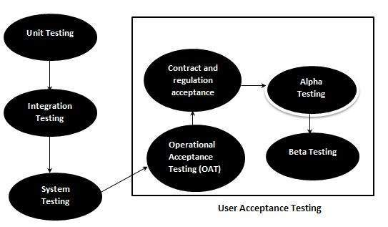

*Figure* 95. Acceptance Testing

**Alpha Testing.** The researchers have implemented a thorough testing process to ensure the stability and functionality of the system. During the first phase of Alpha testing, they conduct internal testing to identify and fix any bugs or issues. The researchers test the systems key features, such as QR code scanning, attendance monitoring, and SMS notifications, to ensure that they are working correctly. After the initial testing is completed, the researchers release the system to a small group of users, including students, teachers, nurses, and guards, who will test the system in a real-world setting. These users provide feedback on the systems ease of use, report any issues or bugs they encounter, and help the researcher to improve the system before it is released to a wider audience. The researchers used the feedback received from the users to refine the user interface and improve the systems overall usability. By following this testing process, the researchers ensure that the system is functioning correctly, meets the needs of its users, and provides a positive user experience. As a result, the system is more likely to be adopted and used effectively by a wider audience, contributing to the success of the project.

**Beta Testing.** Once the system has undergone alpha testing, its ready for an open beta test. The developed web system would be available to all college students and faculty members. The goal is to get feedback from diverse users to identify and fix any remaining bugs or issues. The system is tested for handling many users and traffic in this phase. The researchers would simulate heavy usage scenarios, such as multiple users scanning QR codes simultaneously or sending out a high volume of SMS notifications. The goal is to ensure the system can handle the load and perform consistently under heavy usage. The final phase of beta testing is security testing. The system is tested for vulnerabilities and potential security breaches, such as unauthorized access to sensitive data or hacking attempts. The researchers would work to fix any security issues before the system is released to the public.

**3.7.5 Deployment Plan**

The following shows the deployment of CSAMS: A Web-based Attendance Monitoring System with Contact Tracing and Notification via SMS using QR Code for CSTC College of Sciences, Technology and Communications, Inc.

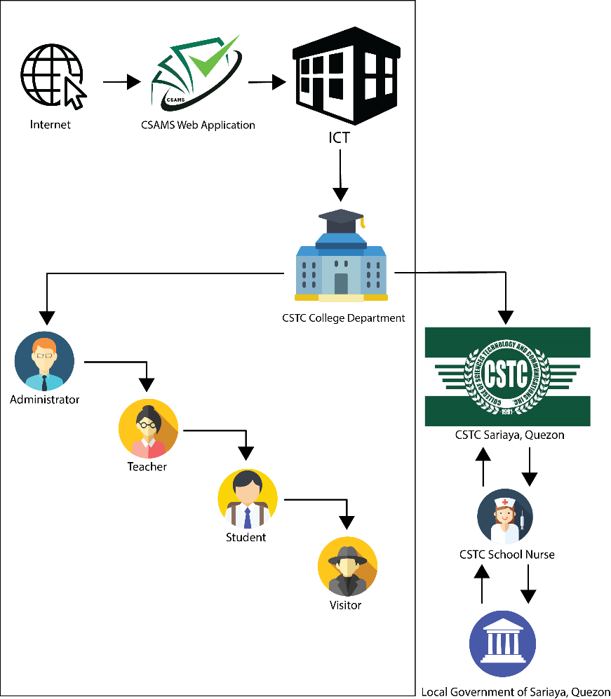

*Figure 96*. CSAMS Deployment Plan

Figure 96. shows the deployment plan for CSAMS, a web-based attendance monitoring system with contact tracing and SMS notification using a QR code, involves several key steps. The first step is to deploy the approach to the ICT of the school campus through the internet, which would serve as the primary administrator of the developed web system. The ICT would have to coordinate with all college departments in the CSTC to ensure the proper implementation and distribution of the system.

Once the system is in place, it would be distributed to the target end-users. However, the system would not be deployed to the entire campus but only to the target end-users. The purpose of this is to ensure that the system is used only by the researchers target users, which can cause potential misuse of the system. Moreover, suppose the college students and visitors have a symptom that can lead to a severe risk at the school, the school nurse and the local government unit (LGU) would have private communication as they track and investigate with the help of the developed web system.

In summary, the deployment plan for CSAMS involves providing the system to the Neo LMS office, coordinating with college departments for implementation and distribution, providing the system to target end-users, and ensuring that the system is not misused. This plan can help ensure that the system is used effectively and complies with all relevant regulations and guidelines.

**CHAPTER IV**

**RESULTS AND DISCUSSION**

In terms of evaluating the developed system, the researchers have conducted a survey and based in ISO (International Standard Organization) 25010 to be answered by IT Experts, College Teachers, Students and Visitors of CSTC Sariaya, Quezon. The developed system evaluated based on the given eight (8) criteria this includes, functional suitability, performance efficiency, usability, compatibility, reliability, security, maintainability, and portability.

**4.1 System Performance Result**

In this page, it discusses the interpretation of the results based on face-to-face surveys and online surveys provided by the researchers based on the study entitled “CSAMS: A Web-based Attendance Monitoring System with Contact Tracing and Notification via SMS using QR Code for CSTC College of Sciences, Technology and Communications, Inc.”

This section presents the evaluation made by fifty (50) respondents consists of five (5) IT Experts and (45) non-IT Experts which include the admin, teachers, students and visitor of College of Sciences, Technology and Communications, Sariaya Quezon. The researchers provide as set of questionnaires connected to the developed web-based system. The questions presented by the researchers was based on the International Standard Organization (ISO 25010). The developed web-based system is based on (8) criteria the Functional Suitability, performance efficiency, compatibility, usability, reliability, security, maintainability, and portability. The researchers use purposive sampling because it was used as to select who are best or has a purpose to the developed web-based system with the value of Very Good, Good, Fair, and Needs Improvement.

The researchers provided a questionnaire in a form of a face-to-face survey and google forms. The researchers discussed and demonstrated the developed web-based system and assist the user through it content and functionalities. The researchers also discussed what are the usefulness of the developed system as the technology innovate. After the discussion and the demonstration, the researchers allowed the respondents to ask any question related to the developed web-based system criteria.

**4.2 Perception of the Respondents**

Table 23.

*Four Point Scale Rating*

|  |  |  |
| --- | --- | --- |
| **Scale** | **Statistical Limits** | **Verbal Interpretation** |
| 4 | 3.25 – 4.00 | Very Good |
| 3 | 2.50 – 3.24 | Good |
| 2 | 1.75 – 2.49 | Fair |
| 1 | 1.00 – 1.74 | Needs Improvement |

In table 23, the researchers used the four-point scale using the checklist survey questionnaire given to the respondents to test and evaluate the performance of the developed web-based system.

**4.3 Tabulation of Result**

*Table 24.*

*End user Evaluation Result for Functional Suitability Criteria of the developed web-based system*

|  |  |  |  |  |  |  |  |
| --- | --- | --- | --- | --- | --- | --- | --- |
| **Functional Suitability** | **4** | **3** | **2** | **1** | **Total** | **Mean** | **Verbal Interpretation** |
| 1. The web-based system provides a function such as login, scanning QR code to take attendances, and declaring survey for the users. | 38(154) | 7(21) | 0 | 0 | 45 | 3.89 | Very Good |
| 2. The web-based system can scan QR code to make an attendance properly. | 39(156) | 6(18) | 0 | 0 | 45 | 3.87 | Very Good |
| 3. The web-based system can easily fulfill the task like answering health declaration form. | 33(132) | 12(36) | 0 | 0 | 45 | 3.73 | Very Good |
| **Mean:** | | | | | **3.83** | | **Very Good** |

**Legend N = 45**

Table 24 shows the respondents evaluation result for Functional Suitability. The respondents used and navigate the CSAMS web-based system and found it interesting as they go through different functions like login, scan QR code and take a survey. The average result of Functional Suitability criteria got a 3.83 which is equivalent to Very Good.

Table 25.

*End user Evaluation Result for Performance Efficiency Criteria of the web-based system*

|  |  |  |  |  |  |  |  |
| --- | --- | --- | --- | --- | --- | --- | --- |
| **Performance Efficiency** | **4** | **3** | **2** | **1** | **Total** | **Mean** | **Verbal Interpretation** |
| 1. The web-based system can accurately scan the QR code to take the attendance of the students. | 37(148) | 8(24) | 0 | 0 | 45 | 3.82 | Very Good |
| 2. The web-based system can work and utilizes the data after updating some of the user’s personal information, teacher subjects and survey questionnaire. | 29(116) | 16(48) | 0 | 0 | 45 | 3.64 | Very Good |
| 3. The web-based system maintain its performance while the user accessing camera to take the attendance. | 34(136) | 11(33) | 0 | 0 | 45 | 3.76 | Very Good |
| **Mean:** | | | | | **3.74** | | **Very Good** |

**Legend N = 45**

Table 25 shows the respondents evaluation result for Performance Efficiency. The respondents used and navigate the CSAMS web-based system and found efficient as they accessing camera and scan QR Code accurately. The average result of Performance Efficiency criteria got a 3.74 which is equivalent to Very Good.

Table 26

*End user Evaluation Result for Compatibility Criteria of the web-based system*

|  |  |  |  |  |  |  |  |
| --- | --- | --- | --- | --- | --- | --- | --- |
| **Compatibility** | **4** | **3** | **2** | **1** | **Total** | **Mean** | **Verbal Interpretation** |
| 1. The web-based system can open/access the camera without delaying user personal devices. | 27(108) | 18(54) | 0 | 0 | 45 | 3.60 | Very Good |
| 2. The web-based system can scan QR code, starting a class and taking surveys without any errors while multiple users are using it. | 28(112) | 17(51) | 0 | 0 | 45 | 3.62 | Very Good |
| 3. The web-based system can be load and navigate to a compatible browser such as Google Chrome, Firefox, Kiwi Browser and Microsoft Edge etc. | 33(132) | 12(36) | 0 | 0 | 45 | 3.73 | Very Good |
| **Mean:** | | | | | **3.65** | | **Very Good** |

**Legend N = 45**

Table 26 shows the respondents evaluation result for Compatibility. The researcher scanned the QR code simultaneously and it satisfied them as the web-based system are working fine. Also, the respondents used it in different browser and gets the same result. The average result of Compatibility criteria got a 3.65 which is equivalent to Very Good.

Table 27

*End user Evaluation Result for Usability of the web-based system*

|  |  |  |  |  |  |  |  |
| --- | --- | --- | --- | --- | --- | --- | --- |
| **Usability** | **4** | **3** | **2** | **1** | **Total** | **Mean** | **Verbal Interpretation** |
| 1. The web-based system has a friendly user-interface that can easily navigate by the user. | 34  (136) | 11  (33) | 0 | 0 | 45 | 3.76 | Very Good |
| 2. The web-based system has a real-time monitoring of the students and visitors while taking their survey. | 33  (132) | 12  (36) | 0 | 0 | 45 | 3.73 | Very Good |
| 3. The web-based system can generate report through excel and print for the student list, teacher list, admin list and the answered survey of the visitors and student. | 35  (140) | 10  (30) | 0 | 0 | 45 | 3.78 | Very Good |
| **Mean:** | | | | | **3.76** | | **Very Good** |

**Legend N = 45**

Table 27 shows the respondents evaluation result for Usability. The respondents’ feedback to the UI design were great as they said it was friendly and simple. The respondents also include that it was a good innovation as the face to face will start soon. The average result of Usability criteria got a 3.76 which is equivalent to Very Good.

Table 28

*End user Evaluation Result for Portability Criteria of the web-based system*

|  |  |  |  |  |  |  |  |
| --- | --- | --- | --- | --- | --- | --- | --- |
| **Portability** | **4** | **3** | **2** | **1** | **Total** | **Mean** | **Verbal Interpretation** |
| 1. The web-based system can adapt and be used to any various user’s devices such as cellphone, laptop and personal computer. | 39  (156) | 6  (18) | 0 | 0 | 45 | 3.87 | Very Good |
| 2. The web-based system is sufficient to what the users’ needed features in their designated dashboard. | 29  (116) | 16  (48) | 0 | 0 | 45 | 3.64 | Very Good |
| 3. The web-based system run smoothly on any devices that has a functional web browser. | 35  (140) | 10  (30) | 0 | 0 | 45 | 3.78 | Very Good |
| **Mean:** | | | | | **3.76** | | **Very Good** |

**Legend N = 45**

Table 28 shows the respondents evaluation result for Portability. The respondent used the system through cellphone and laptop as they navigate to the web-based system and found out that it was responsive and smooth to the cellphone which is the better things because most of the respondents uses mobile device. Also, the respondents have good feedback to the features of the web-based system which they needed as the user. The average result of Portability criteria got a 3.76 which is equivalent to Very Good.

**Overall Evaluation of the CSAMS Web-based system**

*Figure 97.* *End User Overall Evaluation of the CSAMS Web-based System*

Figure 97 shows the summary of the developed web-based system evaluation was presented using graph to see if the following features were achieved in Functional Suitability, Performance Efficiency, Compatibility, Usability and Portability. The Functional Suitability obtained the highest weighted average mean of 3.83 showing the web-based system was functional. Moreover, the Compatibility criteria have the lowest weighted average mean of 3.65.

**4.4 Results and Evaluation by IT Experts**

Table 29

*IT Experts Evaluation Result for Functional Suitability Criteria of the web-based system*

|  |  |  |  |  |  |  |  |
| --- | --- | --- | --- | --- | --- | --- | --- |
| **Functional Suitability** | **4** | **3** | **2** | **1** | **Total** | **Mean** | **Verbal Interpretation** |
| 1. The web-based system provides a function such as login, scanning QR code to take attendances, and declaring survey for the users. | 2(8) | 3(9) | 0 | 0 | 5 | 3.4 | Very Good |
| 2. The web-based system can scan QR code to make an attendance properly. | 2(8) | 2(6) | 1(2) | 0 | 5 | 3.2 | Good |
| 3. The web-based system can easily fulfill the task like answering health declaration form. | 3(12) | 2(6) | 0 | 0 | 5 | 3.6 | Very Good |
| **Mean:** | | | | | **3.4** | | **Very Good** |

**Legend = 5**

Table 29 shows the respondents evaluation result for Functional Suitability. As IT Experts used and navigate the web-based system they try scanning QR code and upon scanning it has a multiple pop-up confirmation regarding to attendance but overall, it fulfills the task that the IT experts wants to do. The average result of Functional Suitability criteria got a 3.4 which is equivalent to Very Good. The web-based system has a real-time monitoring of the students and visitors while taking their survey.

Table 30

*IT Experts Evaluation Result for Performance Efficiency Criteria of the web-based system*

|  |  |  |  |  |  |  |  |
| --- | --- | --- | --- | --- | --- | --- | --- |
| **Performance Efficiency** | **4** | **3** | **2** | **1** | **Total** | **Mean** | **Verbal Interpretation** |
| 1.The web-based system can accurately scan the QR code to take the attendance of the students. | 2(8) | 3(9) | 0 | 0 | 5 | 3.4 | Very Good |
| 2.The web-based system can work and utilizes the data after updating some of the user’s personal information, teacher subjects and survey questionnaire. | 1(4) | 3(9) | 0 | 1(1) | 5 | 2.8 | Good |
| 3.The web-based system maintains its performance while the user accessing camera to take the attendance. | 1(4) | 4(12) | 0 | 0 | 5 | 3.2 | Good |
| **Mean:** | | | | | **3.13** | | **Good** |

**Legend = 5**

Table 30 shows the respondents evaluation result for Performance Efficiency. As the IT Experts explore and navigate some features, they were satisfied for accurately scanned the QR Code and accessing the camera. However, the IT Experts feedbacks need some pop confirmation after updating or deleting data in other features in the web-based system. The average result of Performance Efficiency criteria got a 3.13 which is equivalent to Good.

Table 31

*IT Experts Evaluation Result for Compatibility Criteria of the web-based system*

|  |  |  |  |  |  |  |  |
| --- | --- | --- | --- | --- | --- | --- | --- |
| **Compatibility** | **4** | **3** | **2** | **1** | **Total** | **Mean** | **Verbal Interpretation** |
| 1. The web-based system can open/access the camera without delaying user personal devices. | 1(4) | 4(12) | 0 | 0 | 5 | 3.2 | Good |
| 2. The web-based system can scan QR code, starting a class and taking surveys without any errors while multiple users are using it. | 1(4) | 3(9) | 0 | 1(1) | 5 | 2.8 | Good |
| 3. The web-based system can be load and navigate to a compatible browser such as Google Chrome, Firefox, Kiwi Browser and Microsoft Edge etc. | 2(8) | 2(6) | 1(2) | 0 | 5 | 3.2 | Good |
| **Mean:** | | | | | **3.06** | | **Good** |

**Legend = 5**

Table 31 shows the respondents evaluation result for Compatibility. As the IT Experts go through accessing the camera it didn’t affect their personal devices but scanning QR Code there are some bugs needed to adjusts as well as navigating to different browsers. The average result of Compatibility criteria got a 3.13 which is equivalent to Good.

Table 32

*IT Experts Evaluation Result for Usability Criteria of the web-based system*

|  |  |  |  |  |  |  |  |
| --- | --- | --- | --- | --- | --- | --- | --- |
| **Usability** | **4** | **3** | **2** | **1** | **Total** | **Mean** | **Verbal Interpretation** |
| 1. The web-based system has a friendly user-interface that can easily navigate by the user. | 0 | 4  (12) | 0 | 1(1) | 5 | 2.6 | Good |
| 2. The web-based system has a real-time monitoring of the students and visitors while taking their survey. | 1(4) | 3  (9) | 1(2) | 0 | 5 | 3.0 | Good |
| 3. The web-based system can generate report through excel and print for the student list, teacher list, admin list and the answered survey of the visitors and student. | 2(8) | 3  (9) | 0 | 0 | 5 | 3.4 | Very Good |
| **Mean:** | | | | | **3.0** | | **Good** |

**Legend = 5**

Table 32 shows the respondents evaluation result for Usability. As the IT Experts explore to the web-based system some of the texts were hard to read and misaligned paddings. However, it has a good interface and design. The average result of Usability criteria got a 3.0 which is equivalent to Good.

Table 33

*IT Experts Evaluation Result for Reliability Criteria of the web-based system*

|  |  |  |  |  |  |  |  |
| --- | --- | --- | --- | --- | --- | --- | --- |
| **Reliability** | **4** | **3** | **2** | **1** | **Total** | **Mean** | **Verbal Interpretation** |
| 1. The web-based system can be access anytime and anywhere as long as the user has a set of devices and internet connection. | 1(4) | 4(12) | 0 | 0 | 5 | 3.2 | Good |
| 2. The web-based system can accommodate sets of users simultaneously. | 1(4) | 2(6) | 1(2) | 1(1) | 5 | 2.6 | Good |
| 3. The web-based system can recover any data loss and re-establish it with the same records or data needed. | 0 | 3(9) | 1(2) | 1(1) | 5 | 2.4 | Fair |
| **Mean:** | | | | | **2.73** | | **Good** |

**Legend = 5**

Table 33 shows the respondents evaluation result for Reliability. As the IT Experts uses the web-based system they can access it anywhere as some of the IT Experts where accommodate through Google Meet. However, as the researcher were asking if how many respondents used it simultaneously, they were unsatisfied. Also, the web-based system has no super admin that can control the admins. The average result of Reliability criteria got a 2.73 which is equivalent to Good.

Table 34

*IT Experts Evaluation Result for Security Criteria of the web-based system*

|  |  |  |  |  |  |  |  |
| --- | --- | --- | --- | --- | --- | --- | --- |
| **Security** | **4** | **3** | **2** | **1** | **Total** | **Mean** | **Verbal Interpretation** |
| 1. The web-based system data and users’ answered survey of the student and visitor are only accessible by the system administrator. | 2(8) | 3(9) | 0 | 0 | 5 | 3.4 | Very Good |
| 2. The web-based system has terms and condition to make some statement about what policy are needed to be follow. | 2(8) | 3(9) | 0 | 0 | 5 | 3.4 | Very Good |
| 3. The web-based system can create, delete and sets the role of the user in the system administrator side panel only. | 2(8) | 2(6) | 0 | 1(1) | 5 | 3.0 | Good |
| **Mean:** | | | | | **3.26** | | **Very Good** |

**Legend = 5**

Table 34 shows the respondents evaluation result for Security. The IT Experts feedback to the security of the web-based system they were satisfied that the data are only accessible by the admin and terms and condition which is primary needed. On the other hand, it has no super admin that can create, update and delete the admins of the web-based system. The average result of Security criteria got a 3.26 which is equivalent to Very Good.

Table 35

*IT Experts Evaluation Result for Maintainability Criteria of the web-based system*

|  |  |  |  |  |  |  |  |
| --- | --- | --- | --- | --- | --- | --- | --- |
| **Maintainability** | **4** | **3** | **2** | **1** | **Total** | **Mean** | **Verbal Interpretation** |
| 1. The web-based system can be modified programmatically with no to minimal interruptions to its operation. | 0 | 4(12) | 1(2) | 0 | 5 | 2.8 | Good |
| 2. The web-based system can reuse data from the user’s answered survey to make a report. | 0 | 5(15) | 0 | 0 | 5 | 3.0 | Good |
| 3. The web-based system can maintain their functionality of the while updating some user information, survey questionnaire and setting subjects. | 1(4) | 3(9) | 1(2) | 0 | 5 | 3.0 | Good |
| **Mean:** | | | | | **2.93** | | **Good** |

**Legend = 5**

Table 35 shows the respondents evaluation result for Maintainability. The IT Expert explore the web-based system the feedbacks were unsatisfied to some features of the web-based system. It has a minor bug which slows the process of updating the information. The average result of Maintainability criteria got a 2.93 which is equivalent to Good.

Table 36

*IT Experts Evaluation Result for Portability Criteria of the web-based system*

|  |  |  |  |  |  |  |  |
| --- | --- | --- | --- | --- | --- | --- | --- |
| **Portability** | **4** | **3** | **2** | **1** | **Total** | **Mean** | **Verbal Interpretation** |
| 1. The web-based system can adapt and be used to any various user’s devices such as cellphone, laptop and personal computer. | 3(12) | 2(6) | 0 | 0 | 5 | 3.6 | Very Good |
| 2. The web-based system is sufficient to what the users’ needed features in their designated dashboard. | 2(8) | 3(9) | 0 | 0 | 5 | 3.4 | Very Good |
| 3. The web-based system run smoothly on any devices that has a functional web browser. | 2(8) | 2(6) | 1(2) | 0 | 5 | 3.2 | Good |
| **Mean:** | | | | | **3.4** | | **Very Good** |

**Legend = 5**

Table 36 shows the respondents evaluation result for Portability. As the IT Experts explore their overall feedbacks was the web-based system portability in some web browser. However, the web-based system can adapt from personal computer to cellphones. Lastly, some features or task are not implemented to the web-browser. The average result of Portability criteria got a 3.40 which is equivalent to Very Good.

*Figure 98.* Summary of the CSAMS Web-based system Evaluation Results for IT Experts based on ISO 25010

Figure 98 shows the summary of the developed web-based system evaluation presented using graph to see if the following features were achieved in Functional Suitability, Performance Efficiency, Compatibility, Usability, Reliability, Security, Maintainability and Portability. The Functional Suitability and Portability obtained the highest weighted average mean of 3.40 showing the web-based system was functional. Moreover, the Reliability criteria have the lowest weighted average mean of 2.73.

**Summary of the System Evaluation Result**

*Figure 99.* Summary of the System Evaluation Results Based on the ISO 25010 Software Criteria.

In Figure 99, the summary of system evaluation was presented using graph to see if the following features were achieved (Functional Suitability, Performance Efficiency, Compatibility, Usability, and Portability). The Functional Suitability obtained the highest weighted average mean of 3.64 showing that the system was functional. On the other hand, the Compatibility criterion registered the lowest and got a weighted mean of 3.36.

**CHAPTER V**

**SUMMARY OF FINDINGS, CONCLUSIONS AND RECOMMENDATIONS**

In terms of evaluating the developed system, the researchers have conducted a survey and based in ISO (International Standard Organization) 25010 to be answered by IT Experts, College Teachers, Students and Visitors of CSTC Sariaya, Quezon. The developed system evaluated based on the given eight (8) criteria this includes, functional suitability, performance efficiency, usability, compatibility, reliability, security, maintainability, and portability.

**5.1 Summary of Findings**

Based on all the data gathered, the following summaries were found:

1. CSAMS was an efficient and user-friendly solution for attendance tracking. The utilization of QR codes and smartphones has significantly improved attendance tracking, making it more accessible and faster. Moreover, generation of the QR code for the subject were found to be secured as it can only be used in the specific time created in the subject. Even if a student knows the value of a QR code and uses a third-party generator, the CSAMS system will not recognize it and prevent any manipulation of attendance in the web system. The generated attendance reports have also made it easier for teachers and administrators to manage attendance data. However, the system currently lacks the functionality to apply timeframe-based filters, such as weekly or monthly reports. This missing feature can make it difficult for teachers to examine attendance records over time, which can influence decisions about student performance and school policy. The system received an average score of 3.74 on the Performance Efficiency criteria, indicating that it is very good.
2. The evaluation of CSAMS indicates that it has the potential to be an alternative for the traditional pen and paper method of contact tracing record management. CSAMS was found to provide a safer way for the visitors and students to fill out health declaration forms. Additionally, CSAMS was found to improve data security of the contact tracing record management, as access to contact tracing records is restricted to the administrator. Moreover, the system has been evaluated to be user-friendly, facilitating ease of navigation and input of health declaration information upon entry to the campus. A notable advantage of the system is that it minimizes the risk of exposure to infectious diseases, as users can utilize their personal devices to access the system, thus reducing the need of using shared pen and paper found in the manual way for recording contact tracing information. The use of digitalization in the health declaration form is a valuable strategy for promoting safety and convenience in managing campus visitors in the context of contact tracing. The average result of the Functional Suitability criteria was 3.83, which indicates that the system is very good.
3. CSAMS is an effective way to send SMS notifications to the guardian or parent of a college student, allowing real-time updates of a student’s arrival to the campus. The ability of the system to accurately identify the name of the student during notification ensures that the intended recipient receives the message. The Functional Suitability criteria scored 3.76 which is Very Good. Such features can contribute to increased transparency and reassurance for parents or guardians, ensuring that their child arrives at school safely.
4. It was determined that the CSAMS successfully notified the school nurse and guard at CSTC when an individual filled out the health declaration form and reported more than two (2) symptoms. The system ability to send SMS notifications to the school nurse and guard upon identification of an individual with more than two symptoms allows for prompt and efficient response to potentially symptomatic cases. It was found that this feature enables the school nurse to act immediately and assist the symptomatic person while also maintaining their privacy. Moreover, there was a denied entry notification showing on their screen after they declared more than two symptoms in the health declaration form to ensure the safety and wellbeing of everyone on campus during the ongoing COVID-19 pandemic.  This characteristic is critical in preventing potential transmission of COVID-19 on the campus by promptly identifying and isolating symptomatic individuals. The average result of the Functional Suitability criteria was 3.83, which indicates that the system is very good.

**5.2 Conclusion**

Based on the findings, the following conclusions were made possible:

1. CSAMS is a viable solution for attendance tracking through the utilization of QR codes and smartphones. The use of secured QR Codes for class attendance has provided teachers with peace of mind, as it ensures that the data cannot be altered and provides an efficient method for tracking attendance. Moreover, this not only saves time for the teachers but also ensures accuracy, as the data is collected digitally. Additionally, the generation of attendance report has made it easier for teacher to manage attendance data efficiently. Overall, CSAMS offered a range of benefits, including improved efficiency, user-friendliness, accessibility, security, and streamlined data management, making it a valuable tool for organizations seeking to enhance operations and optimize workflows.
2. Implementing a digital health declaration form, such as the CSAMS, is beneficial, not only for visitors, but also for students allowing them to concentrate on their studies and work in a safe and healthy environment. This digital tool can help to enhance the precision and effectiveness of data collection in a healthcare environment, while minimizing the risk of exposure to infectious diseases for students and visitors. Overall, CSAMS has significantly contributed to promoting health and safety in the institutions, and its adoption is a step in the right direction towards ensuring a safer and healthier future for all the students.
3. CSAMS is an effective way to send SMS notifications to parents or guardians of college students. This increases the transparency and reassurance for parents or guardians, allowing them to monitor their child’s safety upon its arrival at school. Overall, the implementation of CSAMS improves communication between parents or guardians and the institution, leading to better collaboration and ultimately contributing to the safety and well-being of college students. In addition to the conclusion stated, this system helps the institution to demonstrate its commitment to student safety and enhance its reputation as a responsible and reliable provider of education.
4. The use of the CSAMS for symptom monitoring on the CSTC campus provides a valuable tool for promoting safety and preventing the spread of COVID-19. It can be concluded that the CSAMS helps to identifying potentially symptomatic cases in the school setting. This proactive approach enables the school to quickly respond to potential cases, thereby contributing to the overall public health effort to mitigate the spread of COVID-19. Moreover, the use of CSAMS helps the institution to have structured action plan for implementing quarantine or make a general sanitization in the school campus for any possible outbreak of the virus from the suspected person. Overall, the use of CSAMS in school is a practical and effective strategy to promote safety and prevent further exposure of the infectious diseases similar to COVID-19.
   1. **Recommendations**
5. CSAMS are recommended to have a full report feature to enable teachers to easily track attendance statistics for their class over a selected time period. The generation of report should be customizable to allow teachers to choose the time period they wish to analyze, whether it be weekly or monthly. Overall, implementing a full report feature that displays attendance for a chosen time period would significantly improve the CSAMS and provide teachers with the tools they need to track their student’s attendance.
6. In order to make it simpler to identify college students, it is advised that the CSAMS include a profile photo with the names of students throughout the attendance-taking process. The addition of a profile photo would give instructors a confirmation to help them match each student’s name with their corresponding image, decreasing the chance of attendance monitoring errors.
7. The SMS provider could offer a customized sender ID feature that allows the school name to appear as the sender of the SMS. This will help parents easily identify the message and trust its authenticity. Overall, by customizing the Sender ID, providing real-time updates, using multiple channels, personalizing the message, and providing additional information, CSAMS can create a comprehensive SMS provider that will help parents stay informed about their child entry into the school premises.
8. It is recommended to employ a multi-channel notification system in conjunction with alerting the school nurse and guard in order to ensure timely communication of critical information. It includes various modes of communication such as email, or mobile application notifications. By using a multi-channel approach, relevant personnel can receive alerts and updates promptly, even if they are not physically present on the school campus. This can improve the effectiveness of emergency response procedures and increase the safety of students and staff.

**REFERENCES**

Abdul Rabu, S. N., Hussin, H., & Bervell, B. (2018). QR code utilization in a large classroom: Higher education students’ initial perceptions. Education and Information Technologies, 24(1), 359–384. https://doi.org/10.1007/s10639-018-9779-2  
Patel, A., Joseph, A., Survase, S., & Nair, R. (2019, April 8). Smart Student Attendance System Using QR Code. Papers.ssrn.com. <https://papers.ssrn.com/sol3/papers.cfm?abstract_id=3370769&fbclid=IwAR264ONyY8bf0WMLEc80y5LYeqXeE6k7tctP3dcQlRSsABCBeqvLFdWWHHc>

Abdul Rabu, Siti Nazleen. (2019). The Design and Implementation of Student Attendance Tracking System Using QR Code Card. <https://www.researchgate.net/publication/335015442_The_Design_and_Implementation_of_Student_Attendance_Tracking_System_Using_QR_Code_Card/citation/download>

Abeler, J., Bäcker, M., Buermeyer, U., & Zillessen, H. (2020). COVID-19 Contact Tracing and Data Protection Can Go Together. JMIR mHealth and uHealth, 8(4), e19359. https://mhealth.jmir.org/2020/4/e19359/

Adam, S. I., & Andolo, S. (2019, August 1). A New PHP Web Application Development Framework Based on MVC Architectural Pattern and Ajax Technology. IEEE Xplore. <https://doi.org/10.1109/ICORIS.2019.8874912>

Agrawal, S. (2020). Intro to MySQL - DZone Database. Dzone.com. https://dzone.com/articles/introduction-to-mysql-1?fbclid=IwAR2xqOjOhw4OW3wtZvCzKJQ0Qtvwa35_PhT-5fUROfO4Y_wvmv79grIq7C4

Ahmed, N., Michelin, R., Xue, W., Ruj, S., Malaney, R., Kanhere, S., Seneviratne, A., Hu, W., Janicke, H., & Jha, S. (2020). A Survey of COVID-19 Contact Tracing Apps. IEEE Journals & Magazine | IEEE Xplore. https://ieeexplore.ieee.org/abstract/document/9144194

Alampay, E. A., Asuncion, X. V. and delos Santos, M. (2018). ‘Management of social media for disaster risk reduction and mitigation in Philippine local government units’. In: Proceedings of the 11th International Conference on Theory and Practice of Electronic Governance — ICEGOV ’18. ACM Press. https://doi.org/10.1145/3209415.3209452.

Alghamdi, A. A. (2021). Impact of the COVID-19 pandemic on the social and educational aspects of Saudi university students’ lives. PLOS ONE, 16(4), e0250026. https://doi.org/10.1371/journal.pone.0250026

Amora, E., Romero, K., Amoguis, C., & Olandria, J. (2021). Digital Attendance and Accomplishment Report Monitoring System (DIGIATT). International Multidisciplinary Research Journal. 3. 123-133. 10.54476/iimrj293. <https://www.researchgate.net/publication/360617825_Digital_Attendance_and_Accomplishment_Report_Monitoring_System_DIGIATT>

Amora, E., Romero, K., Amoguis, R., Olandria, J. Ph.D., Olandria E., Bernales, Romero, P. (2021). QUARANTINE PASS TRACER SYSTEM: IOER INTERNATIONAL MULTIDISCIPLINARY RESEARCH JOURNAL, VOL. 3, NO. 2. <https://www.ioerimrj.com/wp-content/uploads/2021/07/Quarantine-Pass-Tracer-System.pdf>

Anglemyer, Andrew & Moore, Theresa & Parker, Lisa & Chambers, Timothy & Grady, Alice & Chiu, Kellia & Parry, Matthew & Wilczynska, Magdalena & Flemyng, Ella & Bero, Lisa. (2020). Digital contact tracing technologies in epidemics: a rapid review. Cochrane Database of Systematic Reviews. 2020. 10.1002/14651858.cd013699.

Bender, L. (2020). Interim Guidance for COVID-19 Prevention and Control in Schools. In ERIC. UNICEF. <https://eric.ed.gov/?id=ED604378>

Canada, H. (2020, September 15). Download COVID Alert: Canada’s exposure notification app. Aem. <https://www.canada.ca/en/public-health/services/diseases/coronavirus-disease-covid-19/covid-alert.html>

Carnovale, M., & Louisy, K. (2021). Public Health, Technology, and Human Rights: Lessons from Digital Contact Tracing. ArXiv:2107.07552 [Cs, Econ, Q-Fin]. <https://arxiv.org/abs/2107.07552>

Carreon, J. (2019). The Features of Quick Response (QR) Code as an Attendance Monitoring System: Its Acceptability and Implication to Classroom. https://www.academia.edu/39708387/The_Features_of_Quick_Response_QR_Code_as_an_Attendance_Monitoring_System_Its_Acceptability_and_Implication_to_Classroom?fbclid=IwAR2SR2TMV8yxNtdLEVUyDjb6WBzFhYNRPuDY2pKkUSvY3-hsI4_1tlgP4ZU

Carreon, J., & Maleriado, M. A. (2019). The Features of Quick Response (QR) Code as an Attendance Monitoring System: Its Acceptability and Implication to Classroom. Ascendens Asia Journal of Multidisciplinary Research Abstracts, 3(2N). <https://ojs.aaresearchindex.com/index.php/AAJMRA/article/view/10528>

Chang et al. (2018, September 1). Data Matters: Using Chronic Absence to Accelerate Action for Student Success. Attendance Works. <https://www.attendanceworks.org/data-matters/>

Childress, C. (2018). The Influence of an Electronic Attendance Monitoring System on Undergraduate Academic Success. Dissertations. <https://aquila.usm.edu/dissertations/1560/>

Craig, J., & Sturm, R. (2017). Web-Based Application - an overview | ScienceDirect Topics. Www.sciencedirect.com. <https://www.sciencedirect.com/topics/computer-science/web-based-application?fbclid=IwAR3Z2h-YeCpcqQyuq6Bxb5sORywuEb9FDxHzpz5D16pLrAFDhV54hysZABk>

Cyber Success. (2021, October 24). What Is Bootstrap and Advantages of Bootstrap in Web Development. Cyber Success. <https://www.cybersuccess.biz/advantages-of-bootstrap/>

Dharshini, P. (2020). What are the Advantages and Disadvantages of PHP! Www.linkedin.com. <https://www.linkedin.com/pulse/what-advantages-disadvantages-php-zuan-education?fbclid=IwAR0yERpbe5WJ0Hza-sKGDaMWRRN1XeFrj0SxMIP4egNHQPqXDcQiqeDEgFk>

Dharshini, P. (2020). What are the Advantages and Disadvantages of PHP! Www.linkedin.com. https://www.linkedin.com/pulse/what-advantages-disadvantages-php-zuan-education?fbclid=IwAR0yERpbe5WJ0Hza-sKGDaMWRRN1XeFrj0SxMIP4egNHQPqXDcQiqeDEgFk

Epstein. (2020, September 9). Tracking COVID-19: Contact Tracing in the Digital Age. Www.who.int. https://www.who.int/news-room/feature-stories/detail/tracking-covid-19-contact-tracing-in-the-digital-age

EZCheck.me. (2021). EZCheck.me. Ezcheck.me. <https://ezcheck.me/blog/online-educational-policies-in-different-countries-how-qr-code-attendance-app-helps-to-track-students-performance-during-the-pandemic>

Flores, R., & Asuncion, X. V. (2020). Toward an improved risk/crisis communication in this time of COVID-19 pandemic: a baseline study for Philippine local government units. Journal of Science Communication, 19(07), A09. https://doi.org/10.22323/2.19070209

Gasser, U., Ienca, M., Scheibner, J., Sleigh, J., & Vayena, E. (2020). Digital tools against COVID-19: taxonomy, ethical challenges, and navigation aid. The Lancet Digital Health, 2(8), e425–e434. <https://www.sciencedirect.com/science/article/pii/S2589750020301370>

Grano, C., Gavin, E., & Cogan, R. (2021). Through the Looking Glass: Reflections from Three School Nurses Amid the COVID-19 Pandemic. Ojin.nursingworld.org. https://ojin.nursingworld.org/MainMenuCategories/ANAMarketplace/ANAPeriodicals/OJIN/TableofContents/Vol-26-2021/No2-May-2021/Through-the-Looking-Glass-Reflections-from-Three-School-Nurses-Amid-the-COVID-19-Pandemic.html

Gupta, S. (2020, July 8). What Is Bootstrap In Programming? A Web Development Beginner’s Guide. Springboard Blog. <https://www.springboard.com/blog/software-engineering/what-is-bootstrap/>

Hayes, A. (2021). Quick Response (QR) Code Definition. Investopedia. https://www.investopedia.com/terms/q/quick-response-qr-code.asp

Hernandez-Orallo, E., Manzoni, P., Calafate, C. T., & Cano, J. C. (2020). Evaluating How Smartphone Contact Tracing Technology Can Reduce the Spread of Infectious Diseases: The Case of COVID-19. IEEE Access, 8, 99083–99097. https://ieeexplore.ieee.org/abstract/document/9102306

Hossain, M. S., Zhou, X., & Rahman, M. F. (2018). Examining the impact of QR codes on purchase intention and customer satisfaction on the basis of perceived flow. International Journal of Engineering Business Management, 10, 184797901881232. <https://doi.org/10.1177/1847979018812323>

Iffan, M., Dewantara, M. I., Ferdiansyah, D., & Alexander, A. (2021). Designing a Web-based Online Attendance Information System Application - ProQuest. Www.proquest.com. <https://www.proquest.com/openview/8db2dae08de3be1e50e449a7b11fa692/1?pq-origsite=gscholar&cbl=4998670>

Jadhav, S., Gagare, A., Gunjal, P., & VidyaJagtap. (2018). (PDF) "Effect of implementing “QR Code Attendance System” during Examination in SHCT-Limits and Possibilities ". ResearchGate. <https://www.researchgate.net/publication/328306138_Effect_of_implementing_>

Jeson, Jacinto & Galgo, Jeson. (2020). Efficacy of Scan Attendance Manager Application Using Quick Response Code in Dagohoy National High School, Bohol, Philippines. Journal of English Language Studies. 2. 1-12. 10.32996/ijes.2020.2.4.1. <https://www.researchgate.net/publication/345249135_Efficacy_of_Scan_Attendance_Manager_Application_Using_Quick_Response_Code_in_Dagohoy_National_High_School_Bohol_Philippines?fbclid=IwAR0z8x0RmxaKFRGY58hCXNkSzLhrn12O2R-CQCKtgSvLc15crCFMTGOslxs>

Khamooshi, P. (2019). The benefits of using web-based applications | Geeks Insights. Www.geeks.ltd.uk. <https://www.geeks.ltd.uk/insights/the-benefits-of-using-web-based-applications>.

Kotevski, Z., Blazheska-Tabakovska, N., & Dimovski, T. (2020, October 16). Web-Based Solution for Student Attendance Tracking: Development and Evaluation. Eprints.uklo.edu.mk. [http://eprints.uklo.edu.mk/5877/](https://l.facebook.com/l.php?u=http%3A%2F%2Feprints.uklo.edu.mk%2F5877%2F%3Ffbclid%3DIwAR1849lLDg1byV2X9ETGW1ttDA3a5UK_csa556oWJBVlt_nlTV_BCYXWBl0&h=AT0jYJx2JJf-Hi8dyVDvxFmuf_JNexLpCYjW_sLF-UjsVQUNPJBZnCwcIzUFawEhA_g01oarGqpCPZ0Ng97PtdmDCP2ybKaOahzB-UsSgLszABGpI2mfTNV17_vEDgzs_O7OzQ)

Kotevski, Z., Blazheska-Tabakovska, N., Bocevska, A., & Dimovski, T. (2018). On the Technologies and Systems for Student Attendance Tracking. International Journal of Information Technology and Computer Science, 10(10), 44–52. <https://doi.org/10.5815/ijitcs.2018.10.06>

Kotevski, Z., Blazheska-Tabakovska, N., Bocevska, A., & Dimovski, T. (2018).  On the Technologies and Systems for Student Attendance Tracking. ResearchGate. <https://www.researchgate.net/publication/328377150_On_the_Technologies_and_Systems_for_Student_Attendance_Tracking>

Kretzschmar, M. E., Rozhnova, G., Bootsma, M. C. J., van Boven, M., van de Wijgert, J. H. H. M., & Bonten, M. J. M. (2020). Impact of delays on effectiveness of contact tracing strategies for COVID-19: a modelling study. The Lancet Public Health, 5(8), e452–e459. https://doi.org/10.1016/s2468-2667(20)30157-2

Krish Compusoft Services. (2021). The benefits of web applications in today’s technological era. Www.kcsitglobal.com. https://www.kcsitglobal.com/blogs/detail-blog/the-benefits-of-web-applications-in-todays-technological-era

Kromann, F. M. (2018). Securing MySQL. Beginning PHP and MySQL, 605–636. <https://doi.org/10.1007/978-1-4302-6044-8_26>

Kromann, F. M. (2018). Using PHP with MySQL. Beginning PHP and MySQL, 637–662. <https://doi.org/10.1007/978-1-4302-6044-8_27>

Lamey, D. (2018). THE EVOLUTION OF TECHNOLOGY: PAST, PRESENT AND FUTURE. Discovertec.com; DiscoverTec. https://www.discovertec.com/blog/evolution-of-technology

Laura. (2021). What Are the Benefits of Using Php and Mysql? – Lotus RB. Lotusrb.org. https://lotusrb.org/what-are-the-benefits-of-using-php-and-mysql/?fbclid=IwAR0c8Ut1E3OJl2VveTpJk_pU13m9fgVr4qj00EZdTIveiBH4lYGiuYM9BA4

M. A. H. M. A. H et.al, (2021). Enhancing the Transparency of Student Merit System Using QR Code Technology: A Smart Campus Initiative. Turkish Journal of Computer and Mathematics Education (TURCOMAT), 12(3), 2047–2052. <https://doi.org/10.17762/turcomat.v12i3.1072>

Maleriado, M. A., & Carreon, J. (2021). The Features of QR Code as Attendance Monitoring System: Its Acceptability and Implication to Classroom – The IAFOR Research Archive. Papers.iafor.org. <https://papers.iafor.org/submission44683/>

Marcel, G., & Flaubert, H. (2022). A Development of an Online Student Attendance Management Information System: Case Study “University of Tourism, Technology, and Business Studies.” International Journal of Scientific Research in Computer Science and Engineering, 10(1), 32–48. <https://www.isroset.org/journal/IJSRCSE/full_paper_view.php?paper_id=2694>

Martinsson, E., Garmy, P., & Einberg, E.-L. (2021). School Nurses’ Experience of Working in School Health Service during the COVID-19 Pandemic in Sweden. International Journal of Environmental Research and Public Health, 18(13), 6713. https://doi.org/10.3390/ijerph18136713

McIntosh, C. E., Brelage, P. K., Thomas, C. M., Wendel, J. M., & Phelps, B. E. (2022). School nurse and COVID‐19 response. Psychology in the Schools. https://doi.org/10.1002/pits.22708

Medel, D. A., Odicta, J. M. N., Santos, M. Z. L. T., & Intal, G. L. D. (2021). Proposed innovations on contact tracing system using contactless smart cards in the Philippines. 11th Annual International Conference on Industrial Engineering and Operations Management, IEOM 2021, 3280–3291. <https://pesquisa.bvsalud.org/global-literature-on-novel-coronavirus-2019-ncov/resource/pt/covidwho-1399988>

Medel, D. A., Odicta, J. M. N., Santos, M. Z. L. T., & Intal, G. L. D. (2021). Proposed innovations on contact tracing system using contactless smart cards in the Philippines. [https://pesquisa.bvsalud.org/global-literature-on-novel-coronavirus-2019- ncov/resource/pt/covidwho-1399988](https://pesquisa.bvsalud.org/global-literature-on-novel-coronavirus-2019-%20ncov/resource/pt/covidwho-1399988)

Montemayor, M. T. (2020). Contact tracing efficiency improves: DOH. Www.pna.gov.ph. https://www.pna.gov.ph/articles/1114889

Nakamoto, I., Wang, S., Guo, Y., & Zhuang, W. (2020). A QR Code–Based Contact Tracing Framework for Sustainable Containment of COVID-19: Evaluation of an Approach to Assist the Return to Normal Activity. JMIR mHealth and uHealth, 8(9), e22321. <https://mhealth.jmir.org/2020/9/e22321/>

Nonyelum, O. F. (2020). Iterative and Incremental Development Analysis Study of Vocational Career Information Systems. Papers.ssrn.com. https://papers.ssrn.com/sol3/papers.cfm?abstract_id=3715318

Owusu, P. N. (2020). Digital technology applications for contact tracing: the new promise for COVID-19 and beyond? Global Health Research and Policy, 5(1). https://doi.org/10.1186/s41256-020-00164-1

Park, S., Choi, G. J., & Ko, H. (2020). Information Technology–Based Tracing Strategy in Response to COVID-19 in South Korea—Privacy Controversies. JAMA, 323(21), 2129. https://jamanetwork.com/journals/jama/article-abstract/2765252

Reegtech. (2020, November 16). Reegtech Nigeria Limited | Web Based Time Attendance Solution. <https://reegtechnigeria.com/web-based-time-attendance-solution/>

Ríos, J. M., & Pedreira-Souto, N. (2019). Approach of Agile Methodologies in the Development of Web-Based Software. Information, 10(10), 314. https://doi.org/10.3390/info10100314

Rivera, R., & Lagarteja, J. (2020). Study On the Impact and Effectiveness of QR Code And SMS-Based Attendance Monitoring System Among the Students of Callang National High School. <http://www.ijstr.org/final-print/mar2020/Study-On-The-Impact-And-Effectiveness-Of-Qr-Code-And-Sms-based-Attendance-Monitoring-System-Among-The-Students-Of-Callang-National-High-School.pdf>

S. Talabis, D. A., Babierra, A. L., H. Buhat, C. A., Lutero, D. S., Quindala, K. M., & Rabajante, J. F. (2021). Local government responses for COVID-19 management in the Philippines. BMC Public Health, 21(1). https://doi.org/10.1186/s12889-021-11746-0

Singh, G., Dwivedi, R., & Anand, A. (2019). Attendance monitoring and management using QR code-based sensing with cloud-based Processing. International Journal of Scientific Research in Computer Science Applications and Management Studies IJSRCSAMS, 8(5). <http://www.ijsrcsams.com/images/stories/Past_Issue_Docs/ijsrcsamsv8i5p8.pdf>

Skulmowski, A., & Rey, G. D. (2020). COVID ‐19 as an accelerator for digitalization at a German university: Establishing hybrid campuses in times of crisis. Human Behavior and Emerging Technologies, 2(3), 212–216. <https://doi.org/10.1002/hbe2.201>

Tabuga, A., Domingo, S., Diokno-Sicat, C., Gilbert, V., & Ulep, T. (2020). Innovating Governance: Building Resilience against COVID-19 Pandemic and Other Risks. https://pidswebs.pids.gov.ph/CDN/PUBLICATIONS/pidsdps2023.pdf

Uni Assignment Centre. (2020). The Advantages of Mysql Information Technology Essay. Www.uniassignment.com. <https://www.uniassignment.com/essay-samples/information-technology/the-advantages-of-mysql-information-technology-essay.php>

Uzayr, S. bin. (2020, October 26). The Impact of Bootstrap on Web Design and Development. Buddy: The DevOps Automation Platform. <https://buddy.works/tutorials/the-impact-of-bootstrap-on-web-design-and-development>

Wave. (2019). What is a QR Code? | QRcode.com | DENSO WAVE. Qrcode.com. https://www.qrcode.com/en/about/

Wave. (2019). What is a QR Code? | QRcode.com | DENSO WAVE. Qrcode.com. https://www.qrcode.com/en/about

Webb, K. (2020). Being the Voice of Reason Within Your School Community During a Pandemic and Beyond. NASN School Nurse, 1942602X2095630. https://doi.org/10.1177/1942602x20956301

Webxloo. (2022). PHP and MySQL Development Advantages. Webxloo. https://webxloo.com/technology/php-mysql.html?fbclid=IwAR3KJb9tsHFP3u7kH6K6y4Wtoy1ttJwp4-8T3ma93LJ2K7X3Ra8W-E6DIP4#:~:text=MySQL%20is%20a%20first%20choice

Whitelaw, S., Mamas, M., Topol, E., & van Spall, H. (2020). Applications of digital technology in COVID-19 pandemic planning and response. ScienceDirect. https://www.sciencedirect.com/science/article/pii/S2589750020301424

WHO. (2020). Contact tracing in the context of COVID-19. <https://apps.who.int/iris/bitstream/handle/10665/332049/WHO-2019-nCoV-Contact_Tracing-2020.1-eng.pdf>

**Appendix “A”**

**REQUEST LETTER FOR CSTC**

April 1, 2022

**FR. HARRIS IÑIGO GARCIA**

VP Administration

College of Sciences, Technology and Communications, Inc.

Gen. Luna St. Maharlika Highway Arellano Subd. Sariaya, Quezon

Dear Fr. Iñigo:

Warmest greetings!

In partial fulfillment of our requirements for our Capstone Project, we undergraduates of the College of Sciences, Technology, and Communication, Inc.'s Bachelor of Science in Information Technology, namely: Gio Cabuyao, John Kent Abulencia, and Monsoure De La Cruz, would like to humbly request to conduct an interview for a capstone project proposal entitled CSAMS: A Web-based Attendance Monitoring System with Contact Tracing and Notification via SMS using QR Code in College Students of College of Sciences, Technology and Communication, Inc.

Our group may request your precious time to be part of our study. We would like to develop a web-system that will help the institution to monitor the visitors, and college students when they enter the school premises. The proposed system will also help the teachers for a better attendance monitoring, generate an accurate report, real-time entry monitoring, and a solution for contact tracing as preventive measures of the institution against COVID-19.

With this request, all the information and data that we will gather from this interview are private and confidential strictly for educational purpose only.

We believe that you are with us in our enthusiasm to finish the requirements as compliance for our subject and to develop our well-being. We are anticipating your positive response regarding this matter. This interview would only take 1 to 2 hours of your time. Should you have any concerns and clarification, please e-mail us at [abulenciajohnkent@gmail.com](mailto:abulenciajohnkent@gmail.com) or contact us at the mobile number 09665227694.

Thank you very much.

Best Regards,

**John Kent A. Abulencia**

**Gio R. Cabuyao**

**Monsoure Dela Cruz**

Researchers

Noted:

**JORGE T. JADER, MIT**

Capstone Adviser

School of Information Technology

Approved:

**FR. HARRIS IÑIGO GARCIA**

VP Administration

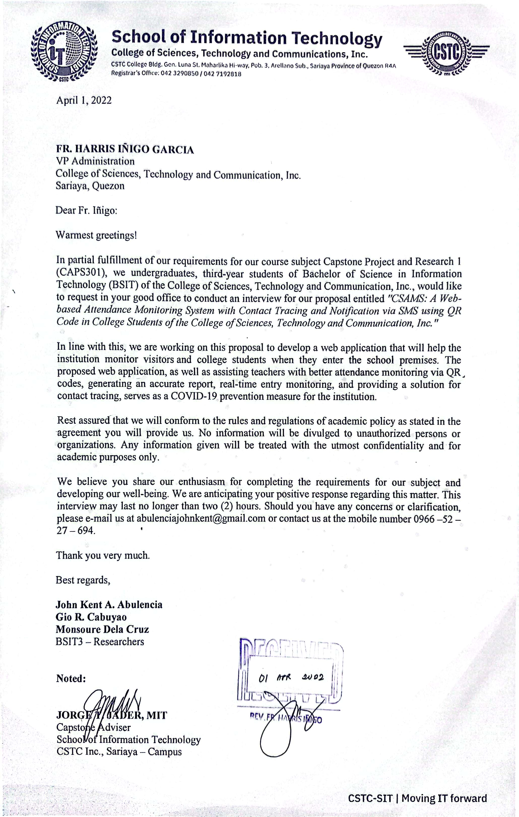

**REQUEST LETTER FOR LGU SARIAYA**

June 8, 2022

**Eriberto Gerardo A. Gabiola**

Sanitation Inspector V

LGU Sariaya, Quezon

Brgy. Poblacion 6 Sariaya, Quezon

Dear Sir:

Warmest greetings!

In partial fulfillment of our requirements for our Capstone Project, we undergraduates of the College of Sciences, Technology, and Communication, Inc.'s Bachelor of Science in Information Technology, namely: Gio Cabuyao, John Kent Abulencia, and Monsoure De La Cruz, would like to humbly request to conduct an interview for a capstone project proposal entitled CSAMS: A Web-based Attendance Monitoring System with Contact Tracing and Notification via SMS using QR Code in College Students of College of Sciences, Technology and Communication, Inc.

Our group may request your precious time to be part of our study. We would like to develop a web-system that will help the institution to monitor the visitors, and college students when they enter the school premises. The proposed system will also help the teachers for a better attendance monitoring, generate an accurate report, real-time entry monitoring, and a solution for contact tracing as preventive measures of the institution against COVID-19.

With this request, all the information and data that we will gather from this interview are private and confidential strictly for educational purpose only.

We believe that you are with us in our enthusiasm to finish the requirements as compliance for our subject and to develop our well-being. We are anticipating your positive response regarding this matter. This interview would only take 1 to 2 hours of your time. Should you have any concerns and clarification, please e-mail us at [abulenciajohnkent@gmail.com](mailto:abulenciajohnkent@gmail.com) or contact us at the mobile number 09665227694.

Thank you very much, and stay safe!

Best regards,

**John Kent A. Abulencia**

**Gio R. Cabuyao**

**Monsoure Dela Cruz**

BSIT3-Researchers

Noted:

**JORGE T. JADER, MIT**

Capstone Adviser

School of Information Technology

Approved:

**ERIBERTO GERARDO A. GABIOLA**

Sanitation Inspector V LGU Sariaya

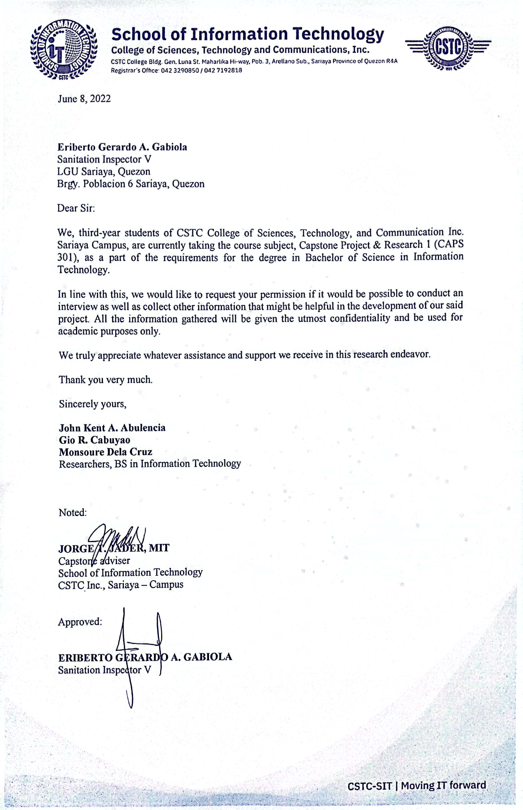

**CONSENT LETTER FOR CSTC**

April 1, 2022

Fr. Harris Iñigo Garcia

VP Administration

College of Sciences, Technology and Communications, Inc.

Gen. Luna St. Maharlika Highway Arellano Subd. Sariaya, Quezon

Dear Sir:

Warmest greetings!

In partial fulfillment of the requirements for our Capstone Project, we undergraduates of the College of Sciences, Technology, and Communication, Inc.'s Bachelor of Science in Information Technology, namely: Gio Cabuyao, John Kent Abulencia, and Monsoure De La Cruz, would like to ask for permission to conduct a capstone project proposal entitled CSAMS: A Web-based Attendance Monitoring System with Contact Tracing and Notification via SMS using QR Code in College Students of College of Sciences, Technology and Communication, Inc.

In regard with this, we would like to humbly request to your good office for formal consent, and collaboration for us to gather the necessary data in developing our capstone project proposal. Rest assured that the data we’ll gather will remain confidential and be used strictly for academic purposes only.

We believe that you are with us in our enthusiasm to finish the requirements as compliance for our subject and to develop our well-being. We are anticipating your positive response regarding this matter. Should you have any concerns and clarification, please e-mail us at [abulenciajohnkent@gmail.com](mailto:abulenciajohnkent@gmail.com) or contact us at the mobile number 09665227694.

Thank you very much, and stay safe!

Best Regards,

**John Kent A. Abulencia**

**Gio R. Cabuyao**

**Monsoure Dela Cruz**

BSIT3-Researchers

Noted:

**JORGE T. JADER, MIT**

Capstone Adviser

School of Information Technology

Approved:

**FR. HARRIS IÑIGO GARCIA**

VP Administration

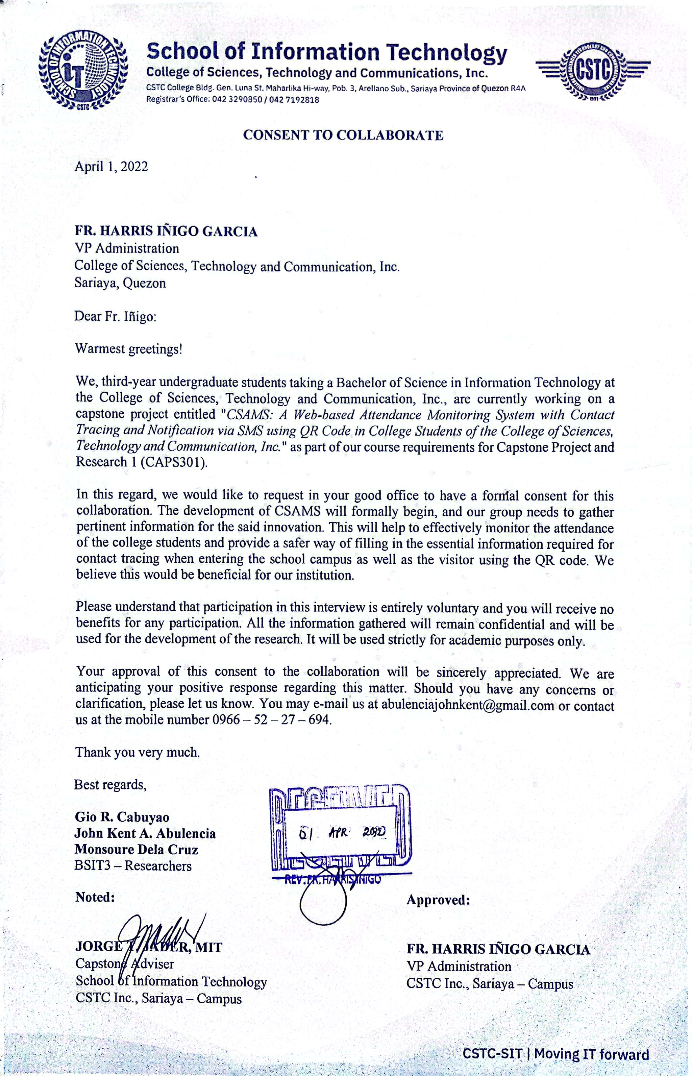

**CONSENT LETTER FOR LGU SARIAYA**

June 8, 2022

Eriberto Gerardo A. Gabiola

Sanitation Inspector V

LGU Sariaya, Quezon

Brgy. Poblacion 6 Sariaya, Quezon

Dear Sir:

Warmest greetings!

In partial fulfillment of our requirements for our Capstone Project, we undergraduates of the College of Sciences, Technology, and Communication, Inc.'s Bachelor of Science in Information Technology, namely: Gio Cabuyao, John Kent Abulencia, and Monsoure De La Cruz, would like to humbly request to conduct an interview for a capstone project proposal entitled CSAMS: A Web-based Attendance Monitoring System with Contact Tracing and Notification via SMS using QR Code in College Students of College of Sciences, Technology and Communication, Inc.

Our group may request your precious time to be part of our study. We would like to develop a web-system that will help the institution to monitor the visitors, and college students when they enter the school premises. The proposed system will also help the teachers for a better attendance monitoring, generate an accurate report, real-time entry monitoring, and a solution for contact tracing as preventive measures of the institution against COVID-19.

With this request, all the information and data that we will gather from this interview are private and confidential strictly for educational purpose only.

We believe that you are with us in our enthusiasm to finish the requirements as compliance for our subject and to develop our well-being. We are anticipating your positive response regarding this matter. This interview would only take 1 to 2 hours of your time. Should you have any concerns and clarification, please e-mail us at [abulenciajohnkent@gmail.com](mailto:abulenciajohnkent@gmail.com) or contact us at the mobile number 09665227694.

Thank you very much, and stay safe!

Best regards,

**John Kent A. Abulencia**

**Gio R. Cabuyao**

**Monsoure Dela Cruz**

BSIT3-Researchers

Noted:

**JORGE T. JADER, MIT**

Capstone Adviser

School of Information Technology

Approved:

**ERIBERTO GERARDO A. GABIOLA**

Sanitation Inspector V LGU Sariaya

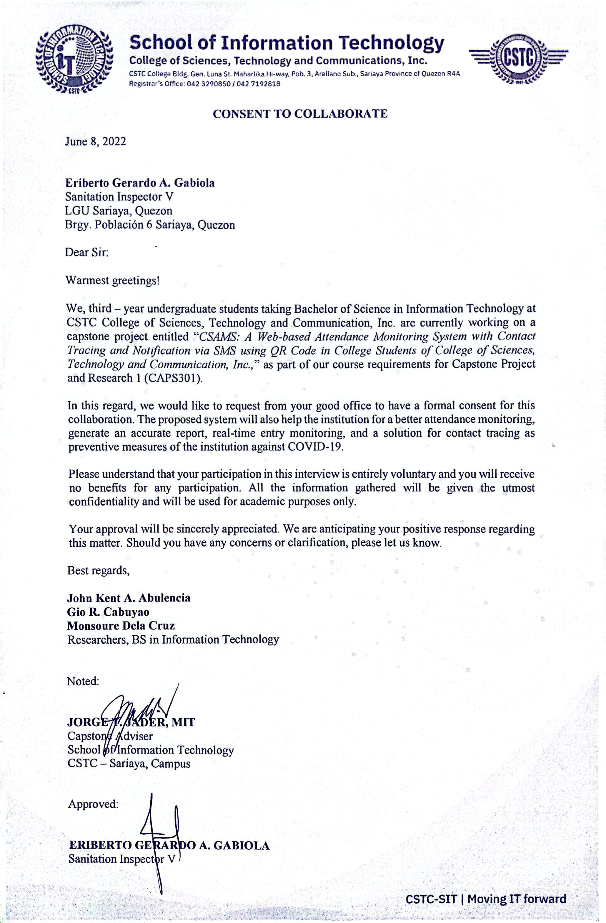

**Appendix “B”**

**GANTT CHART**

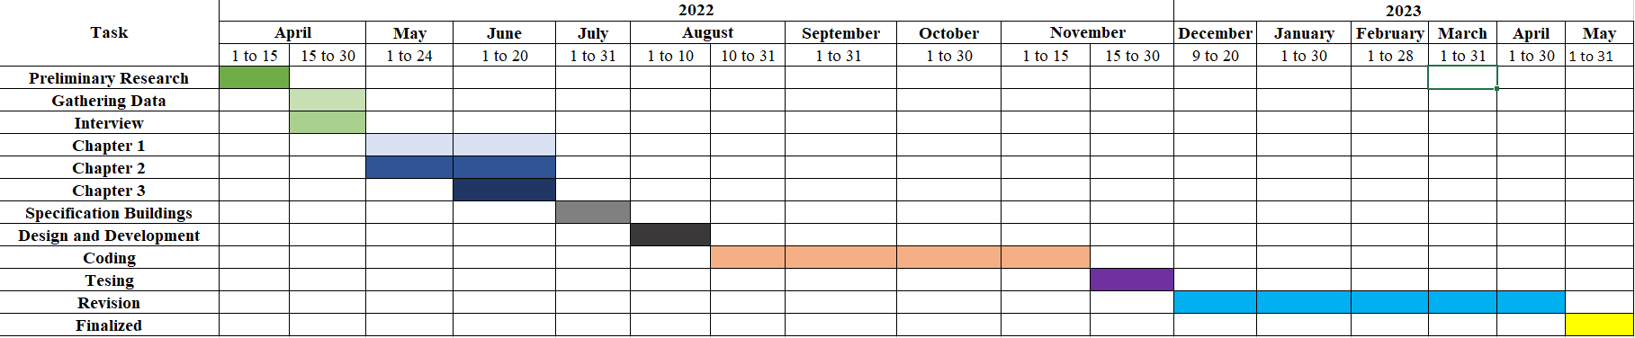

**Appendix “C”**

**LETTER FOR RESPONDENTS**

November 2022

Dear Respondents:

Good day!

We, the proponents are currently working on our capstone project entitled “***CSAMS: A Web-based Attendance Monitoring System with Contact Tracing and Notification via SMS using QR Code for CSTC College of Sciences, Technology and Communications, Inc.”*** as course requirement in the degree of Bachelor of Science in Information Technology at College of Sciences, Technology and Communications, Inc.

In connection with this, we would like to ask for your time and seek your help in answering the survey questionnaire that would be of great help to our research. Rest assured that all your answers would be held strictly confidential.

Thank you very much for your consideration and support.

Respectfully yours,

Gio R. Cabuyao

John Kent A. Abulencia

Monsoure De La Cruz

BSIT4-Researchers

Noted:

**JORGE T. JADER, MIT**

Capstone Adviser

School of Information Technology

CSTC – Sariaya Campus

**LETTER FOR IT EXPERTS**

November 2022

Dear IT Experts:

The undersigned is a 4th year BSIT Bachelor of Science and Information Technology students of College of Sciences, Technology and Communications, Inc. Sariaya, Quezon Campus undertaking a capstone project and research entitled “***CSAMS: A Web-based Attendance Monitoring System with Contact Tracing and Notification via SMS using QR Code for CSTC College of Sciences, Technology and Communications, Inc.***” as a course requirement for the subject Capstone Project and Research 2 (CAPS 401).

With your expertise, we humbly asking your permission to validate the survey questionnaire, for the testing of the effectiveness of the system using the attached rating tool. Rest assured that all data gathered will be treated with outmost confidentiality and will be used for academic purposes only.

We are looking forward that our request would merit your positive response.

Respectfully yours,

Gio R. Cabuyao

John Kent A. Abulencia

Monsoure De La Cruz

BSIT4-Researchers

Noted:

**JORGE T. JADER, MIT**

Capstone Adviser

School of Information Technology

CSTC – Sariaya Campus

**Appendix “D”**

**SURVEY QUESTIONNAIRE FOR END USERS**

**Direction:** Please shade the circle that best describes the performance of the Web-Based System. For details, please contact **GIO CABUYAO, JOHN KENT ABULENCIA, MONSOURE DE LA CRUZ** or text/call as at the following numbers 09453143447, 09665227694, 09062469081.

Name: (Optional): _______________________________

Profession:

* End-user
* IT Expert

|  |  |  |  |  |
| --- | --- | --- | --- | --- |
| **Criteria 1: Functional Suitability** | 4 | 3 | 2 | 1 |
| 1. The web-based system provides a function such as login, scanning QR code to take attendances, and declaring survey for the users. | Very Good  Fair  Good  Needs Improvement | | | |
| 1. The web-based system can scan QR code to make an attendance properly. | Very Good  Fair  Good  Needs Improvement | | | |
| 1. The web-based system can easily fulfill the task like answering health declaration form | Very Good  Fair  Good  Needs Improvement | | | |

|  |  |  |  |  |
| --- | --- | --- | --- | --- |
| **Criteria 2: Performance Efficiency** | 4 | 3 | 2 | 1 |
| 1. The web-based system can accurately scan the QR code to take the attendance of the students. | Very Good  Fair  Good  Needs Improvement | | | |
| 1. The web-based system can work and utilizes the data after updating some of the user’s personal information, teacher subjects and survey questionnaire. | Very Good  Fair  Good  Needs Improvement | | | |
| 1. The web-based system maintains its performance while the user accessing camera to take the attendance. | Very Good  Fair  Good  Needs Improvement | | | |

|  |  |  |  |  |
| --- | --- | --- | --- | --- |
| **Criteria 3: Compatibility** | 4 | 3 | 2 | 1 |
| 1. The web-based system can open/access the camera without delaying user personal devices. | Very Good  Fair  Good  Needs Improvement | | | |
| 1. The web-based system can scan QR code, starting a class and taking surveys without any errors while multiple users are using it. | Very Good  Fair  Good  Needs Improvement | | | |
| 1. The web-based system can be load and navigate to a compatible browser such as Google Chrome, Firefox, Kiwi Browser and Microsoft Edge etc. | Very Good  Fair  Good  Needs Improvement | | | |

|  |  |  |  |  |
| --- | --- | --- | --- | --- |
| **Criteria 4: Usability** | 4 | 3 | 2 | 1 |
| 1. The web-based system has a friendly user-interface that can easily navigate by the user. | Very Good  Fair  Good  Needs Improvement | | | |
| 1. The web-based system has a real-time monitoring of the students and visitors while taking their survey. | Very Good  Fair  Good  Needs Improvement | | | |
| 1. The web-based system can generate report through excel and print for the student list, teacher list, admin list and the answered survey of the visitors and student. | Very Good  Fair  Good  Needs Improvement | | | |
| **Criteria 5: Portability** | 4 | 3 | 2 | 1 |
| 1. The web-based system can adapt and be used to any various user’s devices such as cellphone, laptop and personal computer. | Very Good  Fair  Good  Needs Improvement | | | |
| 1. The web-based system is sufficient to what the users’ needed features in their designated dashboard. | Very Good  Fair  Good  Needs Improvement | | | |
| 1. The web-based system run smoothly on any devices that has a functional web browser. | Very Good  Fair  Good  Needs Improvement | | | |

If you have any further comment or additional specification, please write them below:

Signature

**SURVEY QUESTIONNAIRE FOR IT EXPERTS**

**Direction:** Please shade the circle that best describes the performance of the Web-Based System. For details, please contact **GIO CABUYAO, JOHN KENT ABULENCIA, MONSOURE DE LA CRUZ** or text/call as at the following numbers 09453143447, 09665227694, 09062469081.

Name: (Optional): _______________________________

Profession:

* End-user
* IT Expert

|  |  |  |  |  |
| --- | --- | --- | --- | --- |
| **Criteria 1: Functional Suitability** | 4 | 3 | 2 | 1 |
| 1. The web-based system provides a function such as login, scanning QR code to take attendances, and declaring survey for the users. | Very Good  Fair  Good  Needs Improvement | | | |
| 1. The web-based system can scan QR code to make an attendance properly. | Very Good  Fair  Good  Needs Improvement | | | |
| 1. The web-based system can easily fulfill the task like answering health declaration form | Very Good  Fair  Good  Needs Improvement | | | |

|  |  |  |  |  |
| --- | --- | --- | --- | --- |
| **Criteria 2: Performance Efficiency** | 4 | 3 | 2 | 1 |
| 1. The web-based system can accurately scan the QR code to take the attendance of the students. | Very Good  Fair  Good  Needs Improvement | | | |
| 1. The web-based system can work and utilizes the data after updating some of the user’s personal information, teacher subjects and survey questionnaire. | Very Good  Fair  Good  Needs Improvement | | | |
| 1. The web-based system maintains its performance while the user accessing camera to take the attendance. | Very Good  Fair  Good  Needs Improvement | | | |

|  |  |  |  |  |
| --- | --- | --- | --- | --- |
| **Criteria 3: Compatibility** | 4 | 3 | 2 | 1 |
| 1. The web-based system can open/access the camera without delaying user personal devices. | Very Good  Fair  Good  Needs Improvement | | | |
| 1. The web-based system can scan QR code, starting a class and taking surveys without any errors while multiple users are using it. | Very Good  Fair  Good  Needs Improvement | | | |
| 1. The web-based system can be load and navigate to a compatible browser such as Google Chrome, Firefox, Kiwi Browser and Microsoft Edge etc. | Very Good  Fair  Good  Needs Improvement | | | |

|  |  |  |  |  |
| --- | --- | --- | --- | --- |
| **Criteria 4: Usability** | 4 | 3 | 2 | 1 |
| 1. The web-based system has a friendly user-interface that can easily navigate by the user. | Very Good  Fair  Good  Needs Improvement | | | |
| 1. The web-based system has a real-time monitoring of the students and visitors while taking their survey. | Very Good  Fair  Good  Needs Improvement | | | |
| 1. The web-based system can generate report through excel and print for the student list, teacher list, admin list and the answered survey of the visitors and student. | Very Good  Fair  Good  Needs Improvement | | | |

|  |  |  |  |  |
| --- | --- | --- | --- | --- |
| **Criteria 5: Reliability** | 4 | 3 | 2 | 1 |
| 1. The web-based system can be access anytime and anywhere as long as the user has a set of devices and internet connection. | Very Good  Fair  Good  Needs Improvement | | | |
| 1. The web-based system can accommodate sets of users simultaneously. | Very Good  Fair  Good  Needs Improvement | | | |
| 1. The web-based system can recover any data loss and re-establish it with the same records or data needed. | Very Good  Fair  Good  Needs Improvement | | | |

|  |  |  |  |  |
| --- | --- | --- | --- | --- |
| **Criteria 6: Security** | 4 | 3 | 2 | 1 |
| 1. The web-based system data and users’ answered survey of the student and visitor are only accessible by the system administrator. | Very Good  Fair  Good  Needs Improvement | | | |
| 1. The web-based system has terms and condition to make some statement about what policy are needed to be follow. | Very Good  Fair  Good  Needs Improvement | | | |
| 1. The web-based system can create, delete and sets the role of the user in the system administrator side panel only. | Very Good  Fair  Good  Needs Improvement | | | |

|  |  |  |  |  |
| --- | --- | --- | --- | --- |
| **Criteria 7: Maintainability** | 4 | 3 | 2 | 1 |
| 1. The web-based system can be modified programmatically with no to minimal interruptions to its operation. | Very Good  Fair  Good  Needs Improvement | | | |
| 1. The web-based system can reuse data from the user’s answered survey to make a report. | Very Good  Fair  Good  Needs Improvement | | | |
| 1. The web-based system can maintain their functionality of the while updating some user information, survey questionnaire and setting subjects. | Very Good  Fair  Good  Needs Improvement | | | |

|  |  |  |  |  |
| --- | --- | --- | --- | --- |
| **Criteria 8: Portability** | 4 | 3 | 2 | 1 |
| 1. The web-based system can adapt and be used to any various user’s devices such as cellphone, laptop and personal computer. | Very Good  Fair  Good  Needs Improvement | | | |
| 1. The web-based system is sufficient to what the users’ needed features in their designated dashboard. | Very Good  Fair  Good  Needs Improvement | | | |
| 1. The web-based system run smoothly on any devices that has a functional web browser. | Very Good  Fair  Good  Needs Improvement | | | |

If you have any further comment or additional specification, please write them below:

Signature

**Appendix “E”**

**GRAMMARIAN’S CERTIFICATION**

This is to certify that the Capstone Project entitled *“CSAMS: A Web-based Attendance Monitoring System with Contact Tracing and Notification via SMS using QR Code for CSTC College of Sciences, Technology and Communications, Inc.”*, developed and submitted by Gio Cabuyao, John Kent Abulencia and Monsoure De La Cruz has been read, examined and edited by the undersigned.

**ANGELA J. NIEVA-LUSTANAS, LPT, MAEd**

Grammarian

**Appendix “F”**

**USER MANUAL**

1. **QR Code**

By using any type of QR Code scanner, the user can scan the QR Code provided at the school entrance to take you to the link of the website, or you can manually type the link of the developed web system.

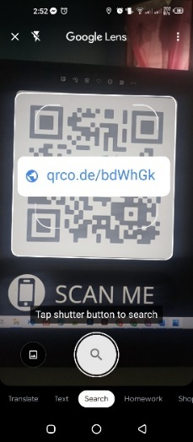

1. **Visitor’s Health Declaration Form**

If the visitors enter the CSTC the visitor needs to declare their health status. The visitor will click the “I am Visitor” button as they answer the health declaration form.

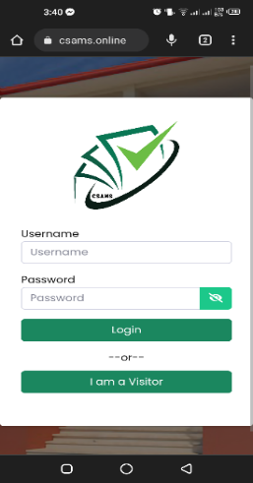

1. **Visitor’s Identification form**

The visitors must fill out the information given in the form. After clicking the submit button, the visitor moves to the next page or the health declaration form.

**

1. **Terms and Conditions**

If the user clicks the Terms and Condition, the user can view what the developed system acquired about their personal information which can be identified to these terms and condition. These terms and condition were presented for protection of both users and school.

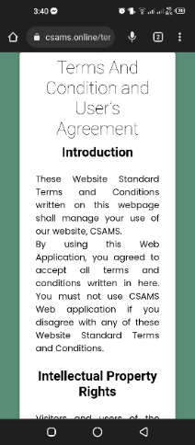

1. **Health Declaration Form**

After declaring the user’s information, it will proceed to health declaration form or for the contact tracing. This will help the nurse to identify which user needs some serious attention.

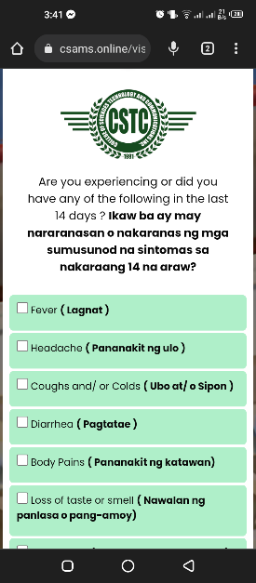

1. **Confirmation of Health Declaration Form**

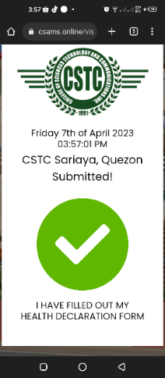After the visitors completed the identification and health declaration form it will show the approval passed to which the visitors can proceed to the school campus.

1. **Student’s Login**

For the student, they need to fill out their username and password to proceed to their designated accounts.



1. **Health Declaration Form**

Same as the visitors, the students also need to answer the health declaration form to proceed to their account.

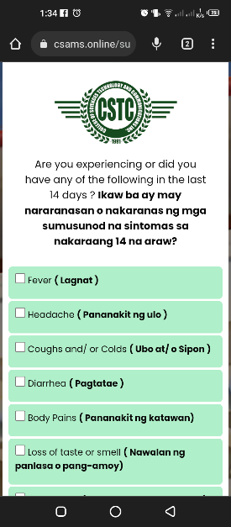

1. **Confirmation of Health Declaration Form**

After completing the Health Declaration form, it will show the approval form and the student can click the continue button to proceed to their accounts.

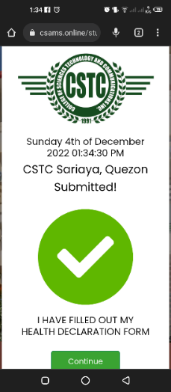

1. **Class Today**

Click the “Class Today” in the side panel to take you to your class today and have an attendance.

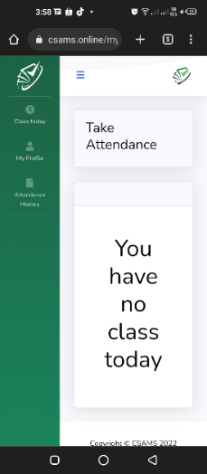

1. **Attendance**

If students have classes the “SCAN QR CODE” button will appear.

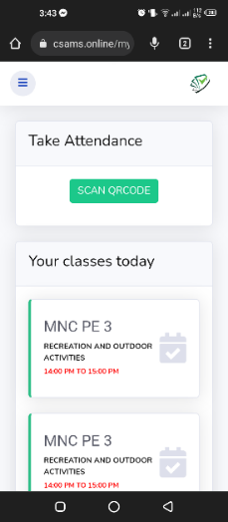

* After clicking the “SCAN QR CODE” button it will show the “Request Camera Permission” to open your camera and start scanning the QR Code given by the teacher to take attendance.

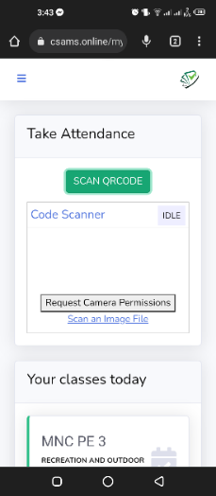

1. **My Profile**

If the students want to change their contact number and password, click My Profile in the side panel.

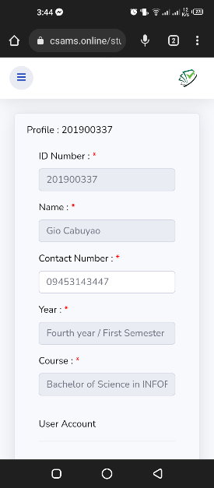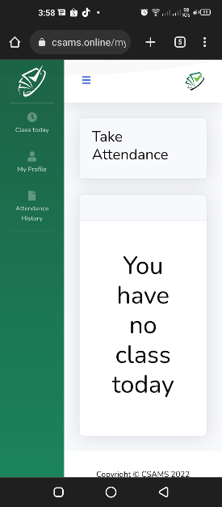

* The students can also see their subject list in the My Profile page.

1. **Attendance History**

By Clicking the Attendance History in the side panel, the students can view their attendance history.



1. **Class Today**

If the teacher has classed today their subject will appear in their dashboard and it will show the “Start Class”.



1. **Generated QR Code**

After the teacher starts the class, there is a QR Code that the student has to scan to take their attendance. The teacher can also view how many students that are present and absent.



* The teacher can also manually set present the student that has no gadget to scan the QR Code to take attendance.



1. **Subject List**

In the side panel it shows the “My Subject” to view their assign subject.



* After clicking the “My Subject” it will show their respective subject. Also, it will show the “VIEW STUDENTS” which shows the enrolled students in your subject.



* After clicking the “VIEW STUDENTS,” you can view the list of names students enrolled in their subject.



1. **Class History**

Click the “Class History” in the side panel to see the history of your class.

* The teacher can also view the students that is present, late and absent by clicking the “Student” button.



1. **Class History**

Click the “Class History” in the side panel to see the history of your class.

* The teacher can also view the students that is present, late and absent by clicking the “Student” button.





1. **My Profile**

Click the “My Profile” to see your ID Number, Name, Contact Number, Username, and Password. The teacher can also change their contact number and password in the “My Profile”.

1. **Logout**

To log out of your account, click the CSAMS logo in the right corner, and then the popup appears. After that, click the “Logout” button to log out of your account.



1. **Admin Dashboard**

The admin dashboard consists of Home, Account Management, Subject, and Setting. The admin can also view the number of registered admin, teachers, students, nurses, and all subjects.



* Click “Account Management” to create accounts and then select if student, teacher, or nurse.

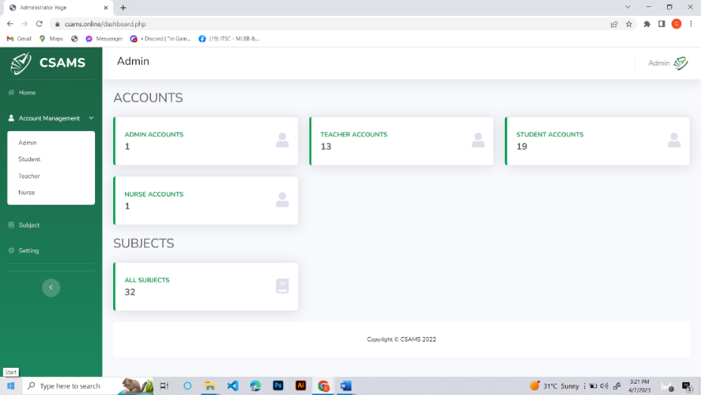

1. **Creating Account**

Click the “Add Student” button to create a new account for students.



* 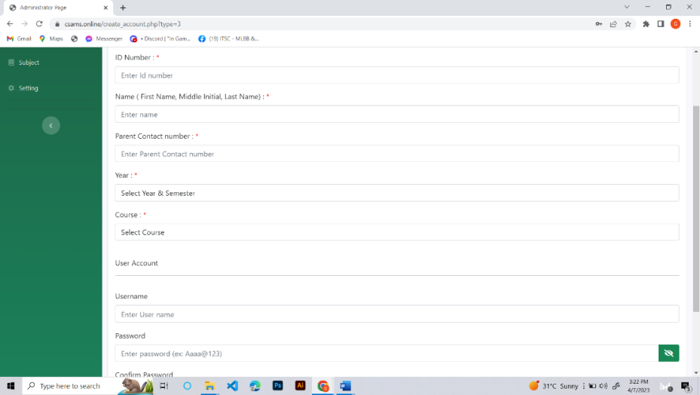Now, the registation form will appear and need to fill out the information given to create a student account.
* After you fill out the information, click the “Create Account” button to finish the registration of the user account.

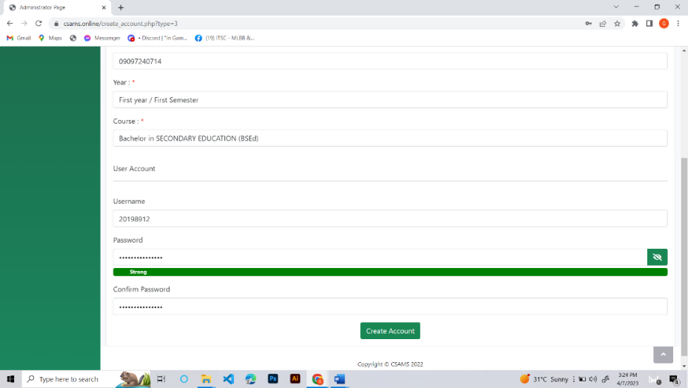

1. **Adding Subject to the Student**

To add subject in the students, click the “view” button.

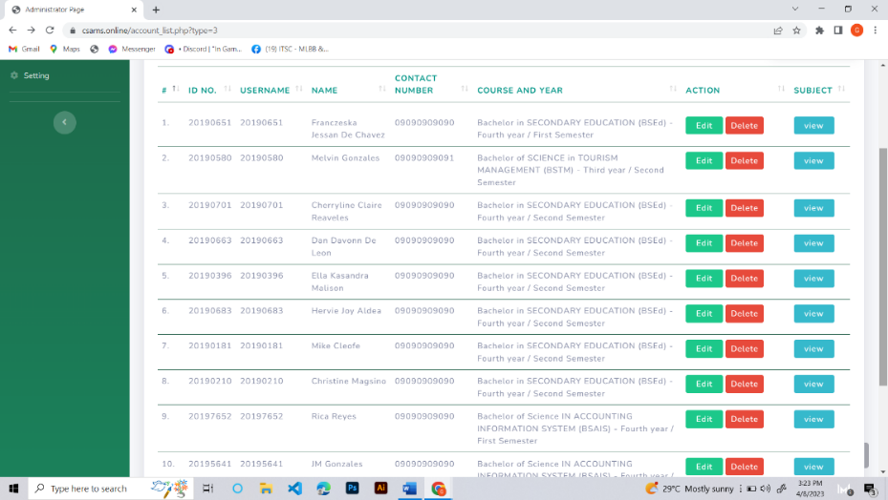

* Choose the subject in this drag-down and then click the “Add Subject” button to add the subject to the student’s account.



1. **Creating Subject**

Click “Subject” in the side panel to create a subject. After that, fill out the information given to complete the registration of the subject.

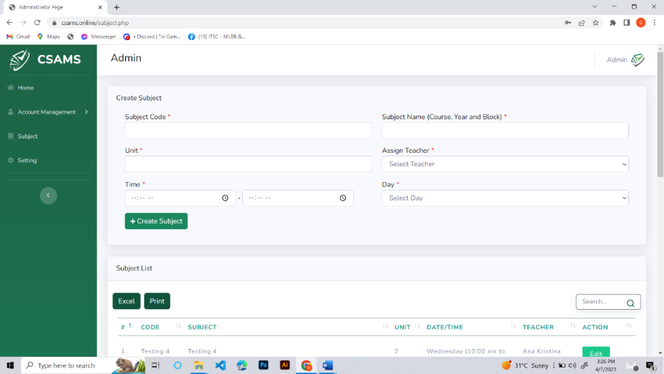

1. **Settings**

Click the “Settings” to view and change the contact number of the assigned nurses and guard. After inputting the contact numbers the admin can click the Update Settings to register their number.

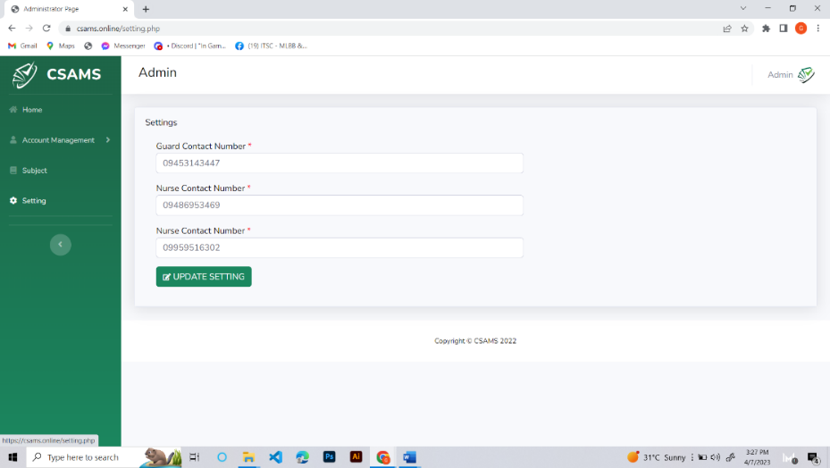

1. **Logout**

To log out your account, click the CSAMS logo in the right corner, and then the popup appears. After that, click the “Logout” button to log out of your account.

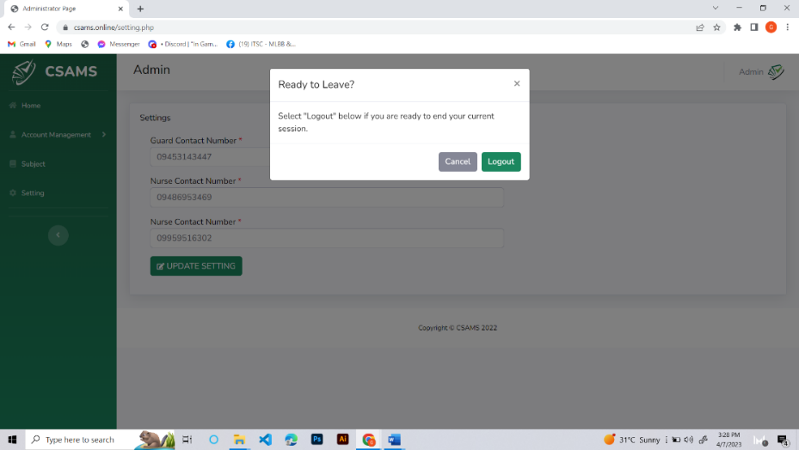

1. **Survey Customization**

In the nurse account the “Survey Customization” in the side panel is used for creating, editing and deleting survey questions.



* Click “Edit” button to edit the survey questions.

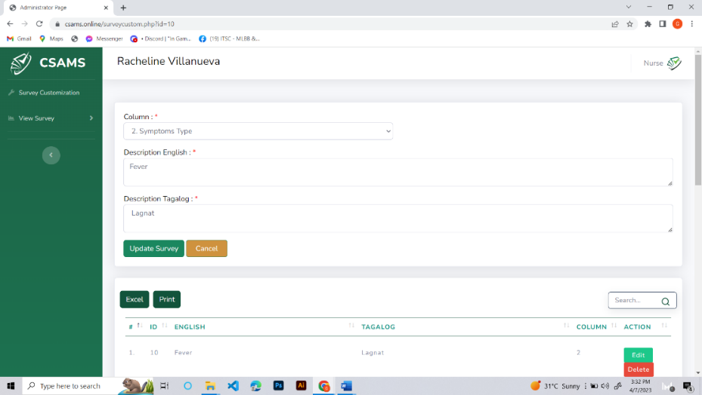

* Click the “Delete” button and then click “Yes” in the pop-up window for deleting survey questions.

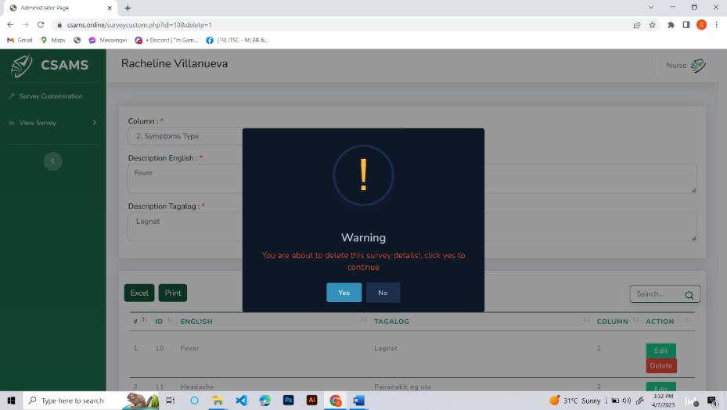

1. **Viewing user’s survey**

Moreover, in the View Survey it will show the “Students Survey” and “Visitors Survey”. After clicking either Students or Visitors Survey, it show the “view” button and by clicking it, the answered survey will appear.

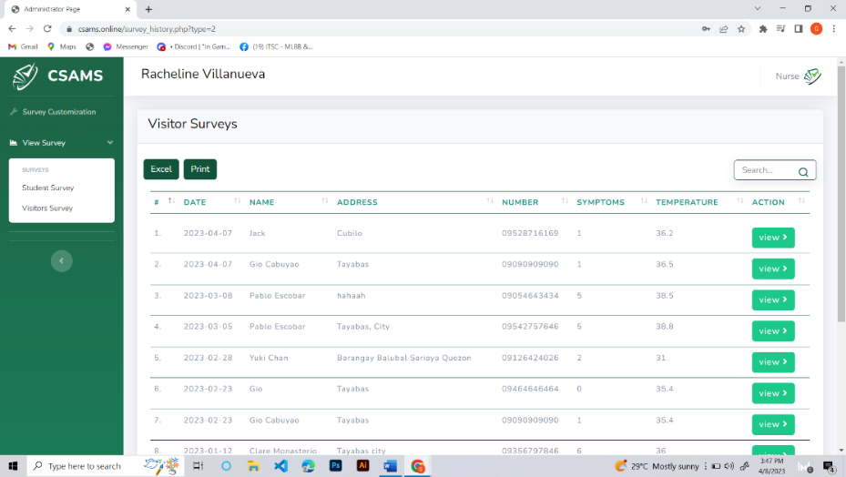

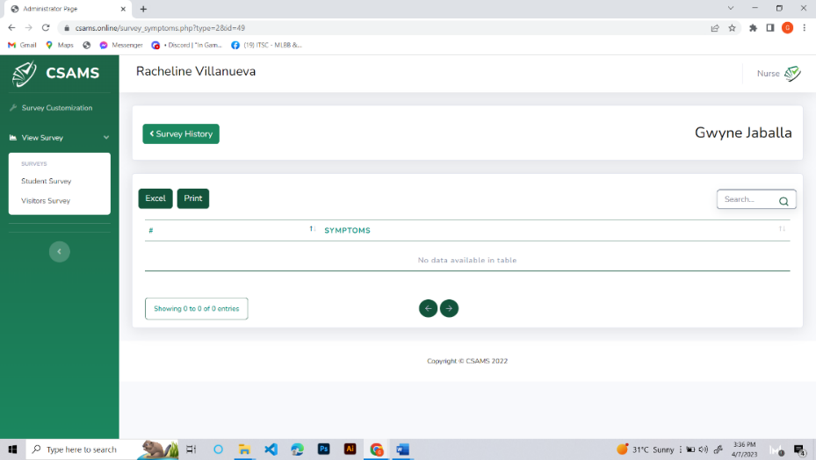

1. **Log out**

To log out your account, click the CSAMS logo in the right corner, and then the popup appears. After that, click the “Logout” button to log out of your account.

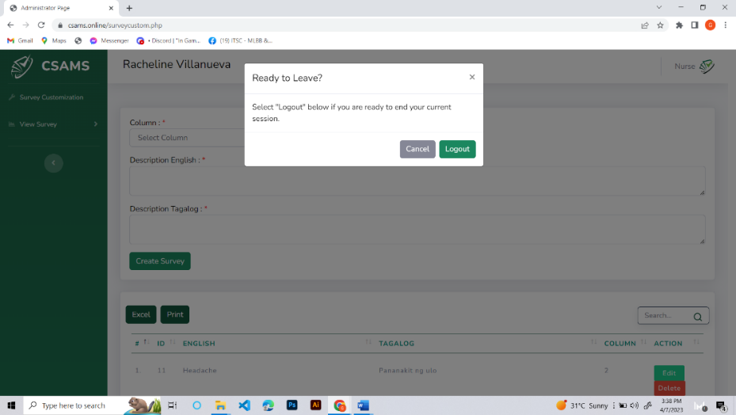

**Appendix “G”**

**NARRATIVE REPORT FOR SURVER**

On April 2022, the researcher started gathering information for their target client, the CSTC College of Sciences, Technology and Communications, Inc., according to Father Harris Iñigo they faced a major challenge in keeping track of student attendance during the COVID-19 pandemic. With the health and safety protocols in place, there was a need for a reliable and efficient attendance monitoring system that would also include contact tracing and notifications via SMS. This led to the development of a web-based attendance monitoring system called CSAMS.

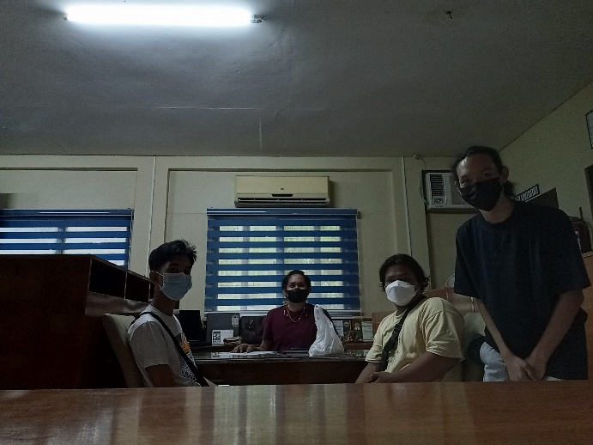

This developed web-based system was created and entitled "A Web-based Attendance Monitoring System with Contact Tracing and Notification via SMS using QR Code." The system's goal is to assist the school in automating its attendance monitoring procedure. Also, it will keep tabs on people's whereabouts and alert them if they come into contact with an infected person.

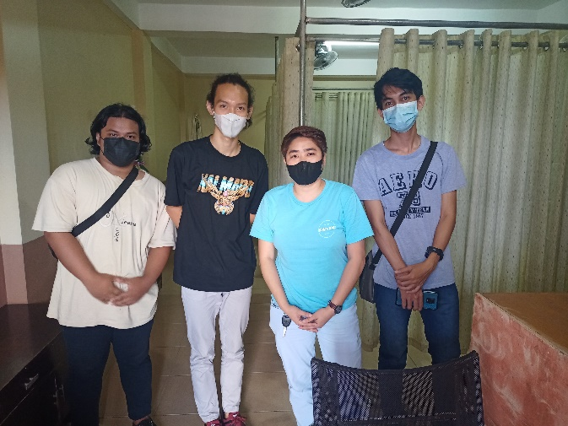

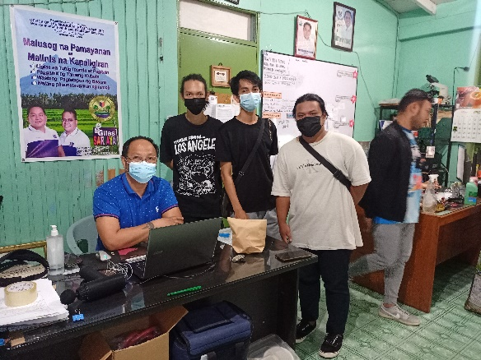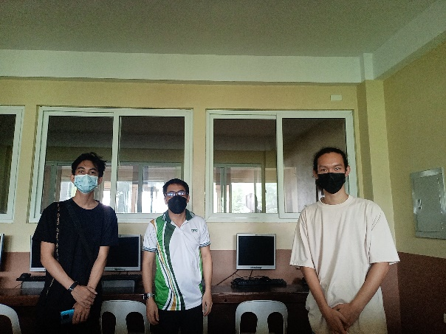

By May - June 2022, the researchers conducted a detailed understanding of the school's attendance monitoring and contact tracing procedure that served as the foundation for creating CSAMS, a web-based attendance monitoring system with contact tracing. To ascertain the needs and specifications for the system, the researchers conducted interviews with the admin, nurse, and LGU Sariaya to ensure that the created system is simple to use, effective, and reliable based on their feedback.

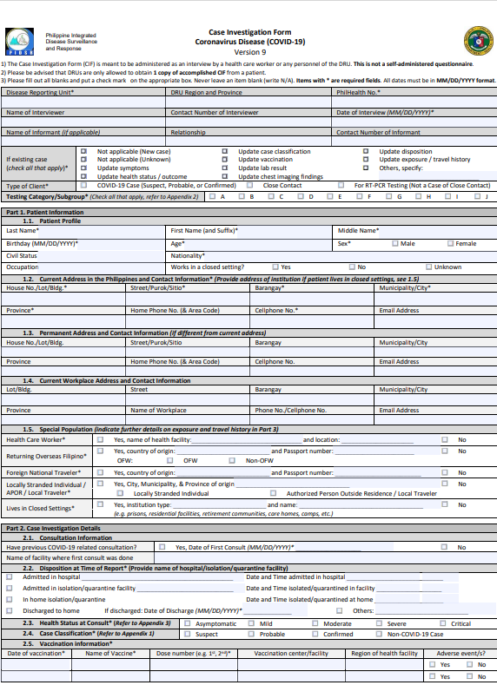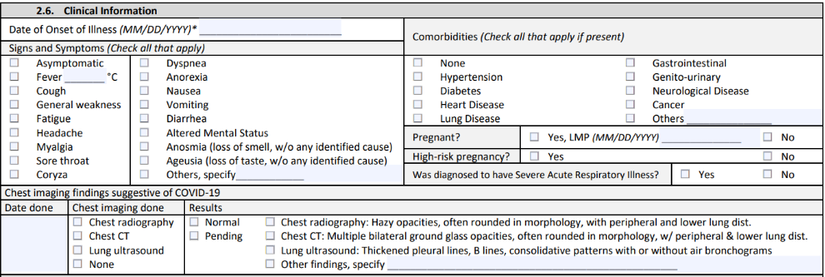

Also, the LGU provided the researchers their sample of case investigation form that is being used by the Disease Surveillance and Response Team when conducting a contact tracing interview. It was created under the approval of WHO which the IATF needs regarding the guidelines for doing contact tracing. The case investigation form is used for COVID-19 symptoms monitoring under the pretext of identifying the common indicator for identifying COVID-19 infected individuals. The Case Investigation Form above is tailored and used the 2.6 Clinical Information serving as the basis of the researchers to create the health declaration form for the developed web-based system.

In November – December 5 2022, the researchers introduced the CSAMS, a developed web-based system for tracking attendance that incorporates contact tracing and SMS alerting utilizing QR codes. This developed web-based system was intended to assist the CSTC College of Sciences, Technology, and Communications, Inc. in automating their attendance tracking process and implementing digital contact tracing in the college department. Additionally, the researchers created a web-based interface that lets users enter and view attendance data. A notification feature was also added to the system. The developed web-based system automatically sends an SMS notification to the nurses and guards if ever the students and visitors declare their status as they enter the school.

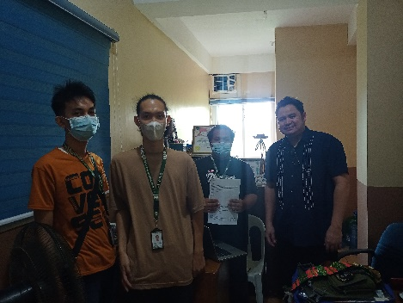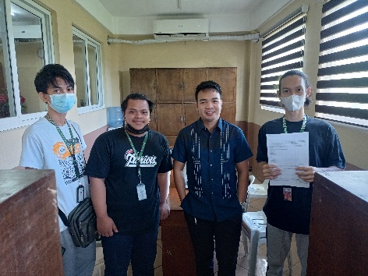

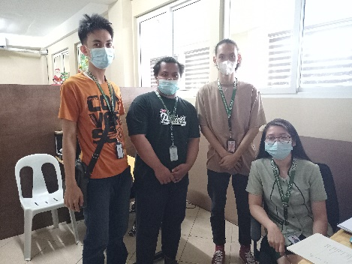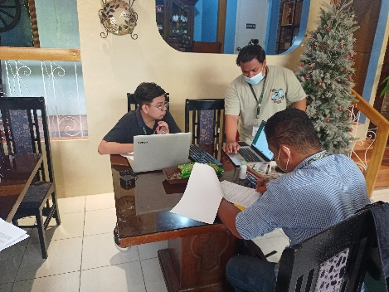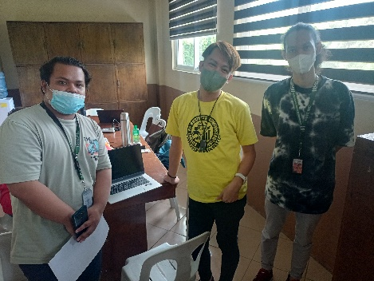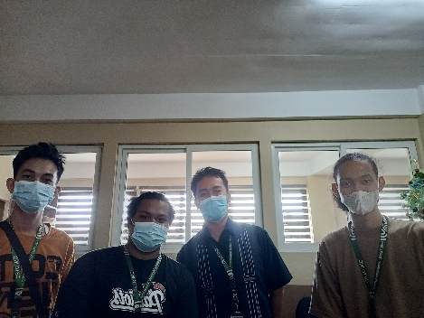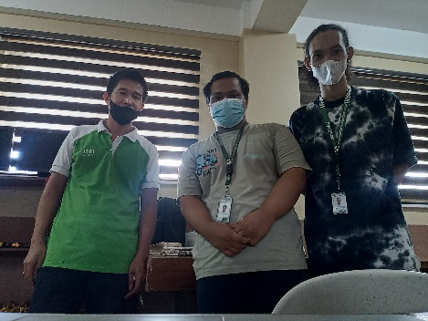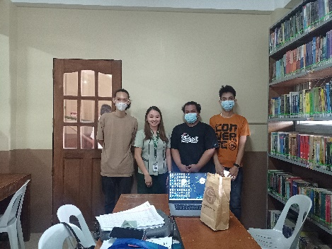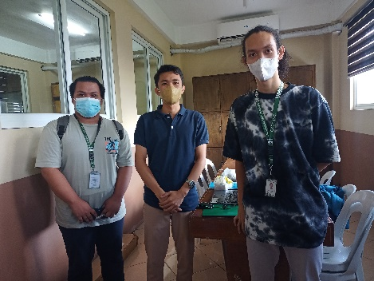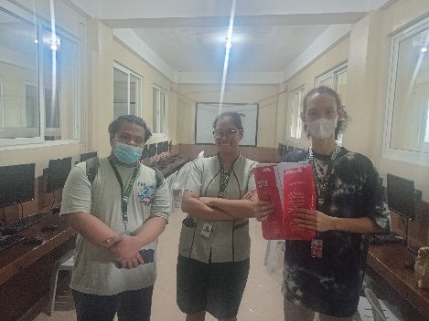

**Appendix “H”**

**DEFENSE PICTURE**

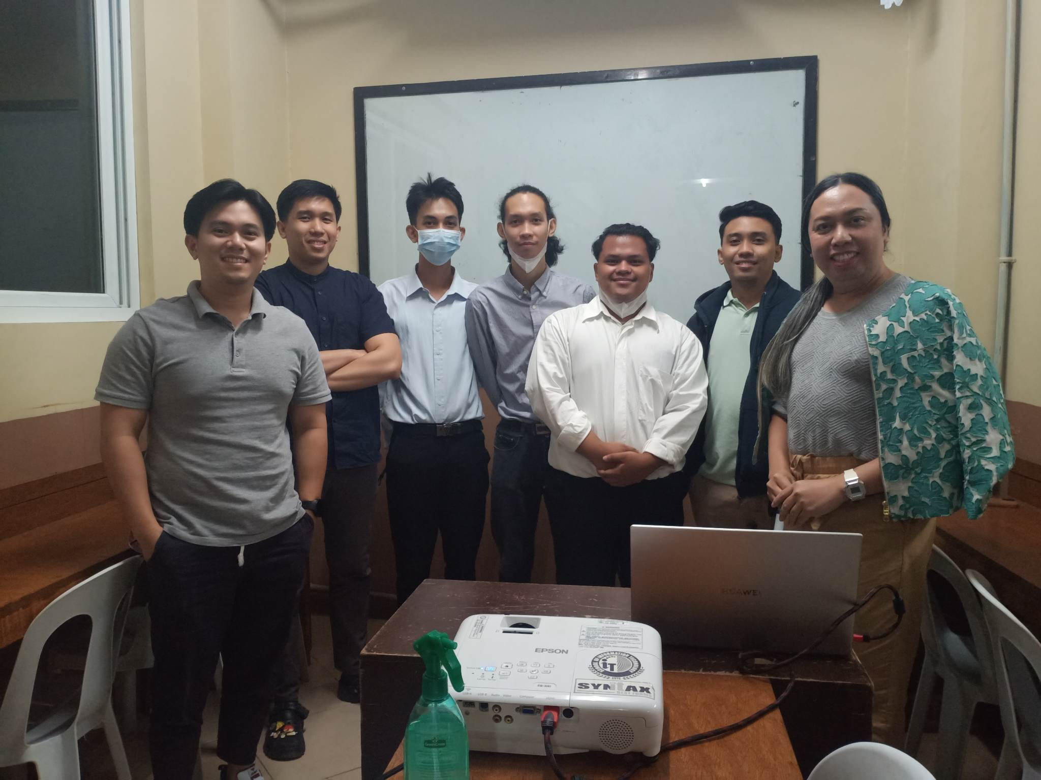

The final defense of the 4th-year BSIT students' Capstone Project was held on December 8, 2022, at 8:00 a.m. at the CSTC Inc. Sariaya Campus. The panel, consists of distinguished professionals in the field of information technology, brought their expertise and experience to the table, evaluating the student's work based on its technical, practical, and theoretical aspects, with the presence of Mr. Rhoderrick S. Carriaga, Engr. John C. Valdoria, and Mr. Mark Bryan Valencia, all MIT graduates, only added to the excitement and pressure of the occasion.

The researchers’ Capstone Project adviser, Jorge T. Jader, also played a vital role in guiding the team throughout the project's development. His insights and feedback helped ensure that the project met the required standards and addressed the needs of the target users.

The researchers presented their Capstone Project using a combination of slides and live demonstrations, showcasing the features and functionality of the developed web-based system. The panel asked the students various questions, including technical queries, design choices, and project management practices. The researchers answered confidently and impressively, displaying a depth of understanding and expertise beyond their academic years.

The defense allowed the researchers to showcase their technical skills, knowledge, and creativity. It was also a chance to demonstrate how their project could improve attendance monitoring, contact tracing, and communication within the CSTC College of Sciences, Technology, and Communications, Inc. The researcher’s success in completing their Capstone Project with such excellence reflected their dedication, perseverance, and passion for technology. It was also a testament to the quality of education and training the CSTC College of Sciences, Technology, and Communications, Inc provided.

Appendix “I”

**RELEVANT SOURCE CODE**

**Create User Account**

<?php

include('includes/header.php');

include('includes/navbar.php');

$type = "";

if ($_GET["type"] == 1){

$type = "Admin";

}else if ($_GET["type"] == 2){

$type = "Teacher";

}else if ($_GET["type"] == 3){

$type = "Student";

}else if ($_GET["type"] == 4){

$type = "Nurse";

}

$ut = $_GET["type"];

$account = new accounts;

$data = $account->getAllUser($ut);

?>

<div class="container-fluid">

<!-- DataTales Example -->

<div class="card shadow mb-4">

<div class="card-header py-3">

<div style="float:left"><?php echo $type; ?> List</div>

<div style="float:right">

<a type="button" class="btn btn-primary" href="create_account.php?type=<?php echo $_GET["type"]; ?>">

Add <?php echo $type?>

</a>

</div>

</div>

<div class="card-body mobile-card">

<table class="table table-bordered" id="datatable" width="100%" cellspacing="0">

<thead>

<tr>

<th>#</th>

<th>ID No.</th>

<th>Username</th>

<th>Name</th>

<th>Contact Number</th>

<?php if ($ut == 3){ ?>

<th>Course and Year</th>

<?php } ?>

<th class="notoExport" style="width:150px">Action</th>

<?php if ($ut == 3){ ?>

<th class="notoExport">SUBJECT</th>

<?php } ?>

</tr>

</thead>

<tbody>

<?php

$counter = 0;

while($rows = $data->fetch_assoc()){

++$counter;

?>

<td><?php echo $counter; ?>.</td>

<td><?php echo $rows['id_no']; ?></td>

<td><?php echo $rows['username']; ?></td>

<td><?php echo $rows['name']; ?></td>

<td><?php echo $rows['number']; ?></td>

<?php if ($ut == 3){ ?>

<td><?php echo $rows['course'].' - '.$rows['year']; ?></td>

<?php } ?>

<td>

<a href="update_user.php?id=<?= $rows['id']; ?>&type=<?php echo $ut; ?>" name="ebtn"

class="btn btn-success btn-sm">&nbsp;&nbsp;Edit&nbsp;&nbsp;</a>

</form>

<a href="?type=<?php echo $ut; ?>&id=<?= $rows['id']; ?>&delete=1" type="submit"

name="delete_student" value="<?= $rows['id'];?>"

class="btn btn-danger btn-sm">Delete</button>

</td>

<?php if ($ut == 3){ ?>

<td>

<a href="student_subject.php?studid=<?= $rows['id'];?>" type="submit" name="delete_student"

value="<?= $rows['id'];?>" class="btn btn-info btn-sm">&nbsp;&nbsp;view&nbsp;&nbsp;</button>

</td>

<?php } ?>

</tr>

<?php } ?>

</tbody>

</table>

</div>

</div>

</div>

</div>

</div>

</div>

<!-- /.container-fluid -->

<?php

include('includes/scripts.php');

include('includes/footer.php');

?>

**Attendance History**

<?php

include('includes/header.php');

include('includes/navbar.php');

$account = new accounts;

$attendance = $account->attendanceHistory();

?>

<div class="container-fluid">

<div class="card shadow mb-4">

<div class="card-header py-3">

<div style="float:left">Attendance History</div>

</div>

<div class="card-body mobile-card">

<table class="table table-bordered" id="datatable" width="100%" cellspacing="0">

<thead>

<tr>

<th>#</th>

<th>DATE</th>

<th>DAY</th>

<th>SUBJECT</th>

<th>TEACHER</th>

<th>TIME-IN</th>

<th>STATUS</th>

</tr>

</thead>

<tbody>

<?php $counter = 0; while($row = $attendance->fetch_assoc()){ ++$counter?>

<tr>

<td><?php echo $counter; ?>.</td>

<td><?php echo $row["date"]; ?></td>

<td><?php echo $row["day"]; ?></td>

<td><?php echo $row["subjectname"]; ?></td>

<td><?php echo $row["name"]; ?></td>

<td><?php echo $row["timein"]; ?></td>

<td>

<?php

if ($row["status"] == 0){

echo "<span class='btn btn-danger btn-sm'>Absent</span>";

}else if ($row["status"] == 1){

echo "<span class='btn btn-success btn-sm'>Present</span>";

}else if ($row["status"] == 2){

echo "<span class='btn btn-success btn-sm'>Late</span>";

}

?>

</td>

</tr>

<?php } ?>

</tbody>

</table>

</div>

</div>

</div>

<?php

include('includes/scripts.php');

include('includes/footer.php');

?>

<script>

$(document).ready(function() {

setTimeout(() => {

$(".pass").val("");

}, 300);

})

</script>

**Class History Code**

<?php

include('includes/header.php');

include('includes/navbar.php');

$account = new accounts;

$classes = $account->classHistory();

?>

<div class="container-fluid">

<div class="card shadow mb-4">

<div class="card-header py-3">

<div style="float:left">Class History</div>

</div>

<div class="card-body mobile-card">

<table class="table table-bordered" id="datatable" width="100%" cellspacing="0">

<thead>

<tr>

<th>#</th>

<th>DATE</th>

<th>SUBJECT</th>

<th>DAY</th>

<th>TIME</th>

<th class="notoExport">STUDENT</th>

</tr>

</thead>

<tbody>

<?php $counter = 0; while($row = $classes->fetch_assoc()){ ++$counter?>

<tr>

<td><?php echo $counter; ?>.</td>

<td><?php echo $row["date"]; ?></td>

<td><?php echo $row["subjectname"]; ?></td>

<td><?php echo $row["day"]; ?></td>

<td>

<?php

$timefrom = date_create($row["timefrom"]);

$timeto = date_create($row["timeto"]);

echo date_format($timefrom,"H:s a").' - '.date_format($timeto,"H:s a");

?>

</td>

<td>

<a href='student_attend.php?sid=<?php echo $row["sid"] ?>'

class='btn btn-primary btn-sm'>Student <i class="fa fa-angle-right"></i></a>

</td>

</tr>

<?php } ?>

</tbody>

</table>

</div>

</div>

</div>

<?php

include('includes/scripts.php');

include('includes/footer.php');

?>

<script>

$(document).ready(function() {

setTimeout(() => {

$(".pass").val("");

}, 300);

})

</script>

**Create Account Source Code**

<?php

include('includes/header.php');

include('includes/navbar.php');

$account = new accounts;

$classes = $account->classHistory();

?>

<div class="container-fluid">

<div class="card shadow mb-4">

<div class="card-header py-3">

<div style="float:left">Class History</div>

</div>

<div class="card-body mobile-card">

<table class="table table-bordered" id="datatable" width="100%" cellspacing="0">

<thead>

<tr>

<th>#</th>

<th>DATE</th>

<th>SUBJECT</th>

<th>DAY</th>

<th>TIME</th>

<th class="notoExport">STUDENT</th>

</tr>

</thead>

<tbody>

<?php $counter = 0; while($row = $classes->fetch_assoc()){ ++$counter?>

<tr>

<td><?php echo $counter; ?>.</td>

<td><?php echo $row["date"]; ?></td>

<td><?php echo $row["subjectname"]; ?></td>

<td><?php echo $row["day"]; ?></td>

<td>

<?php

$timefrom = date_create($row["timefrom"]);

$timeto = date_create($row["timeto"]);

echo date_format($timefrom,"H:s a").' - '.date_format($timeto,"H:s a");

?>

</td>

<td>

<a href='student_attend.php?sid=<?php echo $row["sid"] ?>'

class='btn btn-primary btn-sm'>Student <i class="fa fa-angle-right"></i></a>

</td>

</tr>

<?php } ?>

</tbody>

</table>

</div>

</div>

</div>

<?php

include('includes/scripts.php');

include('includes/footer.php');

?>

<script>

$(document).ready(function() {

setTimeout(() => {

$(".pass").val("");

}, 300);

})

</script>

**Edit Account Source Code**

<?php

session_start();

require 'dbconfig.php';

include('includes/header.php');

include('includes/navbar.php');

?>

<link href="https://cdn.jsdelivr.net/npm/bootstrap@5.1.3/dist/css/bootstrap.min.css" rel="stylesheet">

<div class="container mt-5">

<div class="row">

<div class="col-md-12">

<div class="card">

<div class="card-header">

<h4>Update Student Information

<a href="studentdashboard.php" class="btn btn-danger float-end">BACK</a>

</h4>

</div>

<div class="card-body">

<?php

if(isset($_GET['id']))

{

$id = mysqli_real_escape_string($connection, $_GET['id']);

$query = "SELECT * FROM student WHERE id='$id' ";

$query_run = mysqli_query($connection, $query);

if(mysqli_num_rows($query_run) > 0)

{

$student = mysqli_fetch_array($query_run);

?>

<form action="studcode.php" method="POST">

<div class="mb-3">

<label>Student Name</label>

<input type="text" name="name" value="<?=$student['name'];?>" class="form-control">

</div>

<div class="mb-3">

<label>Account Type</label>

<input type="text" name="usertype" value="<?=$student['usertype'];?>" class="form-control">

</div>

<div class="mb-3">

<label>ID Number</label>

<input type="text" name="id" value="<?=$student['id'];?>" class="form-control">

</div>

<div class="mb-3">

<label>Contact Number</label>

<input type="text" name="contact" value="<?=$student['contact'];?>" class="form-control">

</div>

<div class="mb-3">

<label>Course and Year</label>

<input type="text" name="course" value="<?=$student['course'];?>" class="form-control">

</div>

<div class="mb-3">

<label>Username</label>

<input type="text" name="username" value="<?=$student['username'];?>" class="form-control">

</div>

<div class="mb-3">

<label>Password</label>

<input type="text" name="password" value="<?=$student['password'];?>" class="form-control">

</div>

<button type="submit" name="update_student" class="btn btn-primary">Update</button>

</div>

</form>

<?php

}

else

{

echo "<h4>No Such Id Found</h4>";

}

}

?>

</div>

</div>

</div>

</div>

</div>

**Database Configuration Source Code**

<?php

class DatabaseAccount {

private $server_name = "localhost";

private $username = "u310295298_admin";

private $password = "Admin@12345";

private $db_name = "u310295298_csams";

protected $conn;

public function __construct(){

if (!headers_sent() && !isset($_SESSION)){ session_start(); }

if (isset($_SESSION["acount_user_id"])){

if ((time() - $_SESSION["last_login_timestamp"]) > 900) {

header("Location: actions/php/logout.php");

}else{

$_SESSION["last_login_timestamp"] = time();

}

}else{

header("Location: actions/php/logout.php");

}

$this->conn = new mysqli($this->server_name, $this->username, $this->password, $this->db_name);

if($this->conn->connect_error){

die("Unable to connect to database " . $this->db_name . ": " . $this->conn->connect_error);

}

}

}

class DatabaseLogin {

private $server_name = "localhost";

private $username = "u310295298_admin";

private $password = "Admin@12345";

private $db_name = "u310295298_csams";

protected $conn;

public function __construct(){

// if (!isset($_SESSION)){ session_start(); }

// if (isset($_SESSION["acount_user_id"])){

// if ((time() - $_SESSION["last_login_timestamp"]) > 900) {

// header("Location: actions/php/logout.php");

// }else{

// $_SESSION["last_login_timestamp"] = time();

// }

// }else{

// header("Location: actions/php/logout.php");

// }

$this->conn = new mysqli($this->server_name, $this->username, $this->password, $this->db_name);

if($this->conn->connect_error){

die("Unable to connect to database " . $this->db_name . ": " . $this->conn->connect_error);

}

}

}

Subject Creation Source Subject

<?php

session_start();

include('includes/header.php');

include('includes/navbar.php');

include('classes/accounts.php');

$account = new accounts;

$data = $account->getAllUser(2);

$subject = $account->getAllsubject(0);

$id = 0;

$code = "";

$name = "";

$unit = "";

$tf = "";

$tt = "";

$tid = "";

if (isset($_GET["delete"])){

$id = $_GET["id"];

$account->deleteSubject($id);

echo "<script>window.location.href = '/subject.php'</script>";

}else{

if (isset($_GET["id"])){

$datarow = $account->getAllsubject($_GET["id"]);

$subjectrow = $datarow->fetch_assoc();

$id = $subjectrow["id"];

$code = $subjectrow["subjectcode"];

$name = $subjectrow["subjectname"];

$unit = $subjectrow["unit"];

$tf = $subjectrow["timefrom"];

$tt = $subjectrow["timeto"];

$tid = $subjectrow["teacher_id"];;

}

}

?>

<div class="container-fluid">

<div class="card shadow mb-4">

<div class="card-header py-3">

Create Subject

<div class="card-body">

<form method="POST" action="actions/php/addUpdateSubject.php">

<div class="row">

<div class="col-sm-6">

<div class="form-group">

<p>

<input type="hidden" class="form-control" name="id" value="<?php echo $id ?>" />

Subject Code <span style="color:red">*</span></br>

<input type="text" class="form-control" value="<?php echo $code ?>" required

name="subjectcode" />

</p>

</div>

</div>

<div class="col-sm-6">

<div class="form-group">

<p>

Subject name <span style="color:red">*</span></br>

<input type="text" class="form-control" value="<?php echo $name ?>" required

name="subjectname" />

</p>

</div>

</div>

<div class="col-sm-3">

<div class="form-group">

<p>

Unit <span style="color:red">*</span></br>

<input type="number" required class="form-control" value="<?php echo $unit ?>"

required name="unit" />

</p>

</div>

</div>

<div class="col-sm-5">

<div class="form-group">

<p>

Time <span style="color:red">*</span></br>

<input type="time" name="timefrom" value="<?php echo $tf ?>" class="form-control"

style="width:45%; display:inline-block" /> -

<input type="time" name="timeto" value="<?php echo $tt ?>" required

class="form-control" style="width:45%; display:inline-block" />

</p>

</div>

</div>

<div class="col-sm-4">

<div class="form-group">

<p>

Assign Teacher <span style="color:red">*</span></br>

<select class="form-control" required name="teacher">

<option value="">>>select teacher<<< /option>

<?php while($row = $data->fetch_assoc()){ ?>

<option value="<?php echo $row["id"]; ?>"

<?php echo $row["id"] == $tid ? "selected='selected'" : "" ?>>

<?php echo $row["name"]; ?></option>

<?php } ?>

</select>

</p>

</div>

</div>

<div class="col-sm-4">

<?php if ($id > 0 ){ ?>

<button type="submit" class="btn btn-primary"><i class="fa fa-edit"

style="font-size:0.8em;"></i> Update Subject</button>

<a href="subject.php" type="button" class="btn btn-primary"><i class="fa fa-arrow-left"

style="font-size:0.8em;"></i> &nbsp;&nbsp; Cancel &nbsp; &nbsp;</a>

<?php } ?>

<?php if ($id == 0 ){ ?>

<button type="submit" class="btn btn-primary"><i class="fa fa-plus"

style="font-size:0.8em;"></i> Create Subject</button>

<?php } ?>

</div>

</div>

</form>

</div>

</div>

</div>

<div class="card shadow mb-4">

<div class="card-header py-3">

<div style="float:left">Subject List</div>

</div>

<div class="card-body">

<table class="table table-bordered" id="datatable" width="100%" cellspacing="0">

<thead>

<tr>

<th>#</th>

<th>CODE</th>

<th>SUBJECT</th>

<th>UNIT</th>

<th>TIME</th>

<th>TEACHER</th>

<th>ACTION</th>

</tr>

</thead>

<tbody>

<?php $counter = 0; while($row = $subject->fetch_assoc()){ ++$counter?>

<tr>

<td><?php echo $counter; ?>.</td>

<td><?php echo $row["subjectcode"]; ?></td>

<td><?php echo $row["subjectname"]; ?></td>

<td><?php echo $row["unit"]; ?></td>

<td>

<?php

$timefrom = date_create($row["timefrom"]);

$timeto = date_create($row["timeto"]);

echo date_format($timefrom,"H:s a").' to '.date_format($timeto,"H:s a");

?>

</td>

<td><?php echo $row["name"]; ?></td>

<td>

<a href="?id=<?php echo $row['id']; ?>" name="ebtn" class="btn btn-success btn-sm"

style="padding:5px 17px">Edit</a>

</form>

<a href="?id=<?php echo $row['id']; ?>&delete=1" name="delete_student"

class="btn btn-danger btn-sm">Delete</button>

</td>

</tr>

<?php } ?>

</tbody>

</table>

</div>

</div>

</div>

<?php

include('includes/scripts.php');

include('includes/footer.php');

?>

Survey History Source Code

<?php

include('includes/header.php');

include('includes/navbar.php');

$account = new accounts;

$type = 0;

if (isset($_GET["type"])){

$type = $_GET["type"];

}

$survey = $account->getAllSubmitSurvey($type);

?>

<div class="container-fluid">

<div class="card shadow mb-4">

<div class="card-header">

<?php

if ($type == 1){

echo "<h4>Student Surveys</h4>";

}else if ($type == 2){

echo "<h4>Visitor Surveys</h4>";

}

?>

</div>

<div class="card-body mobile-card">

<table class="table table-bordered" id="datatable" width="100%" cellspacing="0">

<thead>

<?php if ($type == 1){ ?>

<tr>

<th>#</th>

<th>DATE</th>

<th>ID</th>

<th>STUDENT</th>

<th>COURSE</th>

<th>YEAR</th>

<th>NUMBER</th>

<th>SYMPTOMS</th>

<th class="notoExport">action</th>

</tr>

<?php } ?>

<?php if ($type == 2){ ?>

<tr>

<th>#</th>

<th>DATE</th>

<th>NAME</th>

<th>ADDRESS</th>

<th>NUMBER</th>

<th>SYMPTOMS</th>

<th>TEMPERATURE</th>

<th class="notoExport">action</th>

</tr>

<?php } ?>

</thead>

<tbody>

<?php

$student = 0;

$visitor = 0;

while($row = $survey->fetch_assoc()){

if ($type == 1) { ++$student;?>

<tr>

<td><?php echo $student; ?>.</td>

<td><?php echo $row["date"]; ?></td>

<td><?php echo $row["id_no"]; ?></td>

<td><?php echo $row["name"]; ?></td>

<td><?php echo $row["course"]; ?></td>

<td><?php echo $row["year"]; ?></td>

<td><?php echo $row["number"]; ?></td>

<td><?php echo $row["survey"]; ?></td>

<td class="notoExport">

<a href="survey_symptoms.php?type=1&id=<?php echo $row["id"]; ?>" class="btn btn-success"> view <i class="fa fa-angle-right"></i></a>

</td>

</tr>

<?php }else if ($type == 2) { ++$visitor; ?>

<tr>

<td><?php echo $visitor; ?>.</td>

<td><?php echo $row["date"]; ?></td>

<td><?php echo $row["name"]; ?></td>

<td><?php echo $row["address"]; ?></td>

<td><?php echo $row["number"]; ?></td>

<td><?php echo $row["survey"]; ?></td>

<td><?php echo $row["temp"]; ?></td>

<td>

<a href="survey_symptoms.php?type=2&id=<?php echo $row["id"]; ?>" class="btn btn-success"> view <i class="fa fa-angle-right"></i></a>

</td>

</tr>

<?php } } ?>

</tbody>

</table>

</div>

</div>

</div>

<?php

include('includes/scripts.php');

include('includes/footer.php');

?>

**Appendix “J”**

**TEST CASE DOCUMENT FOR ADMIN DASHBOARD**

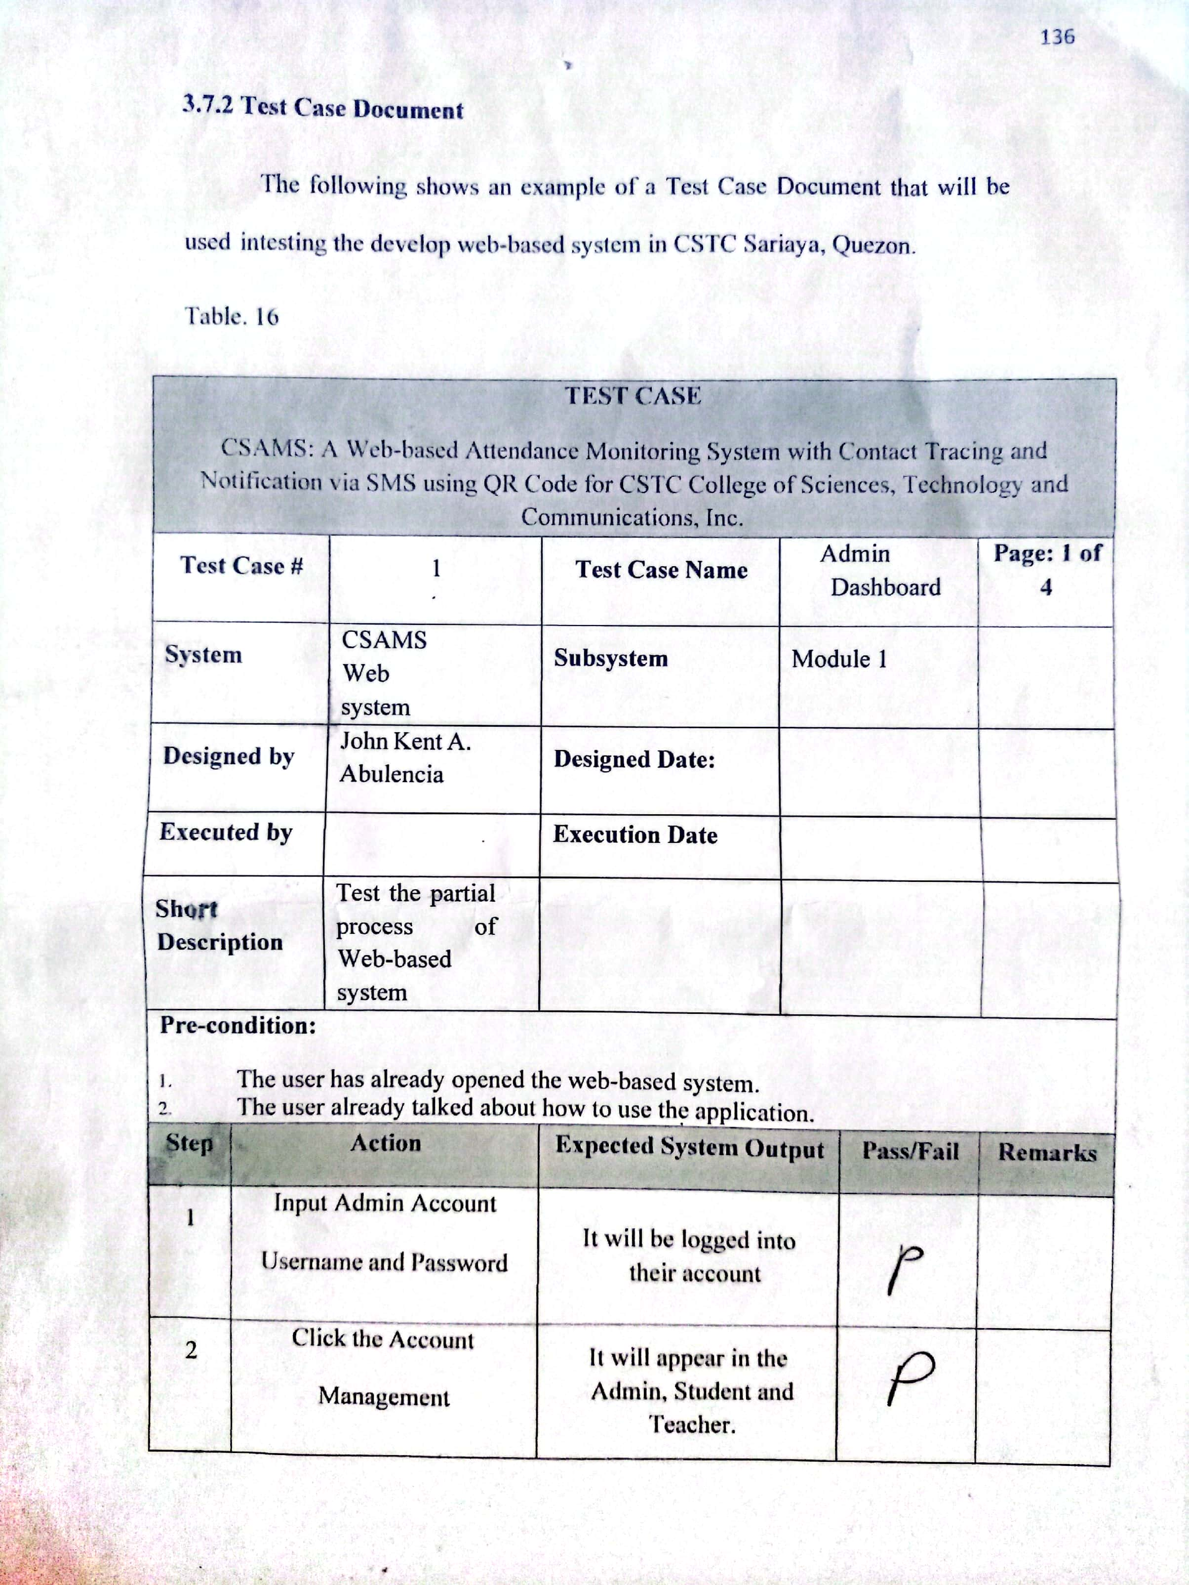

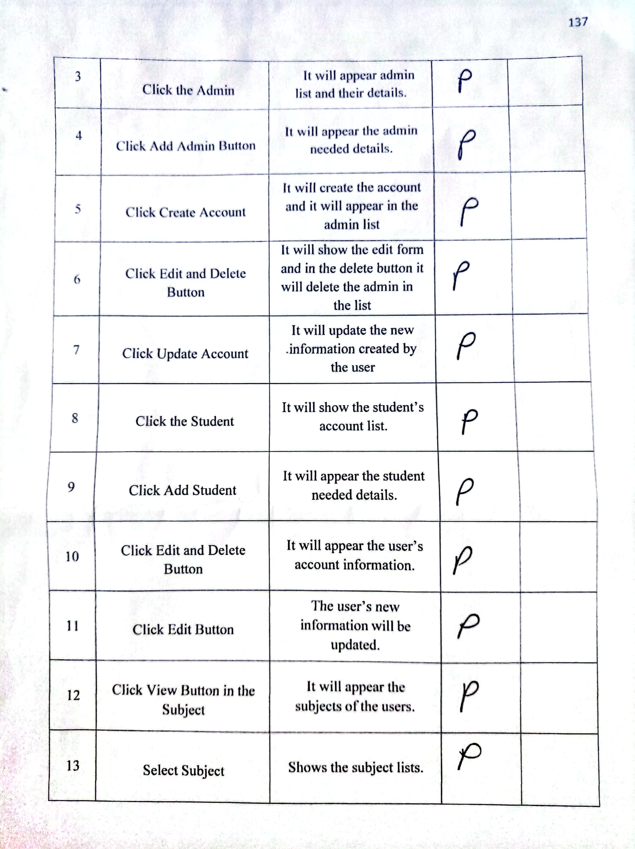

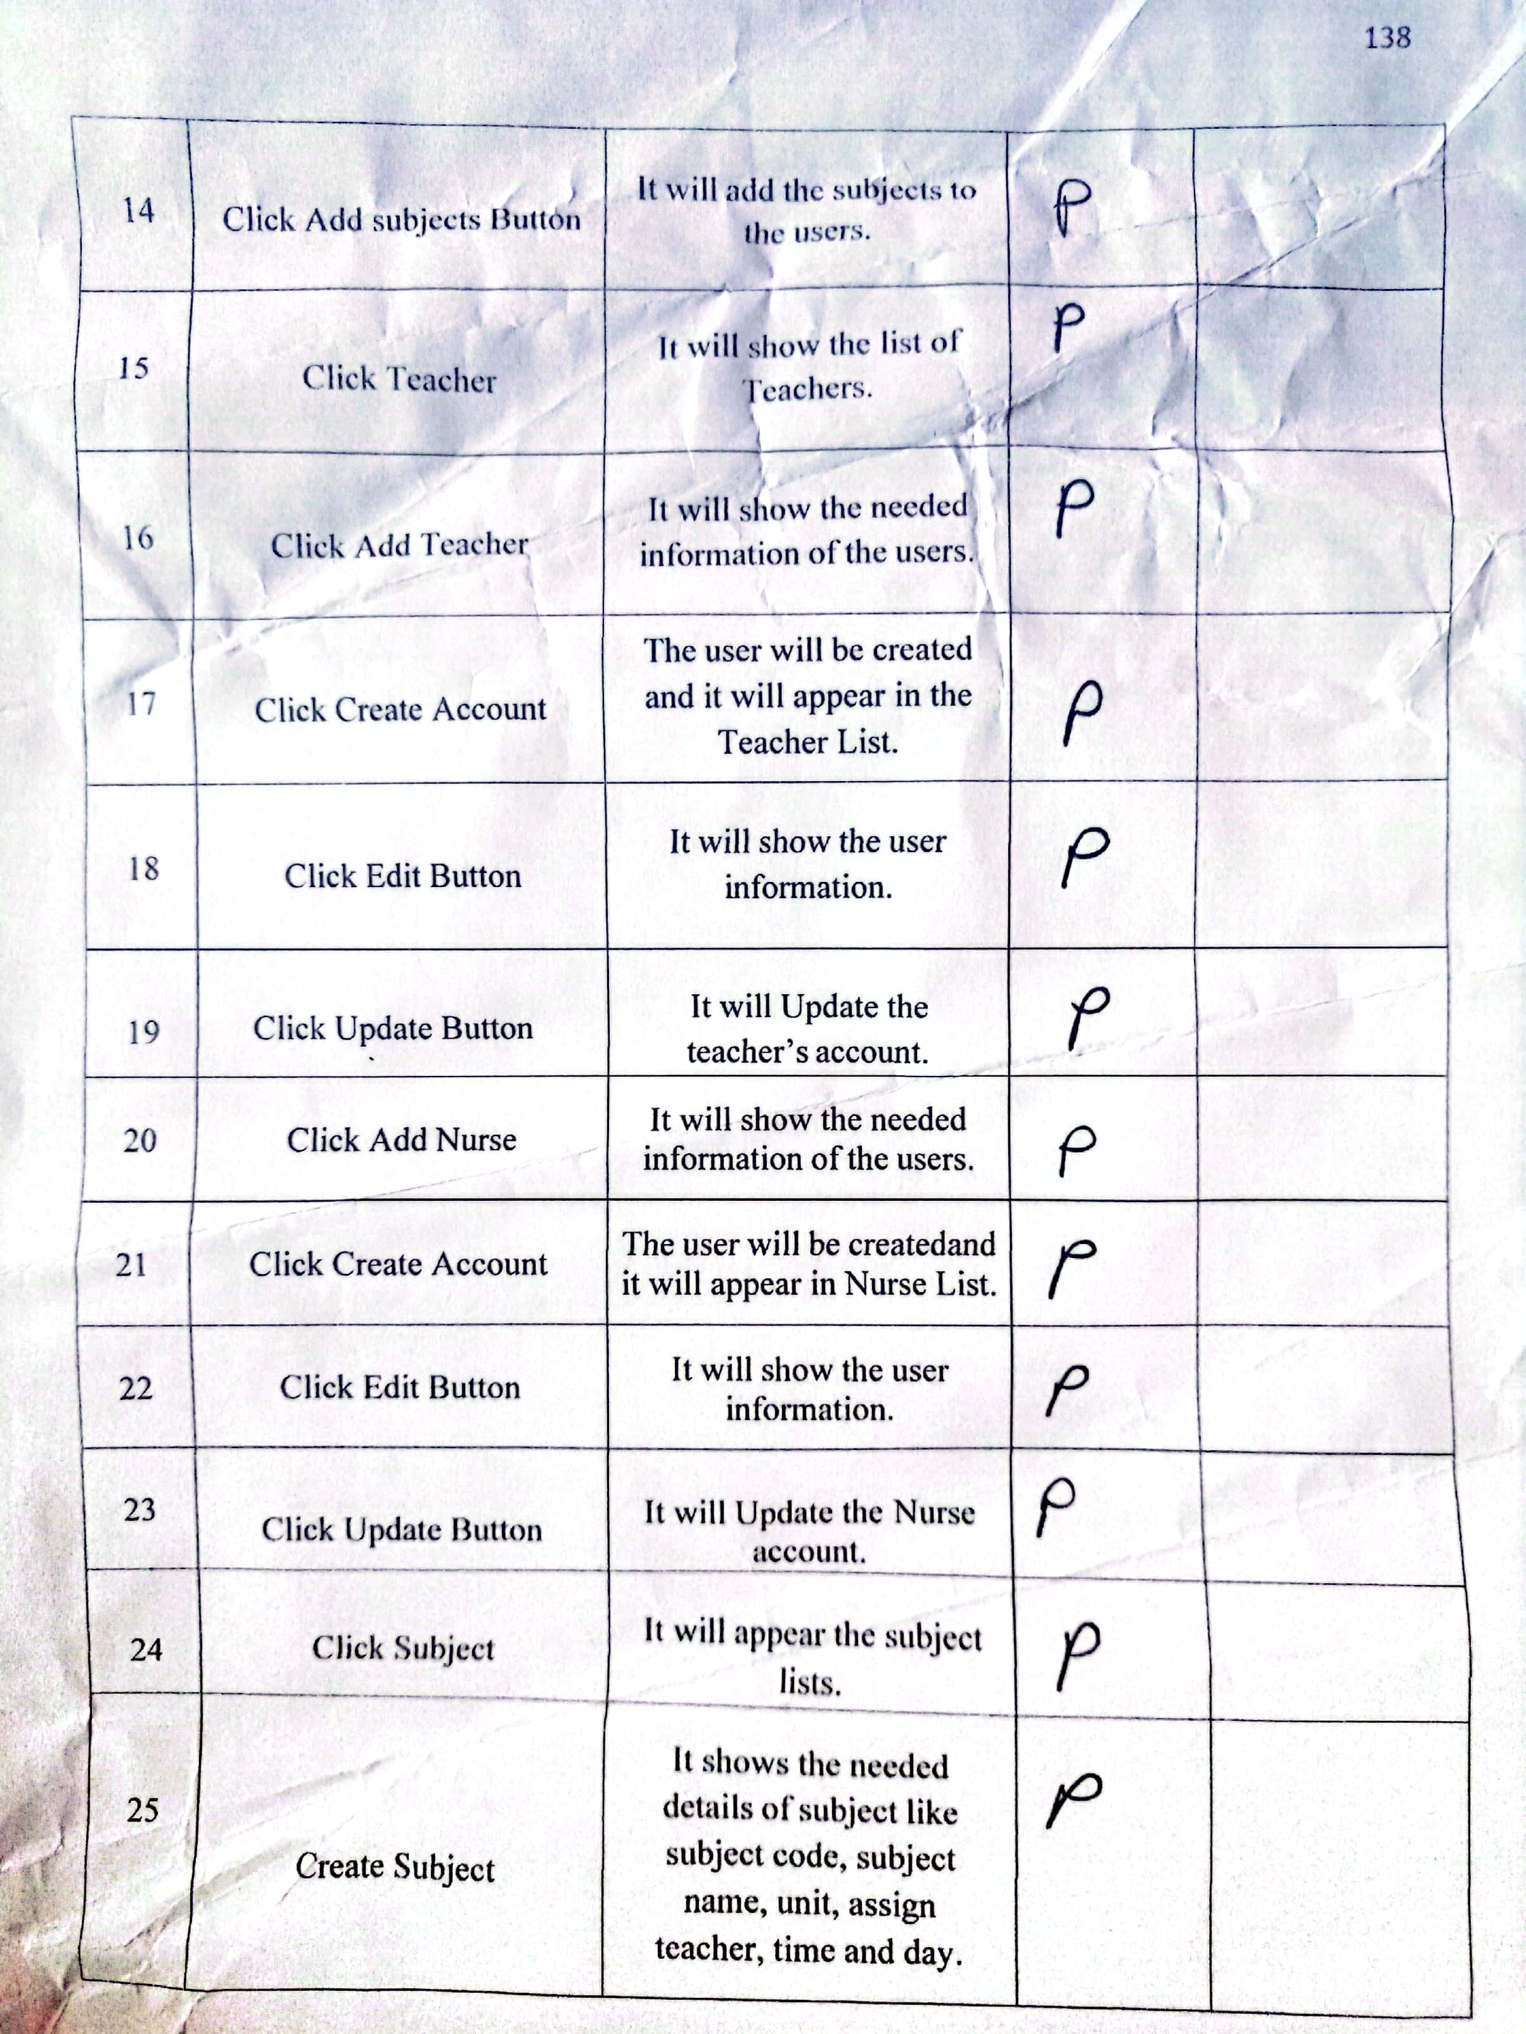

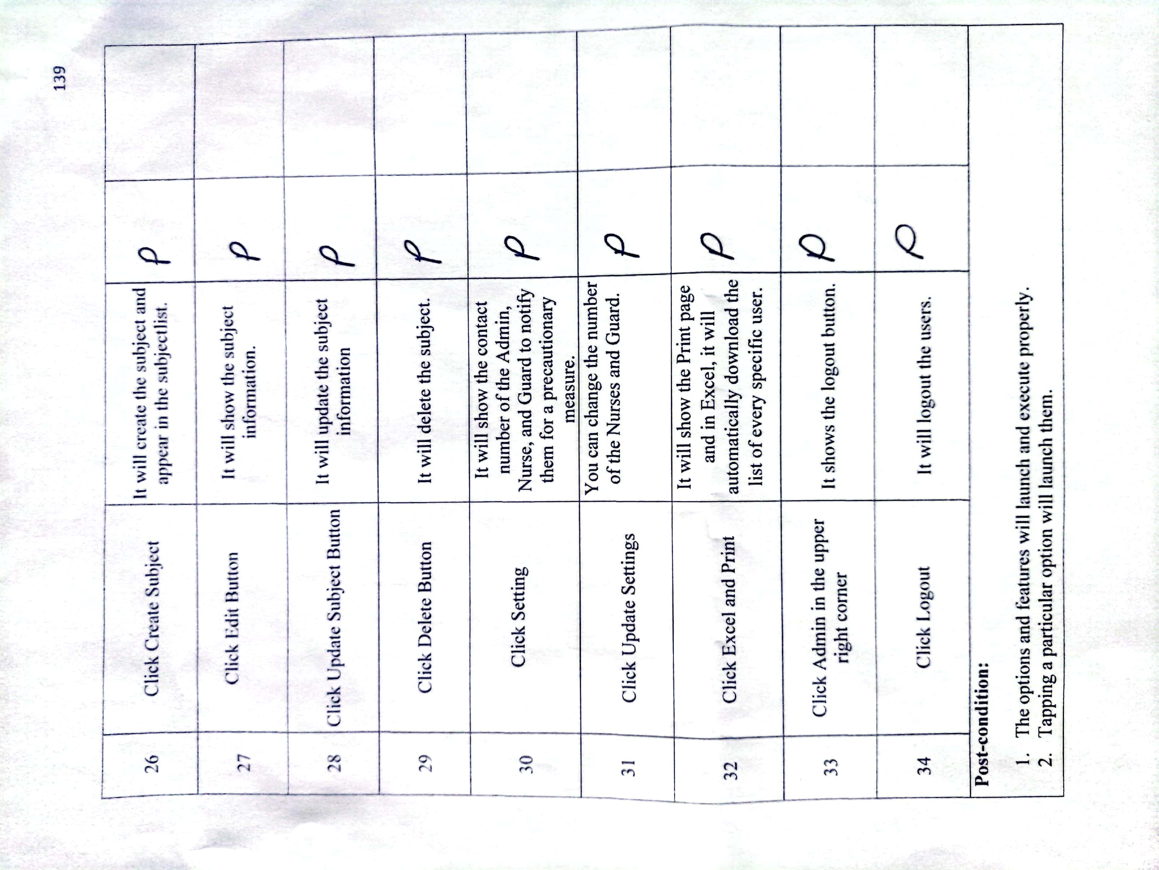

**TEST CASE DOCUMENT FOR VISITOR PANEL**

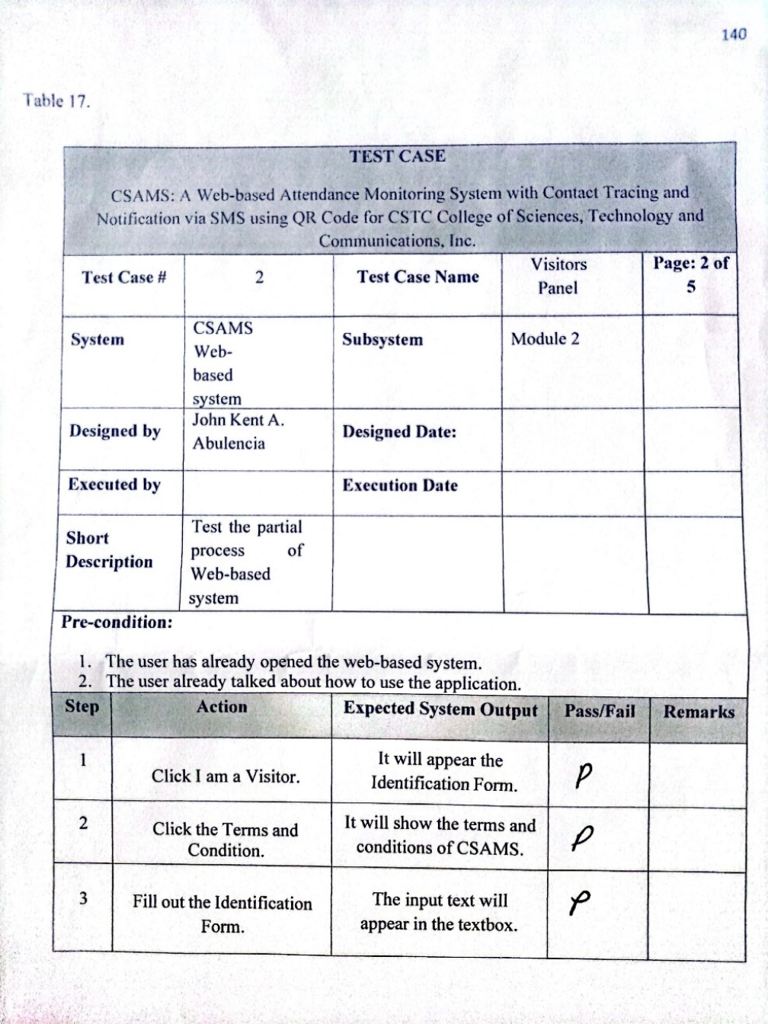

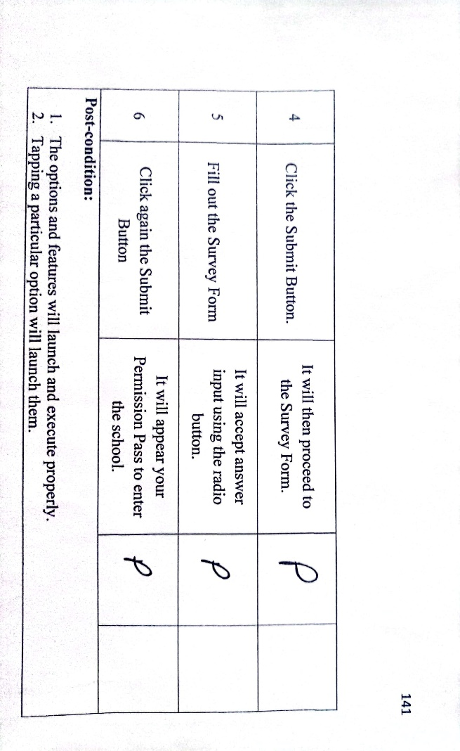

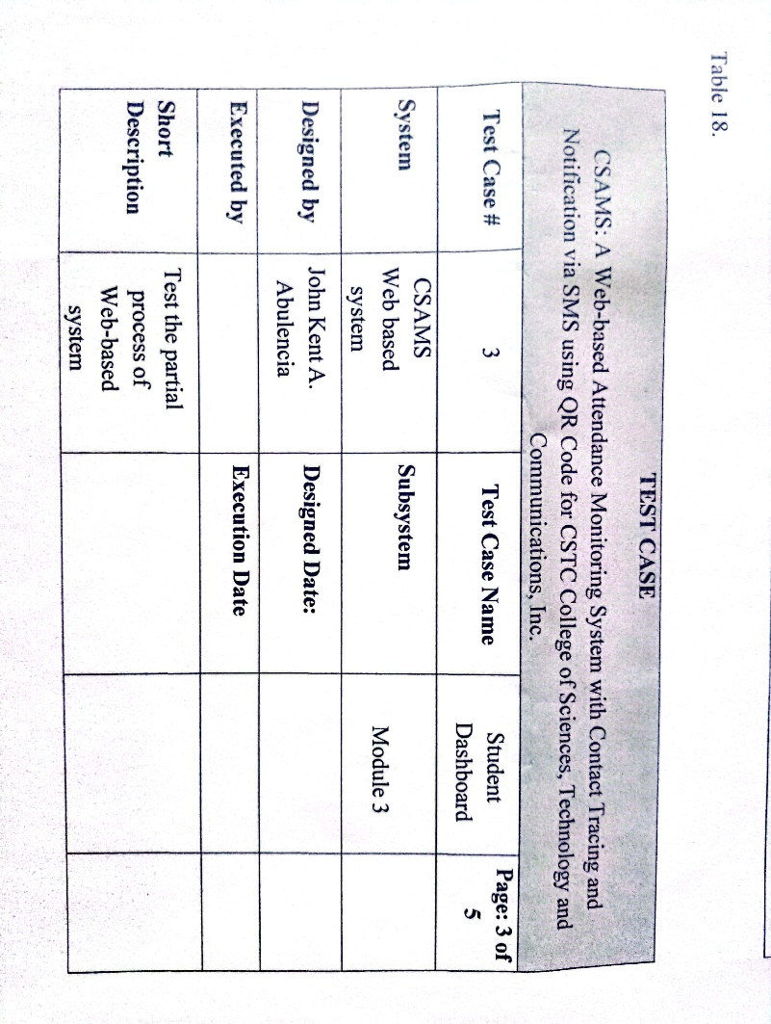**TEST CASE DOCUMENT FOR STUDENT DASHBOARD**

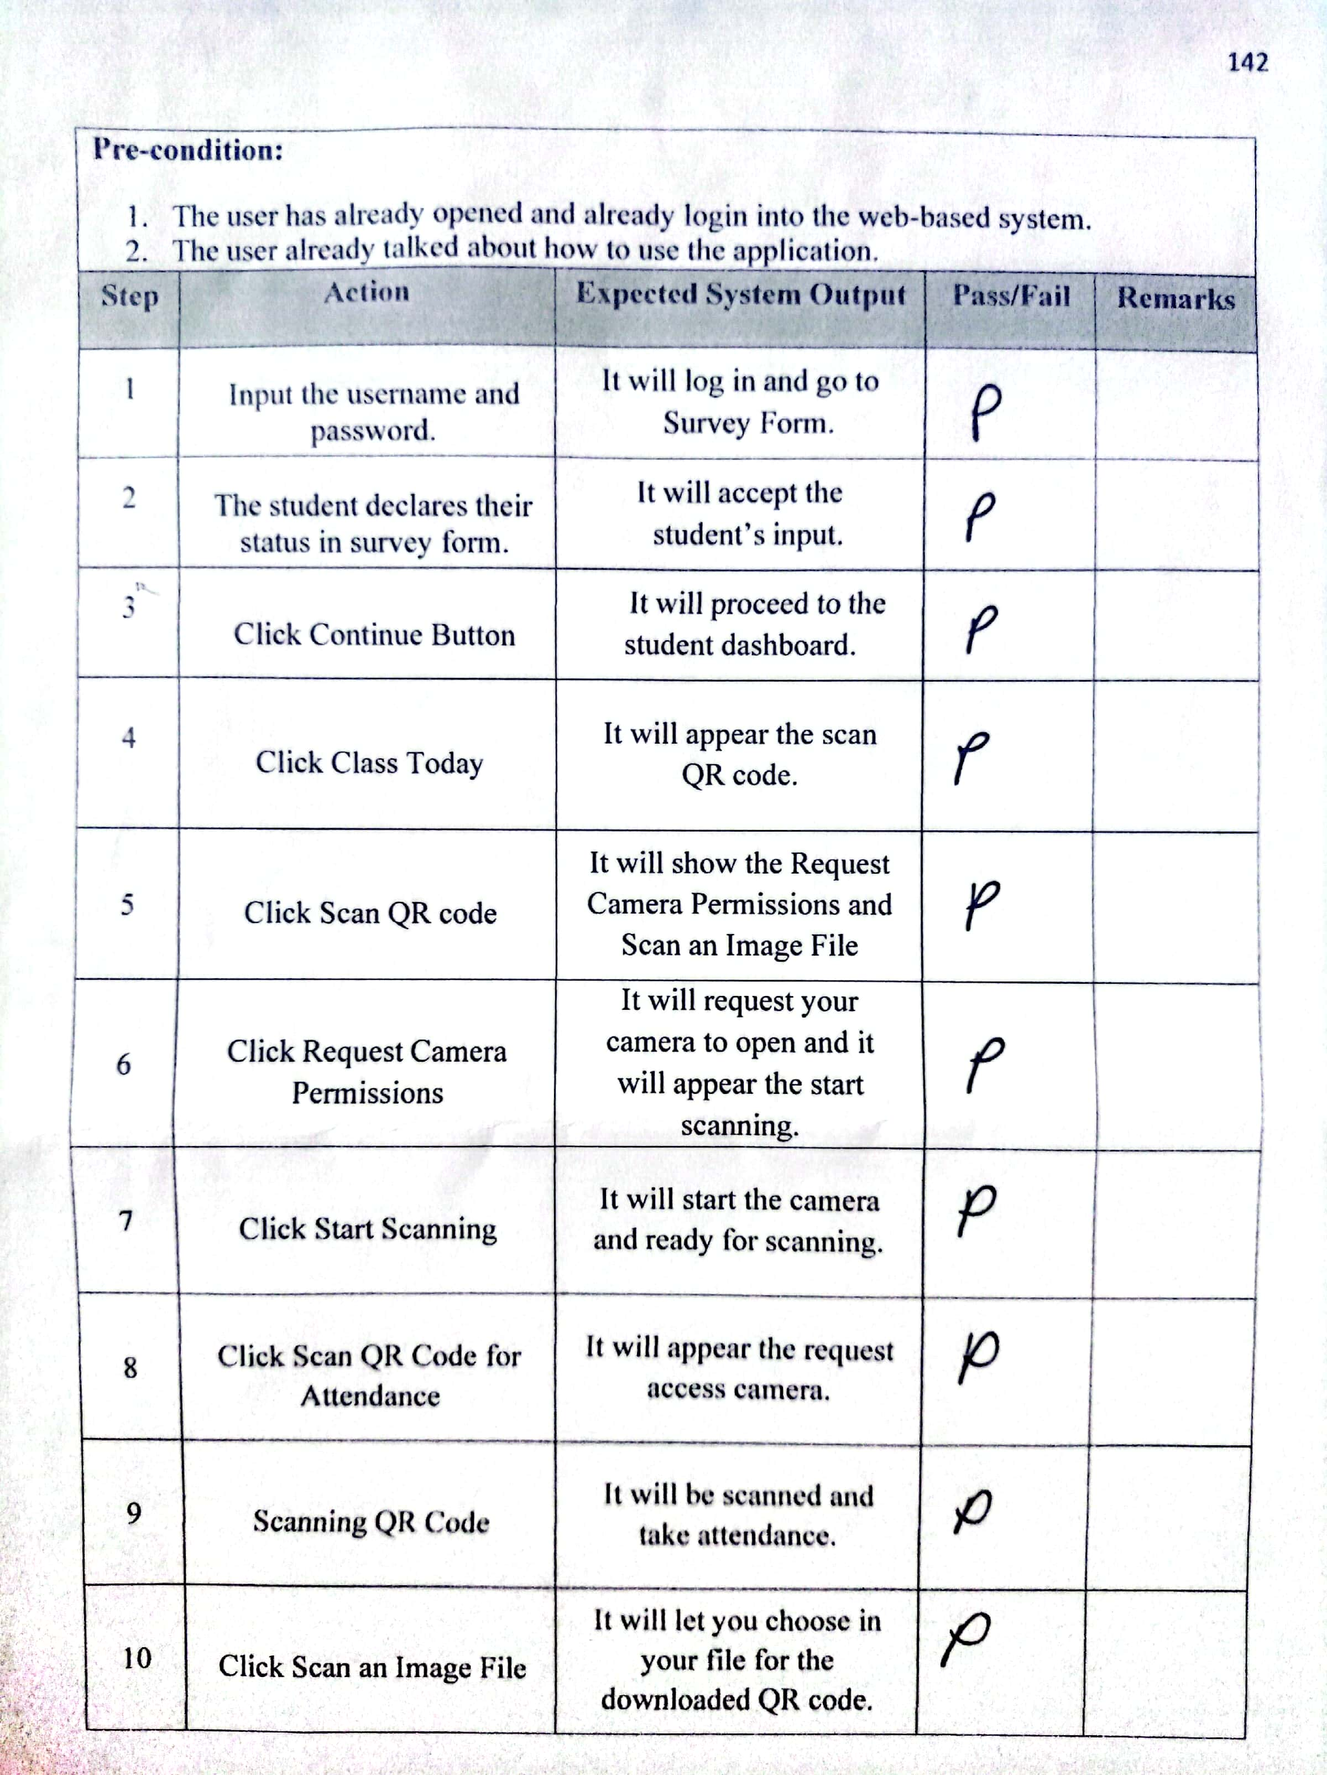



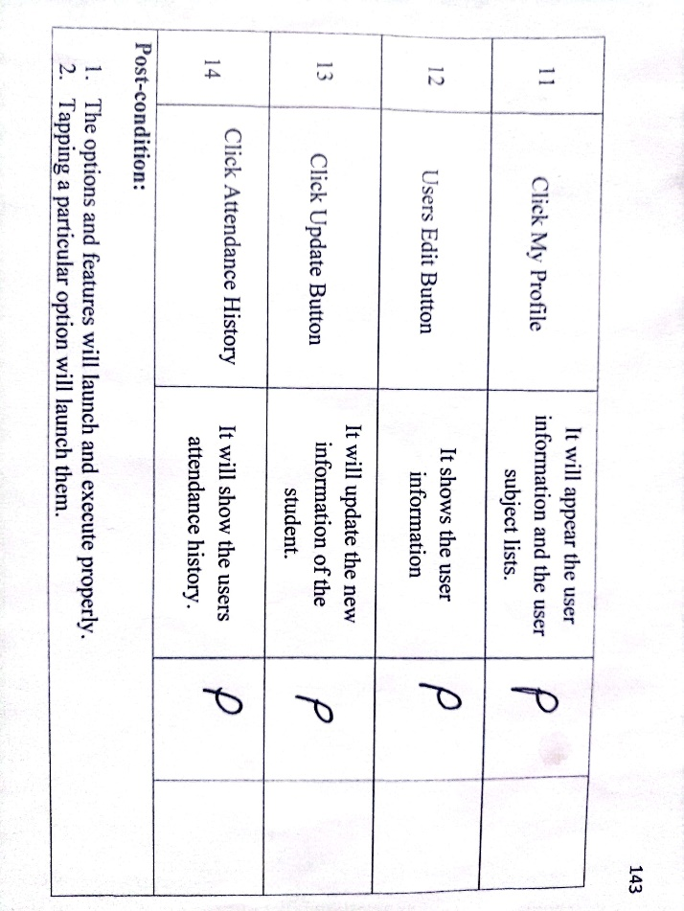

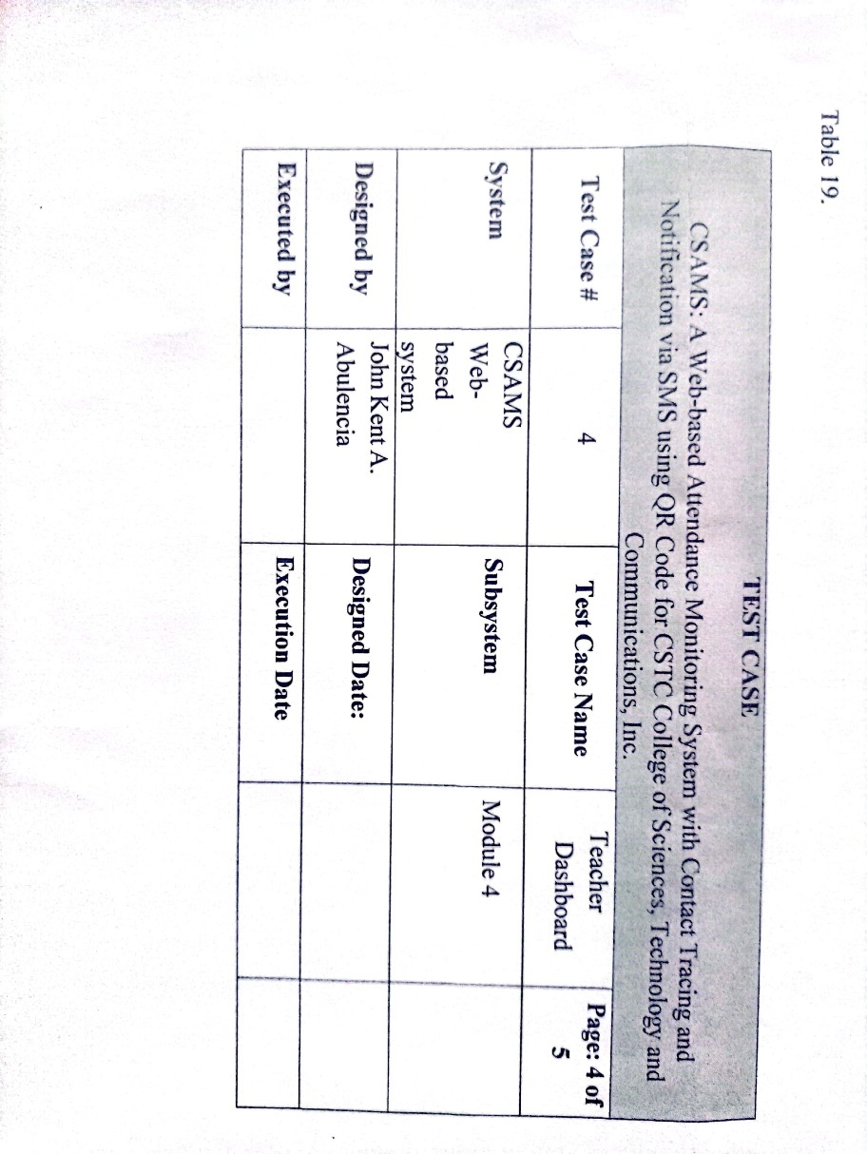**TEST CASE DOCUMENT FOR TEACHER DASHBOARD**

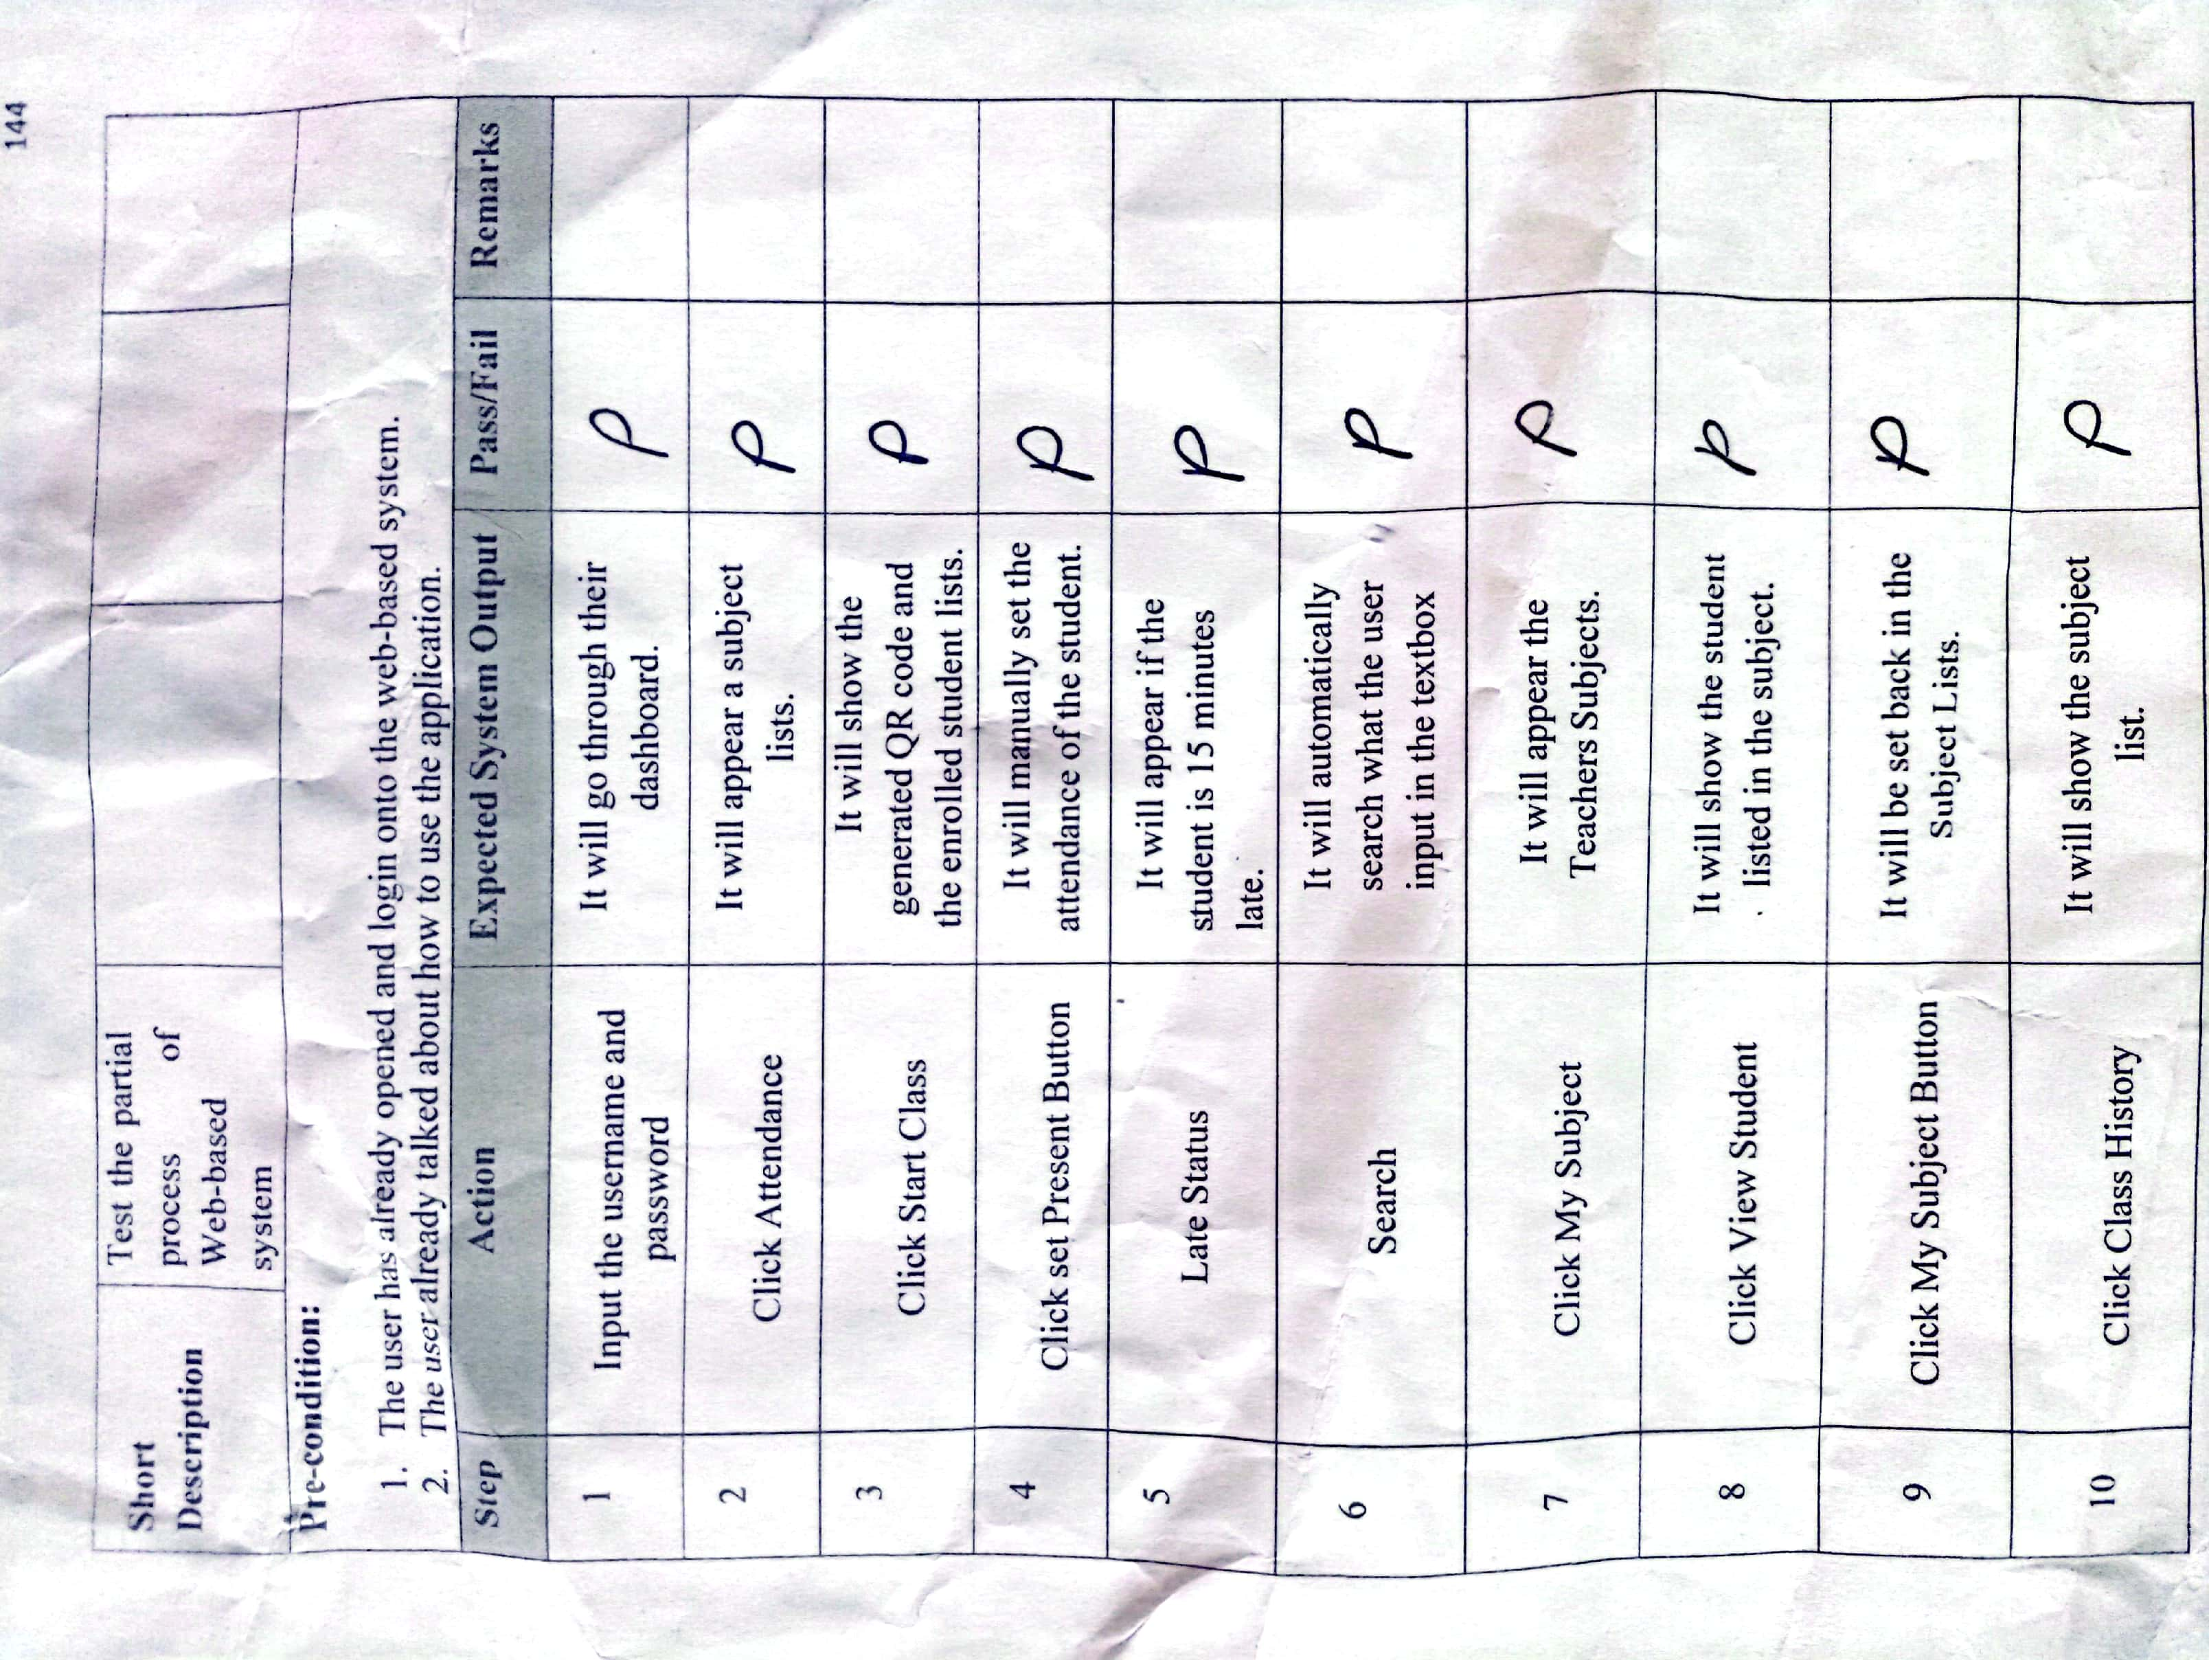

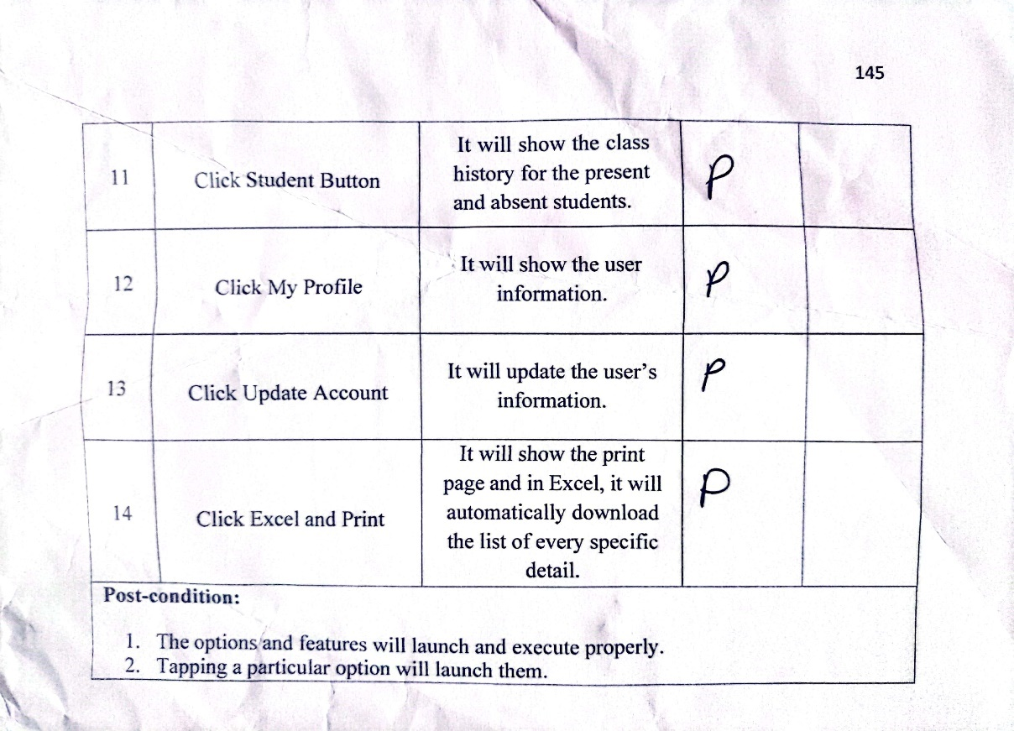

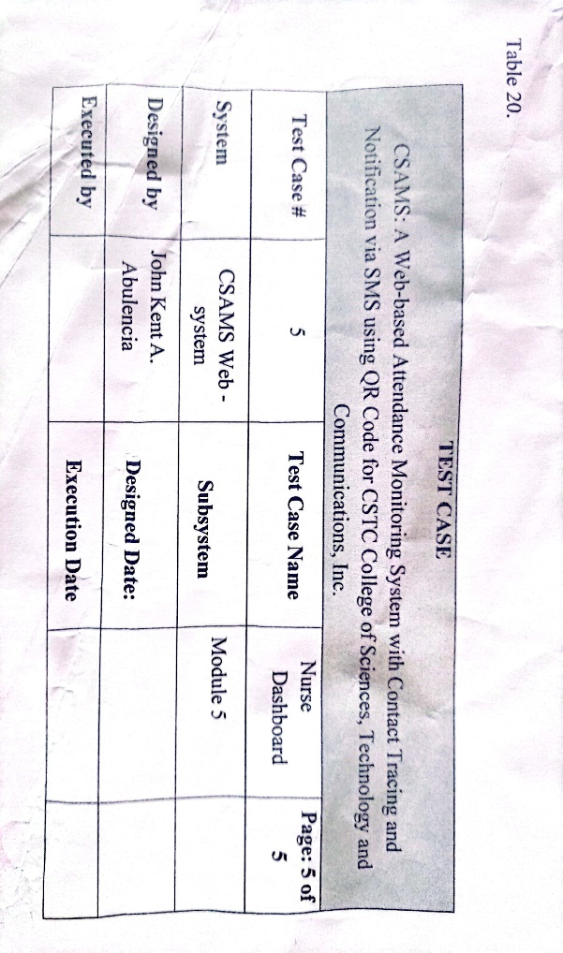**TEST CASE DOCUMENT FOR NURSE DASHBOARD**

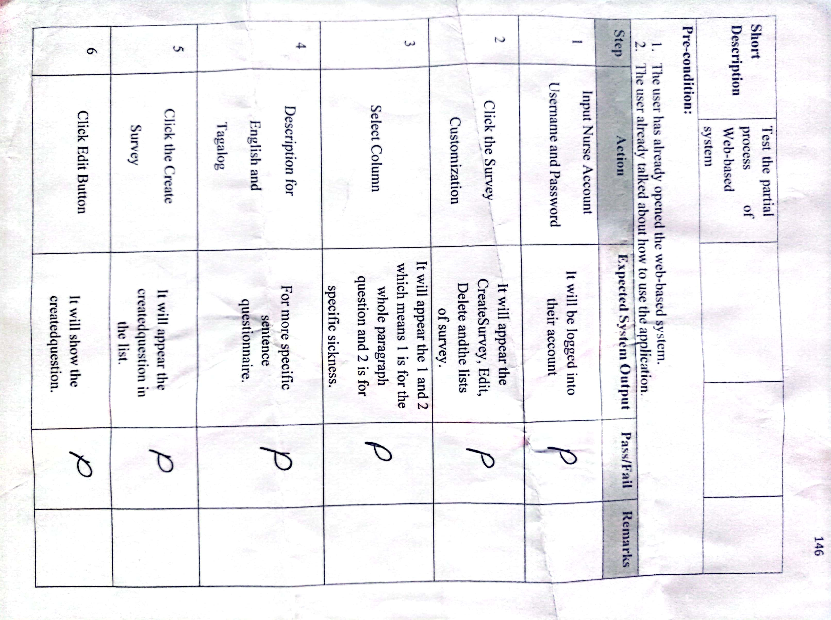

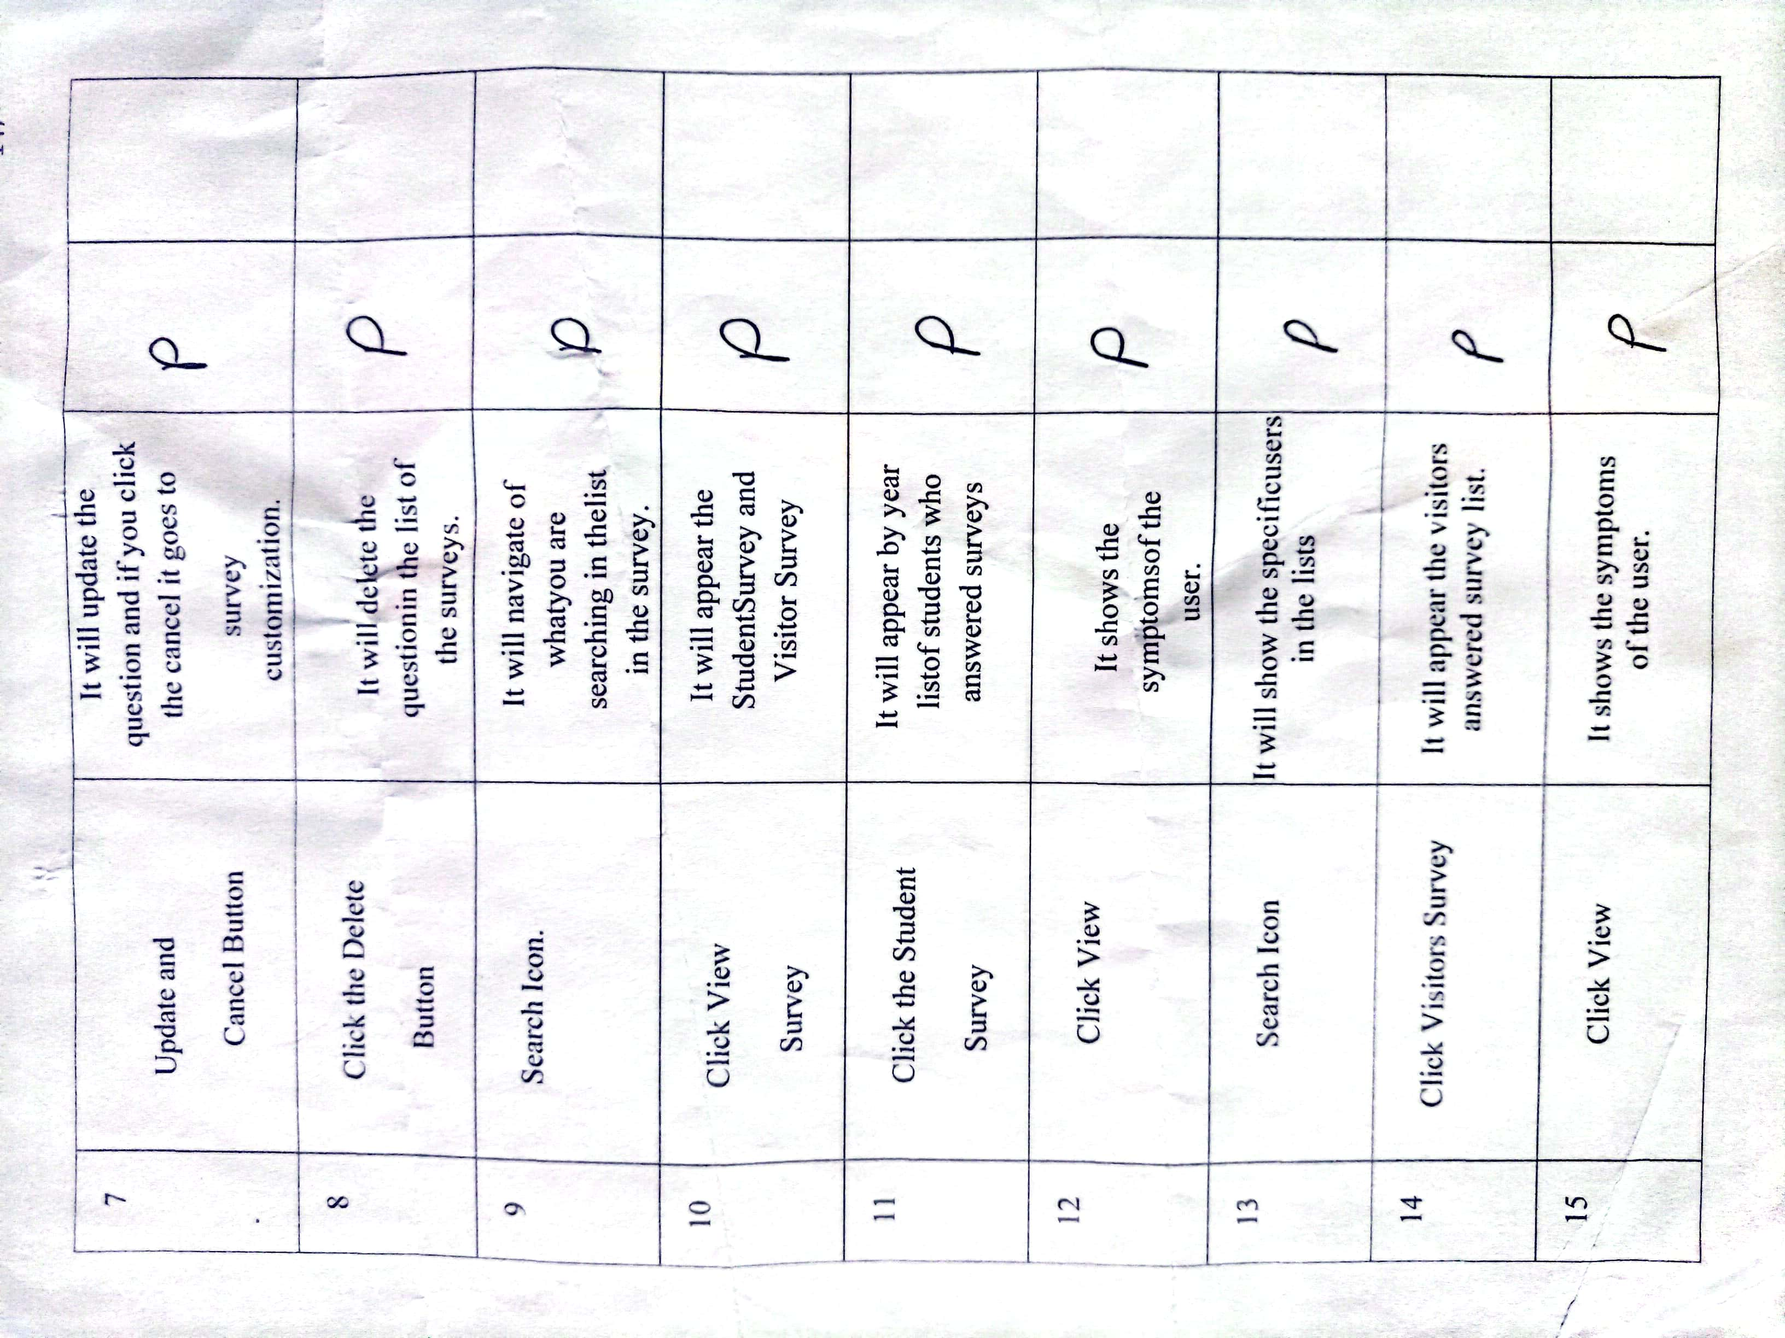

**Appendix “K”**

**CURRICULUM VITAE**



**JOHN KENT A. ABULENCIA**

Address: Brgy. Angeles Zone – 4 Tayabas, City

Mobile Number: 09665227694

Email: [abulenciajohnkent@gmail.com](mailto:abulenciajohnkent@gmail.com)

**PERSONAL INFORMATION:**

Date of Birth : December 23, 2000

Birthplace : Tayabas, City

Age : 22

Civil Status : Single

Citizenship : Filipino

Religion : Catholic

Father’s Name : Conrado C. Abulencia Jr.

Mother’s Name : Efleda A. Abulencia

**EDUCATIONAL BACKGROUND:**

**TERTIARY: Bachelor of Science in Information Technology (BSIT)**

College of Sciences, Technology and Communications, Inc.

Sariaya, Quezon

2019-2023

**SECONDARY: College of Sciences, Technology and Communications, Inc.**

Sariaya, Quezon

2017-2019

**Luis Palad National High School**

Tayabas, City

2013-2017

**PRIMARY: Tayabas East Central School 1**

Tayabas, City

2007-2013

**CHARACTER REFERENCES:**

**Engr. John C. Valdoria, MIT**

Professor

CSTC College of Sciences, Technology and Communications, Inc.

Sariaya, Quezon

0917-156-0806

**Jeremiah Lemuel O. Aldea**

Professor

CSTC College of Sciences, Technology and Communications, Inc.

Sariaya, Quezon

0926-184-9877

**Angelito Remos**

Professor

CSTC College of Sciences, Technology and Communications, Inc.

Lucena, City

0938-945-9770

*I hereby certify that the above information is true and correct to the best of my knowledge, ability and belief.*

*______________________*

**John Kent A. Abulencia**

**GIO R. CABUYAO**

Address: Brgy. Opias Tayabas, City

Mobile Number: 09453143447

Email: cabuyaogio78@gmail.com

**PERSONAL INFORMATION:**

Date of Birth : January 1, 2001

Birthplace : Tayabas City

Age : 22

Civil Status : Single

Citizenship : Filipino

Religion : Catholic

Father’s Name : Daniel R. Cabuyao

Mother’s Name : Eliza R. Cabuyao

**EDUCATIONAL BACKGROUND:**

**TERTIARY: Bachelor of Science in Information Technology (BSIT)**

College of Sciences, Technology and Communications, Inc.

Sariaya, Quezon

2019-2023

**SECONDARY: College of Sciences, Technology and Communications, Inc.**

Sariaya, Quezon

2017-2019

**Luis Palad National High School**

Tayabas, City

2013-2017

**PRIMARY: Tayabas East Central School 1**

Tayabas, City

2007-2013

**CHARACTER REFERENCES:**

**Engr. John C. Valdoria, MIT**

Professor

CSTC College of Sciences, Technology and Communications, Inc.

Sariaya, Quezon

0917-156-0806

**Jeremiah Lemuel O. Aldea**

Professor

CSTC College of Sciences, Technology and Communications, Inc.

Sariaya, Quezon

0926-184-9877

**Angelito Remos**

Professor

CSTC College of Sciences, Technology and Communications, Inc.

Lucena, City

0938-945-9770

*I hereby certify that the above information is true and correct to the best of my knowledge, ability and belief.*

*___________________*

**Gio R. Cabuyao**

**MONSOURE D. DE LA Cruz**

Address: Limbon, Sariaya, Quezon

Mobile Number: 009062469081

Email: monsouredelacruz16@gmail.com

**PERSONAL INFORMATION:**

Date of Birth : April 20, 2000

Birthplace : Sariaya, Quezon

Age : 22

Civil Status : Single

Citizenship : Filipino

Religion : INC

Father’s Name : Sanito M. De La Cruz

Mother’s Name : Maria Divina D. De La Cruz

**EDUCATIONAL BACKGROUND:**

**TERTIARY: Bachelor of Science in Information Technology (BSIT)**

College of Sciences, Technology and Communications, Inc.

Sariaya, Quezon

2019-2023

**SECONDARY: Canda Integrated Senior High School**

Sariaya, Quezon

2017-2019

**Canda National High School**

Sariaya, Quezon

2013-2017

**PRIMARY: Canda Elementary School**

Sariaya, Quezon

2007-2013

**CHARACTER REFERENCES:**

**Engr. John C. Valdoria, MIT**

Professor

CSTC College of Sciences, Technology and Communications, Inc.

Sariaya, Quezon

0917-156-0806

**Jeremiah Lemuel O. Aldea**

Professor

CSTC College of Sciences, Technology and Communications, Inc.

Sariaya, Quezon

0926-184-9877

**Angelito Remos**

Professor

CSTC College of Sciences, Technology and Communications, Inc.

Lucena, City

0938-945-9770

*I hereby certify that the above information is true and correct to the best of my knowledge, ability and belief.*

*_______________________*

**Monsoure D. De La Cruz**